Dulce Morataya

15 Chapter 9: Music
- 15. iTunes Store
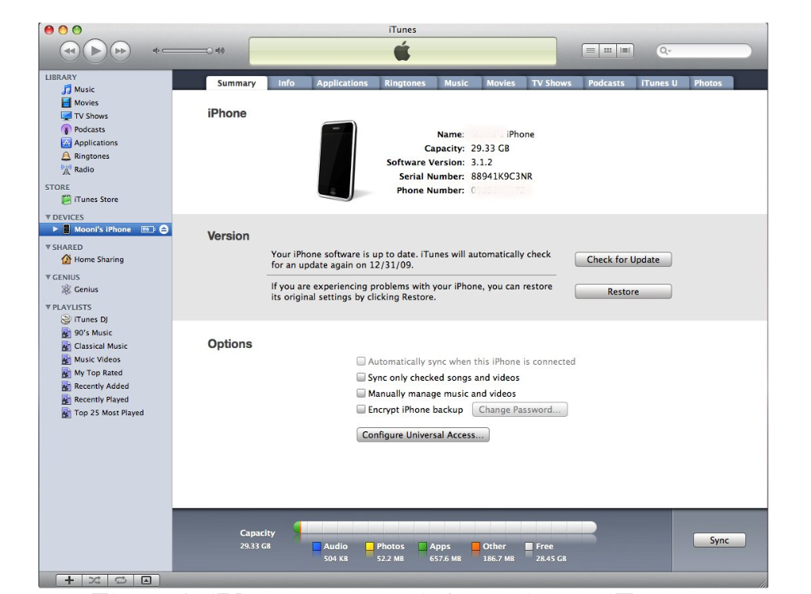

This is image is taken from a journal called, iPhone 3GS Forensics: Logical analysis using Apple iTunes Backup Utility, will allow me to break down how iTunes works in iPhones. This image will give a summary on information on how to use iTunes interface via an iPhone.

Bader, M., & Baggili, I. (n.d.). IPhone 3GS Forensics: Logical Analysis Using Apple ITunes Backup Utility, 4, 6-6.

15 Chapter 9: Music
- 15. iTunes Settings
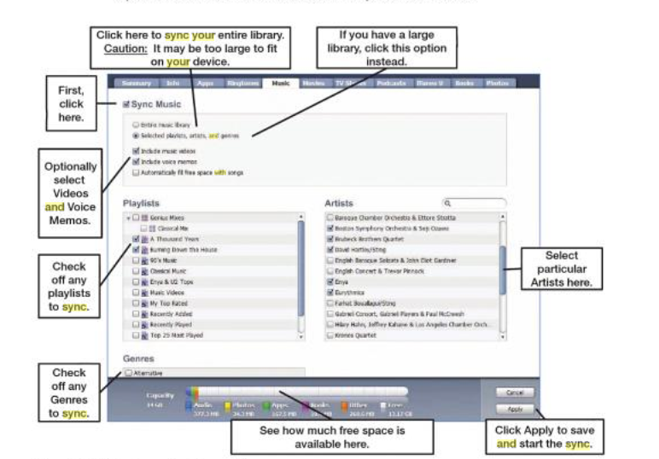

Using this image from the book, iPhone 4 made Simple, will allow me to present a clear representation on the breakdown of iTunes settings and music. It has a clear and concise overview of the fundamentals a user will need when syncing music onto their iPhone.

Trautschold, M., & Mazo, G. (2010). Sync Your iPhone with iTunes. InIPhone 4 made simple (p. 132). New York: APress :.

