Chapter 1: Getting Started
- 2. List of Material
- 3. Turning on and Setting up

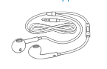
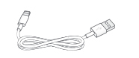
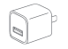

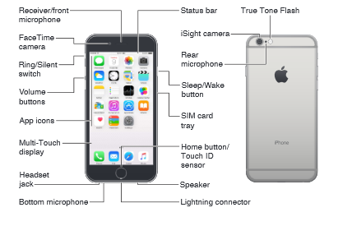

IPhone User Guide. (n.d.). Retrieved October 23, 2015, from https://manuals.info.apple.com/MANUALS/1000/MA1565/en_US/iphone_user_guide.pdf

Chapter 7: Using Email
- 12. Messages

Compose Email on iPhone? (n.d.). Retrieved October 23, 2015, from http://thinktutorial.com/smartphones/iphone/compose-email/

Chapter 6: Using Safari
- 11. Search and Browse Web

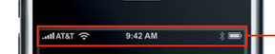

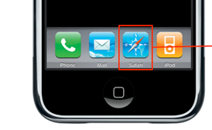

Glaser, R. (n.d.). Campus iPhone & iPod Touch Pre-2.0 Firmware Wi-Fi Setup. Retrieved October 23, 2015, from http://www.macos.utah.edu/documentation/networking/campus_iphone_pre_2_wifi_setup.html

Chapter 4: iPhone Siri
- 8. How to use Siri

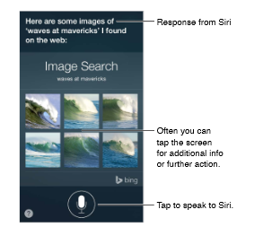

IPhone User Guide. (n.d.). Retrieved October 23, 2015, from https://manuals.info.apple.com/MANUALS/1000/MA1565/en_US/iphone_user_guide.pdf

Chapter 5: Apps (app store)
- 9. Find Apps

How do I download a new application to my Apple iPhone? - Ask Dave Taylor. (2009, April 4). Retrieved October 23, 2015, from http://www.askdavetaylor.com/how_to_download_iphone_app_application_to_apple_iphone_3g/

Chapter 2: The Basics
- 5. Control Center
- 5. Customizing

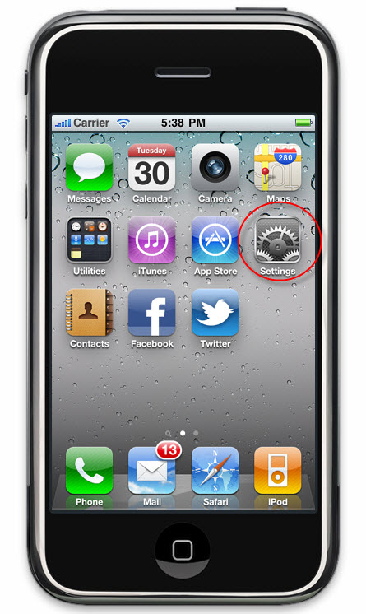
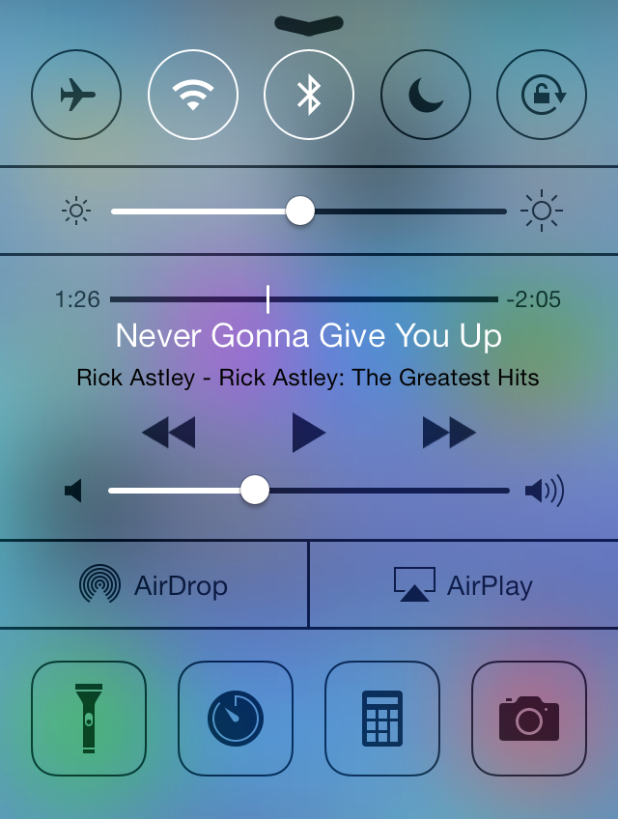

Apple. (n.d.). Retrieved October 23, 2015, from https://support.apple.com/en-us/HT202769

IDX Broker. (n.d.). Retrieved October 23, 2015, from http://www.idxbroker.com/support/kb/questions/357/myAgent - How to Change or Remove an Agent Code

