Dulce Morataya
IMAGES

IOS4.2 Text Tones Can be Changed, but…. (n.d.). Retrieved October 16, 2015.
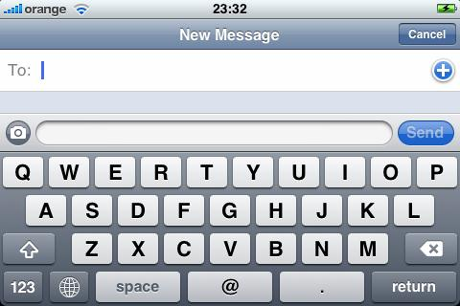

IOS4.2 Text Tones Can be Changed, but…. (n.d.). Retrieved October 16, 2015.

