Visual Display Assignment

Desiree Jean Michel

FAS 240: Visual Merchandising

New York City College of Technology

**Visual Display Assignment**

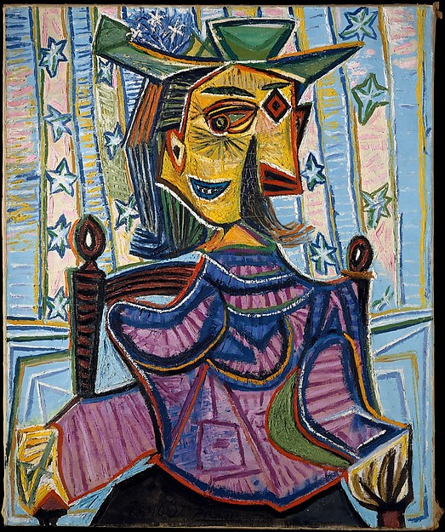 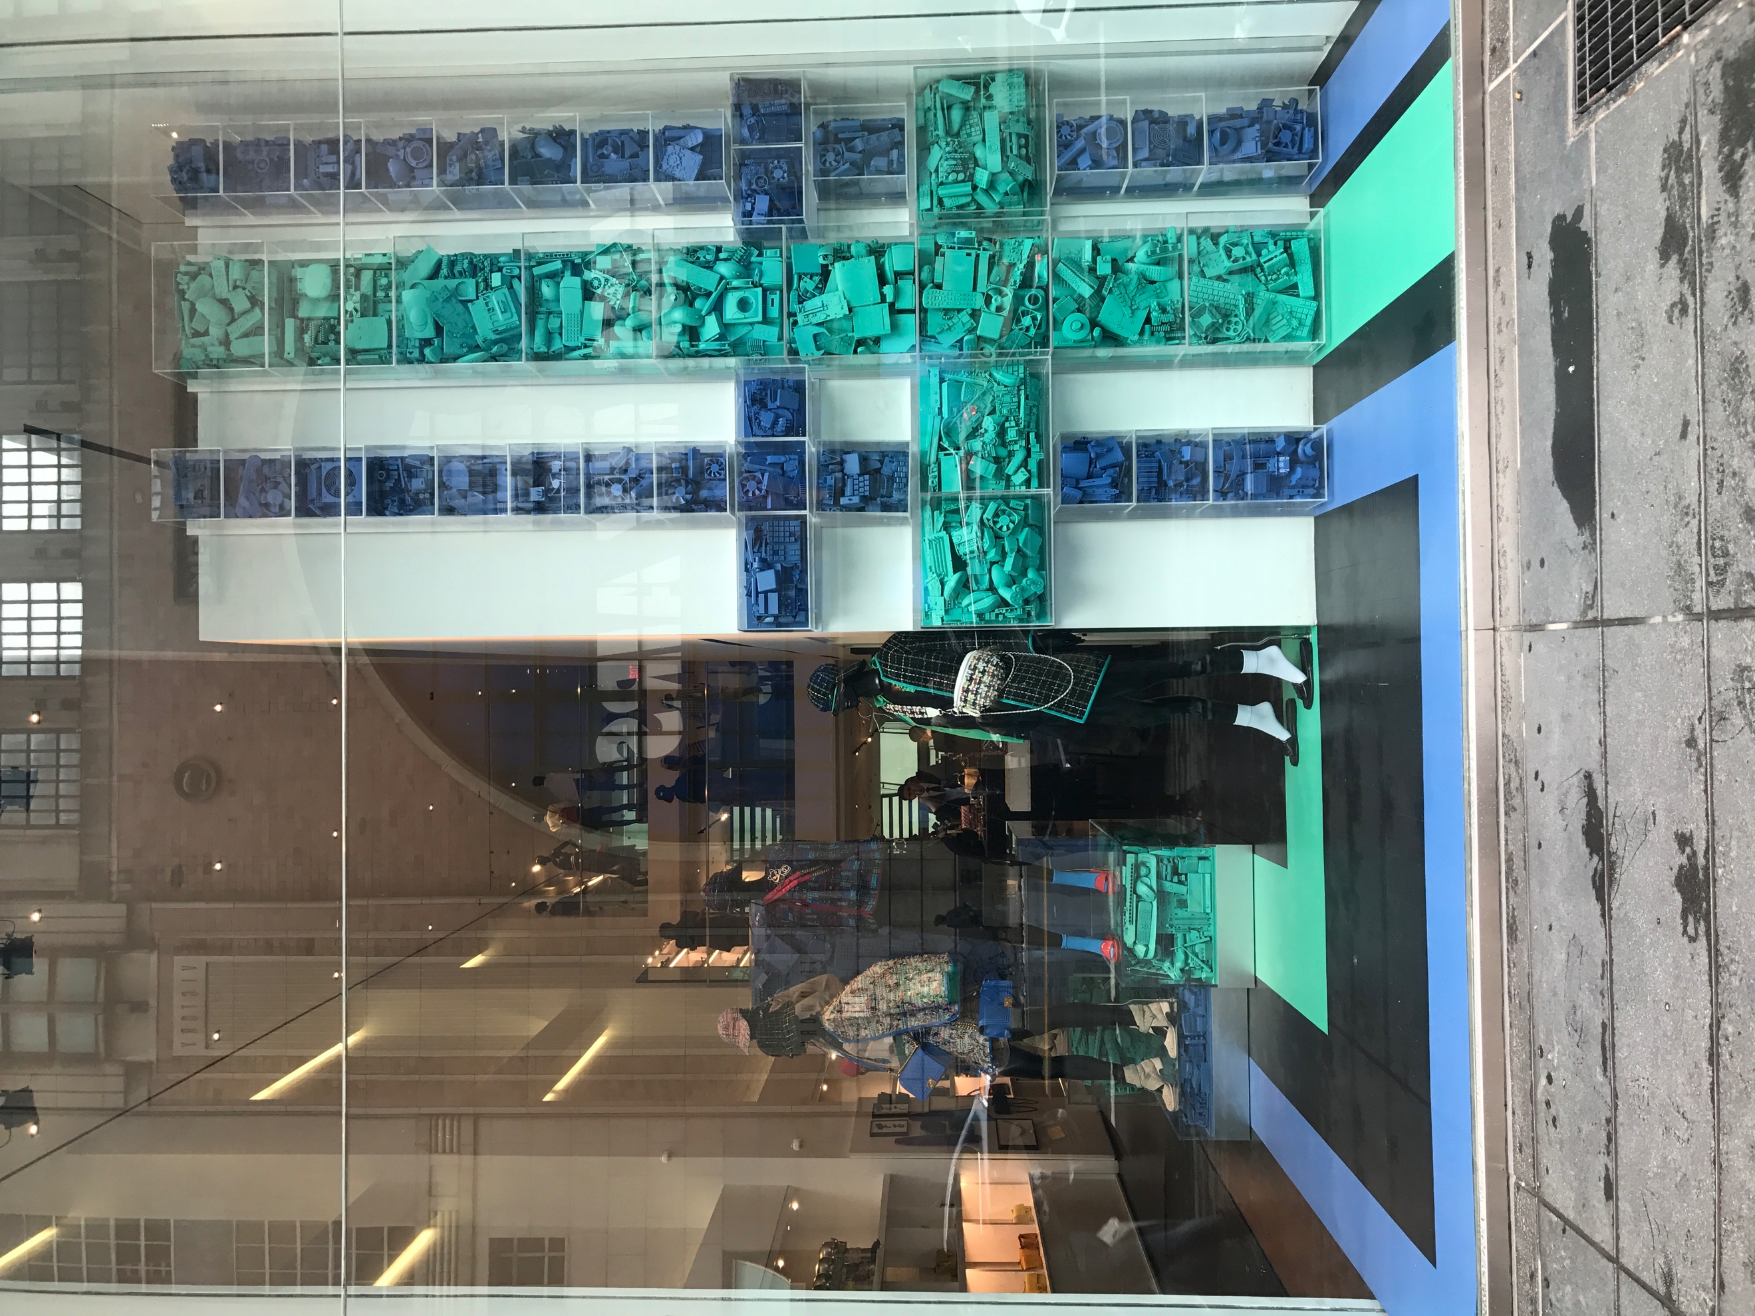

*Figure 1*. *Dora Maar Sitting in an armchair, Figure 2. Chanel Window Display, 2017*

*1939*

**Composition**

Visual displays composition is the arrangement of lines, forms, shapes and color. (Bell and Ternus, 2012) It’s used often to comprehend and analysis the background or meaning of all sorts of visual displays. Each line, forms, shades, colors have deeper meaning than just a glimpse of an eye. Visual displays can also mirror society or has influence on life, in this paper the two visual displays use to compare is Pablo Picasso artwork Dora Mora in an Armchair shown at Metropolitan Museum of Art and Chanel window display located on 15 East 57TH Street New York City.

**Hue**

Hue also known as color is used in visual display *Dora Maar in an armchair,*1939 painted by the late Pablo Picasso. Picasso painted this portrait of surrealist photographer Dora Maar, his lover for over nine years during the yearlong sojourn, temporary stay, in a small town in France where the two (Picasso and Dora Maar) witness the outbreak of world war II. Representing her radical distorted face and body and irregular patterns that seem to tilt and sway can mean a series of things the wallpaper in which the hotel that stood at () The background information will help further understand the portrait and the choice of colors.

A heavy amount of primary, secondary, and tertiary tone of colors, toneis a quality of color- it has to do with whether or not a color is warm or cold, bright or dull, light or dim and pure (Define Tone,2014). Primary color shown in the painting are red and blue, some secondary show is orange, violet and a tint of green; tertiary colors are red-orange and blue green also yellow-orange. The painting contained strong value of red outlines *only* on the woman’s body, red is associated with fire and blood, energy, war, danger, strength, power, determination as well as passion, desire, and love (Color Wheel Pro,2006) the color red can have a conflicting conclusion the love Picasso had for Dora Maar at the time representing war, witnessing world war II.

In addition, the hue of blue, often associated with depth and stability. It symbolizes trust, loyalty, wisdom, confidence, intelligence, faith, truth, and heaven- it is also beneficial to the mind and body giving a calming effect (Color Wheel Pro,2006). The deep hue of blue dominates specific part of her body: her lips, neck lines, curving her breast as well as arms and a tint of blue located on her abdomen. The background contains a serious of tertiary tints and shades of blue.

Furthermore, the woman faces shown shades of yellow-orange represent her lighter skin tone, lustering the picture with a center of joy and happiness. The olive green, traditional color of peace, shown in her hat also reiterating on the side of her abdomen

**Texture**

Texture is defined as the surface treatment or the physical feel; the smooth sheen and roughness of an object (Bell & Turnus, 2011). Juxtaposition is used through the paint brush strokes in the entire painting to enhance the different texture and lines and movement. Picasso use thick aggressive strokes on her hair giving the image a visual texture that her hair is rough shown in *figure 1.* Through the use of his paint brush the artist gave texture to the wrinkles besides her eyes, and on her forehead. On the other hand, Picasso uses soft strokes to illustrates the texture of Dora soft curves.

In the visual display of Chanel there are several textures. The first texture that viewers’ notes are items in the cubes, gradually transforms into smooth lines that leads into the mannequins located in the store. The objects in the cubes can have a similarity to the famously known pattern of Chanel which is tweeding. Tweeding is a woolen material woven in intricate ways to create plain, twill, herringbone and check patterns (Tweed, 2016). Chanel is ironically known for their tweed pieces that many consumers would recognize this statement pattern. The element of texture used in this visual display evokes consumers the symbolism behind the famous pattern.

Line

Lines is the direction a mark navigator towards some lines can be vertical, curved and horizontal. Lines can even form rhythm repetition, balance and proportion often time line formation can show the dominance in display (Bell & Ternus, 2011). Vertical Line are represented as strength height pride majesty as well as dignity which can also represent masculinity to go in depth analyzing the painting vertical line are seen throughout majority of the background. The vertical lines have its breaking point once it reached towards her chest giving the viewer the ability to motion their eyes from the top of the painting downward to the center, her chest, in which there are short break horizontal lines, are easy going calm appear wider also cuts the vertical effect (Bell & Turner, 2011) form with vertical lines emphasize a hallow around her body sitting on the chair. Curved line is shown in only in Mora smile; the curve lining on her chin reiterating her smile, her chest proudly showing her chest as well as the side of her abdomen. One may observe and picking up on Maar posture sitting vertical gives a better meaning to her curved smile assuming she has pride in her posture or her body, highlighting more curve lines are deeply emphasis of the silhouette of her bust and slim stomach Curve lines represent

Thirdly, diagonal lines are action of forceful, strong and dynamic (Bell and Ternus,2012) there wasn’t much details of diagonal lines but the print of her blouse.

In *figure 2,* the visual display consists of vertical and horizontal lines. The use of combined direction creates texture and pattern (Charlotte Janousek, 1995). The vertical and horizontal lines is used to represent the lining in tweeding. Tweeding also consist of directions in the fabric pattern, which is reiterated in the garment worn on the mannequins combining these two lines communicates stability. To furthermore the lines positioned on the wall continues to

Replicates on the floor leading to the other mannequins shown. Horizontal lines on the floor gives a restful appearance in a feminine approach to the garment shown in the visual display. Although diagonal and curve lines weren’t as dominate in this visual display consumers can see both in the garments and accessories in this Chanel visual display.

Balance

In *figure 1,* Picasso painting gives balance to the painting. Balance is an element that is used to make sure a design is symmetrical or asymmetrical (Bell & Ternus, 2011). The women presented in the painting gives proportional balance to the size of the canvas the amount of illustration used in both sides of the subject is equally balanced; the left size is weighted evenly compared to the right side. The build formal balance by arranging elements equally around a central point **(**Principle of balance, 1995) the central point, the women in which the objects around her are layout giving balance. Another component of symmetrical appearance to the eye is the use of color within the background and the woman.

In *figure 2.* Chanel displays asymmetrical balance in the window display. Asymmetricalbalance is also called informal balance. It involves placement of objects in a way that will allow objects of varying visual weight to balance one another around a fulcrum point (Principle of balance, 1995). Through the use informal balance in the visual majority of the balance is shown on the right side of the window gravitating viewers focus towards that side. The elements included are cornered to one side unlike the opposite side, one can see through the left side of the store composite a lighter weight for the visual.

**Dominance**

The Dominance in *figure 1,* has many elements ones’ attention. One element that stood out the most is the women in the painting she stood out the most through the arrangement of hues, it automatically catches ones’ attention. Dominance places Emphasis is created by visually reinforcing something one wants the viewer to pay attention to (Rob Flye, 2011). The focus point would be the combination of color and texture that is used in the female that grasps ones’ attention. Concentrating on the enlargement of the enlargement of a subject or object to what is important gives viewers to know what to connect to (Rob Flye, 2011) the use of rich tones of colors located on the women body isolates from other distractions that is going on in the painting.

Often time in a retail visual display mannequin aren’t always dominant. some element shown in *figure 2* are the object within the lines as well as the color scheme in the window display. The dominance of the lines draws attention through the use of color being compared to the fabric of the garment that’s closes to the window. The colors are dominate setting the mood for what one can expect before shopping at Chanel. The objects are also play a part in dominance in camouflaging with the colors which are also used in the garment.

Contrast

In *figure 1,* Picasso uses a contrast using colors in his paintings. Contrast is defined as the sharp difference. the background includes tints of colors like pink, baby blue, and yellow which seem to give a neutral background. The colors used in the woman contrasts with the colors of the background by using more heavier colors like dark blue, dark green and purple. In addition to the color the size of the woman brings a contrast to the background making her a bigger statement than what is drawn in the background.

In *figure 2,* the is a use of contrast with white and black from the wall of the display to the floors of the store. The main colors used in the display are blue and green which are colors that go together since they sit next to each other on the color wheel. The other element that uses contrast is the size of the lines of the cubes. The cubes contain small and large object in which make the cubes seem larger in size. The small items and large cubes are a contrast to each other.

Proportion

Proportion relates to the relationship size and scale within elements (Bell & Ternus, 2011). In *figure 1,* the woman in the painting seems to be scaled to fit the size of the canvas making is proportioned. The woman is also centered making her balanced in both sides of the canvas. The sizing of the painting is also proportional because is drawn a regular size and nothing is abnormal about her, only her features like her faces and torso.

In *figure 2,* the elements that share a relationship with size are the items in the cubes. The size of the cubes is consistent throughout the length of the visual wall. The items included inside the cubes seem to be less proportional to the item that is holding them. The items inside are also portion because it varies within sizes inside the cubes.

Rhythm

Rhythm is displayed throughout *figure 1* with lines and colors. The repeated colors and lines give an overall flowing of rhythm through the entire piece. Rhythm is a visual tempo or beat. In element of design that refers to a regular repetition of elements of art to produce the look and feel of movement (Rhythm,2016). The tint of colors in the painting is repeated, the structure of lines can catch ones eye the next thing that complement and structures the colors in the painting are the arrangement of lines.

In *figure 2,* the Chanel display starts its rhythm forms within the colors that are shown on the visual wall and the floors. The purple and teal are colors that complement each other but still are the dominating objects in the display. One will start to see this visual from the top of the window then leading it attention to the floor that then leads into the mannequins. The mannequin camouflages with darkness of the floor so one will take their attention straight to the garments that are dressed on them.

Repetition

Repetition is repeated or reiterating an idea or motif (Bell & Ternus, 2011). Repetition is when an item in something is constantly repeated. In *figure 1,* the background repeats the pattern of lines and stars. The background seems to show that it is a background of a wallpaper. Another repeating part of the Picasso painting is the detail of the woman’s sweater. The stripes continue its pattern throughout the whole garments she wears.

In *figure 2,* the Chanel display seems to repeat the items inside the cubes. The items include small accessories that camouflages with the color of lining that it lines up with. Another repeating item in this display is the use of lines, like the fabric of the garment, the colored lines are also repeated in the garment of the tweed jacket on the mannequin in the display.

In sum of, Picasso *Dora Maar in an Armchair* and Chanel visual display group of the elements of design to achieve a united whole, both provide some similarities in color as well as alignment with lines within the background. Picasso painted Dora Maar in an armchair to show society what war can do to something so beautiful Through his vacation the two Picasso and the subject Dora Maar, his lover witnessed World War II. Picasso used Dora someone he knew to be so beautiful, painting her as dismantled and destroyed her beautiful body can represent as damaged or seem unpleasing to the eye. On the other hand, Chanel window display portray the opposite they emphasize the beauty within their iconic tweeding in their new collection.

References

Bell, J & Ternus, K. (2011). *Silent Selling: Best Practices and Effective Strategies in Visual*

*Merchandising.* (4th Edition).Manhattan, NY: Fairchild Books.

Color Wheel Pro - See Color Theory in Action (2016) Retrieved 2017, from http://www.color

wheel-pro.com/color-meaning.html

*Figure 1:* Art (2017) Pablo Picasso Dora Maar in an Armchair | The Met . Retrieved 2017, from http://www.metmuseum.org/art/collection/search/487039

*Figure 2:* Visual Display, Desiree Jeanmichel 2017 Retrieved from Personal Collection

Flye, R. (2011). Emphasis, Dominance and Focal Point. Retrieved 2017, from

http://flyeschool.com/content/emphasis-dominance-and-focal-point

Jirousek, C. (1995). Retrieved 2017, from http://char.txa.cornell.edu/language/element/element.htm

Jirousek, C. Principle of Balance (1995). Retrieved 2017, from http://char.txa.cornell.edu/language/element/element.htm

Esaak, S. (2014) Define Tone. Retrieved 2017, from

https://www.thoughtco.com/tone-definition-in-art-182471