DIGITAL SCRAPBOOK
BY
IBRAHIMA Diallo

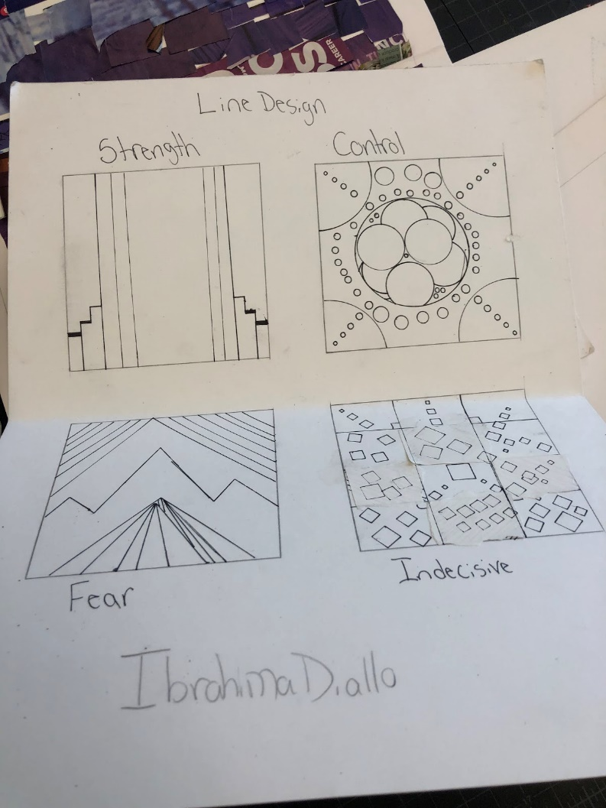 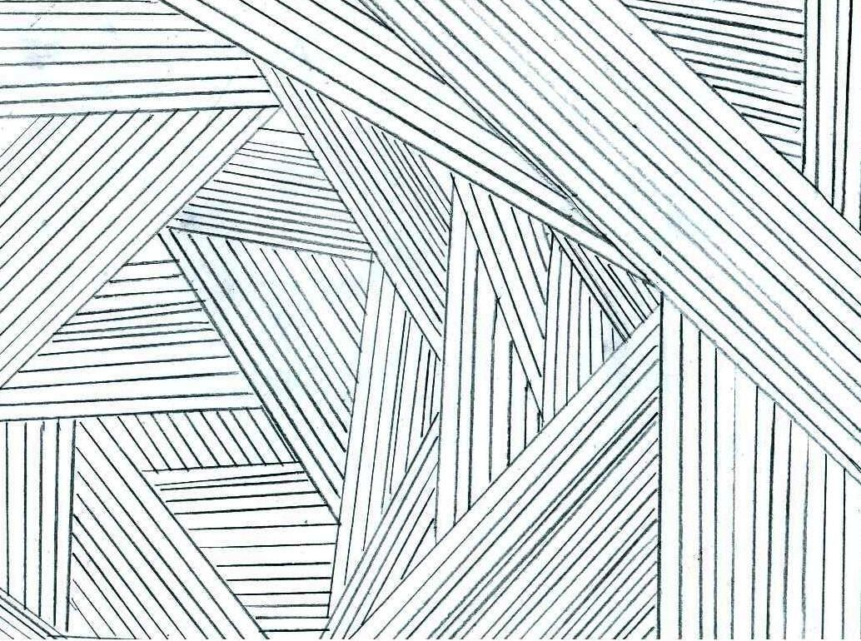Line: in these two examples it shows how lines can be used to justify a use of emotions in our everyday lives whether the actions result in a positive or negative action.
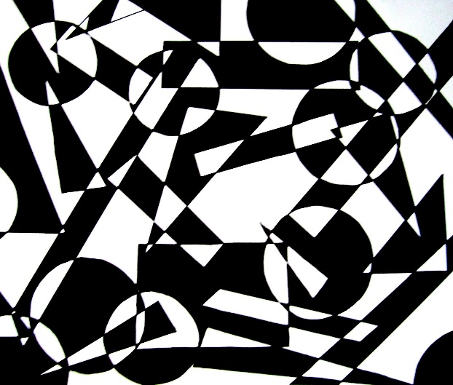
Shape: When it comes to shapes and how it reflects back to the art of design is that although they often come out 2 dimensional, certain aspects of how the shapes are drawn can make them 3 dimensional. As the third picture shows a pattern of triangles on a building which allow the building to stand out.

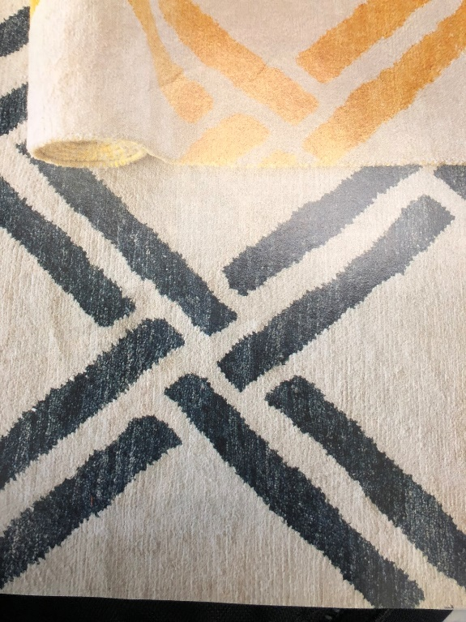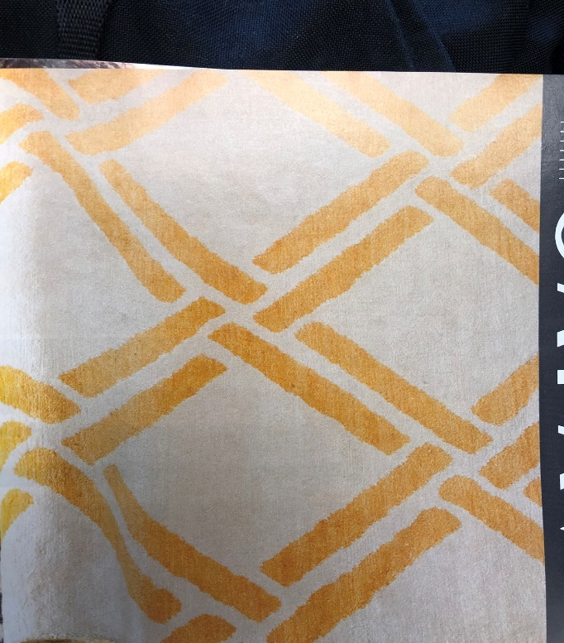
Repetition: This is the act of which something is being repeated in a point where it is trying to give a deeper meaning to individuals.
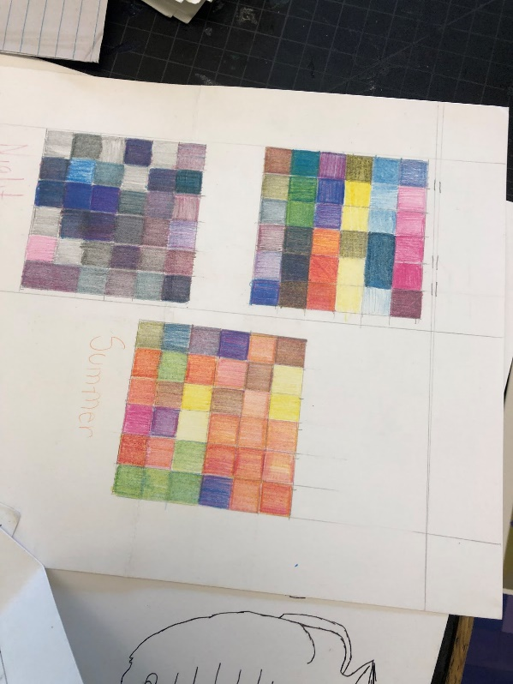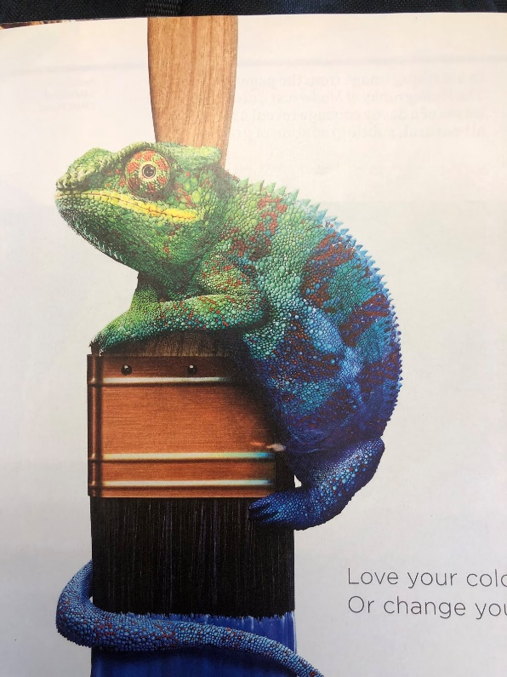
Value/Color: in these two pictures it gives us a sense of lightness and darkness, as well as the color scheme of the hues impacting the images. A sense of primary and secondary colors being used giving the image more taste.

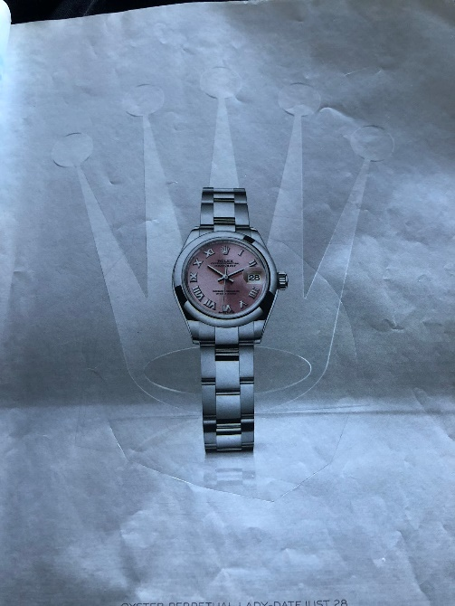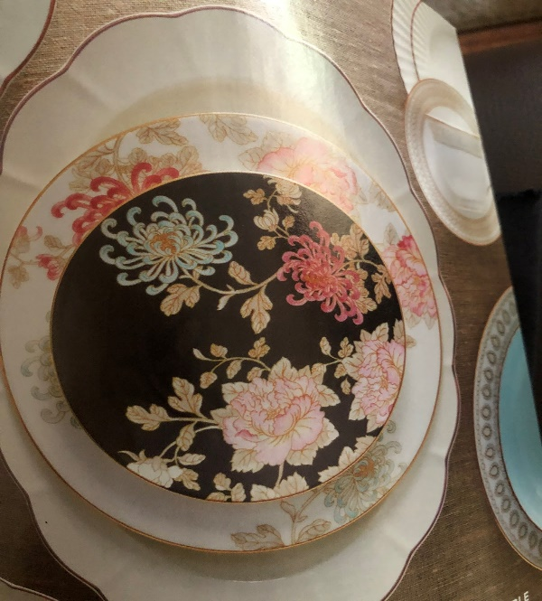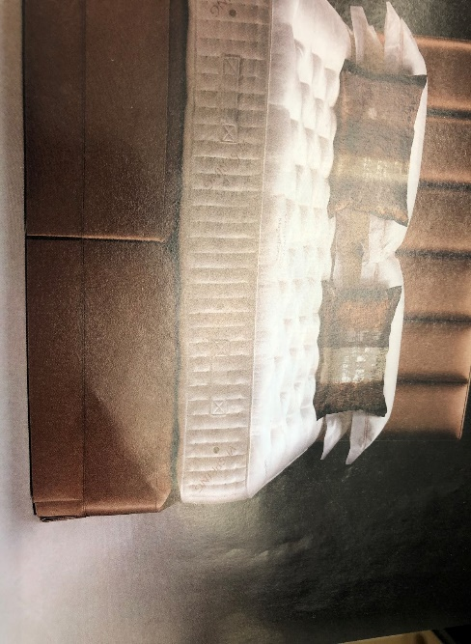Gradation/
Texture: The reason for the combination of gradation and texture is for the fact that they’re in par with each other. The texture displayed in the image is of the alien off of my sweater. The gradation are the other three images especially of the watch in which the gradation makes the watch the very focal point of the whole image.

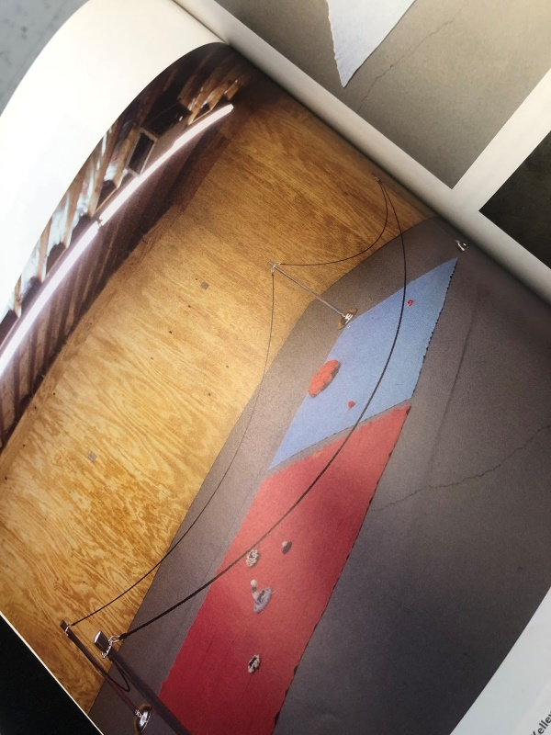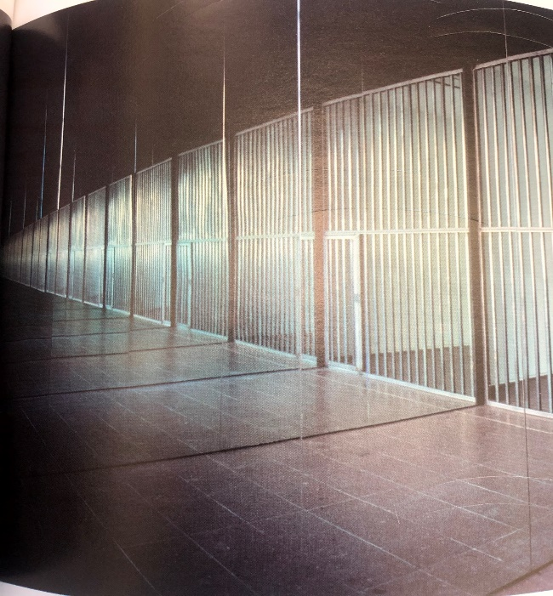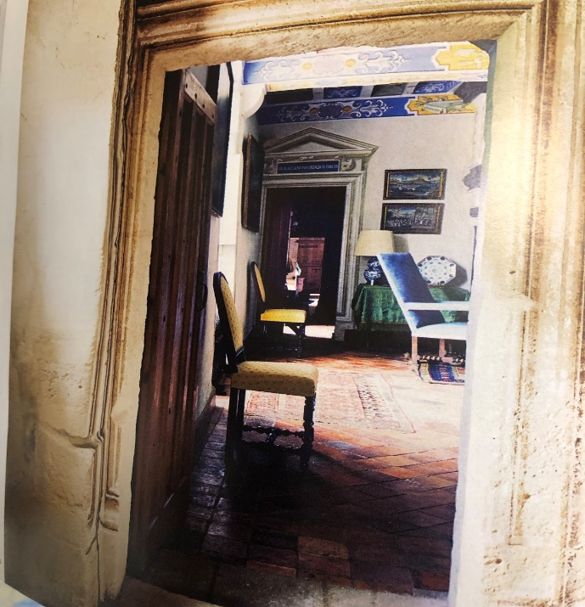Space: the space in which these three images are showing can give us a visualization of what we never imagine from a closed point of view

