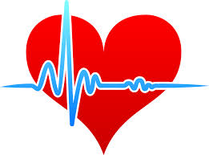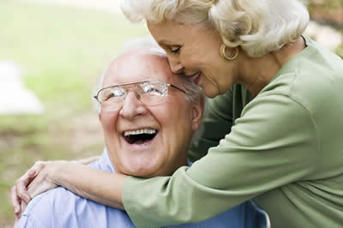

Come join us for a free educational and interactive class on HEART DISEASE. Our topics will include information on hypertension, cholesterol and nutrition.

Goddard Riverside Senior Center

595 Columbus Avenue

New York, NY 10024

11 am to 12:30 pm

### FEATURING:

### INFORMATION ON HEART DISEASE, HYPERTENSION, NUTRITION, AND CHOLESTEROL

### 

### PAMPHLETS & BROCHURES

### EDUCATIONAL BOARDS

### ***FREE BLOOD PRESSURE SCREENING***

HEART DISEASE DISDISEASE

EDUCATION & PREVENTION