Leslie Rosas
Arch 3561
Assignment #3

Average Temperature in New York City
New York City has humid hot summers and wet cold winters. The weather can change dramatically in a matter of hours.

Practical seasons

Fall Season September, October, November: These are some of the most pleasant months in New York City. The air is crisp and clear, and the sun shines often.
Winter Season December, January, February: During these months it can get very cold and very windy. Snow and/or sleet can also make walking slippery.
Spring Season March, April, May: These months are often quite pleasant.
Summer Season June, July, August: The summer months can bring stifling heat and humidity to the city. Even at night, temperatures may remain in the 90s.
Mean Temperature, Precipitation, Temperature extremes records
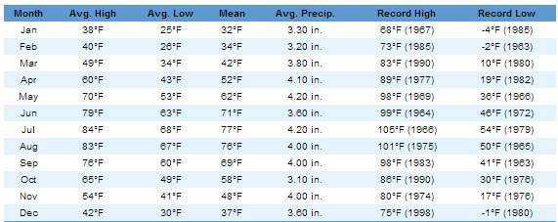

Humidity
The relative humidity typically ranges from 44% (comfortable) to 91% (very humid) over the course of the year, rarely dropping below 22% (dry) and reaching as high as 100% (very humid).
The air is driest around April 15, at which time the relative humidity drops below 56% (mildly humid) three days out of four; it is most humid around August 6, exceeding 87% (very humid) three days out of four.
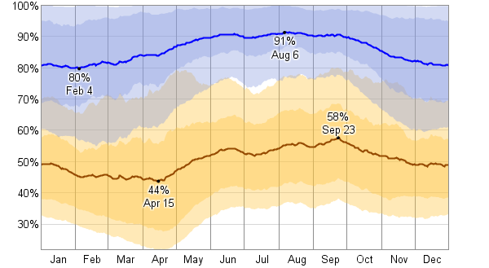
IECC , ASHRAE climate zone
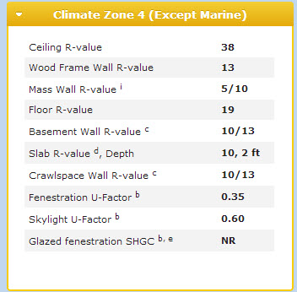
Heating Degree Days
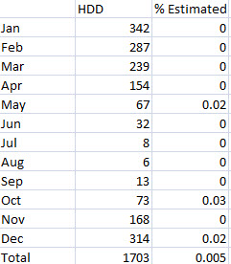

Average Temperature in Irvine, CA
Practical seasons
Irvine, CA, gets 13 inches of rain per year. The US average is 37. Snowfall is 0 inches. The average US city gets 25 inches of snow per year. The number of days with any measurable precipitation is 34.
On average, there are 281 sunny days per year in Irvine, CA. The July high is around 84 degrees. The January low is 41. Our comfort index, which is based on humidity during the hot months, is a 53 out of 100, where higher is more comfortable. The US average on the comfort index is 44.
Mean Temperature, Precipitation, Temperature extremes records
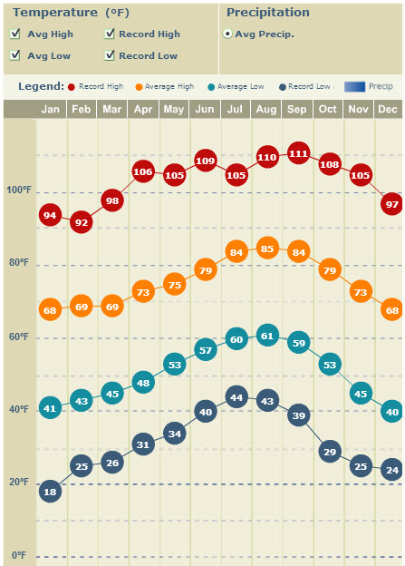
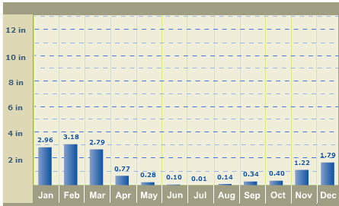

Humidity
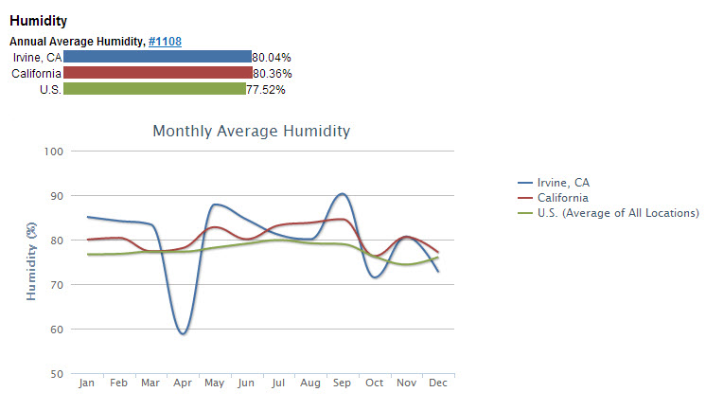

IECC, ASHRAE climate zone
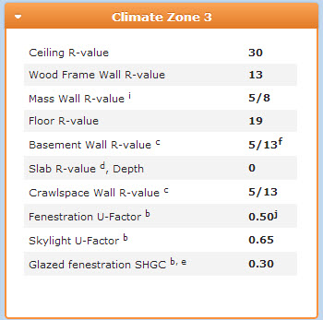

Heating Degree Days: 1,400

WALL SECTION-Team Alberta
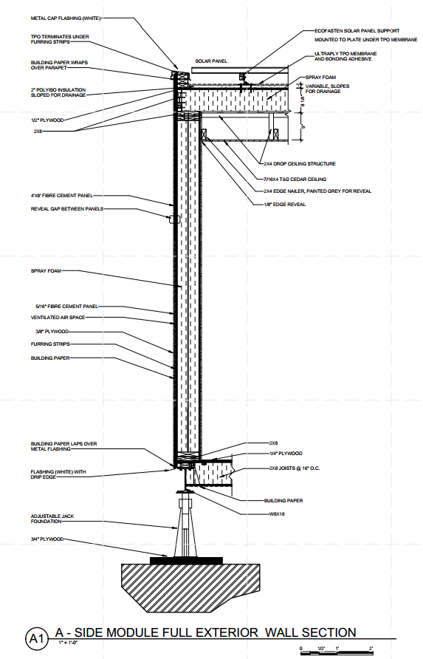
Wall strategy:
Rainscreen w furring strips

Wall address:
Durability: Spray foam insulation with 2x4 wood studs and 1/2” plywood sheathing and ½” gypsum sheathing.
Air leakage: Continuous insulation

Strategies:
Building Paper
Air space
Spray foam insulation

R-value:
5/16” Hardie fiber cement panel 4’x8’= 0.48
Gypsum wall board sheathing (1/2") = 0.45
Building Paper = 0.06
Plywood furring strips (3/8") = 0.47
Plywood sheathing (1/2”) = 0.62
Spray foam insulation with 2x4 wood studs @ 16o.c. =6.00

Total = 8.08

Air Space 1
Vapor Barrier 1

