Table of Contents

Problem # 1 2

Part 1: Finding the reflection coefficient, the Voltage Standing Wave Ratio, the input impedance by calculation. 2

Part 2: Finding the reflection coefficient, the Voltage Standing Wave Ratio, the input impedance using the Smith Chart. 3

Problem # 2 4

**Project 1**

**Team 1:**  Mamadou Bah, Arie Meiman, Daniel Edwards

## Problem # 1

A 690λ- long lossless Z0=75Ω T-line is terminated in in a load ZL=15+j67 Ω. Calculate and use the Smith Chart to find:

1. ΓL;
2. VSWR;
3. Zin

Solution: This problem is divided into two parts:

### Part 1:

Calculation part

Zl=15+i*67; % Load impedance  
Zo=75; % Characteristic impedance of the transmission Line  
% The reflection reflexion  
Lamda=(Zl-Zo)/(Zl+Zo); % The reflexion coefficent at the load  
mag=abs(Lamda); teta=angle(Lamda);  
disp('*********************************************')  
fprintf('The magnitude of the reflexion coefficient is :%f\n and and the phase in degree is : %f\n',mag,teta*180/pi)  
% The voltage standing wave ratio  
disp('*********************************************')  
VSWR=(1+mag)/(1-mag);  
fprintf('The voltage standing wave ration is equal to : %f\n',VSWR)  
disp('*********************************************')  
% The input Impedance  
% tan(beta*lenght)=0.275;  
Zin=Zo*(Zl+i*Zo*(0.275))/(Zo+Zl*i*(0.275));  
fprintf('The input impedance is equal to : %f\n',Zin)  
disp('**********************************************')

*********************************************  
The magnitude of the reflexion coefficient is :0.801589  
 and and the phase in degree is : 95.179522  
*********************************************  
The voltage standing wave ration is equal to : 9.080091  
*********************************************  
The input impedance is equal to : 28.204791  
**********************************************

### Part 2:

1. The reflection coefficient:

* First we have to normalize the load impedance: 

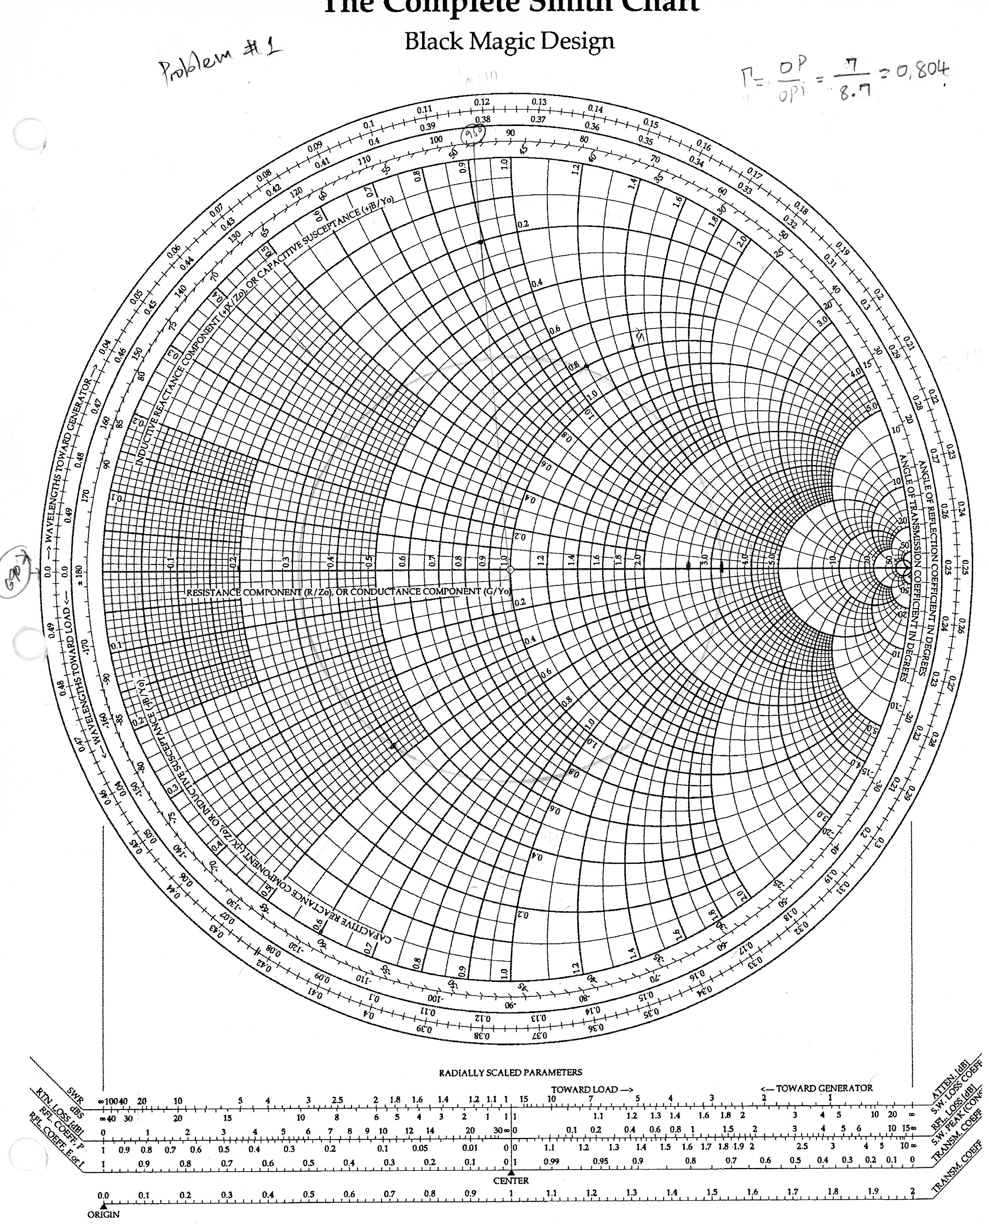

* We find the intersection of the real circle (x= 0.2) circle and the imaginary circle (Im=0.8933)
* 

1. The Voltage Standing Wave Ratio: from the smith chart VSWR= 3.2
2. The input impedance:







## Problem # 2

The input impedance for a 100Ω lossless T-line of length 1.162λ is measured as 12+j42 Ω. Determine the load impedance.

Solution:

t=0.12812;  
Z0=100; Zin=12+j*42; %t=tan(beta*lengh)  
Zl=(Z0)*(Zin-j*Z0*t)/(Z0-j*Zin*t);  
disp('*********************************************')  
disp('The load impedance in ohm is :')  
disp(Zl)  
disp('*********************************************')

*********************************************  
The load impedance in ohm is : 10.9808 +27.8578i  
*********************************************

## Problem # 3

a) Design an open ended shunt-stub matching network to match a load ZL =70+j110 Ω to a 50 Ω impedance T-line. Choose the solution that minimizes the length of the through line.

1. Now suppose the load turns out to be ZL =40+j100 Ω. Determine the reflection coefficient seen looking into the matching network.

Solution:

* We normalize the load impedance: 
* we found the normalized admittance by joining the drawing a line tha start from the intersection of 1.4 j*2.2 and passing by the center of the circle and the intersection of the line and  is 
* we moved along the perimeter clockwise going to the generator until we intersect with the 1+j*b
* we found –b and draw a line that passes to center of the circle;
* the intersection of the line and the outer circle of the smith chart gives us and distane;
* the length is found by subtracting this distance to with give us 
* the distance that we need to travel is found by subtraction 

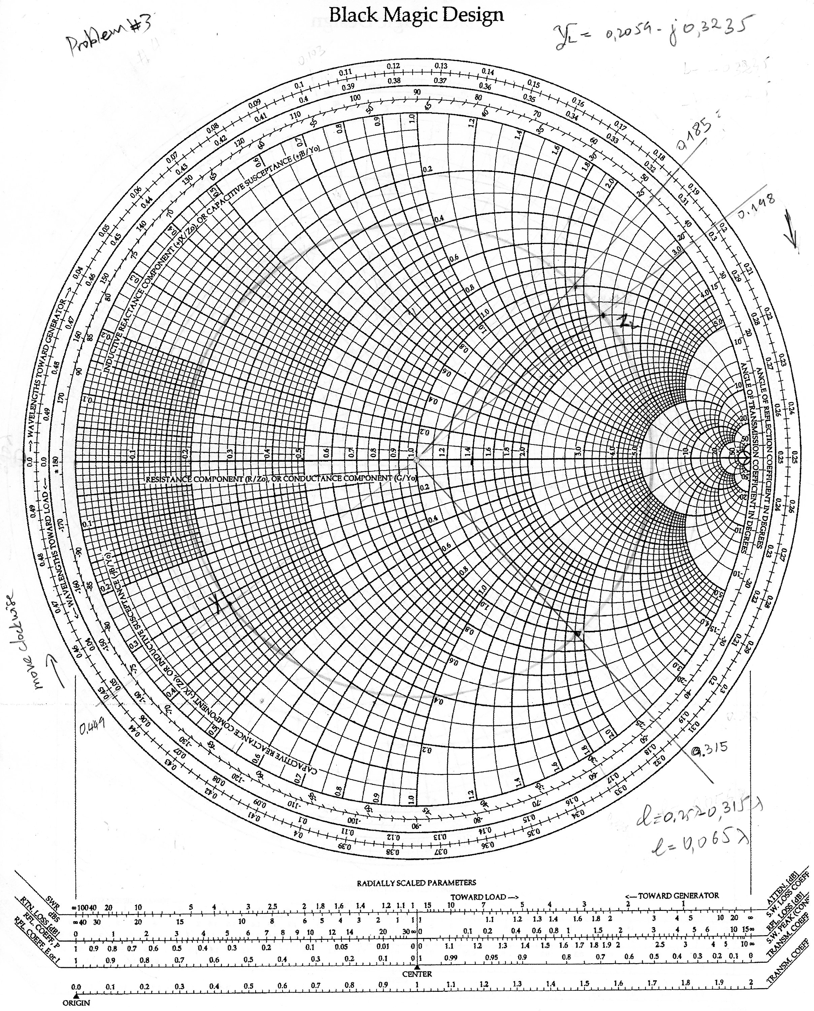

## Problem # 4

A load impedance ZL=25+j90 Ω is to be matched to a 50 Ω line using a shorted shunt stub tuner. Find the solution that minimizes the length of the shorted stub

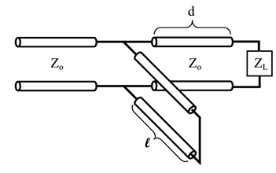

Solution

* We normalize the load impedance: 
* we found the normalized admittance by joining the drawing a line tha start from the intersection of 0.1433 j*0.515 and passing by the center of the circle and the intersection of the line and  is 
* we moved along the perimeter clockwise going to the generator until we intersect with the 1+j*b
* we found –b and draw a line that passes to center of the circle;
* the intersection of the line and the outer circle of the smith chart gives us and distane;
* the length is found by subtracting this distance to with give us 
* the distance that we need to travel is found by subtraction 

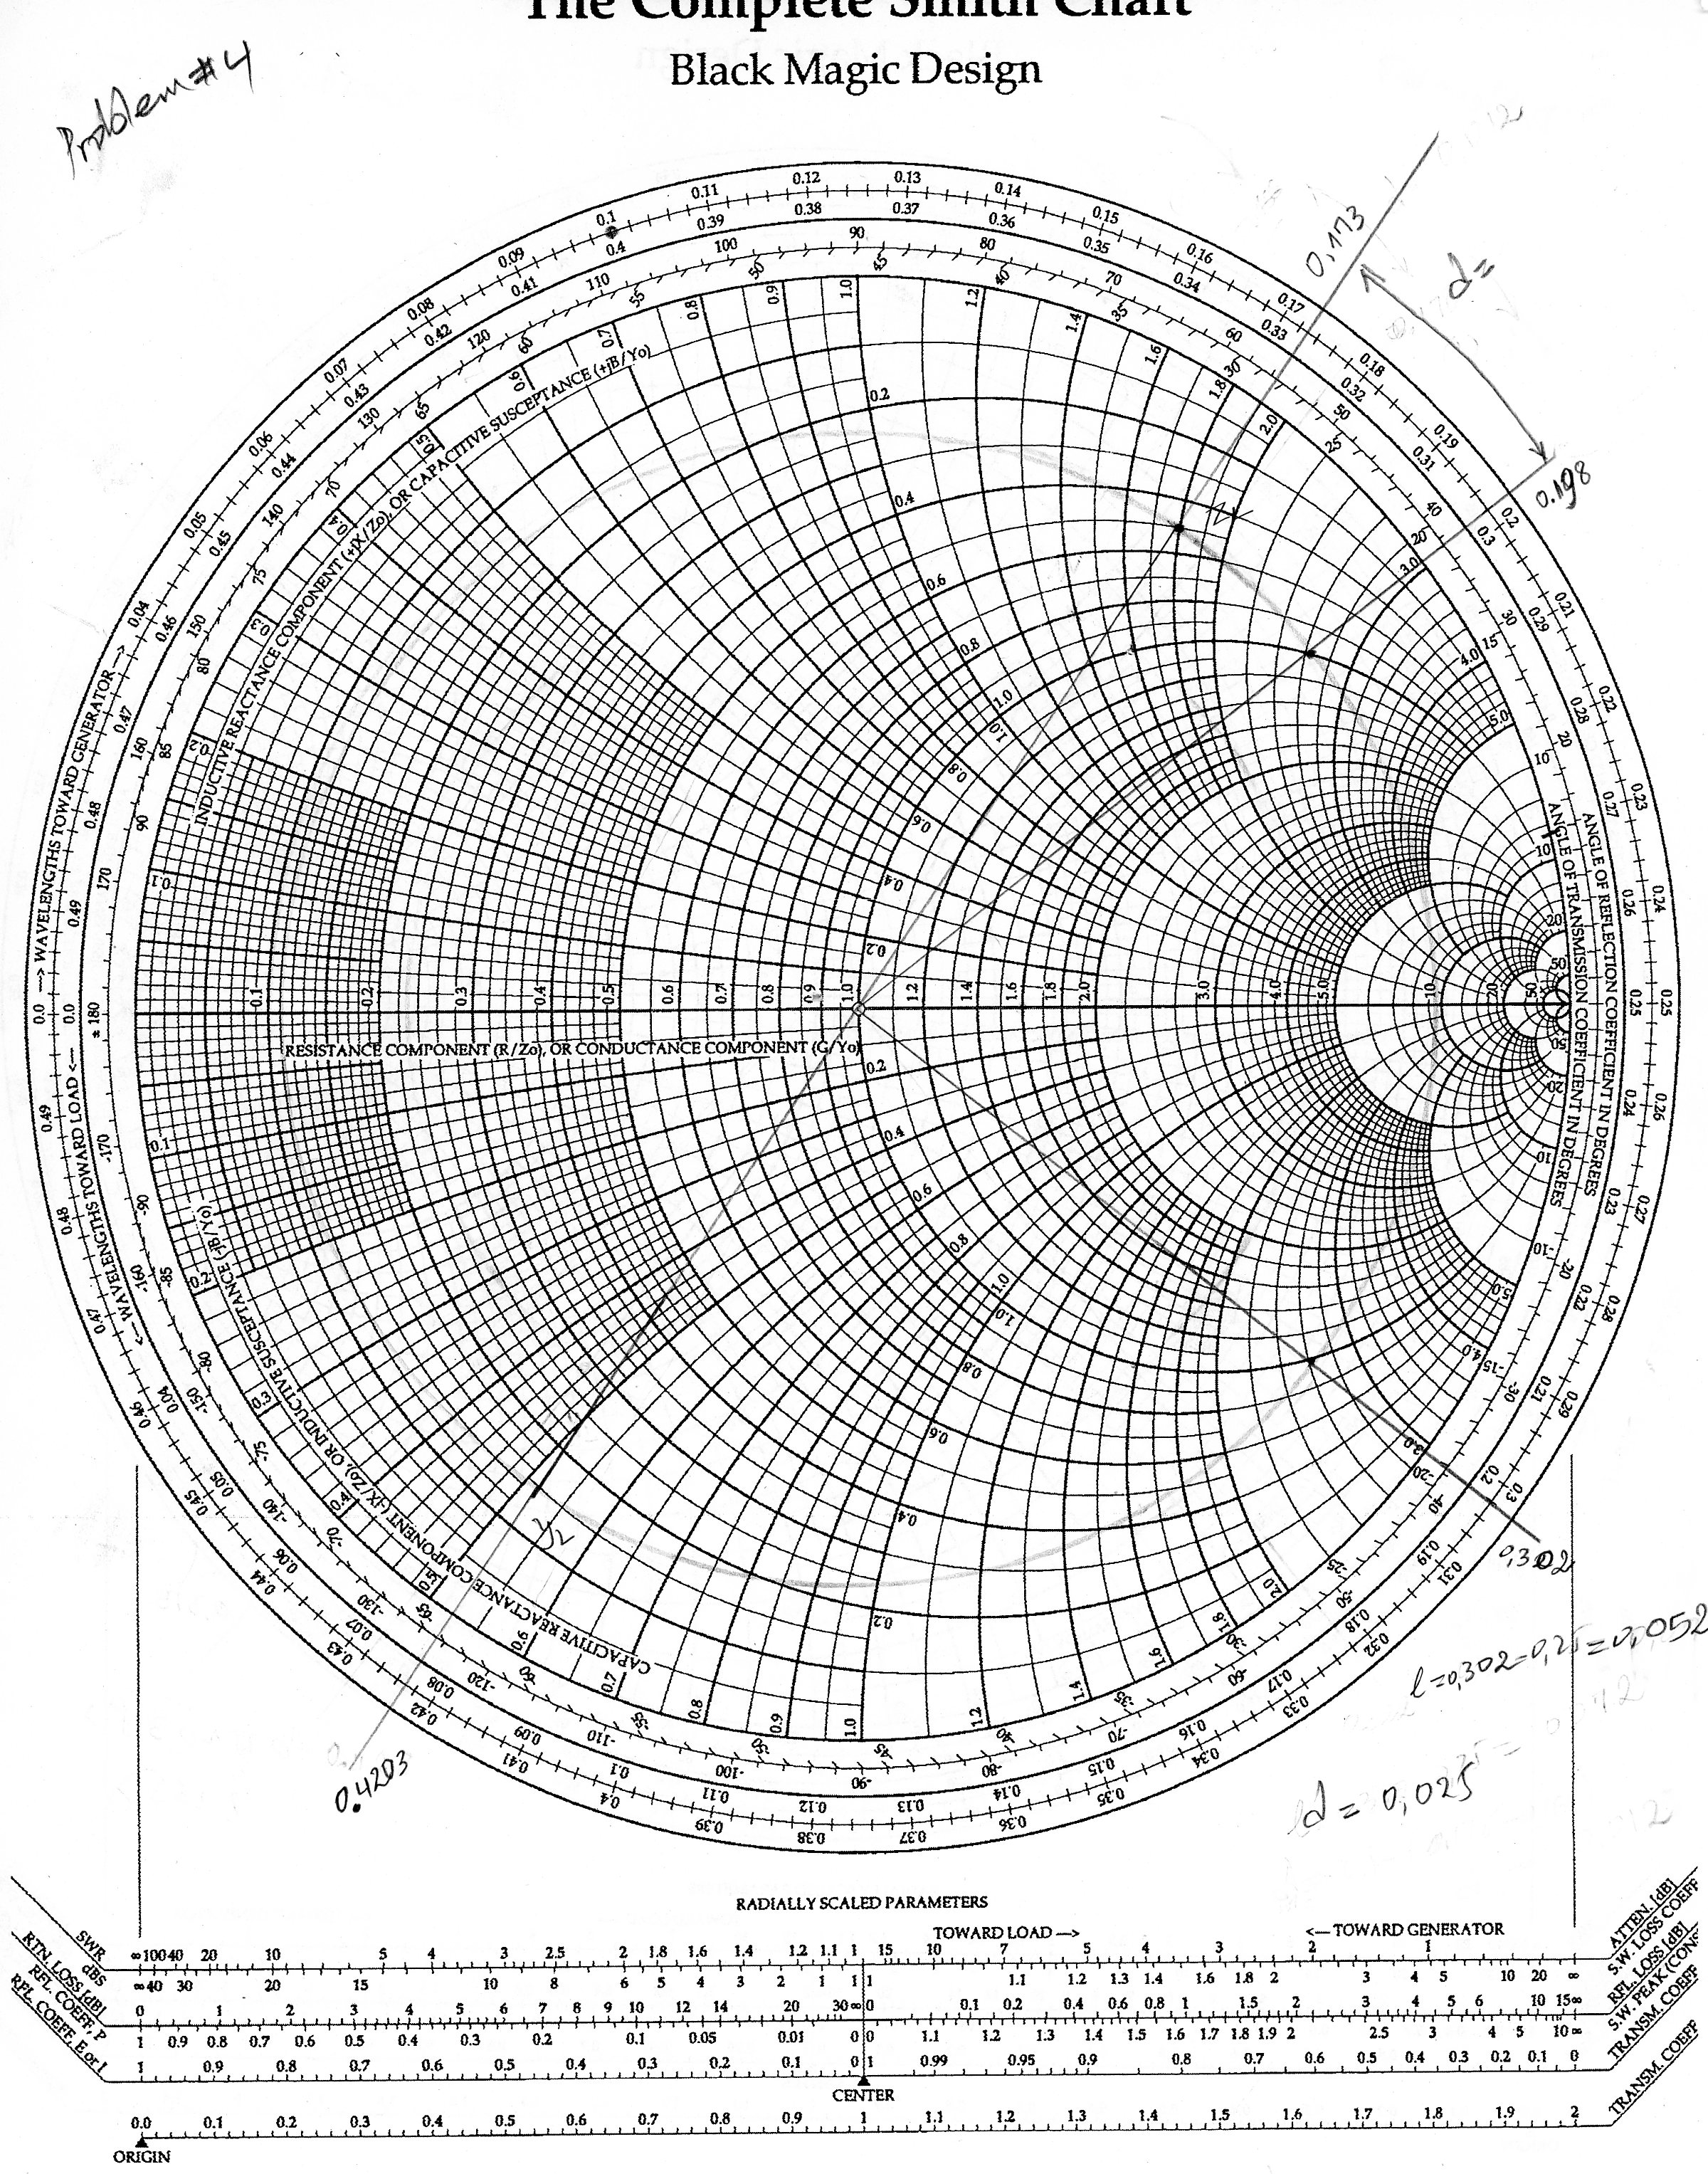

## Problem # 5

1. A 50 Ω line is terminated in a pair of parallel load impedances of 50+j100 Ω and 50 –j100 Ω. Determine the total load admittance and impedance seen by the line.

Solution:

zl2=50+j*100;  
zl1=50-j*100;  
zl=(zl2*zl1)/(zl2+zl1); yl=1/zl;  
disp('*********************************************')  
disp('The total load impedance in ohm is ')  
disp(zl)  
disp('*********************************************')  
disp('The total load admittance in siemens is ')  
disp(yl)  
disp('*********************************************')

*********************************************  
The total load impedance in ohm is   
 125  
*********************************************  
The total load admittance in siemens is   
 0.0080  
*********************************************

## Problem # 6

Consider the figure with the following values VS=10V, RS=30Ω, R0=50Ω, up=0.666c, RL=150Ω, and l=10cm. Plot out to 2ns

1. the voltage at the source end,
2. the voltage at the middle,
3. The voltage at the load end of the T-line.

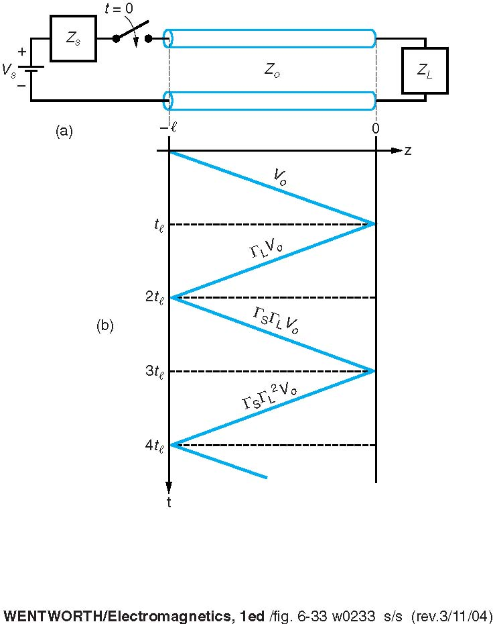Solution