Danielle Daniel-Ramsey

ARTH 110-E414

10 December 2019

Professor McAuliffe

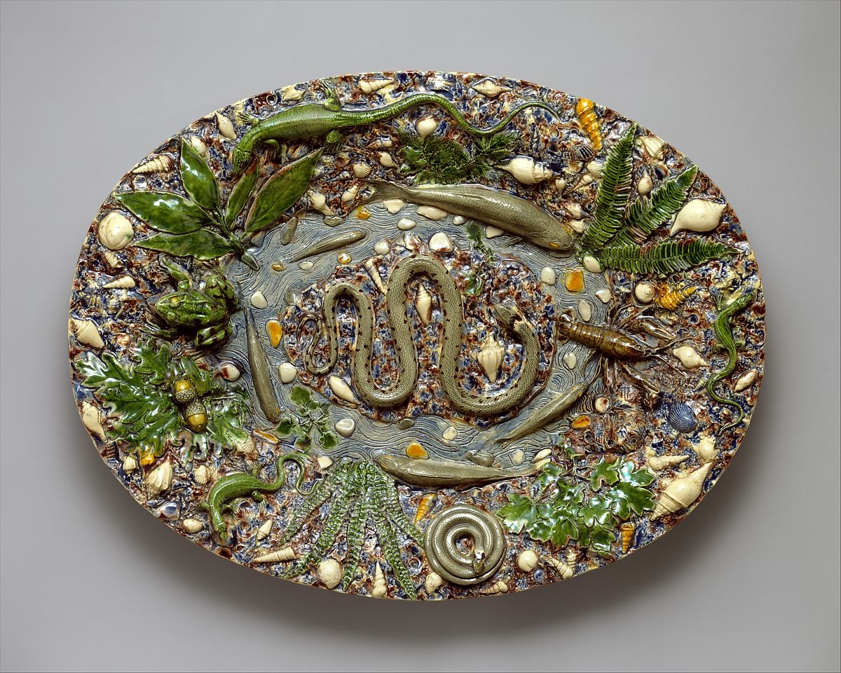
Platter
Artist: Follower of Bernard Palissy,
1510-1590
Culture: French, Paris
Medium: Lead-glazed earthenware
Dates: late 16th century
Dimensions: Overall: 20 ½ x 15 5/8 x 2 13/16 in., 5.5 lb. (52.1 x 39.7 x 7.1 cm, 2472.5 g)
Classification: Ceramics-Pottery
Credit Line: Gift of Julia A. Berwind, 1953
Accession Number: 53.225.52

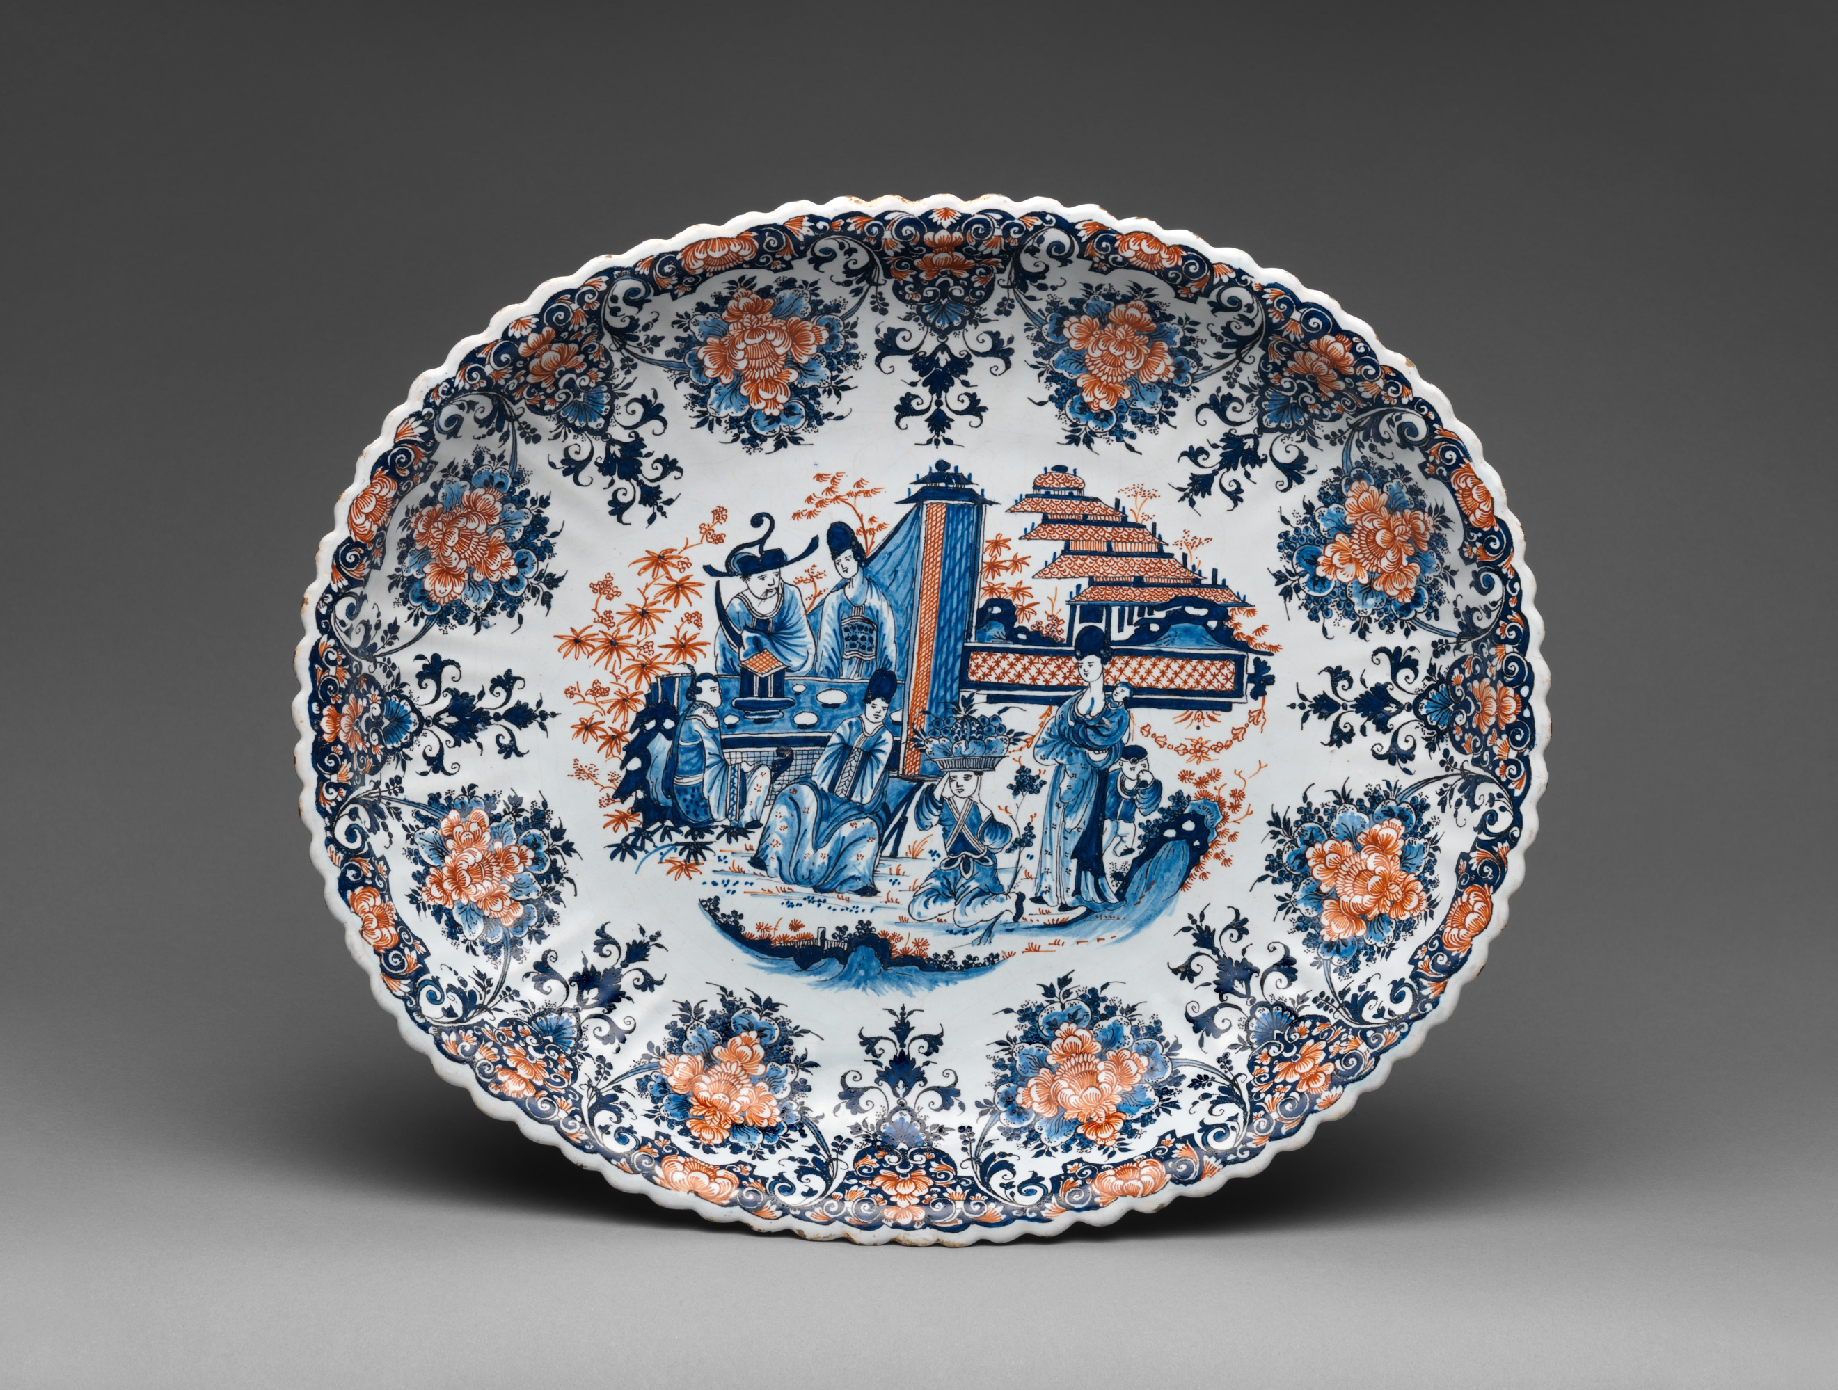
Serving Dish
Artist: Unknown
Culture: French, Rouen
Medium: Faience (tin-glazed earthenware)
Dates: ca. 1720
Dimensions: Overall: 14 x 16 ¾ in. (35.6 x 42.5 cm)
Classification: Ceramics-Pottery
Credit Line: Gift of J. Pierpont Morgan, 1917
Accession Number: 17.190.1861

Tale of Two Dishes

This formal comparison of two decorative art dishes at the Metropolitan Museum of Art in Manhattan. Both the Platter by the Follower of Bernard Palissy (ca. 1590) and Serving Dish (ca. 1720) brings attention to two different approaches to ceramics pottery. Both platters depict images of living things. They are also both painted on a horizontal oval shaped serving dishes and the scale of both dishes are large than your average serving size dish.
The Platter on the top depicts living animals surrounding a pond. There are also three types of plant life growing near the water. On the platter are dozens of tiny sea shells cascaded around the animals. This pond is filled with water and what looks like a foot-long snake. The snake is at the center of the platter, it seems to be resting on a piece of wood or a rock. Surrounding the snake are five fish which look like salmon and a crayfish. Also in the pond are a brown water beetle towards the right of the pond near the twisted snakes head. One can tell at the time during the 16th century that life in nature was a topic of interest. The artist uses animals and insects not often seen in Europe at the time. This artist uses colored glazes to develop a shiny coat over the textured pottery. From the look of the platter, the plant life and animals give it texture so the figures look almost life like. This platter shows the day in the life of these animals. The frog is curled up on the edge of the pond waiting for its prey. There are also three different size geckos crawling away from the water filled with fish and sea shells. Because the artist is making what they see in nature in Europe, there are a lot of earth tones. The plants are a rich green color and so are the baby geckos. The fish and the twisted snake in the pond are a pail grey and sea shells are white. The background of the platter is painted in this royal blue color with specs of brown to give it that earthy concrete look.
In contrast the Serving Dish made in Rouen depicts Chinese people instead of animals in nature. Unlike the Platter on the top, this serving dish is white and only painted in blue or red. This dish shows the viewer a French technique on Chinese imagery. Around the perimeter is a flowery décor that gives it an elegant look. It shows red flowers surrounded by blue flowers. In the center on the dish is a Chinese family gathered in the garden outside of their home. They are a family of seven dressed in traditional Chinese attire. There is a woman holding her child with another small child standing by her leg. Next to that women is an older boy carrying a bowl of fruit and vegetables on top of his head. The small boy is being watched by a woman to the right of him that’s sitting just a few feet away. On the left center side of the dish is a man and a woman sitting at a table accompanied by another small child. Compared to the Platter on the top, though the dish has plenty of flowery details, the serving dish still isn’t as saturated with different figures. The Serving Dish only uses two colors while the Platter uses several colors when painting. One can tell this was done with small brushes to get the small details of the flowers in the garden.

