Danielle Daniel-Ramsey
23 November 2019
Professor McAuliffe
ARTH 1103
Ancient – Classical – Medieval Architecture in New York City - Assignment

General Grant National Memorial (Grant’s Tomb) Riverside Park, Harlem, NYC

This mausoleum, built in 1897, was designed in the style of an ancient Greek temple. It closely resembles the Parthenon located in Athens, Greece because it has wider Doric style columns on the front and stairs going up the front entrance. Grant’s Tomb can also be compared to the Pantheon in Paris, France because of its Neoclassical architecture style.

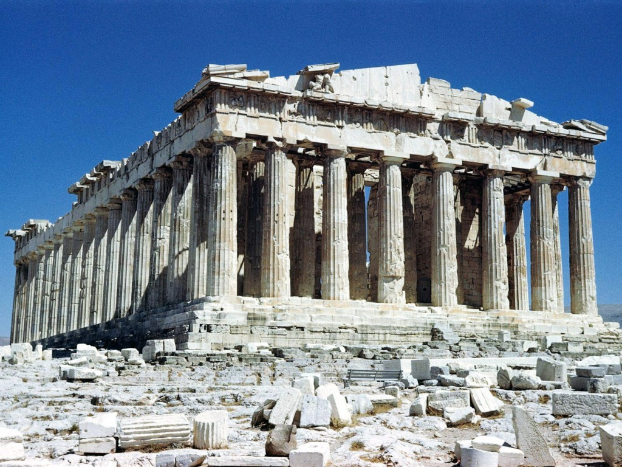

Parthenon (Temple of Athena Parthenos) Acropolis, Athens, Greece Marble 447 – 438 BCE

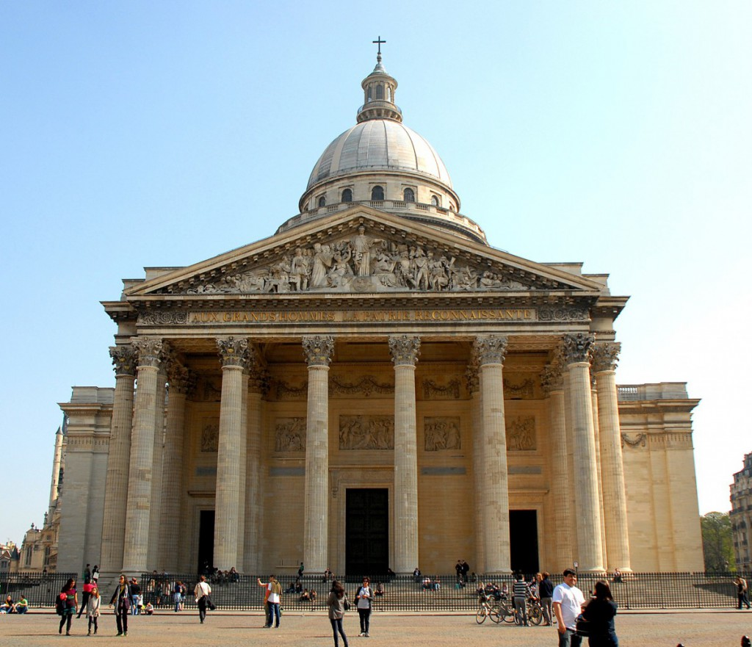

The Pantheon Paris, France French Neoclassical

