Merchandising Planning & Control
Spring Semester 2021

Eliel Morales, Danielle Daniel-Ramsey, and Naja Barber

BUF 2255
Dr. Woods

Table of Content

Buying Project Team ………………….. 3
Abstract ………..……………. 5
DNE Studio contact page ……………………….. 6
Store Layout …………………………………………... 7
VALS …………………………………………………... 9
Jumpsuit Color Palette …………………………………... 11
Swatches ………………………………………... 13
SKUs ………………………………………. 15
Jumpsuit Stencils …………………………………... 18
Research ……………………………………. 21
Part B ……………………………………………... 23
Part C ……………………………………………... ………………… 26

Buying Project Team
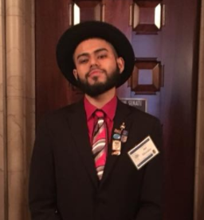
Project Role: Creative Director
My name is Eliel Morales and I am a Senior at the New York City College of Technology. My role as a Creative Director has taught me a lot about Merchandising Planning and Control. Having the opportunity to experience how a store is potentially managed throughout the upcoming seasons has been a truthful hands on experience. At the beginning of this project, I personally was not comfortable with doing a lot of math, but throughout the semester, I slowly came out of my comfort-zone and began diving into numbers that inevitably affects the conditions of the store. The importance of maintaining balance sheets positively is as important as coming up with relevant garments that attract people by the color, textile or silhouette.
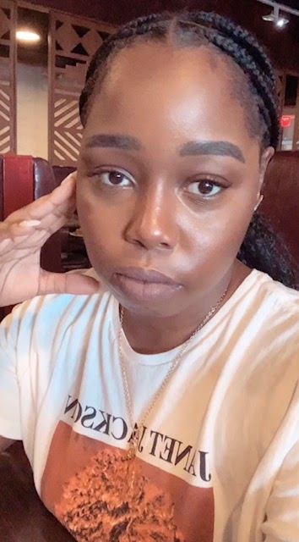
Project Role: Researcher, Writer
My name is Danielle Daniel-Ramsey and I'm currently a senior at City Tech. What I learned from my role as a part of this team is that it takes a lot to become a successful retail buyer. Having to be good and quick with numbers and also be aware of the trends takes a lot of skill and practice. As my role being the researcher and the writer I enjoyed establishing the retail store and figuring out what people that fit in our target market will like to wear when it comes to our jumpsuits. What I took away from my involvement is that the role of a retail buyer is very detailed. I’ve always wanted a career in buying growing up but after completing this project there is definitely more to it than I could have imagined. I believe my strengths when it came to this project was the creative research and the math.

Project Role: Writer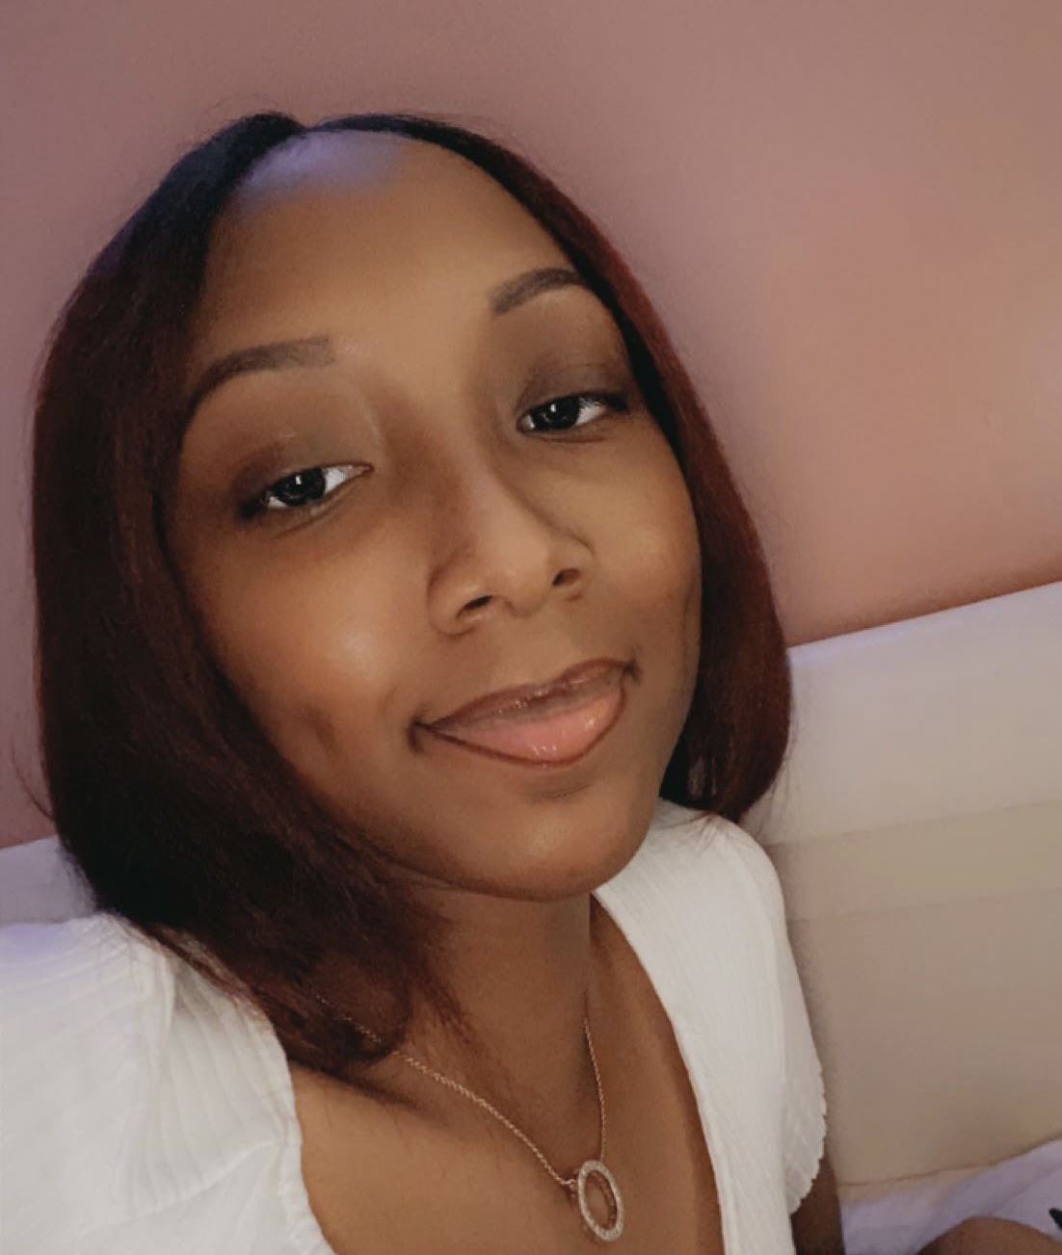
My name is Naja and I am currently finishing up my Baccalaureate degree with one more semester to go! Some things I learned from my role in the group is that being a retail buyer for a company has many challenges. Such as, being able to stay under your budget, calculating the sales for each month, and making sure the numbers are accurate which is very important. My role as the writer, I felt was interesting to learn about our customers and how to meet the demands of the market. Also, I felt it was inspiring to see how we stand out from other clothing businesses in the location that we chose. After the completion of this project I see that being a retail buyer has many layers to it and just because it looks like “a piece of cake on the outside” does not mean it is. My strengths were writing, and contributing creative ideas.

Abstract
After conducting our research as a group we discovered that a retail buyer has many responsibilities. Some responsibilities were the accurate mathematical calculations and knowing how to stay within a company’s budget. Our research included figuring out our ideal target customer based on our clothing. We also learned more about our target customers such as their values, attitude, demographics, and psychographics. As a group we had to select a perfect store layout that would invite customers in and be easy for them to navigate around the store. Another part of our research included finding the season colors for our clothing along with the fabrics we decided to use. Also, we had to do research to find the perfect location for our clothing based on the climate, and the types of people who live there. Our group concluded that the research process was challenging because of the accuracy of the store layout along with the math part but also it was insightful.
Keywords: Mathematical, budget, calculations, target customer, values, attitude, demographics, psychographics

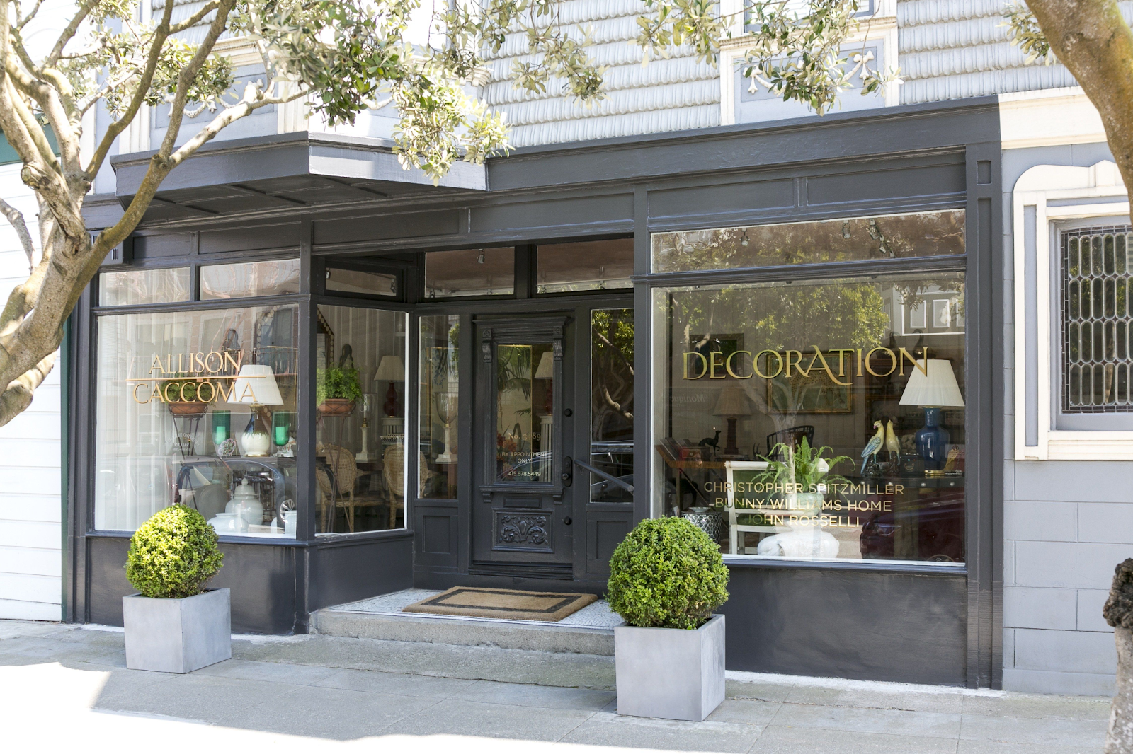

DNE Studios Retail Store
1500 New Britian Ave, West Hartford, CT 06110
www. DNEstudios.com
customersupport@DNEstudios.com
(860) 561-3024

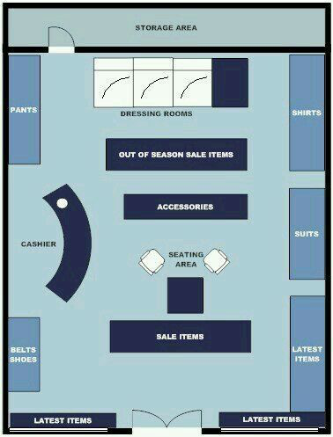

Figure 1. DNE Studios store layout

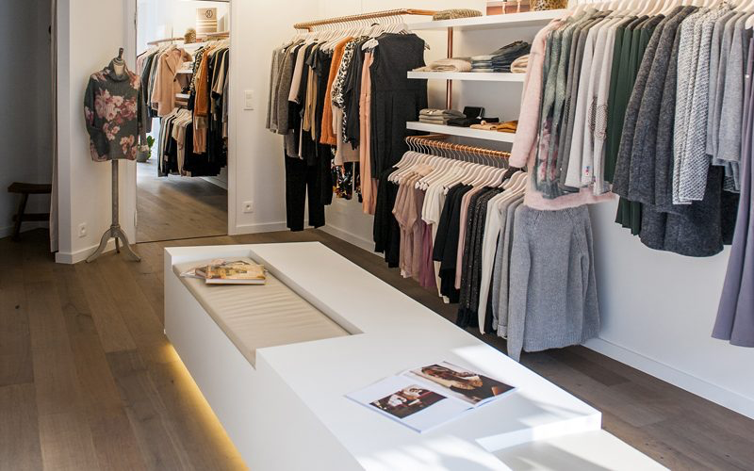
Figure 2. DNE Studios store view from entrance

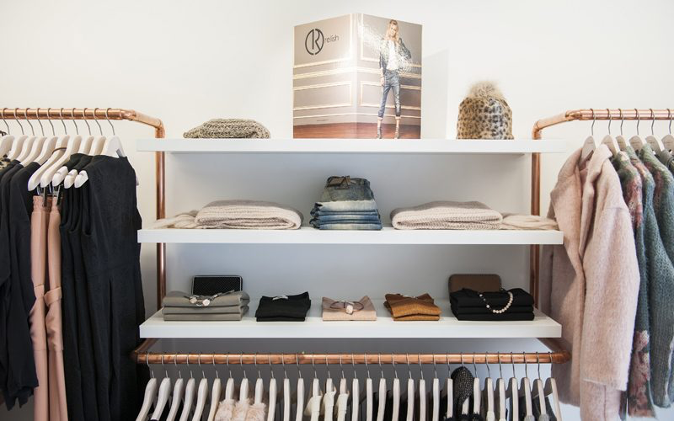
Figure 3. Inside store view
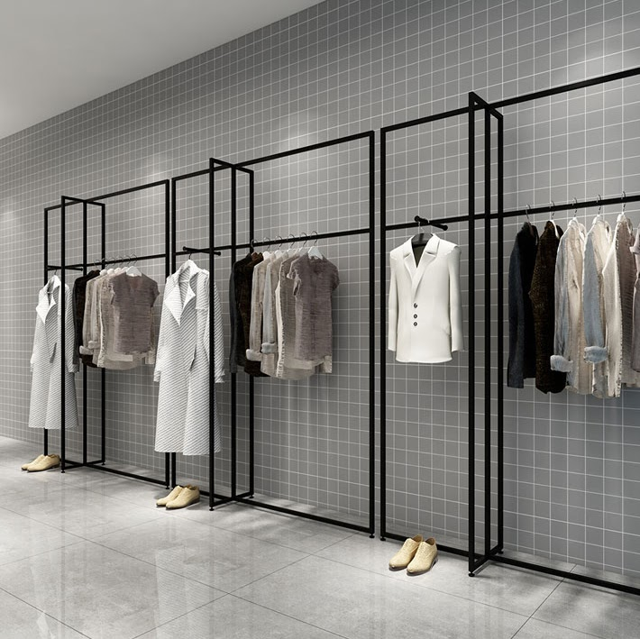
Figure 4. Minimal Layout

VALS & Target Customer

The type of shopper at DNE Studios would probably fall under the experiencers category of the VALS Model. The women in this group are highly resourceful and really are motivated by self-expression. The women in this group are 25 years old at their youngest and are full of energy and life. This gives the experiencers motivation to do social activities and physical exercises like rock climbing and tennis. They are very eager consumers and spend heavily on clothing, music, travel and food.
Our target customer for DNE Studios are single women whose occupation is a teacher, musician, nurse or fitness trainer. She makes between 40K-60K a year and lives in the city of Norwalk, Connecticut. Jennifer Stone is a half Black and half white woman living as a teacher in this part of Connecticut with her female roommate. Jennifer also is a fitness trainer on the side working with other young women aiming for a healthier lifestyle. She enjoys reading fashion magazines and looking on her social media platforms for the latest trends.

Figure 3. Energetic young woman
Figure 4. Woman with phone

This twenty nine year old woman also promotes her fitness training by showing some of her exercise to her thirty thousand followers on her YouTube channel, JenFitMuse. Jennifer has lived in Connecticut her entire life and is accustomed to the city life. Before starting her career as a teacher, Jennifer spent four years studying Communications at the University of UConn. When she’s not working on her next YouTube video Jennifer is being an aunt to her brother's twin daughters or hanging with her best friends Amy and Phoebe. Jennifer is one of four siblings.
Stamford, Connecticut is the hometown of Jennifer, where her parents still live. Jennifer grew up with two sisters and one brother. Her sisters Sophia and Laurel are actually twins and are three years younger and her. Her brother Daniel is happily married and is a firefighter at the age of thirty-one. Though Jennifer’s brand is fitness, she enjoys documenting her fitness journey. She also enjoys watching red carpets and keeping up with the latest fashion trends worn by her favorite celebrities.

Jumpsuit Color Palette
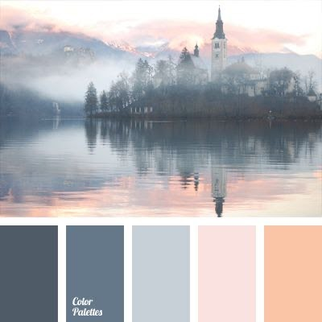
Color palette for Winter
Black: Which represents the mysterious and anonymous feeling when wearing garments of this color.
Grey: Represents the neutrality of a rainy day for our target market. Normally, Grey would be worn during relaxed occasions.
Clouded: For those Sunny days that have no clouds, normally our clients will feel the need to stand out, so being the only cloud in the sky fits the description.
Dawn: For those evenings where our target market would go out during the evening before the weekend starts.
Sunrise: The color needed for an early morning walk to the supermarket, the color will match with the early typical morning mood with small details representing the morning dew.

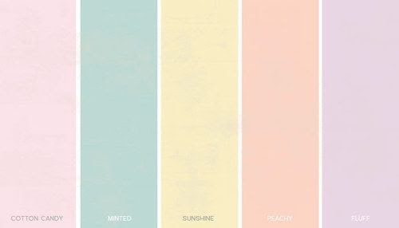
Color palette for Spring/Summer
For the Spring/Summer Collection, we are offering the colors, Cotton Candy, Minted, Sunshine, Peachy, and Fluff. These colors embody the definition of Summer. With these color choices, our target market can move from dark neutral colors, into more expressive colors for the summer. These colors will truly bring out the best of people whenever they decide to spend their leisure time outside with the Summer weather.

Swatch Pages

Cotton
Swatch One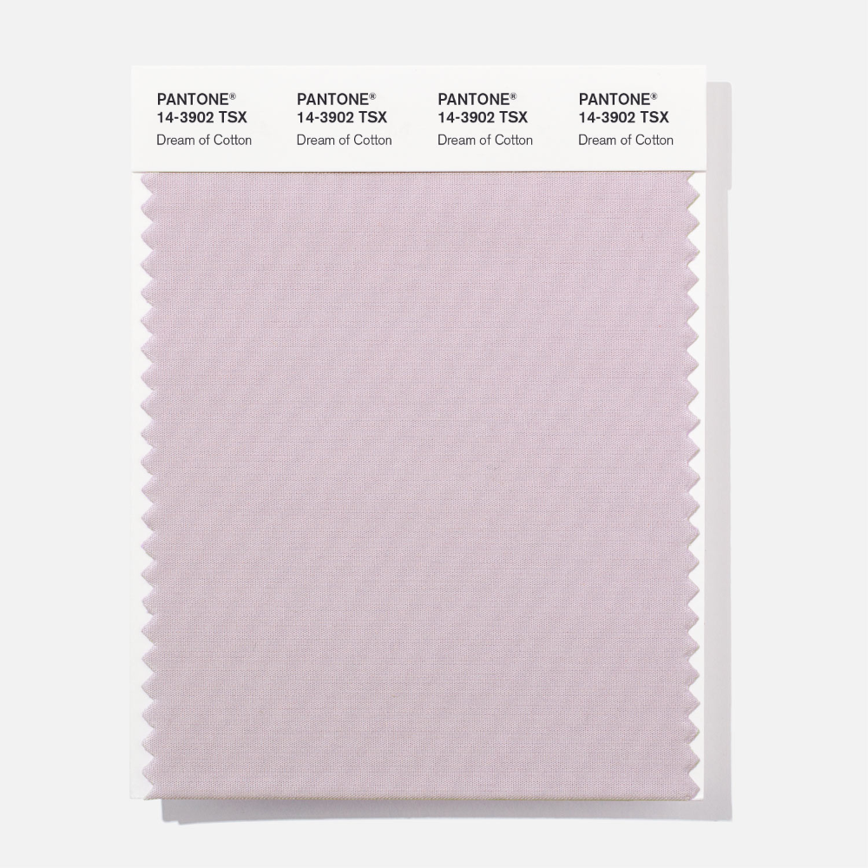

Polyester
Swatch Two
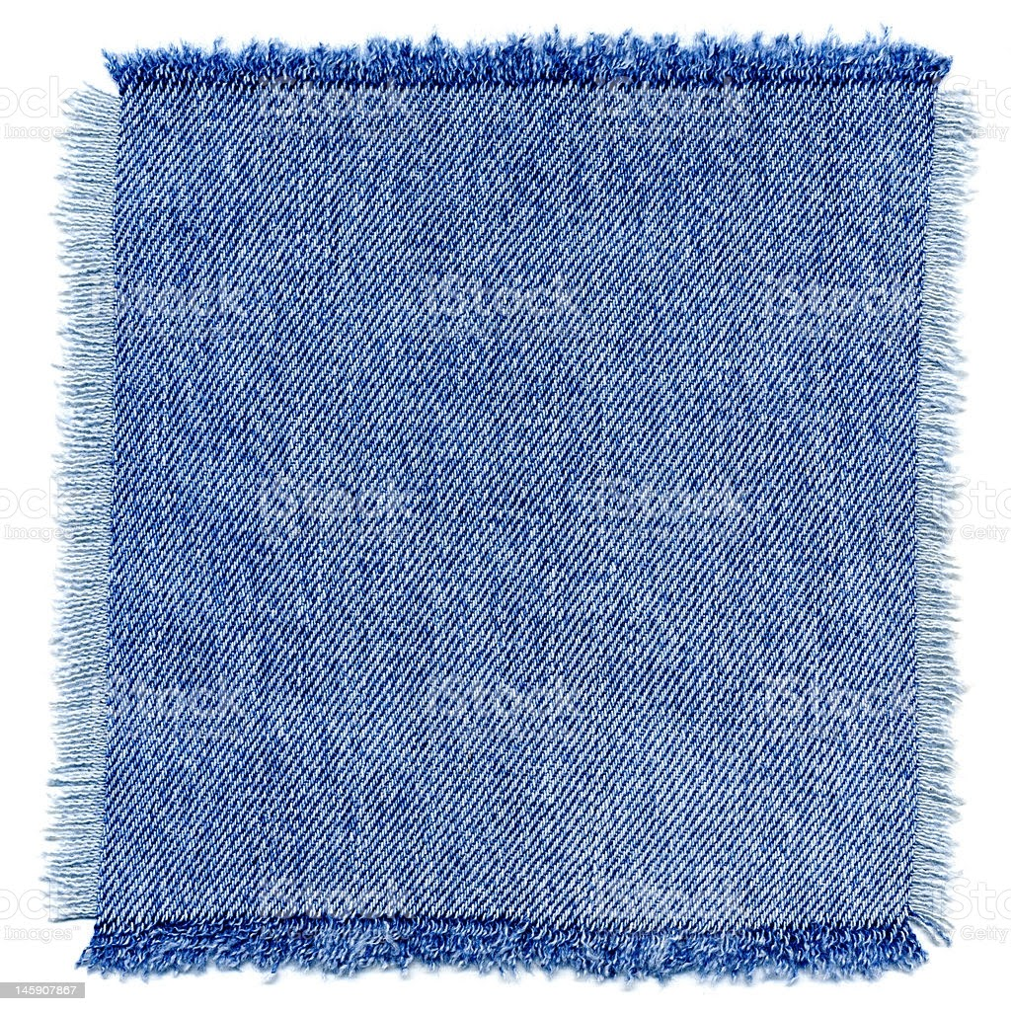
Denim
Swatch Three
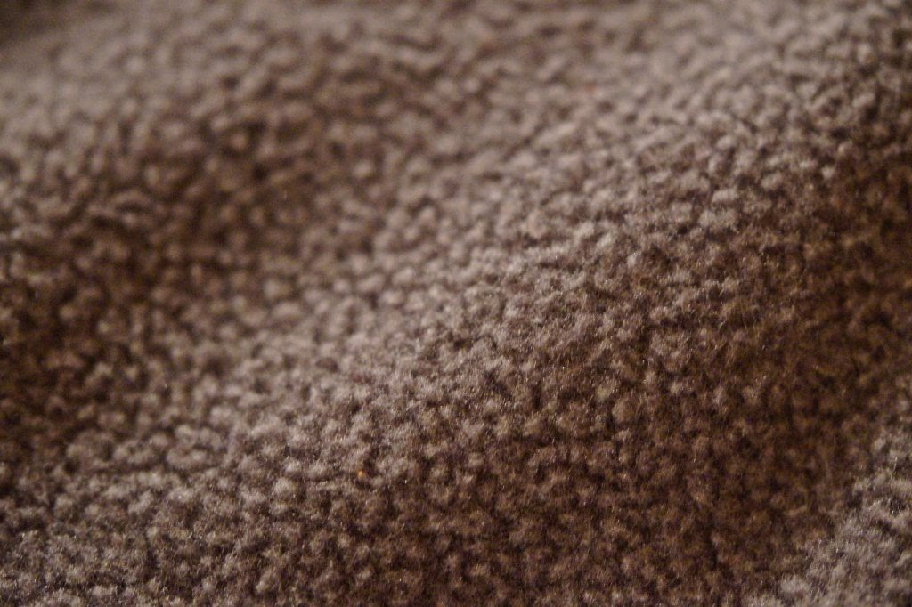
Fleece Lining

Swatch Four
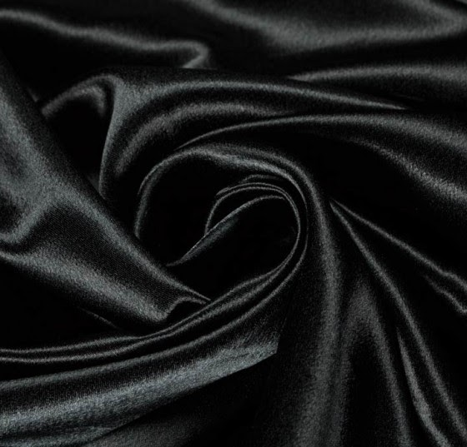
Silking Lining

Swatch Five

SKU Page
Style # Color # Season Size SKU IRN
1232 | 001-Black | Fall 2021 | S | 1232-001-S21 | 985
1232 | 001-Black | Fall 2021 | M | 1232-001-S21 | 986
1232 | 001-Black | Fall 2021 | L | 1232-001-S21 | 987
1232 | 001-Black | Fall 2021 | XL | 1232-001-S21 | 988
1232 | 001-Black | Fall 2021 | 6 | 1232-001-S21 | 989
1232 | 001-Black | Fall 2021 | 8 | 1232-001-S21 | 990
1232 | 001-Black | Fall 2021 | 10 | 1232-001-S21 | 991
1232 | 001-Black | Fall 2021 | 12 | 1232-001-S21 | 992
1233 | 002-Grey | Fall 2021 | S | 1232-002-S21 | 993
1233 | 002-Grey | Fall 2022 | M | 1232-002-S21 | 994
1233 | 002-Grey | Fall 2023 | L | 1232-002-S21 | 995
1233 | 002-Grey | Fall 2024 | XL | 1232-002-S21 | 996
1233 | 002-Grey | Fall 2025 | 6 | 1232-002-S21 | 997
1233 | 002-Grey | Fall 2026 | 8 | 1232-002-S21 | 998
1233 | 002-Grey | Fall 2027 | 10 | 1232-002-S21 | 999
1233 | 002-Grey | Fall 2028 | 12 | 1232-002-S21 | 1000

1234 003-Orange Spring 2021 S 1234-003-S21-S 1001
1234 003-Orange Spring 2021 M 1234-003-S21-M 1002
1234 003-Orange Spring 2021 L 1234-003-S21-L 1003
1234 003-Orange Spring 2021 XL 1234-003-S21-XL 1004
1234 003-Orange Spring 2021 6 1234-003-S21-6 1005
1234 003-Orange Spring 2021 8 1234-003-S21-8 1006
1234 003-Orange Spring 2021 10 1234-003-S21-10 1007
1234 003-Orange Spring 2021 12 1234-003-S21-12 1008
1235 004-Pink Spring 2021 S 1234-003-S21-S 1009
1235 004-Pink Spring 2021 M 1234-003-S21-M 1010
1235 004-Pink Spring 2021 L 1234-003-S21-L 1011
1235 004-Pink Spring 2021 XL 1234-003-S21-XL 1012
1235 004-Pink Spring 2021 6 1234-003-S21-6 1013
1235 004-Pink Spring 2021 8 1234-003-S21-8 1014
1235 004-Pink Spring 2021 10 1234-003-S21-10 1015
1235 004-Pink Spring 2021 12 1234-003-S21-12 1016

Style # | Color # | Season | Size | SKU | IRN
1234 | 005-Minted | Summer 2021 | S | 1234-005-S21-S | 1001
1234 | 005-Minted | Summer 2021 | M | 1234-005-S21-M | 1002
1234 | 005-Minted | Summer 2021 | L | 1234-005-S21-L | 1003
1234 | 005-Minted | Summer 2021 | XL | 1234-005-S21-XL | 1004
1234 | 005-Minted | Summer 2021 | 6 | 1234-005-S21-6 | 1005
1234 | 005-Minted | Summer 2021 | 8 | 1234-005-S21-8 | 1006
1234 | 005-Minted | Summer 2021 | 10 | 1234-005-S21-10 | 1007
1234 | 005-Minted | Summer 2021 | 12 | 1234-005-S21-12 | 1008
1235 | 006-Fluff | Summer 2021 | S | 1235-006-S21 | 1009
1235 | 006-Fluff | Summer 2021 | M | 1235-006-S21 | 1010
1235 | 006-Fluff | Summer 2021 | L | 1235-006-S21 | 1011
1235 | 006-Fluff | Summer 2021 | XL | 1235-006-S21 | 1012
1235 | 006-Fluff | Summer 2021 | 6 | 1235-006-S21 | 1013
1235 | 006-Fluff | Summer 2021 | 8 | 1235-006-S21 | 1014
1235 | 006-Fluff | Summer 2021 | 10 | 1235-006-S21 | 1015
1235 | 006-Fluff | Summer 2021 | 12 | 1235-006-S21 | 1016
1236 | 007-Sunshine | Summer 2021 | S | 1236-007-S21 | 1017
1236 | 007-Sunshine | Summer 2021 | M | 1236-007-S21 | 1018
1236 | 007-Sunshine | Summer 2021 | L | 1236-007-S21 | 1019
1236 | 007-Sunshine | Summer 2021 | XL | 1236-007-S21 | 1020
1236 | 007-Sunshine | Summer 2021 | 6 | 1236-007-S21 | 1021
1236 | 007-Sunshine | Summer 2021 | 8 | 1236-007-S21 | 1022
1236 | 007-Sunshine | Summer 2021 | 10 | 1236-007-S21 | 1023
1236 | 007-Sunshine | Summer 2021 | 12 | 1236-007-S21 | 1024

Jumpsuit Stencils

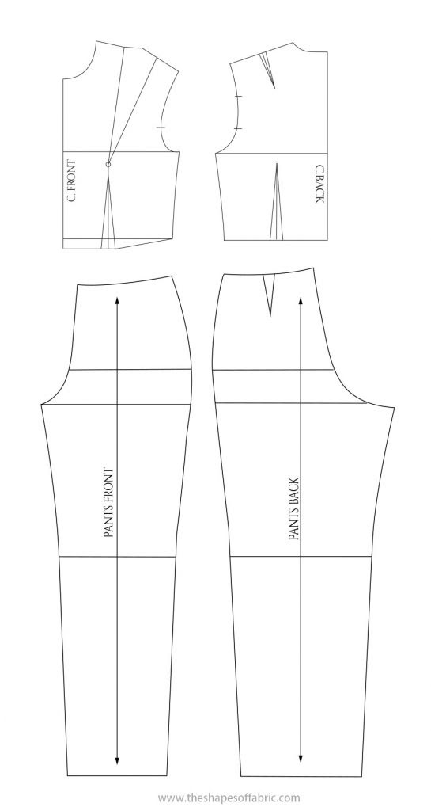
Figure 5. Jumpsuit Stencil

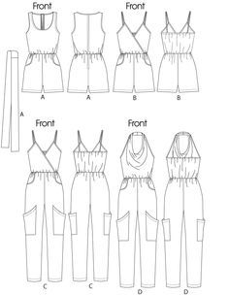
Figure 6. Jumpsuit drawing

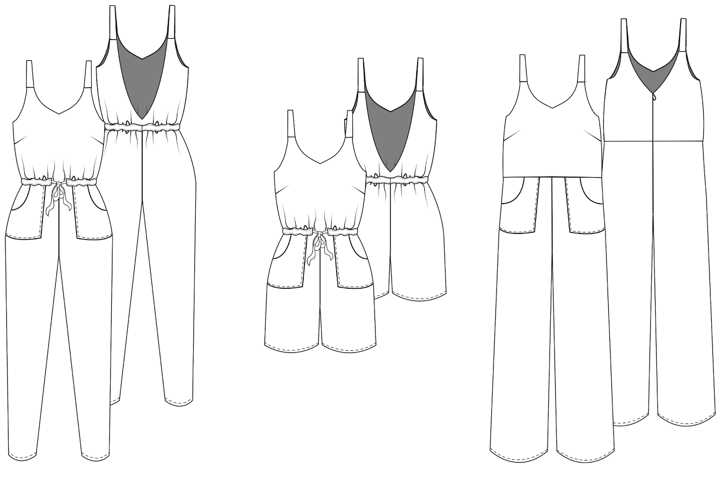
Figure 7. Jumpsuit drawing

The Process of Our Project
DNE Studio’s process while working on this project included research, contributing ideas, solving the math portion, and especially teamwork. Working as a team had many strengths and some obstacles that we overcame as a group. Some strengths were that everyone was assigned a role and knew what they had to do. Another strength was that each member contributed ideas to the group. The research by the group incorporated the VALS & target customer, the layout of the store, the location of the store, the fabric swatches we used, and season colors. Determining the store’s layout was challenging because we had to figure out where we would want our clothing located in the store. DNE Studio had to find which option would be suitable for our customers. Which is why we selected the store layout that we did because they can easily find their way around the store. Also, as soon as the customer enters the store, our products are right at the front.
The location of the store was determined based on the article of clothing we decided to sell. Since, we decided on jumpsuits for the months of February through July. We felt Connecticut would be the best choice because it is known as one of the richest states. Therefore, many people would want to shop for jumpsuits in our store. The VALS & target customer was established by thinking about the type of people who enjoy being comfortable in what they wear. Which is how we came up with single women who are full of energy, love to enjoy life, and have occupations of a fitness trainer, musician, nurse, or teacher. They value traveling, new experiences, family, and are fashionable. Our target customer had a positive outlook on life and is always having fun.
Seasonal colors the group came up with were based on Spring and Summer 2021. The colors we agreed on for the months of February and March were dark gray, light gray, light pink, and light orange. For April and May the colors were different shades of pink, light blue, and different shades of beige. We chose the colors for these months because during the months of February and March the weather is still cold so the colors are more toned down to the season. As we transition to Spring in April and May the weather becomes warmer so therefore we decided on brighter colors. We also researched trend colors for the spring and summer seasons. The fabric swatches that we decided on we’re cotton, polyester, denim, fleece lining, and silk lining. The group felt these fabric choices would be the best because they are comfortable, fashionable, and perfect for our ideal target customer. Which is also why we chose to sell jumpsuits in our store because we want our customers to feel comfortable and confident while wearing them.
Due to the location being in Connecticut, the women that would be wearing these jumpsuits come in the size small to extra large. There are jumpsuits for petite and regular size women. For the winter we have long pant jumpsuits and short jumpsuits for the summer when women want to show off their legs. We also have some stencils of other summer jumpsuits that are both made with shorts and made with long pants. The summer jumpsuits are made with polyester, cotton and linen. This is great because it's light and breathable during the hot summer months. The colors Minted, Peachy and Fluff are going to be made of those fabrics one just mentioned. This is perfect for the target market we are trying to reach. Experiencers are full of energy and enjoy the outdoors and travel.

Part B
The figures below demonstrate how well DNE Studios were throughout the Spring/Summer collection of 2021.
B1. Open to buy for each month
B2. Average monthly sales
B3. Average monthly on order
B4. Markdown % for each month

Planned sales
+ Planned reductions
+Planned EOM Stock
= Total monthly needs
-BOM Stock
=Planned purchases
-Merchandise on order
=Open to buy (At Retail)

 | Planned Sales | On Order | Employee Discount | MD$ | Shortages | EOM | BOM
February | $300,000 | $125,000 | 2% | $8,000 | 2% | $200,000 | $160,000
March | $200,000 | $15,000 | 3% | $12,000 | 4% | $80,000 | $200,000
April | $300,000 | $145,000 | 4% | $4,000 | 5% | $110,000 | $80,000
May | $200,000 | $35,000 | 0% | $3,000 | 7% | $90,000 | $110,000
June | $400,000 | $170,000 | 5% | $18,000 | 2% | $210,000 | $90,000
July | $250,000 | $24,000 | 7% | $25,000 | 3% | $70,000 | $210,000

Solution One
 | Planned Sales | MD % = MD$ / Planned Sales | Planned Reductions = MD + Employee Discounts + Shortages
February | $300,000 | 2.67% | 20,000
March | $200,000 | 6.00% | 26,000
April | $300,000 | 1.33% | 31,000
May | $200,000 | 1.50% | 17,000
June | $400,000 | 4.50% | 46,000
July | $250,000 | 10.00% | 50,000

Solution Two
 | Planned Sales |  | Planned Purchases = Closing Stock of EOM + Sales Amount + MarkDowns - Opening Stock (BOM) |  | Total Monthly Needs/ Demands = Planned Sales + Planned Reductions + EOM
February | $300,000 | 200,000 + 300,000 + 8,000- 160,000= | 348,000 | 300,000 + 20,000 + 200,000= | 520,000
March | $200,000 |  | 92,000 |  | $306,000
April | $300,000 |  | 334,000 |  | $441,000
May | $200,000 |  | 183,000 |  | $307,000
June | $400,000 |  | 538,000 |  | $656,000
July | $250,000 |  | 135,000 |  | $370,000

Solution Three
 | Planned Sales |  | Open to Buy @ Retail = Planned Purchases - Merchandise on Order
February | $300,000 | 348,000 - 125,000 = | $223,000
March | $200,000 |  | $77,000
April | $300,000 |  | $189,000
May | $200,000 |  | $148,000
June | $400,000 |  | $368,000
July | $250,000 |  | $111,000

Solution Four
 | Planned Sales | On Order | Employee Discount | MD$ | Shortages | EOM | BOM
February | $300,000 | $125,000 | 2% | $8,000 | 2% | $200,000 | $160,000
March | $200,000 | $15,000 | 3% | $12,000 | 4% | $80,000 | $200,000
April | $300,000 | $145,000 | 4% | $4,000 | 5% | $110,000 | $80,000
May | $200,000 | $35,000 | 0% | $3,000 | 7% | $90,000 | $110,000
June | $400,000 | $170,000 | 5% | $18,000 | 2% | $210,000 | $90,000
July | $250,000 | $24,000 | 7% | $25,000 | 3% | $70,000 | $210,000

 | Planned Reductions = MD + Employee Discounts + Shortages |  | Planned Purchases = Closing Stock as of EOM + Sales Amount + Markdowns - Opening Stock (BOM) |  | Total Monthly Needs/Demands = Planned Sales + Reductions + EOM |  | Open to Buy @ Retail = Planned Purchases - Merchandise on Order
8,000+.02* 300,000+ .02* 300,000= | $20,000 | 200,000 + 300,000 + 8,000 - 160,000= | $348,000 | 300,000 + 20,000 + 200,000 = | $520,000 | 348,000 - 125,000 | $223,000
 | $26,000 |  | $92,000 |  | $306,000 |  | $77,000
 | $31,000 |  | $334,000 |  | $441,000 |  | $189,000
 | $17,000 |  | $138,000 |  | $307,000 |  | $148,000
 | $46,000 |  | $538,000 |  | $656,000 |  | $368,000
 | $50,000 |  | $135,000 |  | $370,000 |  | $111,000

 | Planned Sales |  | New Sales Plan 6.2% Raise
February | $300,000 | 300,000 + 300,000 * .62 | $486,000
March | $200,000 |  | $324,000
April | $300,000 |  | $486,000
May | $200,000 |  | $324,000
June | $400,000 |  | $648,000
July | $250,000 |  | $405,000

C1.
The purchases equals the Closing stock of EOM plus the Sales Amount and the Mark Downs minus Opening Stock, which amounts to $348,000. In addition, the Planned Reductions, the reductions could possibly reduce the level of stock within the store’s warehouse. Also, the type of reductions include markdowns as well as Employee Discounts and Shrinkages.
The open to buy is equal to the cash that is left at the store disposal, this is equal to the money set aside for planned orders for the current month.

C2.
For the current year compared to the last had seen increased sales. The decrease of the sale periods was 1,820,000 - 300,000 which is $1,520,000. The reason for this is because the company had many visitors, and festival events which happened to attract more consumers into the store. 20

Solution Six
 | Planned Sales | On Order | Employee Discount | MD$ | Shortages | EOM
February | $300,000 | $125,000 | 2% | $8,000 | 2% | $200,000
March | $200,000 | $15,000 | 3% | $12,000 | 4% | $80,000
April | $300,000 | $145,000 | 4% | $4,000 | 5% | $110,000
May | $200,000 | $35,000 | 0% | $3,000 | 7% | $90,000
June | $400,000 | $170,000 | 5% | $18,000 | 2% | $210,000
July | $250,000 | $24,000 | 7% | $25,000 | 3% | $70,000

BOM |  | Planned Reductions = MD / Employee Discounts / Shortages |  | Planned Purchases = Closing Stocks as EOM+ Sales Amount + MD - Opening Stock (BOM) |  | Total Monthly Needs/Demands = Planned Sales + Planned Reductions + EOM
$160,000 | 8,000 + .02* 300,000 + .02*300,000= | $20,000 | 200,000 + 300,000 + 8,000 - 160,000= | $348,000 | 300,000 + 20,000 + 200,000= | $520,000
$200,000 |  | $26,000 |  | $92,000 |  | $306,000
$80,000 |  | $31,000 |  | $334,000 |  | $441,000
$110,000 |  | $17,000 |  | $183,000 |  | $307,000
$90,000 |  | $46,000 |  | $538,000 |  | $656,000
$210,000 |  | $50,000 |  | $135,000 |  | $370,000

 | Open to Buy @ Retail = Planned Purchase Merchandise on Order
348,000 - 125,000= | $223,000
 | $77,000
 | $189,000
 | $148,000
 | $368,000
 | $111,000

Reference

Figure 1 - 2. (2018). Store layout. Retrieved from. https://www.pinterest.com/www183017873/store-layout/

Figure 3 - 4. (2020). Millennial women. Retrieved from. https://www.merkleinc.com/thought-leadership/white-papers/why-millennial-women-buy
Figure 5 - 7. (2021). Jumpsuit stencils. Retrieved from. https://www.theshapesoffabric.com/2020/02/24/draft-a-jumpsuit-pattern-the-easy-way/

