Daniel Cruz April 25, 2019

Digital Media

Spring Term

Research Paper

The designer that I am researching is Shigeo Fukuda. He was born February 4, 1932 in Japan and died January 11, 2009. His work will always be remembered as he was a sculptor, graphic artist and poster designer who also created efficacious optical illusions. His work was eye catching, it made you look twice and made you wonder what was going on in his works. He had a lot of accomplishments but his greatest achievement was in 1987, when he was inducted into the Art Directors Club Hall of Fame in New York City. He was known as “Japan’s consummate visual communicator”. I am going to talk about Shigeo Fukuda’s life, work and achievements throughout this essay.

Shigeo Fukuda was born into a family of toy manufacturers. This might explain how he got into design. His family might have influenced his childhood, he grew up in a environment that was making toys. After the second war ended, he attended the National University of Fine Arts & Music to study designing. In 1956, he graduated. Before attending university, he was already interested in Swiss Style design. He already had an image on what he wanted to do. 10 years later, he got recognized at Czechoslovakian graphic design competition. After that, things start looking good and his works were in for Montreal’s Expo 1967. This was just the start of his career, after these events his career gets a boost and he gets more recognition. Paul Rand saw his work and saw Fukuda’s true potential and decided to take a chance and helped him get his work in New York City.

In the 60’s Fukuda, was writing articles and for a newspaper in Japan. He put his work there sometimes and it was described by New York Times, they stated, “compelling yet simple images distilled from complex concepts.” Fukuda was into illusions a lot, his works had to do with that a lot. He had a different quote on how his designs should be. Almost like a rule to follow every time. He states, “I believe that in design, 30% dignity, 20% beauty and 50% absurdity are necessary. Rather than catering to the design sensitivity of the general public, there is advancement in design if people are left to feel satisfied with their own superiority, by entrapping them with visual illusion.”. This was the rule he followed. Which worked for him because his works were beautiful. Fukuda was anti-war and a environmentalist. His work “Victory 1945” he entered a contest with that work and won it. It was the 1975 Warsaw Poster Contest. He gave all his winnings to the Peace Fund Movement. Which really showed that he was just caring and selfless. He took his works into the next level. In the later years of his career he created his most famous work “Lunch with a Helmet on” which was sculpture of knives, spoons and forks, that created a shadow of a motorcycle. Shigeo Fukuda was the first Japanese to be entered into the Art Directors Club Hall of Fame in New York City. Which is a massive accomplishment to be the first.

(Victory 1975)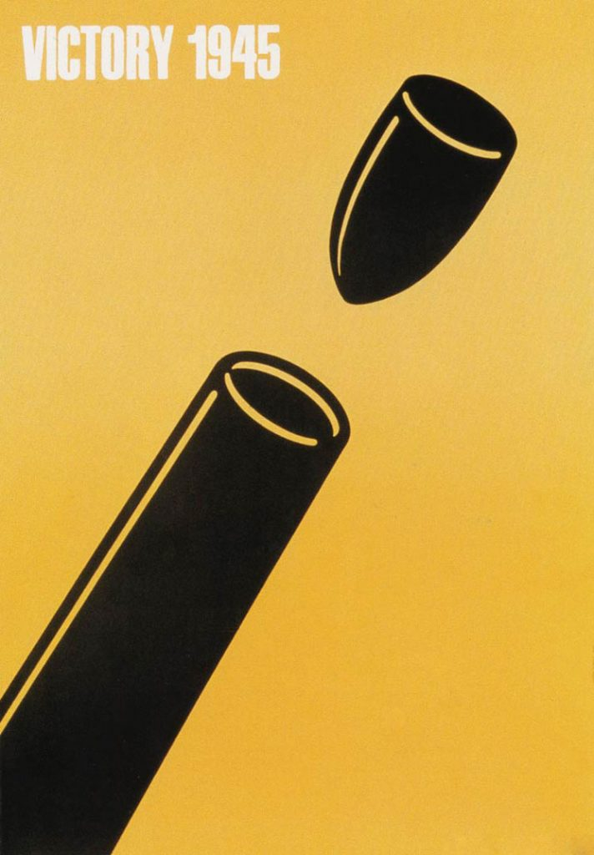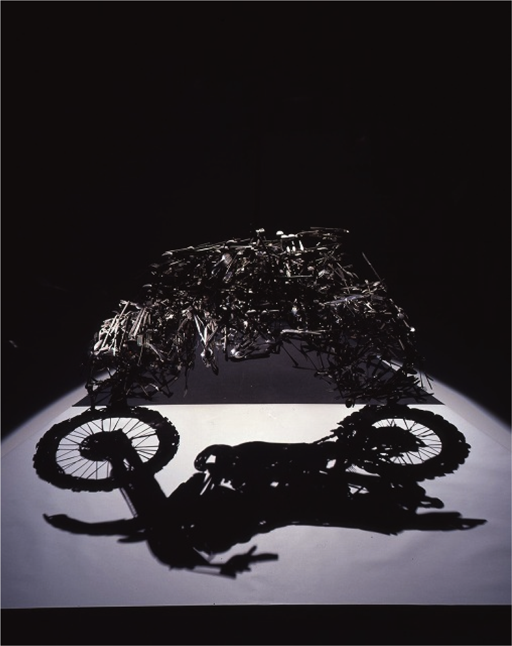(Lunch with a Helmet on)

In conclusion, Shigeo Fukuda started off with nothing but after his hard work he got noticed and that’s when his career really started going. Even after he got famous he kept bringing new works that would be remembered. Unfortunately, he passed away and is no longer here but his works and story will always be here. He accomplished great achievements and is probably more proud that people are looking at his work.