**Perspectives in Hospitality Management**

**HMGT 1101**

**Fall 2022**

|  |  |  |  |
| --- | --- | --- | --- |
| **Instructor** | Prof. Bear Dallis | **Class Number** | 1101 E500, 20565 |
| **E-mail** | mdallis@citytech.cuny.edu | **Day** | Monday |
|  |  | **Location** | N-225 |
| **Office** | N-225 | **Time** | 6-8:30pm |
| **Office Hours:** | 5-6pm | **Class Hours** | 3 |
| **Phone** | 718-207-4402 | **Lab Hours** | 0 |
|  |  | **Credits** | 3 |

­­­­­­­­­­­­­­­­­­­­­­­­­­­­­­­­­­­­­­­______________________________________________________________________________

**Department Mission Statement**

The Hospitality Management Department of New York City College of Technology educates students for careers in the hospitality industry through foundational knowledge of hospitality operations and experiences that cultivate diverse perspectives, lifelong learning, collaboration, and community engagement.

**Program Learning Outcomes**

To graduate students who

1. identify and demonstrate skills relevant to the operational areas of hospitality management. (PLO #1)
2. utilize the dynamics of collaboration in diverse settings. (PLO #2)
3. demonstrate effective communication skills. (PLO #3)
4. exhibit the analytical and social skills essential for success in the global workplace. (PLO #4)
5. value and integrate lifelong learning, civic engagement, ethical reasoning, and social responsibility. (PLO #5)

**Course Description**

An overview of the history, likely directions and organizational structure of the hospitality industry and its role in local, national and global economies. Students are introduced to the nature and scope of the hospitality industry, basic terminology, management concepts, career path explorations and the department’s mission and culture.

**Prerequisites**

Prerequisite: Eligibility for ENG 1101 or ENG 1101CO or ENG 1101ML; Pre- or corequisite: MAT 1190 or MAT 1190CO or higher

**Course Objectives**

Upon completion of HMGT 1101, the student will be able to

1. Identify the scope of the hospitality and tourism industry.
2. Describe the characteristics of the hospitality and tourism industry from a local, national and global perspective.
3. Define the roles and responsibilities of key executives and department heads in the hospitality industry.
4. Differentiate hotel classifications.
5. Classify and examine food and beverage operations.

**Student Learning Outcomes and Assessment**

|  |  |
| --- | --- |
| Student Learning Outcomes | Method of Assessment |
| a. Discuss the scope of the hospitality and tourism industry  (Gen Ed: Communication, PLO #3) | Industry research assignment, Concierge assignment, Shared reading, Weekly homework, Class participation |
| b. Gather information from observation in regard to the hospitality industry from a local, national and global perspective  (Gen Ed: Inquiry/Analysis, PLO #3) | Shared reading, Electronic profile, Concierge assignment, Weekly chapter summaries, Class participation |
| c. Understand and discuss the roles and responsibilities of key executives and department heads in the hospitality industry (HMGT Discipline) | Shared reading, Concierge assignment, Weekly homework, Class participation |
| d. Evaluate and examine hotel classifications  (Gen Ed: Integration) | Shared reading, Concierge assignment, Weekly homework |
| e. Evaluate and apply information discerningly from a variety of sources to classify and examine food and beverage operations (Gen Ed: Integration; PLO#3) | Shared reading, Industry research assignment, Weekly homework |

**Recorded Sessions**

Students who participate in this class with their camera on or use a profile image are agreeing to have their video or image recorded solely for the purpose of creating a record for students enrolled in the class to refer to, including those enrolled students who are unable to attend live.  If you are unwilling to consent to have your profile or video image recorded, be sure to keep your camera off and do not use a profile image. Likewise, students who un-mute during class and participate orally are agreeing to have their voices recorded.  If you are not willing to consent to have your voice recorded during class, you will need to keep your mute button activated and communicate exclusively using the "chat" feature, which allows students to type questions and comments live.

**Grading Procedures**

Electronic Profile 10%

Concierge Assignment 20%

Industry Research Assignment 25%

Shared Reading 15%

Weekly Homework 15%

Class Participation 15%

TOTAL 100%

**Assignments**

***Electronic Profile                                                                                                                      10%***

Students will reflect on who they are as a student, professional, and future industry leader. Then write a personal profile. Think about your academic, career and personal experience and goals.

***Concierge Assignment*** (Writing and Oral Communication Rubrics)***20%***

Students will conduct research to learn about a historically significant tourist attraction in New York City then discuss the scope of the hospitality and tourism industry in writing and through an oral presentation.

***Industry Research Assignment*** (Information Literacy Rubric) ***25%***

Research and write about a trend in one sector of the hospitality industry. Reflect on what skills you plan to develop to become a leader in this sector of the hospitality industry.

***Shared Reading 15%***

Weekly reading assignments will support a weekly discussion of trends in the hospitality industry.

***Weekly Homework                                                                                                      15%***

Articulate, through written responses, the main objectives of the assigned homework on a weekly basis.

***Class Participation                                                                                                                  15%***

Articulation of the student’s developing knowledge of the hospitality industry in a way all students can benefit and contribute to an engaging learning environment.

**Rubric, Industry Research Assignment**

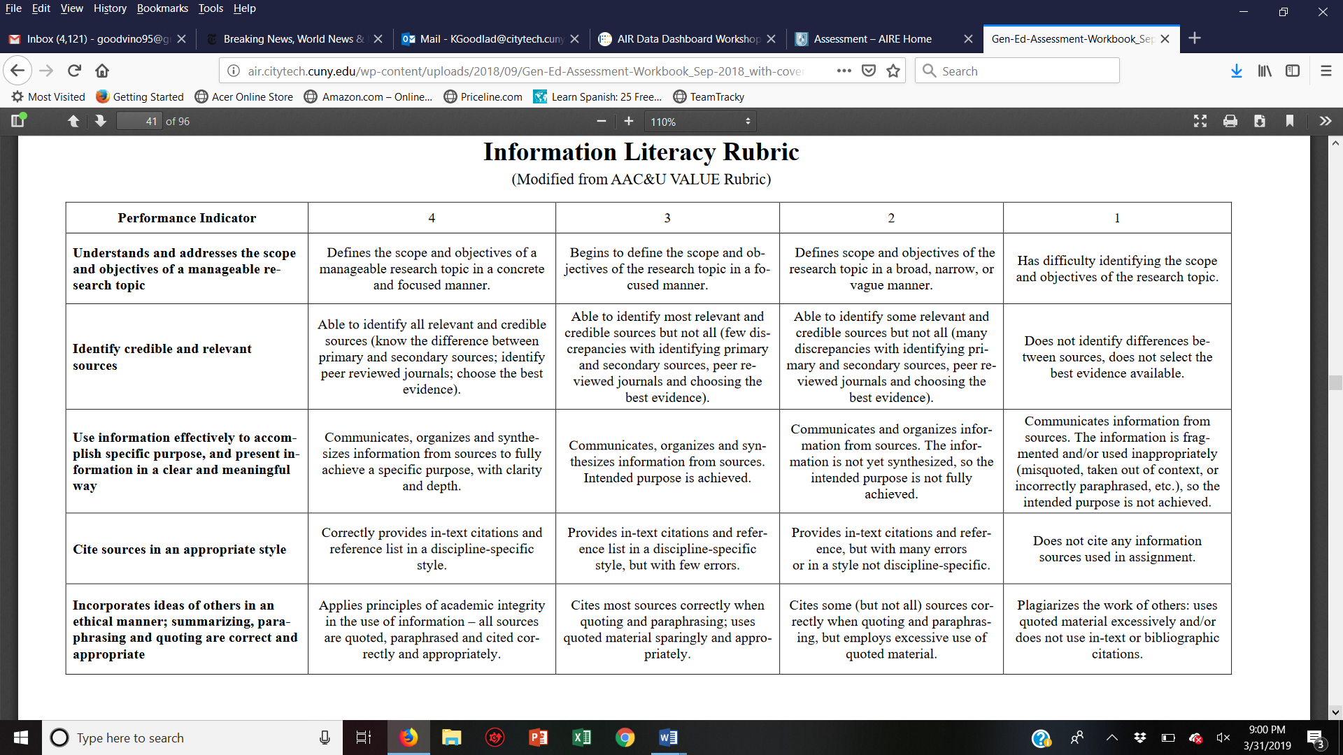

**Rubric, 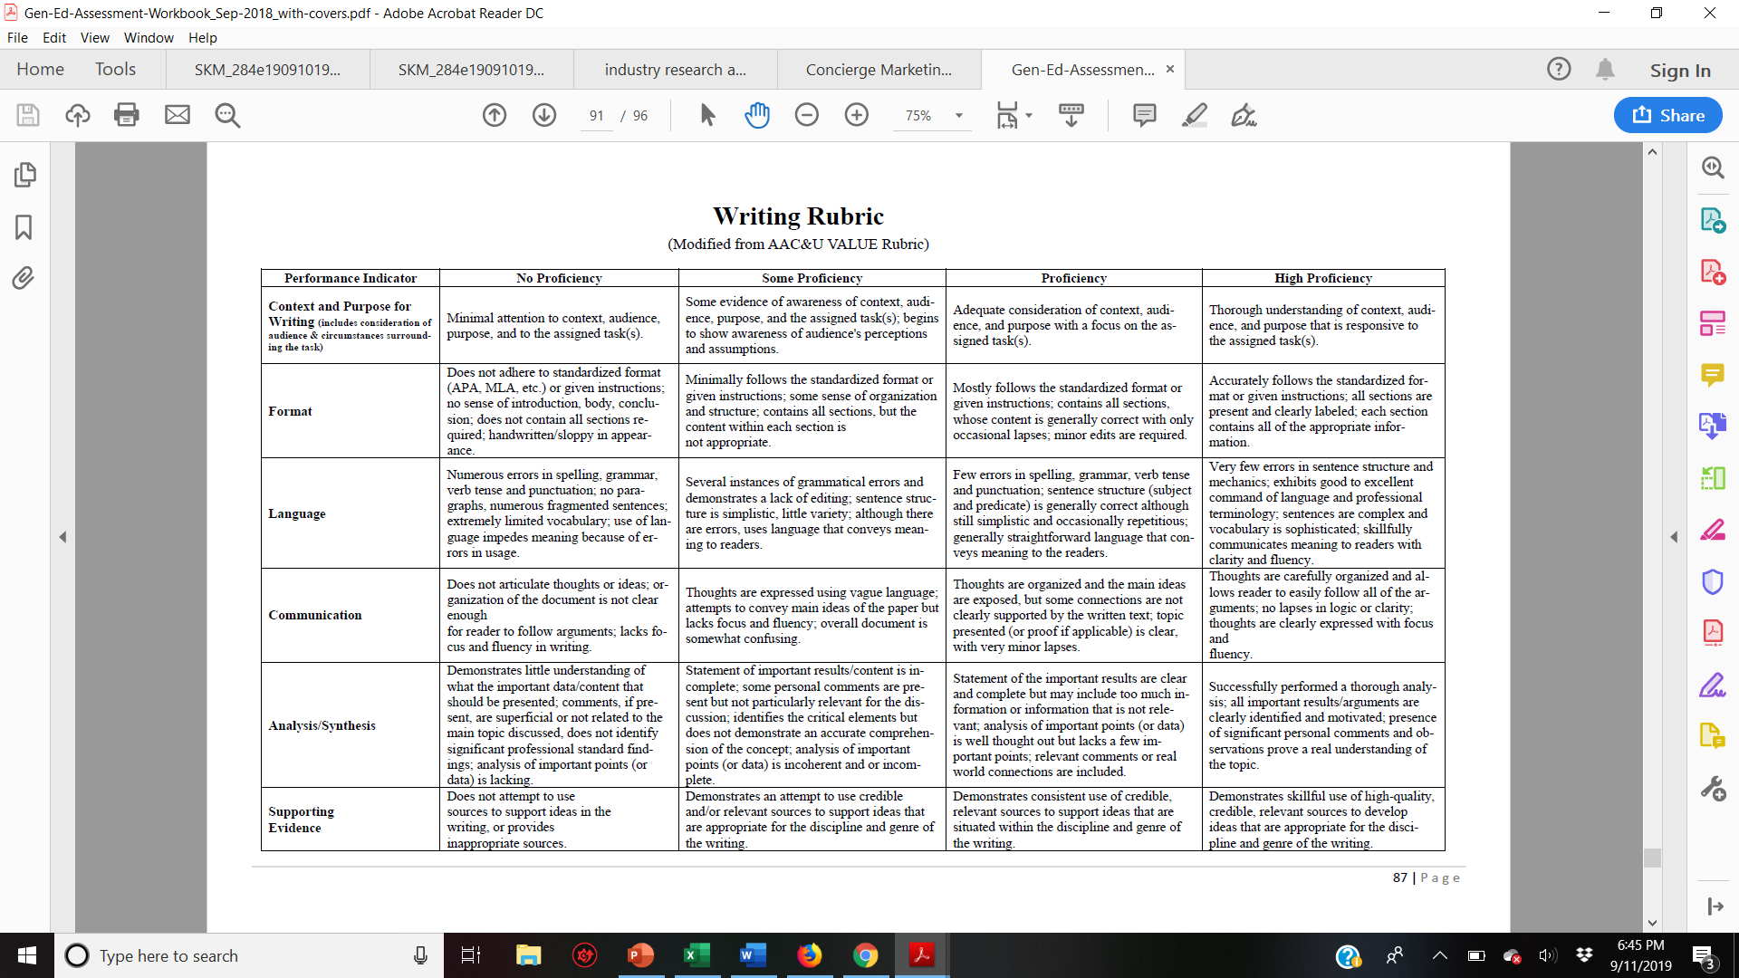Concierge Marketing Assignment**

**Rubric, Concierge Marketing Assignment**

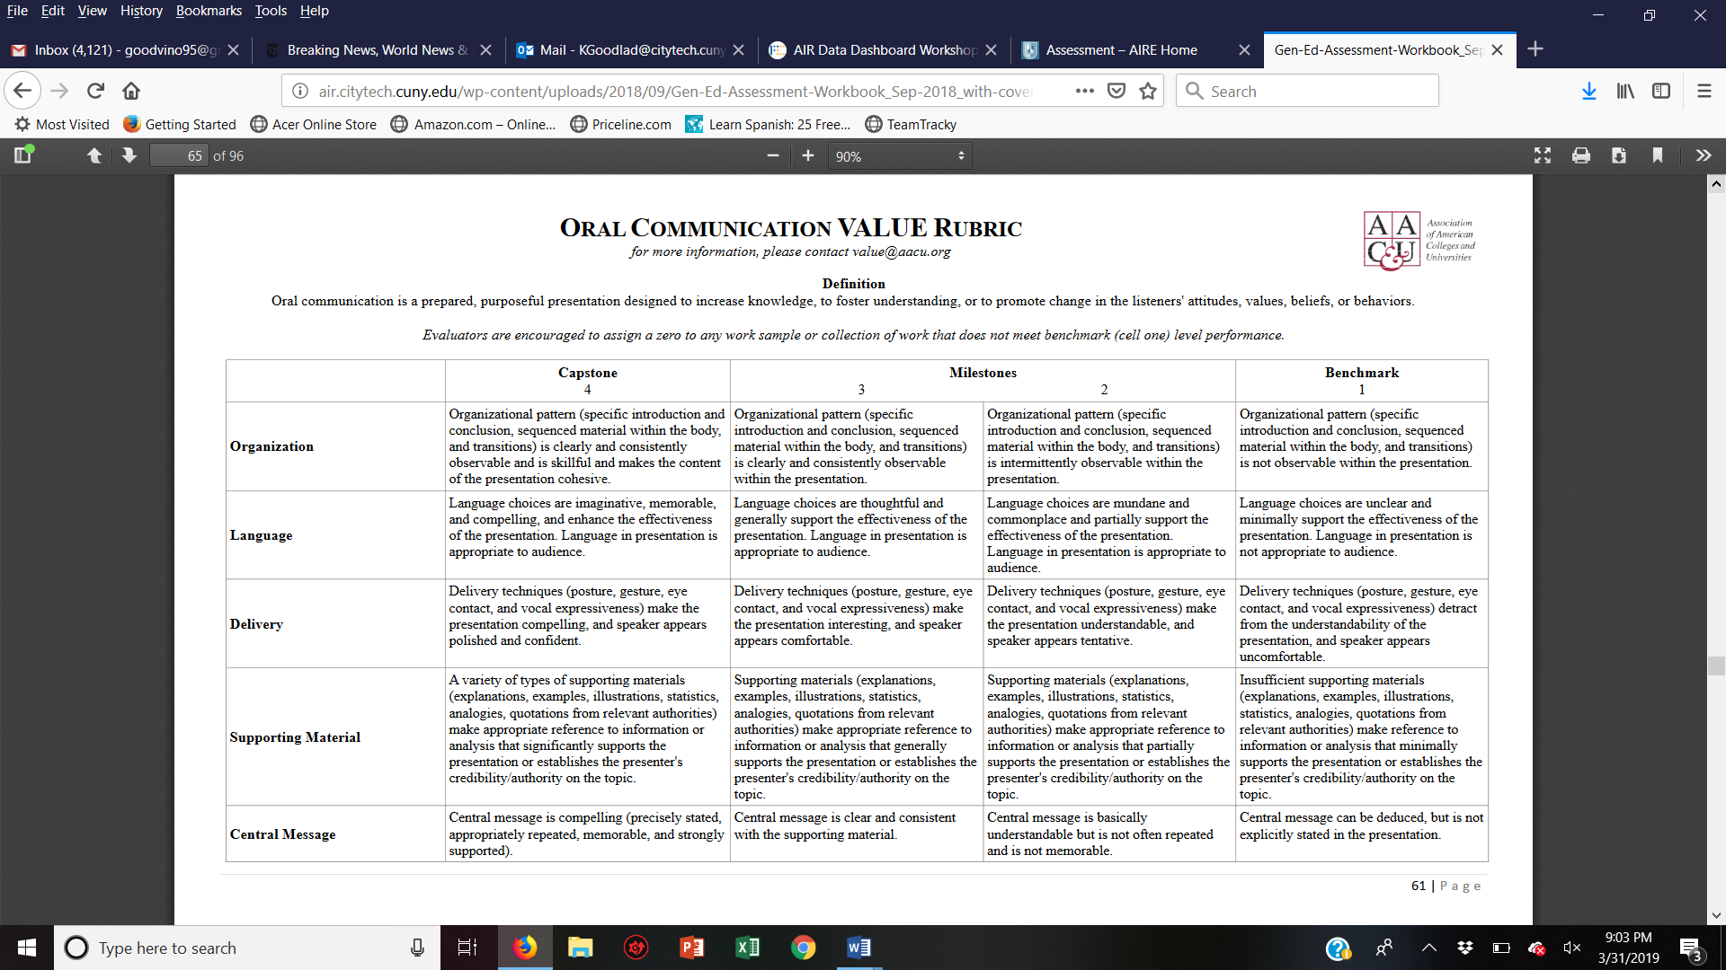

**Grading System**

A 93 – 100

A- 90 – 92.9

B+ 87 – 89.9

B 83 – 86.9

B- 80 -- 82.9

C+ 77 – 77.9

C 70 – 76.9

D 60 – 69.9

F 59.9 and below

**Required Text**

Walker, J. R. (2020). *Introduction to hospitality.* 8th Edition. Hoboken, NJ: Pearson.

**Suggested Reading**

New York Times New York Sections, <https://www.nytimes.com/section/nyregion>

New York Times Travel Section, <https://www.nytimes.com/section/travel>

**Suggested Listening (Podcasts)**

All in the Industry, <https://heritageradionetwork.org/series/all-in-the-industry/>

Be a Better Guide, <https://www.beabetterguide.com/>

Cherry Bombe Radio, <https://cherrybombe.com/radio-cherry-bombe>

Inside Julia’s Kitchen, <https://heritageradionetwork.org/series/inside-julias-kitchen/>

Flatbush and Main, <https://www.brooklynhistory.org/podcasts/>

Fortune on Stage: The Most Powerful Women, <https://www.stitcher.com/podcast/cadence13/the-most-powerful-women>

Suite Spot, <https://www.travelmediagroup.com/suite-spot-hotel-marketing-podcast/>

**Bibliography**

American Hotel & Lodging Association*.* (n.d). *News room*. Retrieved August 15, 2019 <https://www.ahla.com/newsroom>

Brefere, L., Eich Drummond, K., & Barnes, B. (2005). *So you want to be a chef? your guide to culianary careers.* Hoboken, NJ: John Wiley and Sons.

Fiedman, A. (2018). *Chefs, drugs and rock & roll: How food lovers, free spitits, misfits and wandereers created a new American profession.* New York: Harper Collins.

Hospitality Sales and Marketiing Association International*.* (n.d.). *Isights*. Retrieved August 15, 2019: <https://global.hsmai.org/insights/>

Marriott, J. W., & Brown, K. A. (1997). *The spirit to serve: Marriott's way.* New York, NY: Harper Collins

National Restaurant Association. (n.d.)  *Research and trends*. Retrieved August 15, 2019 <https://www.restaurant.org/research>

Sachs, D. and J. Scott. (2018). *The million dollar greeting: today’s best practices for profit, customer retention, and a happy workplace*. USA: Apollo Publishers

Sandoval-Strausz, A. (2007). *The hotel: an American history.* New Haven, CT: Yale Univesity Press.

World Tourism Organization. (n.d.) *What we do*. Retrieved October 12, 2012, from: <http://www2.unwto.org/content/why-tourism>

**Class Meeting Schedule**

## Class 1, Monday, August 29

* **Discussion Topic**: Introduction to Hospitality Management
* **Chapter Reading:** None Due
* **Other Reading**: None Due
* **Homework Due**: Complete Technology Survey
* **Assignment Due:** Technology Survey

## Class 2, Monday, September 12

* **Discussion Topic**: The History of Hospitality and an introduction to the OpenLab
* **Chapter Reading:** Chapter 1 pages 2-24
* **Other Reading**: NY Times Travel Section, see weekly class agenda
* **Homework Due**: See Weekly Homework for assignment
* **Assignment Due:** Electronic Profile

## Class 3, Monday, September 19

* **Discussion Topic**: The Hospitality Industry Continued and Library Resources
* **Chapter Reading:** Chapter 1 pages 2-24
* **Other Reading**: [NY Times Travel Section](https://www.nytimes.com/section/travel), see weekly class agenda
* **Homework Due**: See Weekly Homework for assignment
* **Assignment Due:** Only Weekly Homework is Due

## Class 4, Monday, September 29

* **Discussion Topic**: The Hotel Business, Concierge Assignment Discussed
* **Chapter Reading:** Chapter 2
* **Other Reading**: [NY Times Travel Section](https://www.nytimes.com/section/travel), see weekly [class agenda](https://openlab.citytech.cuny.edu/hmgt1101goodladfall2020/category/course-activities/class-agendas/)
* **Homework Due**: See Weekly Homework for assignment
* **Assignment Due:** Only Weekly Homework is Due

## Class 5, Monday, October 3

* **Discussion Topic**: Hotel Rooms Division and Food and Beverage
* **Chapter Reading:** Chapter 3 and Chapter 4
* **Other Reading**: [NY Times Travel Section](https://www.nytimes.com/section/travel), see weekly class agenda
* **Homework Due**: See Weekly Homework for assignment
* **Assignment Due:** Idea Development, Concierge Assignment

## Class 6, Monday, October 17

* **Discussion Topic**: The Travel and Tourism Industry
* **Chapter Reading:** Chapter 9
* **Other Reading**: [NY Times Travel Section](https://www.nytimes.com/section/travel), see weekly class agenda
* **Homework Due**: See Weekly Homework for assignment
* **Assignment Due: Draft of Concierge Assignment**

## Class 7, Monday, October 24

* **Discussion Topic**: Travel and Tourism in New York City
* **Chapter Reading:** Chapter 9
* **Other Reading**: [NY Times Travel Section](https://www.nytimes.com/section/travel), see weekly class agenda
* **Homework Due**: See Weekly Homework for assignment
* **Assignment Due:** Final Concierge Assignment

## Class 8, Monday, October 31

* **Discussion Topic**: Concierge Presentations
* **Chapter Reading:** None
* **Other Reading**: [NY Times Travel Section](https://www.nytimes.com/section/travel), see weekly class agenda
* **Homework Due**: See Weekly Homework for assignment
* **Assignment Due:** Only Weekly Homework is Due

## Class 9, Monday, November 7

* **Discussion Topic**: Concierge Presentations Discussion of the Industry Research Assignment
* **Chapter Reading:** None
* **Other Reading**: [NY Times Travel Section](https://www.nytimes.com/section/travel), see weekly class agenda
* **Homework Due**: See Weekly Homework for assignment
* **Assignment Due:** Only Weekly Homework is Due

## Class 10, Monday, November 14

* **Discussion Topic**: Restaurant Operations and Beverages
* **Chapter Reading:** Chapter 5 and Chapter 7
* **Other Reading**: [NY Times Travel Section](https://www.nytimes.com/section/travel), see weekly class agenda
* **Homework Due**: See Weekly Homework for assignment
* **Assignment Due:** Initial thoughts on the Industry Research Assignment

## Class 11, Monday, November 21

* **Discussion Topic**: The Restaurant Business and Managed Services
* **Chapter Reading:** Chapter 6 and Chapter 8
* **Other Reading**: [NY Times Travel Section](https://www.nytimes.com/section/travel), see weekly class agenda
* **Homework Due**: See Weekly Homework for assignment
* **Assignment Due:** Only Weekly Homework is Due

## Class 12, Monday, November 28

* **Discussion Topic**: Attractions, Recreation and Clubs
* **Chapter Reading:** Chapter 10
* **Homework Due**: See Weekly Homework for assignment
* **Assignment Due:** Draft Industry Research Assignment

## Class 13, Monday, December 5

* **Discussion Topic**: Meetings, Conventions, Expositions, and Special Events and Review of Industry Research Assignment
* **Chapter Reading:** Chapter 12 and Chapter 13
* **Other Reading**: [NY Times Travel Section](https://www.nytimes.com/section/travel), see weekly class agenda
* **Homework Due**: See Weekly Homework for assignment
* **Assignment Due:** Only Weekly Homework is Due

## Class 14, Monday, December 12

* **Discussion Topic**: Student Directed
* **Chapter Reading:** To be provided
* **Other Reading**: [NY Times Travel Section](https://www.nytimes.com/section/travel), see weekly class agenda
* **Homework Due**: See Weekly Homework for assignment
* **Assignment Due:** Industry Research, Final

## Class 15, Monday, December 19

* **Discussion Topic**: Human Resources and Leadership Development
* **Chapter Reading:** Chapter 14
* **Homework Due**: See Weekly Homework for assignment
* **Assignment Due:** Only Weekly Homework is Due

*Late assignments will not be accepted

### Diversity and Inclusive Education

### This course welcomes students from all backgrounds, experiences and perspectives. In accordance with the City Tech and CUNY missions, this course intends to provide an atmosphere of inclusion, respect, and the mutual appreciation of differences so that together we can create an environment in which all students can flourish. It is the instructor’s goal to provide materials and activities that are welcoming and accommodating of diversity in all of its forms, including race, gender identity and presentation, ethnicity, national origin, religion, cultural identity, socioeconomic background, sexuality and sexual orientation, ability, neurodivergence, age, and etc. Your instructor is committed to equity and actively seeks ways to challenge institutional racism, sexism, ableism and other forms of prejudice. Your input is encouraged and appreciated. If a dynamic that you observe or experience in the course concerns you, you may respectfully inform your instructor without fear of how your concerns will affect your grade.  Let your instructor know how to improve the effectiveness of the course for you personally, or for other students or student groups. We acknowledge that NYCCT is located on the traditional homelands of the Canarsie and Lenape peoples. <https://openlab.citytech.cuny.edu/dice/>

**Student Accessibility**

Qualified students with disabilities, under applicable federal, state, and city laws, seeking reasonable accommodations or academic adjustments must contact the Center for Student Accessibility for information on City Tech’s policies and procedures to obtain such services. Students with questions on eligibility or the need for temporary disability services should also contact the Center at The Center for Student Accessibility:

300 Jay Street, room L-237, 718 260 5143. <http://www.citytech.cuny.edu/accessibility/>

**Professionalism and Participation**

The Department of Hospitality Management follows industry standards in order to educate, develop and mentor future hospitality and tourism professionals. In order to successfully complete a course, students must consistently participate in class and meet deadlines

**NYC College of Technology Statement on Academic Integrity**

Students and all others who work with information, ideas, texts, images, music, inventions, and other intellectual property owe their audience and sources accuracy and honesty in using, crediting, and citing sources. As a community of intellectual and professional workers, the College recognizes its responsibility for providing instruction in information literacy and academic integrity, offering models of good practice, and responding vigilantly and appropriately to infractions of academic integrity. Accordingly, academic dishonesty is prohibited in The City University of New York and at New York City College of Technology and is punishable by penalties, including failing grades, suspension, and expulsion.

As stated in the Academic Integrity Policy Manual,

"academic dishonesty occurs when individuals plagiarize or cheat in the course of their academic work. Plagiarism is the presenting of someone else’s ideas without proper credit or attribution. Cheating is the unauthorized use or attempted use of material, information, notes, study aids, devices or communication during an academic exercise."

The complete text of the College Academic Integrity Policy Manual may be found on the College website.

**Statement of Classroom Behavior**

Each student has the right to study and learn in a comfortable, safe, supportive environment that promotes self-esteem – free of fear, humiliation, intimidation, offensive or suggestive language.

**Use of Electronic Devices**

The use of cellular phones and audio equipment in all academic and study areas of the college is prohibited. Students are not permitted to take calls or text message during class. Students may not use their cell phones as calculators. In some instances, an instructor may allow the use of personal electronic devices for in class activities.

**Writing Style Statement**

The hospitality management department requires that all written work must be prepared using APA Style Publication Manual of the American Psychological Association as a reference guide. This includes editorial formats, abbreviations, use of statistics, graphs, citations and references. Visit the City Tech Library website for APA Style Guides.

