How to enroll in classes
- Log into CUNYFirst account

- Access self service tab under enterprise menu

- Access student center under self service tab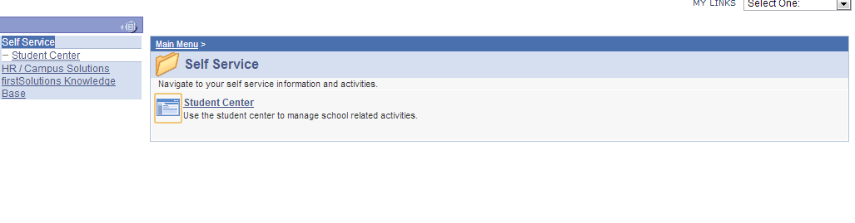
- Under Academics, access enroll option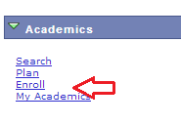

- Once you are in the enroll menu, access the search tab

- Select the CUNY institution you are currently attending, what term you would like the enroll in, and what course subject you are looking for

- Once you find a class, write down the class number

- Go back to Academic menu and on the far right, access enrollment shopping cart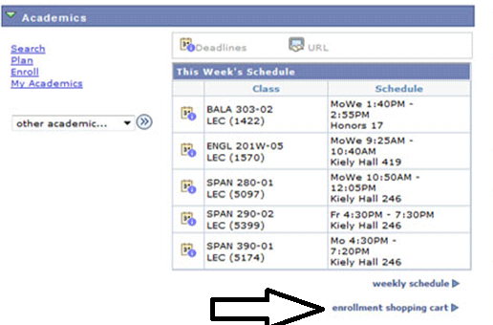
- Add course to shopping cart by entering course class number

- Once class is entered into shopping cart, select enroll.
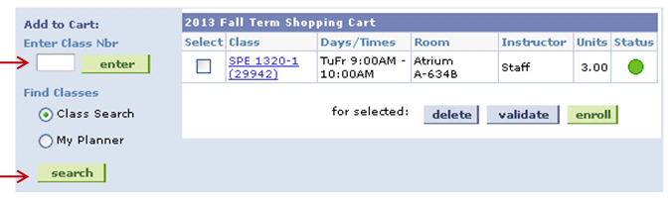
- You are now enrolled in a class!

