Game Design Document
ReSurface- An Interactive Fiction Game
Alenso Labady, Cesivel Sandoval, Rachel Alexander, Rafaela Malavé, Shaquanna Thompson
New York City College of Technology

Section 1- Analysis
Video Game Narrative
The year is 2220 in New York City. It has been 50 years since the ozone layer has broken, and humans are forced to live under a layer of metallic sky. You and your classmate Sabel Hunter have just graduated Law Academy and begin your first day at work. Throughout your shifts, you are given opportunities to gain reputation, items, and rank. When qualified, your team will be assigned to Brittany Goulash, a horticulturist and environmentalist who is hoping to find inhabitable life Above. The team must find a way out from under Metal-attan and traverse through the tunnels, Subterranean, to reach your final destination. Along the way, you may encounter bandits and thieves, you must avoid the AboveGround mutants, and you must protect the team until the destination is reached. Once you and your team reach the New York Botanical Garden, you must find the organism that will help create an immunity to the sun’s harmful rays. Good luck, and may the path be paved with weapons.

Target Audience
Our target audience would be the individuals who are usually on a computer. It could be young and older adults who have a preference on word based game and are seeking games that require decision-making.

Delivery Platform
Resurface will be available on iOS, Android (Google play), Steam, Microsoft Windows, macOS, and Linux. Being a text based adventure game, it is only natural for it to played on a keyboard and mouse.

Review of Competing Games
Zombie Exodus- Hosted Games, 2011, Steam-- Both Zombie Exodus and Resurface are text based post-apocalyptic games that allow you to choose your own path. They both allow the player to customize their character. The difference is in the story and the enemies. Instead of zombies, Resurfaces enemies are mutated creatures and other humans. Resurface is post-apocalyptic but does have comic relief, and it is better than Zombie Exodus for its immersion and sense of humor in parts of the story.

Heart of the House - Choice of Games, 2017, Steam-- Heart of the House and Resurface are both text based adventure games with character customization. Both stories have an element of searching for an important individual. The difference between the two games is in the genre: in Heart of the House you are an orphan in Gothic times, while Resurface is post apocalyptic. Also, Heart of the House is supernatural while the genetic abnormalities of the character in Resurface are due to radiation and evolution. This make Resurface better because it is easier to believe.

Subsurface Circular - Bithell Games, 2017, Steam, Windows, macOS-- Subsurface Circular is a three-dimensional text-based game. The player controls a robot detective in a futuristic setting, tasked to solve cases aboard a subway system below a human city. The player uses the robot to solve a case of a number of robots that have gone missing, solving puzzles to get more information, called "focal points", which then can be used to question other robots to get more information to solve the mystery. Resurface is similar in that parts of the game take place underground, in the old subway system. There is a mystery in how to survive the instability of this post apocalyptic land, and only the right steps will lead to a successful adventure.

Section 2- Design
Player Characteristics
It is a computer game. The player should know that is game is solely based on keyboard and mouse. It is a text- based adventure puzzle game.

Game Mechanics
The player should think himself/ herself as the character in the game and should decide if they were placed in a similar situation and the options are given, what would they decide to do. They should definitely interact with the game’s environment.

Challenge
The goal for the player is to find a habitable location outside of Metal-atten. The choices the player makes about what kind of person they are will affect how quickly they will be assigned to this task, how much help they will receive from their comrades, and whether the mission is a success or failure. If the player decides to be a rebellious, unruly agent, their partner may leave them in an unknown location and they cannot finish the game properly. If they are too much of a straight-edge, they may not get to the destination that will lead to success because they are playing it too safe. If they are a leader, they may have a successful trip as long as they lead their comrades in the right direction, however, they may have to sacrifice certain players as well. Based on the actions taken before the main mission, the player will gain experience, reputation, and possible items that will aid them on the mission later on (but these items may be able to be found later). During the mission, the player may chose to fight, flee or sneak past enemies, and these actions may affect the comrades, the reputation, and the length of the mission. The decisions made can result in killing off the major player, Brittany Goulash, or possible death of themselves, which will force the player to start from the beginning. Once the team makes it to the Botanical Gardens, chances of winning, finding a way to survive the sun’s damage, become apparent.

Section 3- Project Description
Walkthrough
Futuristic Terminology--
Tv: TeleComm
Phone: DataComm
Video Camera: VidTech
Escalator: HiRizer
Car: Hover Hybrid PuttPutt 1X3
Cop Car: Matador 54
Walkie Talkie: Tone Box
Gun: Laser
Future New York, year 2220. 50 years ago, the sun released a solar wave that broke the last remnants of the ozone layer. Thank goodness scientists were aware of the impending doom and cities around the world were able to create a solar protectant, a metallic sky to encase the cities in oxygen and solar regulated dome-like systems, before the solar flare killed all life. Unfortunately, the extent of the Metallic Sky was only large enough to encase Manhattan Island. We now live Under, in a city nickname Metal-atten. (Manhattan, get it?) The world we know and grew up with is a layer of metal sky, protecting us by the sun and storing solar energy to run the city. There is projection technology that imitates night and day, towns outside of Metal-attan are usually inhabited by bandits, smugglers, and crazies, and located in the larger subway stations. The subway tunnels are called Subterranean. Apartments are small and minimalistic, with a flow of technology that lives in the hub (truly Google headquarters). Food is vitamin-like at the most, flavorless—protein bars, nutrition drinks, chemically made stuff. Meat is rare, but vegetables still grow in Central Park, now called Greenhouse One. The people are weaker than normal, but gyms are available but highly regulated to prevent excessive muscularity (resource regulation). Those who can survive above ground are contaminated and have a layer of plastic-like skin over their features, small inset eyes like a mole, and robust because they have true food. Plants can still survive but have evolved into predators of their own, and, without government breathing down their backs, cannibalism isn’t frowned upon Above.
You and your classmate, Sabel Hunter, have finally graduated from Police Academy and are ready to begin your career as Enforcement Officers. It is your first day out of the Academy and into Enforcement.
Act 1- Meet your character
Hello, [name] (Enter your name)
Are you a Male or female?
a) Male
b) Female
Good Morning [name].
As you wake up, the day after graduation, you head
a) to the kitchen to make coffee
b) to the bathroom to take a shower
c) to the bathroom to brush your teeth
[to encourage the player to participate]
Feeling more awake, you turn on the TeleComm. The news pops up, showing the front of City Hall. RoboMrG is reporting the news, telling us about the recent developments of MetalHeads, a gang that is gaining strength fairly quickly. You glance at the clock, amazed to find that it is already 8:15. Oh no! Sabel will be here in 10 minutes! You rush to the closet and grab the first thing that appeals to you. It is:
a) Severe suit uniform- slacks blazer, and dress shoes
b) Business casual- khakis, polo shirt, military boots
c) Casual- jeans, camo t-shirt, sneakers
[Changes Stats]

Running downstairs with your laces flying, you skid to a halt in front of Sabel’s car. Her aviator glasses are firmly pressed against her face and she is tapping information on her DataComm. “Hey [name]. What took you so long? We’re supposed to be at base first thing. I’m checking traffic stats and it doesn’t look good.”

Act 2- In the Field
Later that morning, the two of you are standing in the office awaiting orders. This year, the crime rate is high. People have to seek shelter from governments & rats. Cops have to be on alert and on call 24 hrs a day. Your boss, Frank Bryant swivels around in his chair and asks you “So, do you Want the right folder or the left?”
[If right folder, Go to “34th Street mission”, if left folder go to “42nd Street mission”]
After YOU and Sabel take your folder, you head down the steps of the 14th Precinct to pick up the company car, Matador 54. Inside the car is you kit.
[Inventory] Sidearm, Flashlight, ToneBox, Caution Tape, Grenades (*2), Flares (*4), Extra tire
As you are driving,
If 34th Street-
You come across a commotion in a store. Approximately eight people are yelling at each other, a combination of owner, employees and customers, mainly high school kids, who are trying throw cans at the store. The public is trying to hold them off and someone has a VidTech recorder! We have to step in to stop the commotion. The kids are running away. What You couldn’t believe-- they are in ninja turtle suits and running away with pizza!!!! [This where you decide if you will a) file a report with the owner, b) safely remain in the vehicle, or c) pursue the vagrants. This will affect your business status and may affect your journey later.]
  - file a report with the owner
You rush to the business owners side, “Oh my god, are you alright?” You grab the person’s shoulder to assess any physical damage, seeing a bright red stain near the leg. “Are you okay?!? I think you’re bleeding.” The business owner glares at you and says “That’s tomato sauce. They just stole eight pizzas and you’re sitting here like a chump. How do I know I can trust you? [Pull out your ID]
You glance about, looking for a towel. “I do apologize, but I thought you were injured and as a civil citizen, I thought I should check your status first before running off after possibly armed hooligans.” Standing up, you radio in the need for a drone to survey the surrounding buildings in hopes of finding the hooligans.
While the report is being filed, the hooligans get away and the department is forced to pay for damages to the window, loss of wages, and a new outfit for the woman. However, you have followed protocol and therefore suffer no bad-mouthing from Commissioner Bryant. In fact, he commends your following the orders and asks to meet you in the office tomorrow morning. [Go to “The Next Morning”]

b. safely remain in the vehicle
“Matador 54 to base, we have a situation” You say, clicking the doors firmly locked and glancing nervously at Sabel. She nods encouragingly and fumbles for her laser, although you both know you have to lower the window in order to use it.
It feels like forever until backup arrives, but it’s truly on 2 minutes. They find you and Sebel hyperventilating the the locked car, the business owner glowering at you menacingly from inside her shop, and an otherwise empty street. They ask for a description of the assailants but you cannot provide one. They ask what actions you took to prevent the robbery but you just shake your head. You are escorted back to the base, and begin filling out the necessary paperwork quietly, ashamed at your cowardice. [Go to “Assignment 2”]

c. pursue the vagrants
You run after the goons, yelling at Sabel to help the crowd while you teach these fools a lesson. Skidding around the corner you watch in surprise as the culprits shimmy up a fire escape quickly, looking like roaches in an alley. You rub your hands together and take a running leap, clinging onto the fire escape with the tips of your fingers. With a heave and a grunt, you pull yourself up onto the ladder and run up the stairs to the rooftop.
The culprits have already sprinted almost two rooftops away. You pull out your sidearm and level it at the lower back of the slowest runner. A deep breath and a shot later, the boy goes down. With a whoop and a leap, you run across the roofs to bag and tag your culprit.
Back at the office, the veterans bash your back so hard congratulating you your back is sore by the evening. You go to sleep with a smile on your face, paperwork being filed by the gunshy Sabel instead. [Go to “The Next Morning”]

If 42nd Street-
You and Sabel head to the main two food sources of Metal-atten—M&M Store and Hershey World. You hear a noise from M&M World so You and Sabel rush up the 80 miles per hour escalator. “False alarm” says Sabel, “Let's head back to the Matador”. You say “Olé mutherfucker.” You and Sabel then get a zap from your ToneBox. They have reported sighting horticulturist Brittany Goulash being harassed by the MetalHeads inside the Hershey World. As you both look out the window, these bandits have blocked the entrance and You see Brittany Goulash through the window of Hershey World. Saving Brittany is the first step in Your next adventure. [This is where your choices affect how easy or difficult it will be to convince the director to have you take point on this mission]
- Head down to the basement, where there is a rumored tunnel connecting the two stores.
The tunnel slopes down and the evens out to the basement section, storing the plushy giant M&M’s. “It’s like a graveyard” whispers Sabel, trying to squeeze through two round m&m’s holding hands with creepy smiles. In the back, a door marked “Emergency Exit” opens to a long, crudely made tunnel. You nod energetically. “Yup, I thought so. There were rumors they made a tunnel to connect the two stores. I can’t see a thing down here, though” [pull out your flashlight out]
When you emerge to the Hershey world, the culprits are waiting at the door. Sabel quickly dispatches them and the two of you head up to the balcony where Brittany is hiding behind a giant
- Throw M&M’s at the Creatures
The creatures whoop in glee, stuffing their pockets with the candies and run off quickly, cackling like hyenas. “That didn’t seem good.” Sabel says, and then shrugs. “Let’s go to the basement. I heard there’s a passage” You say. [go to A]
- Hotwire the car in the store and crash through the window of Hershey World
Oh NO! It’s a toy Hover Hybrid PuttPutt 1X3, try again [Choose A or B]

If A or C in 34th Street or 42nd Street, Proceed to The Next Morning-
The next Morning-
Horticulturist and Environmental Explorer Brittany Goulash speaks with Commissioner Frank Bryant, a surly aged man. “These recruits are invaluable. They are ready to take the plunge into the field and they will follow direction. Commissioner Bryant, please consider them for Mission ReSurface.” Bryant glares menacingly at the two of you, and asks, “What do you think about going Above?”
- “Isn’t that where the Moles live? How can we survive that?!”
“And?!” Yells Bryant, shoving his chair back so hard, it knocks into the wall behind him. “We need to find a solution to the problem we are faced with. 50 years ago, we were able to live Above. The plants can survive, and there are species that can survive. What do you expect, to stay in your little hidey-hole forever? You are a disgrace to the force if you want to hide instead of fight!”
“You stammer and look down. “I just… I heard they eat flesh.” Sabel jabs you in the rib, “It’s fine. We’re ready. We’ve been training for this since day one, bro. I got you. Let’s get some weapons.” Bryant smiles appreciatively at Sabel and hands a vidcam to Brittany, “Make sure you get some pictures. I need to see all your progress.” [Go to the Weapons Room]
b. “Sounds like the mission I’ve been waiting for!” You bounce on the toes of your boots and grin manically. Sabel rolls her eyes but she looks just as excited.
“Excellent! To the weapons room with you then. Make sure you grab a ventilator and enough ammo for a month. We cannot be sure how long this mission will take, but you’ll need to get back.” Bryant taps his pen against the table. “It’s been 50 years since I have seen sunlight directly. Please take a picture for me. Here is my vidcam. Any pictures you take will be directly linked to my account.” [Go to the Weapons Room]
c. “Umm…. I think I need more training first, Mr. Bryant”
“Are you serious?! What do you think you’ve BEEN training for, Recruit? Fine, one more round outside. Don’t fucking screw up of it’s everyone’s life on the line.” Frank Bryant throws his pen at you, which you catch, and angrily swivels his chair around. “Pampered babies” is his grumble as you close the door. [Go to Assignment 2]

If B in 34th Street or B and C in 42nd Street, Proceed to Assignment 2-
Assignment 2-
Driving around in The Matador, Sabel and you blaze some angry music. Nothing seems to be going right, and maybe the music will help amp you up for action. “We gotta make a name for ourselves” Sabel says.
- Look for culprits
Proceed to 42nd Street
- Park the car near the highway and monitor speed
A putt-putt rushes by, doing almost 50 miles an hour. Sirens on, sirens blaring loudly, Sabel pulls out of the parking spot. However, you miss the trailer truck making an illegal U-turn and it slams into you. And so end s your short career at Police Enforcement. [End game]

In the Weapons room
“Okay,” says Sabel, grabbing her favorite laser, Multi-Zoner 1543. “Three guns each, a couple knives, do you think we need grenades? I’m gonna take a few anyway.” She starts filling her pockets and belt loops, muttering away while you walk the rows and rows of guns. You decide to:
- Take the same things Sabel has chosen
Three guns (Multi-zoner 1543, Handheld 3, and Rapid Fire) 3 strings of ammo per gun, and several grenades. “This should handle anything coming our way.”
- Take one gun and a lot of ammo.
“This should do it. Not too much weight, and not too much to remember.”
- Take 2 guns and a shitload of grenades.
“We’re in for a bang. If you can’t shoot ‘em, you can probably blow them up”

Act 3-- On the Journey
Based on intensive research and development, Brittany believes that in the Bronx Botanical Garden lies the solution that can improve the lives of everyone. Above lies mutated wild animals and poisonous plants that resulted from intensive amounts of radiation. You guys have rented a PuttPutt to traverse the

3A) Best Ending -- Finding a home with food.
You Sabel and Brittany, are driving to the Bronx Botanical Garden in the Putt Putt to drive away from all the Creatures. You smell something strange in the air.
- Mention something
“Do you guys smell that?” It smells like honey….” “Honey badger!!!” yells Sabel, swerving the car off the path. “Guns up, bitches!” [If Weapons Room =A, show inventory, =B, Get your Gun out, =C, show inventory, guns or grenades]
Stepping out of the car, arms to the teeth, the three of you battle your way through the mutant honey badgers to the source of the smell. It is a peach tree, with peaches on the ground and ripe fruit hanging from every limb. This is what you have been looking for. You only hope the fruit will not mutate you [End]
- Leave it alone, beat a hasty retreat.
The car sputters and dies, leaving the car to come to a roll. You all step out, guns raised, glancing left and right. [Go to 3B]

3B) Worst Ending -- Brittany Dies
A mutated honey badger one of the most dangerous creatures above ground with metallic armor like skin is tracking you, Sabel and Brittany. You notice the badger is on to you and you decide if you should run or fight the honey badger.
a. Shoot the badger
The badger has metallic like armor and bullets will deflect off it’s body. The badger becomes enraged and runs after you with razor like claws. The only way to kill the badger is to throw sulfuric acid. You run to a small lake that contains the acid and lure the badger close to you. As the the badger leaps forward with its claws, at the nick of time you duck and roll out of the way as the badger splashes into the lake of acid. Brittany rushes towards you to make sure you are alright. The dying badger leaps out of the acid and comes at you with its final and crushing death blow. Brittany pushes you out of the way and gets slashed across her mid-section. The badger dies, but in its claws were hints of acid.
b. Run away from the badger
You, Brittany, and Sable start running from the mutated badger. You are able to flee from it but Brittany collapses. As you approach, Sabel notices there is a cut on the left side of Brittany’s arm, and inside the wound is a thorn from a poisonous rose. The poison does have an antidote with a main ingredient plant that lies in the botanical garden, but the poison spreads quickly and you won’t make it in time to save her. Brittany breathes her last breath and apologizes to you and Sabel.

3C) Weird Ending-- It was all a dream. Waking up to your significant other Frank
After tossing and turning all night, YOU smell something strange in the air that seems to be a familiar smell. YOU wonder what could that be, but then YOU start to feel someone tapping YOU continuously on YOUR shoulders. Then suddenly…….. “Honey, Honey wake up it's time to get dress for your big day.” YOU open YOUR eyes and suddenly YOU see It's 8am. It's the morning of Law Academy Graduation. It was all just a dream. Wiping the sweat off YOUR forehead YOU begin to get ready for the big day.
Once YOU and your significant other Frank settle into your seats, the ground begins to rock and shake. Glancing around, you can see huge creatures lumbering toward the crowd. They look like ginormous trees. They have destroyed the Academy and the Mayor yells out “All my cadets get in formation! This is not a drill, I repeat not a drill”.

Visual Map of the Game
(See OpenLab)

Conceptual Art

Metal-attan
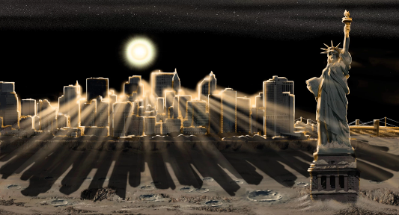
https://www.space.com/21211-new-york-city-other-planets-art.html
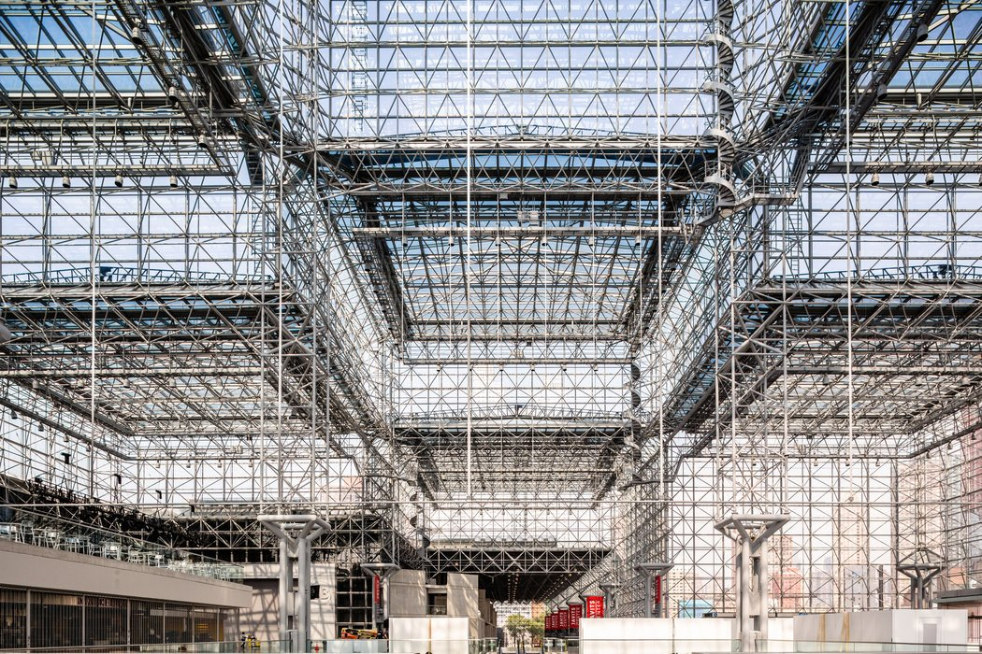
https://www.nytimes.com/2015/09/05/nyregion/making-the-javits-center-less-deadly-for-birds.html

https://pxhere.com/en/photo/553352

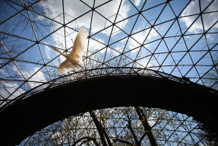
https://cityroom.blogs.nytimes.com/2014/05/07/50-years-later-questions-over-who-designed-a-worlds-fair-dome/

The Subterranean
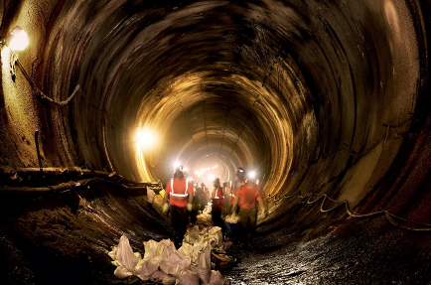
https://www.vanityfair.com/news/politics/2013/10/new-york-city-underground-subway-danger

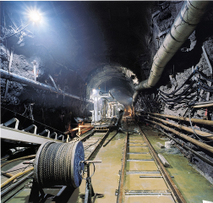
https://www.newyorker.com/magazine/2003/09/01/city-of-water
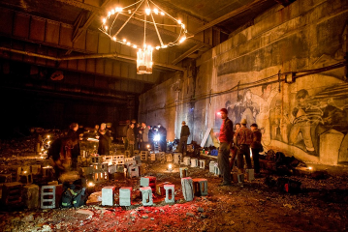
http://lunaticoutpost.com/thread-713343.html

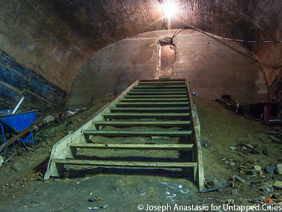
http://lunaticoutpost.com/thread-713343.html

Above
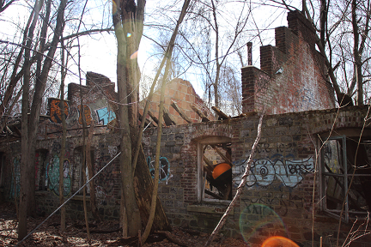
https://onlylivingirlny.com/blog//2017/02/staten-island-farm-colony.html

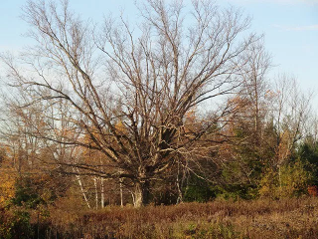
http://www.commonweeder.com/category/rose-of-the-day/

The creatures Above
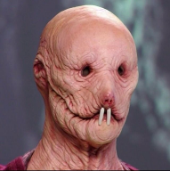
https://imgur.com/gallery/LeYKi

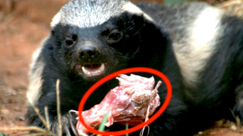http://theywillkillyou.com/video/honey-badger-attack/

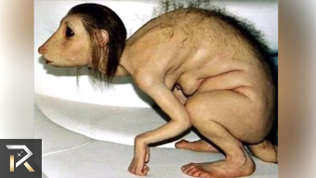
https://www.youtube.com/watch?v=dv486goSIzk

The outfits they may wear
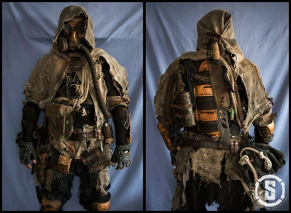
https://i.pinimg.com/originals/85/f4/f7/85f4f74751ef053908e37afacf2b5aa7.jpg

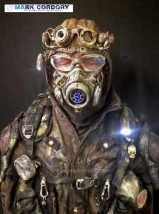
http://www.markcordory.com/Site/Welcome.html
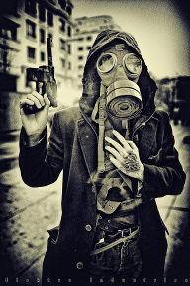
https://elektroindustries.deviantart.com/art/Futile-155871186?q=favby:voodoophotoart/51503185&qo=3

