Instability

Game Design Document
New York City College of Technology
M.T.A.S.K.

Analysis

Video Game Narrative-
​ In​ ​a​ ​fictional​ ​world​ ​where​​ ​​there​ ​are​ ​four​ ​planets​ ​in danger​ ​of​ ​imbalance​ ​and​ ​destruction.​This​ ​story​ ​begins​ ​on​ ​earth,​ ​where​ ​a​ ​young​ ​man named​ ​Leroy​ ​finds​ ​himself​ ​as​ ​the​ ​savior​ ​for​ ​his​ ​entire​ ​galaxy.​ ​Leroy​ ​is​ ​the​ ​son​ ​of​ ​the​ ​ice king​ ​and​ ​his​ ​mother​ ​died​ ​in​ ​child​ ​labor,​ ​leaving​ ​him​ ​with​ ​nothing​ ​but​ ​his​ ​pendant​ ​orb​ ​he wear​ ​around​ ​his​ ​neck.​ ​After​ ​an​ ​altercation​ ​in​ ​his​ ​school’s​ ​gym,​ ​Leroy​ ​discovers​ ​he​ ​has immense​ ​powers,​ ​but​ ​does​ ​not​ ​know​ ​where​ ​it​ ​is​ ​coming​ ​from​ ​or​ ​how​ ​to​ ​control​ ​it.​ ​He​ ​is visited​ ​by​ ​a​ ​temptress who he eventually​ ​grows​ ​to​ ​love​ ​her.​ ​Little​ ​does​ ​he​ ​know,​ ​she​ ​is​ ​the fire​ ​kings​ ​daughter,​ ​plotting​ ​to​ ​capture​ ​him​ ​and​ ​take him to the fire planet.​ She ultimately falls in love with Leroy and helped him travel to the ice planet to meet his father. While with his father in the ice planet, Leroy receives​ ​a​ ​vision projecting​ ​from​ ​his​ ​orb,​ ​it​ ​is​ ​his​ ​mother,​ ​informing him of an imminent attack from the fire planet.​ ​In preparation for the war, Leroy was nominated general and he​ ​helped​ ​unite​ ​the​ ​other​ ​planets​ ​to​ ​build​ ​an​ ​alliance​ ​against​ ​the​ ​fire​ ​planet.​ Moments before the​ ​battle​ ​start,​ ​the​ ​fire​ ​king​ ​realized that he is militarily overmatched and called for a truce with the unify planets. After signing the ceasefire, Leroy attacked the fire planet unexpectedly and demolished their army saving only his love, the fire king’s daughter. In the process Leroy learned to control the orb and brought his love back to earth.

Target Audience
While playing instability you are automatically transported to the year 3050 where you will take form as Leroy. This may draw in gamers of a young age, as well as an older generation because of its “Outer Space” game world.

Delivery Platform-
Our target delivery platform will be anything that is handheld. The game is small and will perform very effectively on handheld devices. Most teenagers have handheld devices like Nintendo 3ds, cellphones, Wii-U, Nintendo Switch, and Playstation Vita. Our game is multiple choice which is also easy to handle, it doesn’t require many buttons to program.

Review of Competing Games-
- Azurik: Rise of Perathia
“The game centers around the main protagonist, Azurik and how he journeys through the vast world of Perathia. His duty is to gather elemental disc fragments scattered across the many realms to harness all elements. Azurik is part of the order of the Lore Guardians. Along with Eldwyn, the grand master, and Balthazar, a professional scholar and combatant. After Balthazar teams up with the guardian of Death, they murder Eldwyn and destroy the balance of the elements by destroying the elemental discs. Leaving Azurik alone, now he must defeat Balthazar and bring back all of the disc fragments in order to restore balance.

In our text adventure based game called “Instability”, the main character, Leroy, faces an enormous decision. He is the only one who is destined to save the universe. The similarities in the two stories are the element based gameplay. Each character has different talents and skillsets based on their origin. Instability is unique because unlike Azurik: Rise of Perathia, our story takes place in the future as well as the depths of outer space. Because of this, instability has a whole different feeling while playing the story.
2) “Driftland The Magic Revival”
Driftland is a game based on the dark ages. A boy has a new found magic in this territory. This boy was the hope of the universe. New sources of magic appeared and the whole planet began to give birth to new magics. Now, the rediscovered power can either restore Driftland to its former glory or devastate what’s left of the planet, when the old conflict inevitably returns.
You take the role of a Mage Overlord with your own castle, tower, and a small realm on one of the islands. With your unique powers, you can explore a procedurally generated world and connect floating islands, expand your increasing kingdom.”
Much like Instability, Driftland has different kingdoms all striving to be number one.
Instability is better because it takes place in space and has different forms of power for each being. In our story, we have many scenes that display the fighting styles and the different powers, so to the gamer, this draws you in. Not only is is a hero’s journey, but it is also a small love story involved. So for those who might not be attracted to the adventure or “Instability” there’s also a love side to it.

3) Spider and web- By Andrew Plotkin
In Spider and web, the player's character, an apparent tourist, has wandered into a blind alley. Upon trying to leave the alley, however, the character is confronted by a voice sneering that this is a lie and threatening dire consequences if the truth is not told. Gradually, the player pieces together that the main character is an unnamed spy who is being interrogated by an equally anonymous enemy. Through interruptions and prodding, the interrogator reveals that the spy was captured in the process of infiltrating an installation under the guise of a tourist.
This game is based on accessing data and trail and error. They lead you on an escape plan with minimal clues and choices. In both games, the protagonists must make difficult choice in order to win the game. Our game is better because it’s simple and easy to operate, which is also why we target the teenage and elderly demographic. We aim to lighten the mood with our fun and unique dialogue.

Design

Player Characteristics
Players should expect a Fantasy type genre and our hero is the typical zero to hero type of character. The player will control the main characters destiny.

Game Mechanics
In order to play the game “crystal orb”, the player must load the game file and run. The game starts with the opening scene where Leroy is in class learning about the different planets and their great warriors. Each scene will offer the player multiple choices to choose from. There will a maximum of 3 choices throughout the game in the A, B, C format. Some routes lead to dead ends or game over and some routes lead to you win. We do not have an inventory or stats system

Challenge
“Instability” is a choose your path adventure game with many unexpected twists and multiple endings. Each choice a player makes will lead to a different story line and may result in a different ending.
There are three objectives the player must accomplish in order to win the game. The player, as Leroy must first defeat the fire king who wants to take control of Leroy’s orb. In the process of going to war or defeating the fire king, Leroy must learn to control the power of the orb and not let it unleash uncontrollably. Finally, in the midst of all this Leroy has to find his love interest and return back to earth with her.
The player must avoid getting Leroy in a situation that angers him. When he is angered, the crystal orb will activate and destroy everything and the game will end. All the paths in the game offer the player a choice to go to the fire planet following Leroy’s love interest. If the players chooses this path the game will end. In the winning path if the players chooses to go to war with the fire king, he will end up killing his love interest, resulting in a loss. Every choice is critical since the player can only win by choosing the path that leads to Leroy defeating the fire king, learning to control the orb, and winning his love interest and bring her back to earth.

Project Description
Walkthrough
Game Starts
The options available all lead to the hero unleashing his power.
A), B), and C) are all viable options.
After the incident, searching for help is the most logical choice. Dahaya also gives you valuable information.
- Run to his friend Dahaya
After Leroy discovers information about his past, the best option would be to reach out to his father. Instability doesn’t just apply to the orb, it applies to Leroy’s life. Searching for missing pieces of his life should give him some sense of balance.
B) Goes to the Ice planet to meet his father
You must remember Dahaya is the fire kings daughter, going to war would put her in danger. Negotiating for peace prevents war and leads you to victory.
- To negotiate the peace with the fire kingdom.
You Win.

Visual Map of the Game

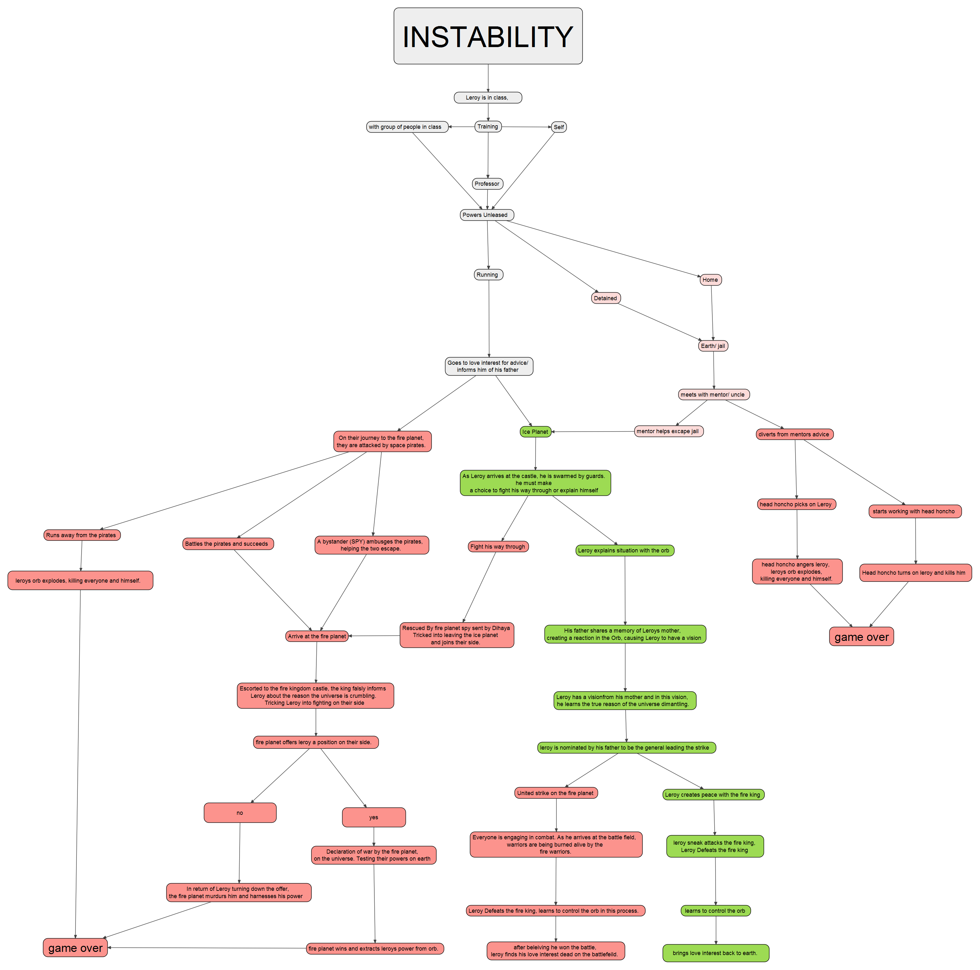
Conceptual Art-

Fire Planet Overview
Earth Planet
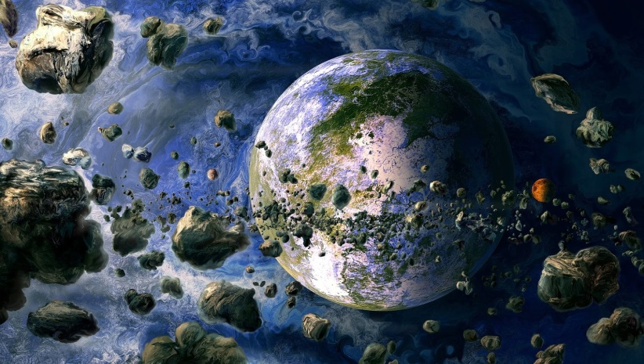
Crystal orb absorbing the fire kings power, and Leroys power

Air planet

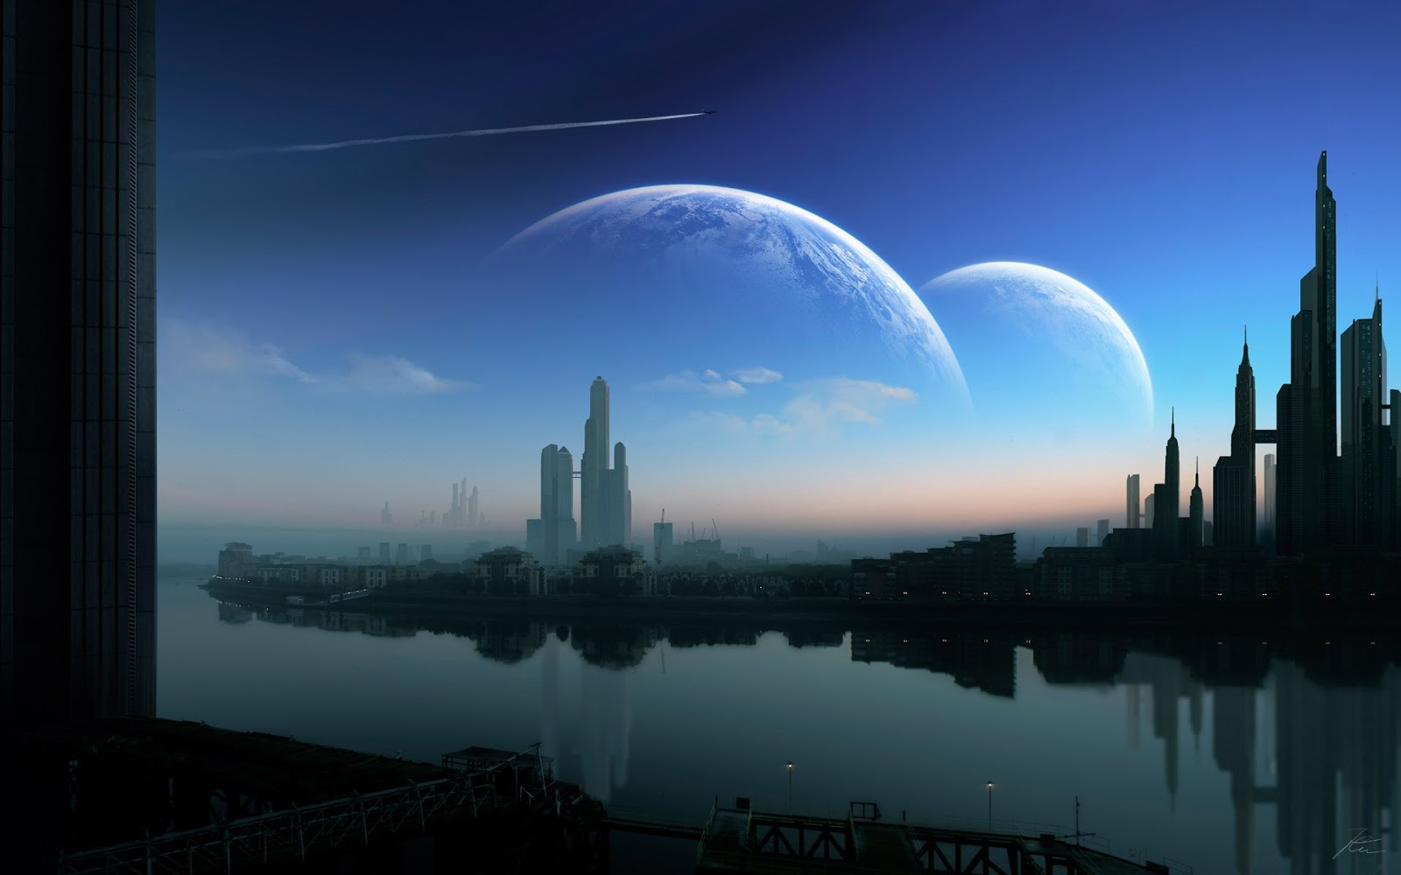
Fire planet Major City
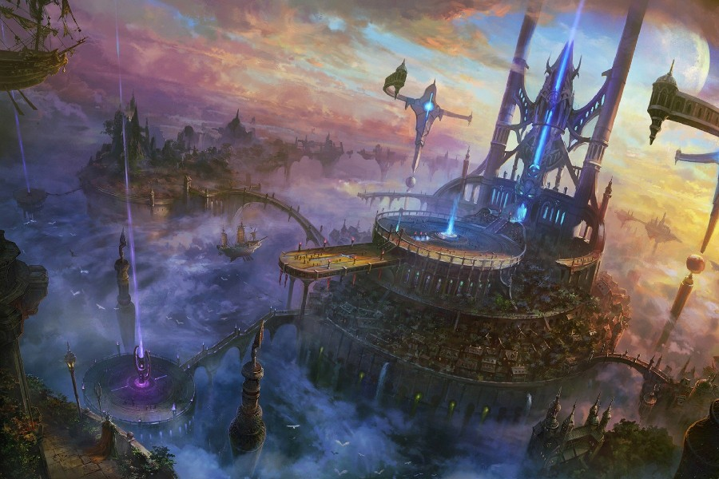
Ice planet overview 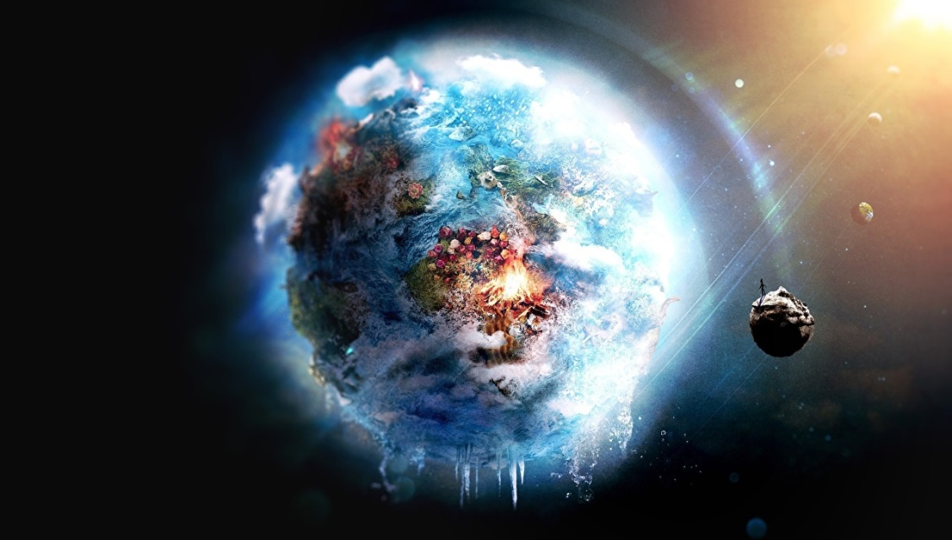
Earth city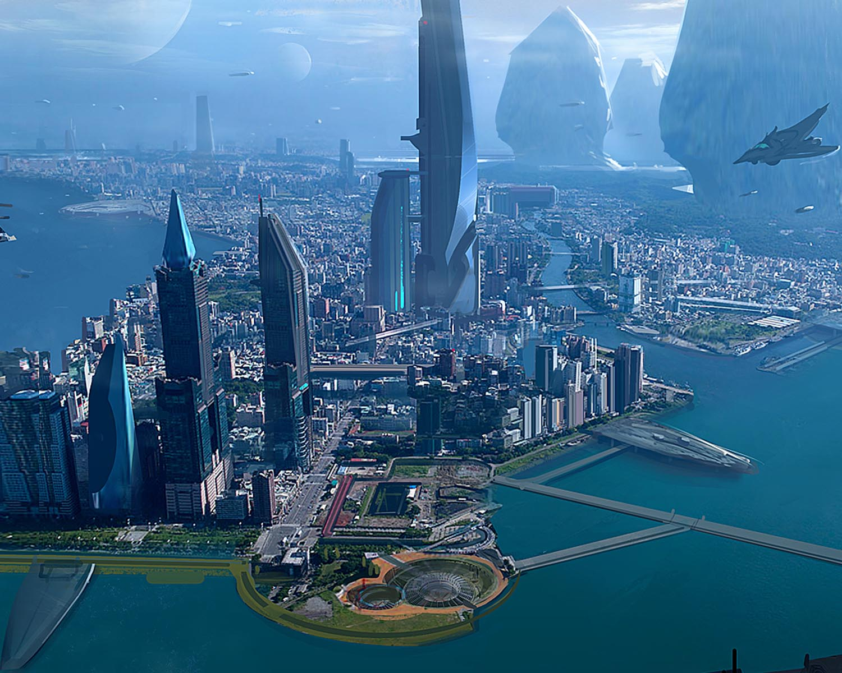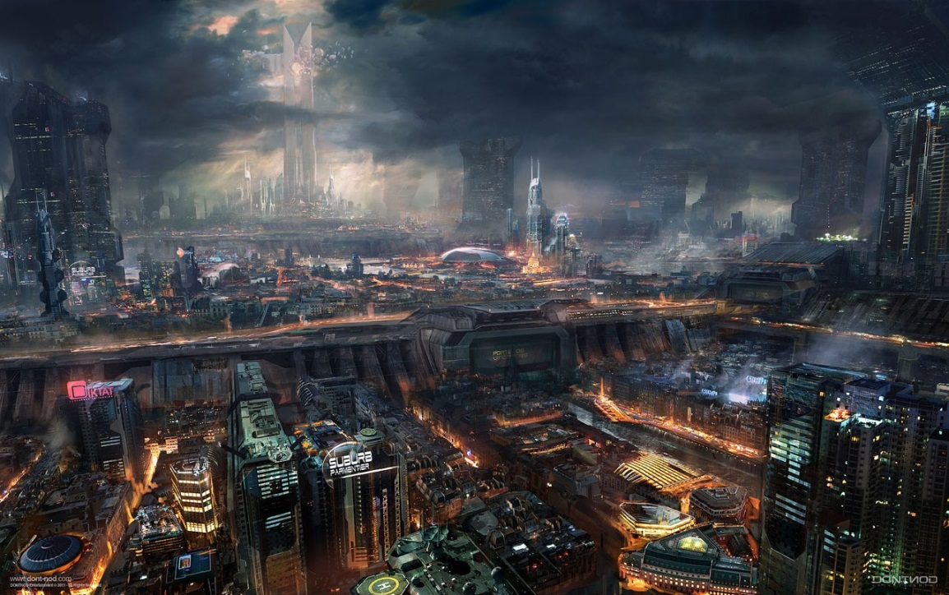Fire Planet City

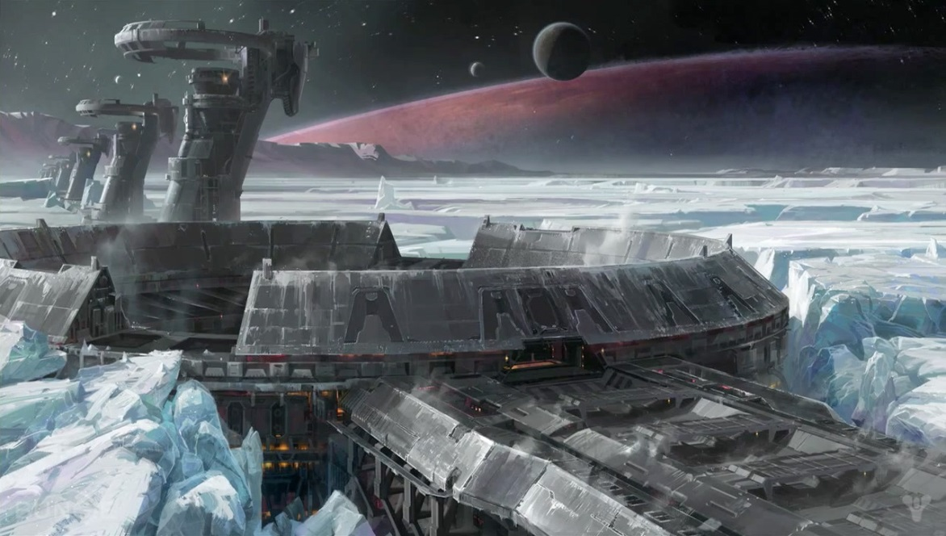Ice planet city
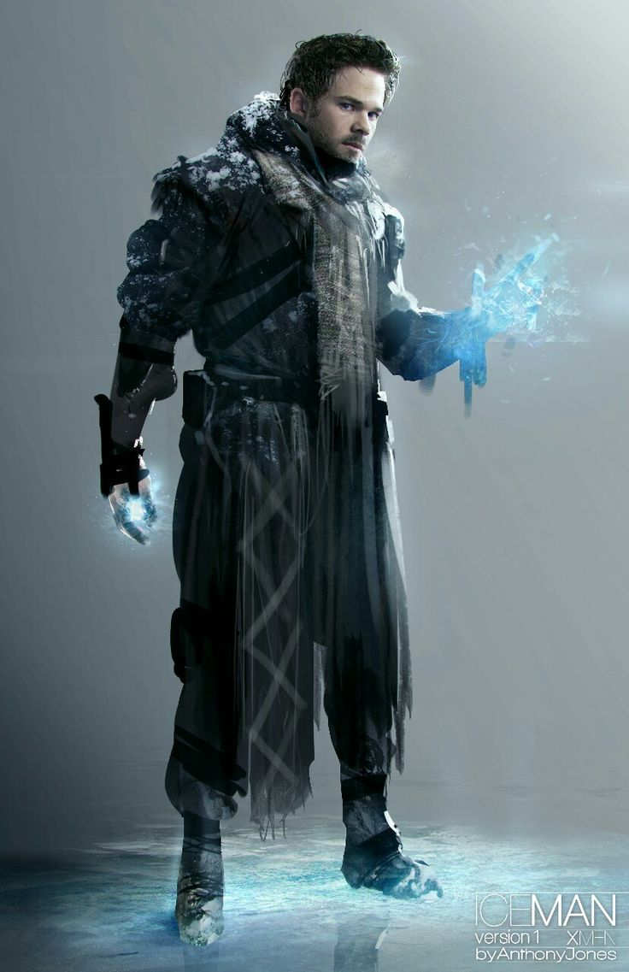Leroy

