Fold
By: Amy Lin,
Veronika Lisetska,
Josh Israeli,
Wally Guo,
Darius Freeman

Section I: Analysis
Video Game Narrative
Dylan is a 15-year-old boy that comes from a paper world, where he himself is made out of paper and everything around him. Dylan lives in the time of the French Revolution where everyone is ranked by classes and the king ruled everything, making the commander pay taxes. He is an orphan and stays in an orphanage in a small town in France. After looking in the bathroom mirror, he sees himself alone. No one is around, causing him to wonder who he really has in this world. He wants to know who his parents are, his background, and why did he end up as an orphan. One day the caretaker of the orphanage saw how sad he was and he explained his story. He told him that he was special and if he really wanted to know the answer to his question then he has to go find the Hermit, who this in the cave in the forest.
Then one day a storm hits France and ruined almost everything even the orphanage. Will Dylan stay to help rebuild the orphanage or will he start his mission? During his mission the only thing Dylan carries with him is papers. He has an endless amount of papers. During his journey he meets a lot of obstacles. For example, getting attacked by the soldiers, getting jumped by the king’s guards, and fighting off the trolls. In order to survive Dylan has to make origami swords or anything that will defeat his opponents. Will Dylan be able to fold his way to survival and find the answers to his questions?

Target Audience
This game is for age group from 13 and up. The game contains violence and can not be played by or in front of the little children because it can damage their mental health. Player should care about our group’s hero, Dylan because he is a young boy that is going through a hard time in his life. A player needs to help Dylan survive all paths.
Our game has a lot of action which makes a player interested. Also, our game is adventure driven and this allows player to be interactive.
Delivery Platform
The ideal platform that our group wants the game Fold to come out is Mobile app or Xbox one. Everyone has a smart phone so it will be easy to assess the game. Xbox version can give more details and better graphics of the game.

Review of Completing Game:
Three similar games to the Fold are Paper Mario, Shin Megami Tensei IV, and King’s Quest. The world of Paper Mario and the world of the Fold are similar because both worlds are set in a paper world. The weapon, enemy, characters, etc. are all made of paper. The concept behind both game idea is near identical to each other. While the plot vastly different from one another, the idea of the inhabitants, the weapons, the locations, etc. are identical to one another. Paper Mario is a game made by Nintendo in August 11, 2000.

Shin Megami Tensei IV and the Fold are similar that both have multiple endings. In the Fold, there are four types of endings. They are a good, bad, neutral, and joke ending. Shin Megami Tensei also have four types of ending. They are law, chaos, neutral, and nihilist ending with law corresponding to good and chaos corresponding to bad. In the law ending of the Fold, Dylan reaches the end without killing anyone. In the neutral ending of the Fold, Dylan ignores everything that happens so far and went back to the orphanage. In the chaos ending of the Fold, Dylan kills many things to reach his goal. Shin Megami Tensei IV was made by Atlus in May 23, 2012.

In King’s Quest, the protagonist goes through a series of trials to become a king. The protagonist in King’s Quest is given some sort of prophecy to tell them what to do to become a king. Similarly, in the Fold, the protagonist, Dylan, goes from becoming an orphan to a king. He discovers his past from a hermit and goes on a journey to find his father, the king. Both character from both games have to go through various trials before reaching their end goal. They either have to go through some treacherous land and fight some monster. King’s Quest is first release in 1980 made by Sierra Entertainment.

Section II: Design
Player Characteristics:
The game is a comedy action adventure fantasy text adventure game. The main character, Dylan, is an orphan with no experience in fighting. One night, a storm hits his home and destroy it. Deciding that this is a great chance to find his past, he ventures into the forest to seek out the hermit to find out about his past. He faces many adversaries on his journey to seek the truth. Player are introduced to a text adventure where the player can choose to kill everything in sight or be a pacifist and resolve all conflict without fighting. They are faced with many obstacles in which they will either survive or get game over. They will encounter magical beings and wield magical power to help aid him on his journey. Players will be given a series of text to navigate through the story. They will be given multiple options to choose from to proceed through the game.

Game Mechanics
The way you play this game on a PC/MAC is by using the keyboard. The player will be prompted of their available choices on the screen. Afterwards the player will enter in their choices to progress the story using the keyboard. Most of the choices are either a word or a couple of words.
On the XBox One choices are selected using the directional pad and selecting your choice with the A button.
Challenge
In order to win the game, you have to make the right choices that keep you on the right path. This game is challenging because it is dynamic and changes along with the player’s choices. You have to pay close attention to what you're doing if you want to stay on the right path to the main ending. If not, who knows what could happen.
Section III: Project Description
Walkthrough
Act I:
In Act I you will find Dylan in the orphanage and he is getting ready to make breakfast for all the kids. For breakfast he has the obtains of choosing French omelets (option 1) or pancakes (option 2) with butter. The other option is ice cream cake which will lead to the kids stealing food due to hunger. Option 1 and 2 will lead to the caretaker telling Dylan that he has to go to the hermit to find the answer to his questions. During his journey he has three things he can bring with him. The choices are paper clothing, paper backpack, a map, and 50 sheets of paper. Having paper is very important because it is needed to help Dylan fight throughout the game.

Act II:
In Act II Dylan starts his journey by going into the forest. In the forest he encounters a river. His options are to attempt to cross or find another route. If he cross it he will get wet and dies from the cold. If he has paper clothes he will survive. If he finds another route he will be rewarded with paper. In the forest he encounters three trolls. First he is attacked by a small troll. Dylan has the choice to run, attack the troll with a weapon, distract it with food. If he runs Dylan will die, if Dylan attacks the troll with a weapon he will encounter another troll, and if he distracts the troll with food he will have a chance to run away. After dealing with the small one Dylan is attacked by a medium troll. While dealing with the medium troll Dylan has the choice of fighting it, fold a paper horse to run faster, or runs away super fast. If Dylan decides to fight it Dylan dies because it is much bigger than him. If Dylan folds a paper horse, he will be able to escape faster, but encounters a bigger troll. If he tries to fight it he will die because the troll is much bigger than Dylan. If Dylan tries to run away he will catch on fire because paper can cause fire after encountering friction. The last troll he encounters is the big old troll who is a little slower. While dealing with the big troll Dylan has the choice of creating a saw and dropping the tree on the troll or running towards the mountains and is saved by the elderly figure who is the hermit. Alternatively he can use paper to create a net to tangle the troll up or no paper is left Dylan dies. Before going into Act III the hermit tells Dylan to go to the palace where the king is.

Act III:
In Act III Dylan is trying to meet the king, but encounters many obstacles on the way due to the French Revolution. He first encounters and is attacked by a pair of French soldiers. Dylan has the choice to pick up a shield to block the bolts and subdue the soldiers. If he does that then he can go deeper into the city. Or he can take the guns from the ground and shoots the soldiers which allows him to collect some papers. After dealing with the soldiers Dylan encounters more guards like the king’s guards. And once again they try to jump Dylan. This time Dylan has the choice of stabbing the king’s guards or taking the shield he used before and throws it at him to knock them out. Both ways will lead Dylan into the palace, but they lead to different types of endings. After getting passed the guards and entering the palace he reveals himself to the king with the factory bar code on his arm. The three endings that the player can end up with are the bad ending (troll, soldiers, and guards were killed), the happy ending where Dylan and the king unites and he becomes the prince (no kill is made), and the neutral ending where Dylan goes back to the orphanage (some killing was done).

Visual Map Of Game

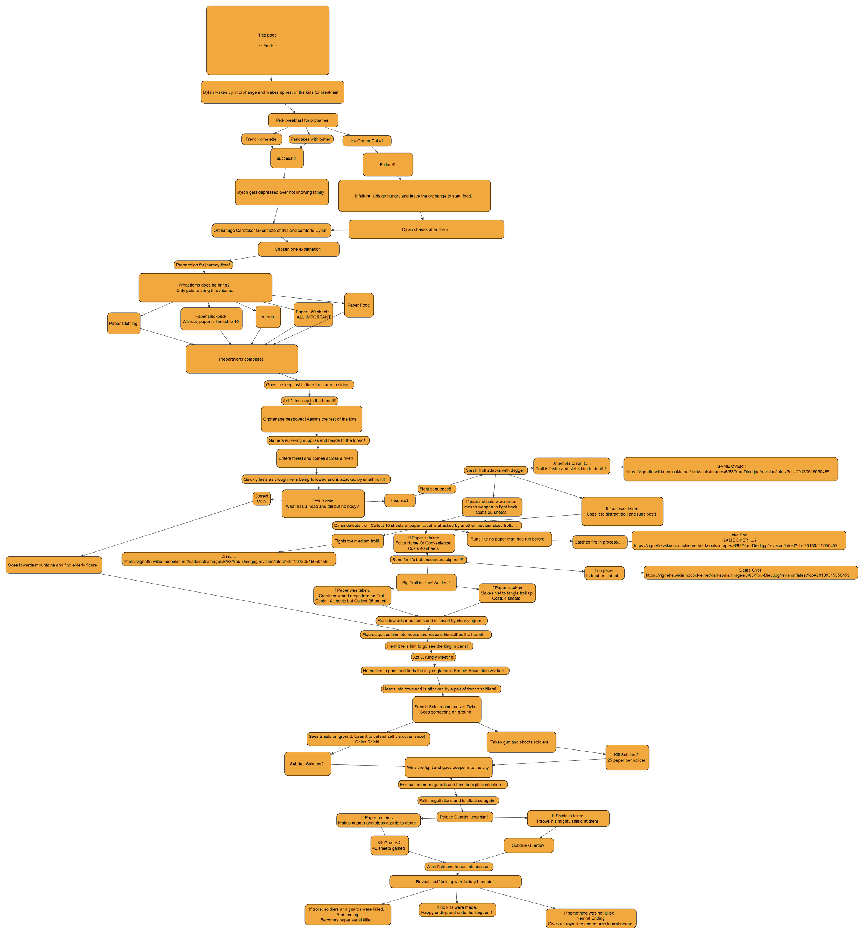

Conceptual Art

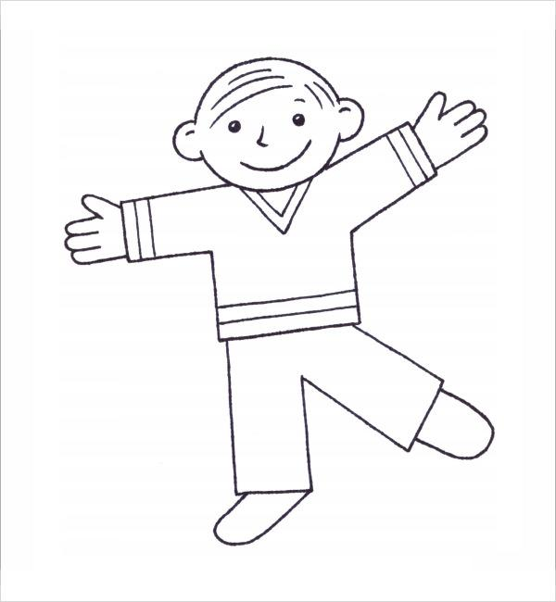
Dylan
https://images.sampletemplates.com/wp-content/uploads/2015/05/Free-Flat-Stanley-Worksheets.jpg

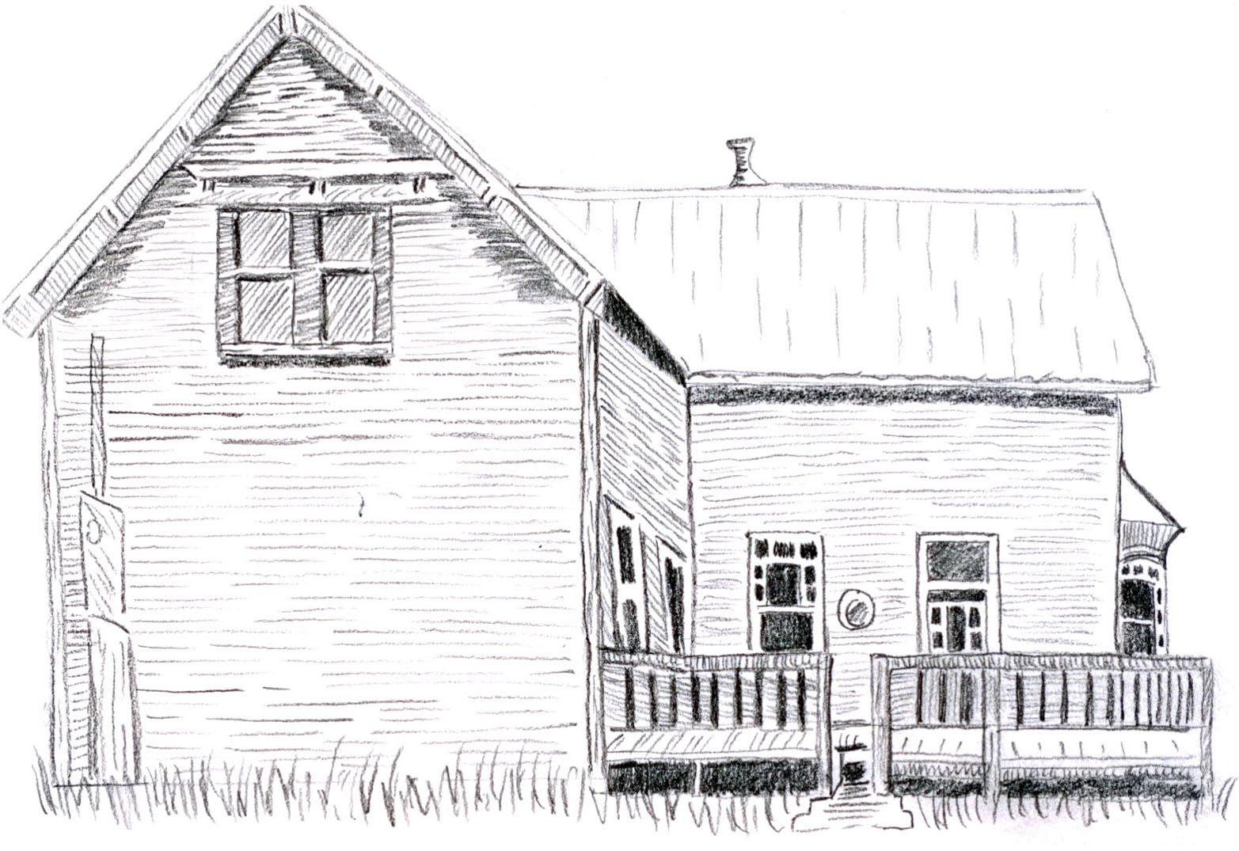
This is the orphanage
https://cathycorner.files.wordpress.com/2011/01/oldhouse1.jpg

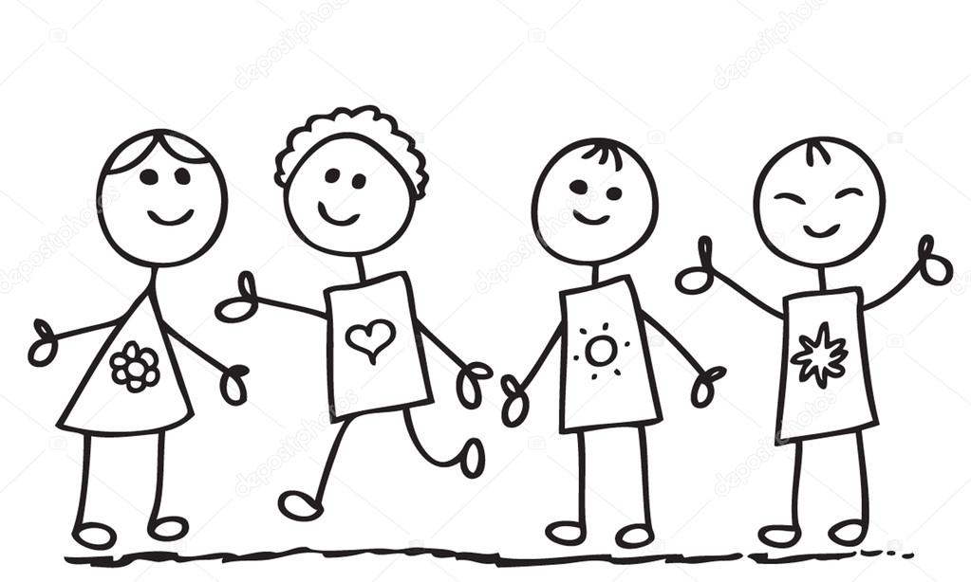
The kids at the orphanage
http://static3.depositphotos.com/1006863/240/v/950/depositphotos_2403334-Doodle-kids.jpg

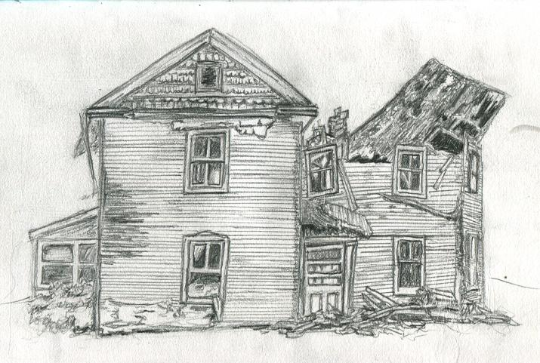
The orphanage after the storm
http://theb-roll.com/wp-content/uploads/2013/02/Drawing054Oldbrokendownhouse.jpg

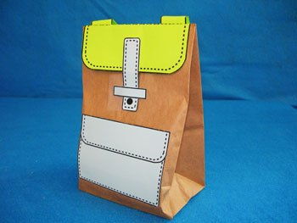
Backpack
https://i2.wp.com/lessonplans.craftgossip.com/files/2009/11/7-Paper-Bag-Backpack.jpg?resize=350%2C263

50 papers
http://www.stickpng.com/assets/images/580b585b2edbce24c47b245f.png

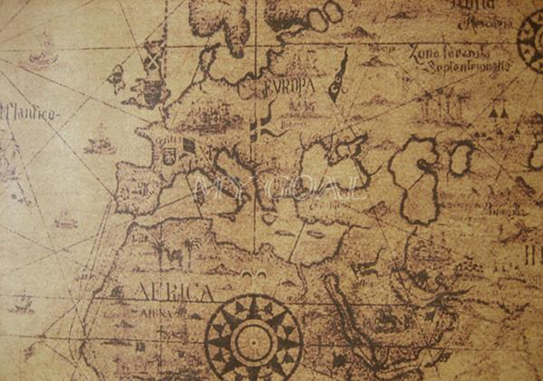
Map
http://photobucket.com/gallery/user/mygoal419/media/cGF0aDovMDEwMzAxMThfenBzODM2MWZmMTEuanBn/?ref=

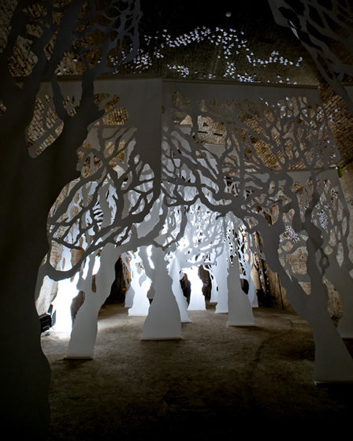
The forest Dylan goes into after leaving the orphanage.
http://soelbergi.com/wp-content/uploads/2012/10/Linear-Trees.jpg

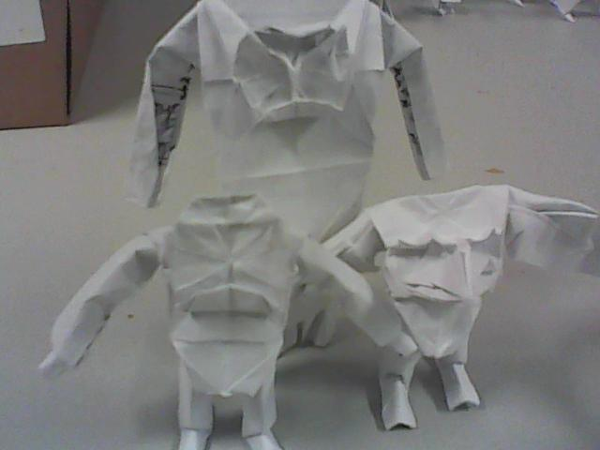
The three trolls that Dylan encounters
http://orig13.deviantart.net/e7cf/f/2013/143/5/5/origami_troll_people_4_by_williamclinch-d66b25f.jpg

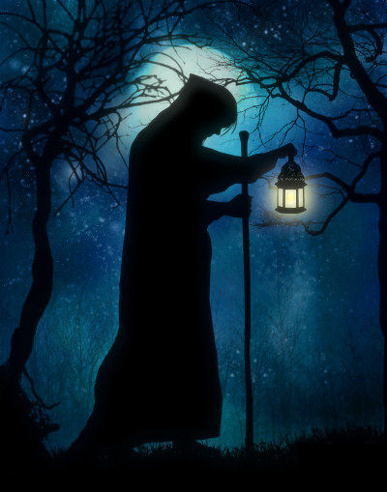
The Hermit
https://lonerwolf.com/wp-content/uploads/2013/06/diogenes-biography-outcast.png

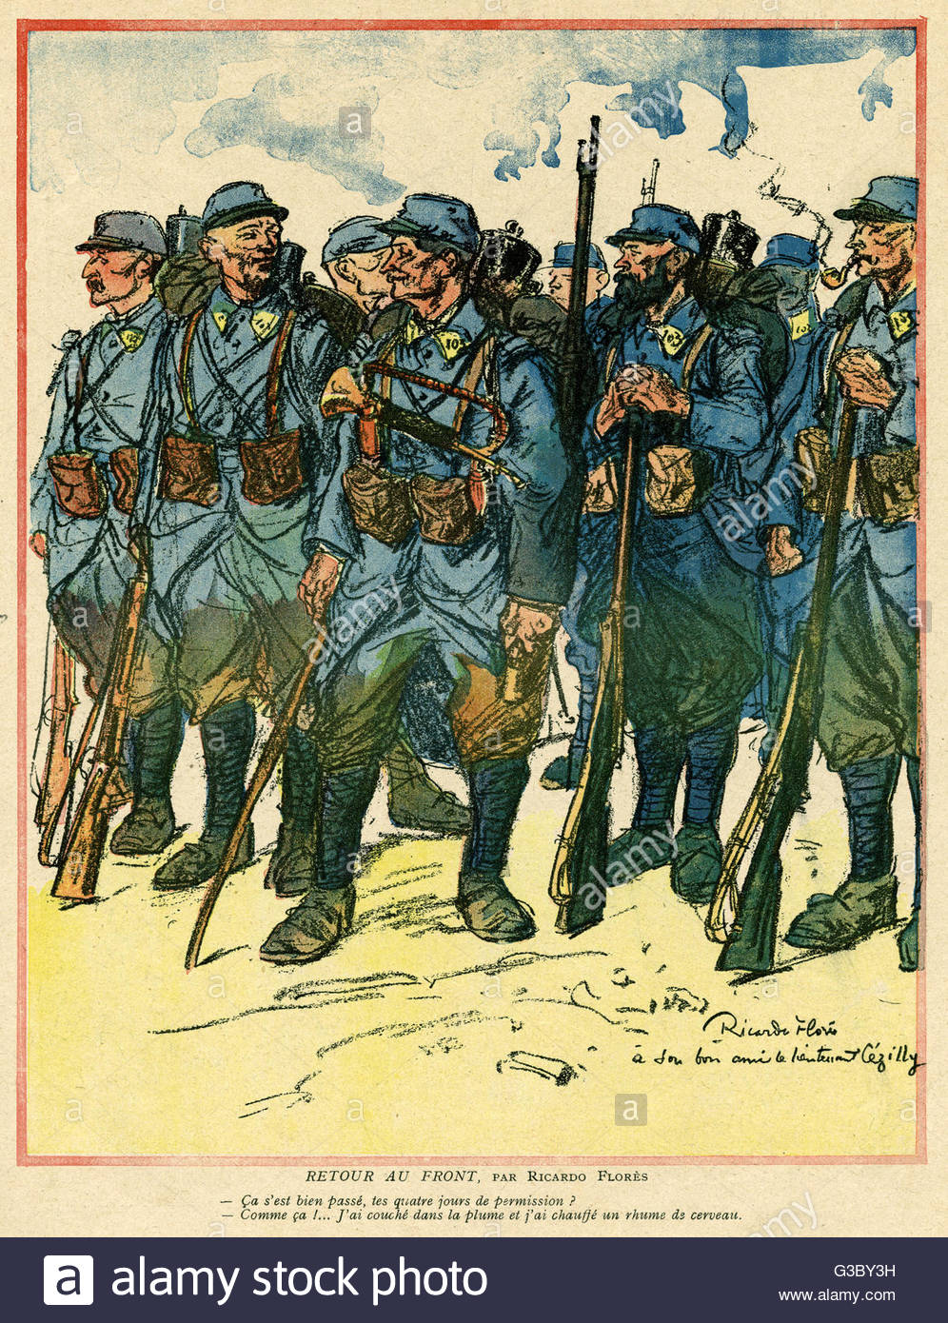
French Soldiers
https://goo.gl/images/QmJKUU

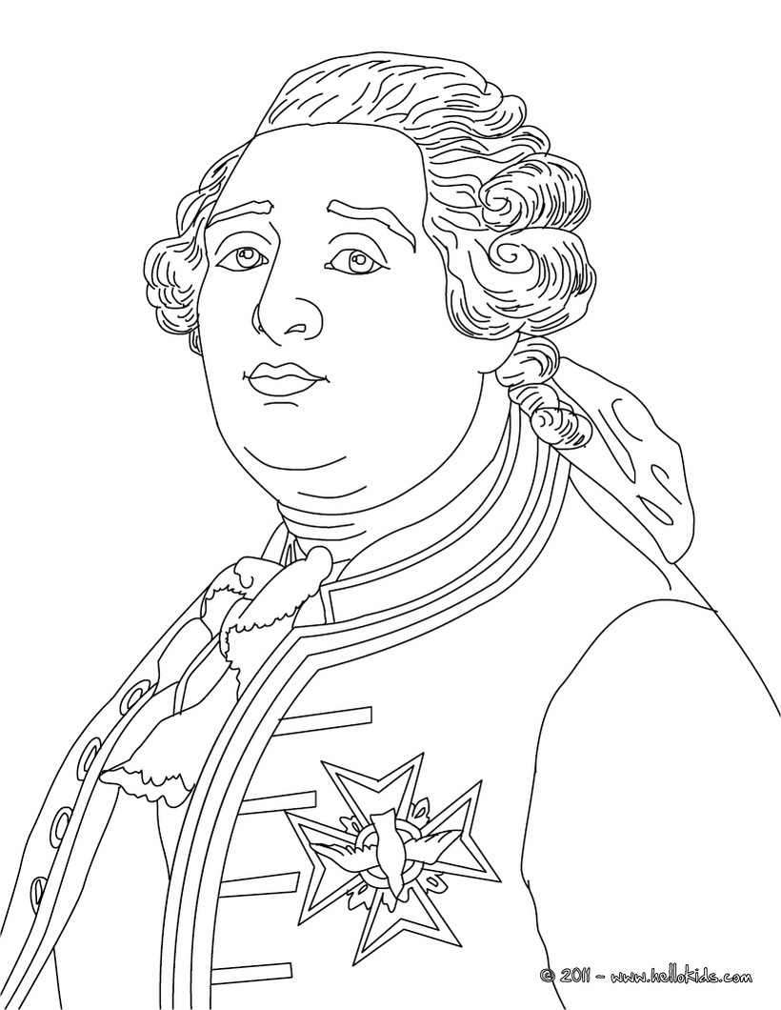The King or Dylan’s Father https://goo.gl/images/Zs2eb8

