Game Design Document
Don’t Open The Box
Arif Sahiti, Kounthida Phansourivong, Louis Cai, Saheba Lokhandwala, Elizabeth Zhagui
New York City College of Technology

Analysis

Video Game Narrative
Brave police officer Jack Sack uncovers a legend of a silver box, that has been circulating through New York. A legend has been told that whoever opens the box will be cursed and have 30 days to live. Jack ignores the myth and proceeds with opening the box. Inside the box he finds a key, when he goes to grab the key a collage of images flash into his mind: Jack walking down the street and getting shot; an old newspaper headline about a drunk driving accident with Jack dying; an abandoned house that nobody has entered for years. Jack ignores the visions and puts away the key. Since Jack was done with his day he decides to head home. He gets home and takes a quick nap, then suddenly wakes up to a noise but can’t manage to move his body, from a distance he sees a little girl who face is covered with her long silky hair. She approaches him and says “7 days” and disappears.
When Jack is finally able to move, he gets up, takes the box and goes straight to Michelle. Michelle is a private detective as well as Jack’s ex-girlfriend.
When Jack reaches Michelle, he starts to explain what had happened without caring if she thought he was going crazy. As this is happening the key that Jack had found was with him, but he forgets to show the key to Michelle and just gave her the box. Michelle decides to examine the box and as she opens the box she also find a key, but hers was small and white. When she touches the key, she goes through the same flashes Jake did. when Jake sees Michelle’s reaction they both realize that she is also now part of the curse.
As they both realize that there is nothing else to do than to compare their visions, they realize that they both has a vision of A mansion. The mansion Jack had once rented out for their anniversary.
Michelle put up a straight face to show Jack that none of this was affecting her so she volunteers to drive up to the mansion. Because Jack feels guilty he doesn’t protest and lets her drive up. On their way to the mansion Michelle is distracted and almost passes a red light, when she finally stops she sees two tall guys wearing all black. They were hard to miss, as she pays attention to them she notices the light turns green, but she can’t manage to move her leg to press the gas. She starts to panic and at that time she sees the tall guys put up a poster that said “7 days” and disappear. As they disappear she is finally able to move and keeps driving up the mountain without knowing what to expect.
As they drive up to the Mansion they notice that the door suddenly opens…
They both looked at each other wondering if to go in or not. Since Michelle is a detective she is the first to walk towards the house. Once inside another door opens. Each door leads to different situations. Inside they get have the option to work together as a team or go their separate ways to solve hidden puzzles, riddles, and get tricked by evil twins. The options conclude to the survival of both of them, only one of them, or Jack ending up with Michelle’s evil twin.

Target Audience

The game “The BOX” is a mixture of a lot of different genre’s but the main 2 being science-fiction and horror. Ideally it would be a game meant for teenagers and adults rather than children because of the gory qualities of this game. The story takes place in a future tense New York City which off the bat would appeal to city lovers. Our general target audience is everyone, because there is a little bit of everything involved in the story line. Things like Romance, action, mystery, and thriller comes into play to appeal to all base lines.

Delivery Platform
The idea is to have everyone onto this game, generally in this day and age the best way to reach that is through phone apps as well as a game console like Playstation 4 and xbox. The game as an app would beneficially work well because it would be an interactive game. The players would be asked questions and given options as to what route they would like to follow and every different move they make would have a different end result, could be good or could be bad.

Review of Competing Games
Life Is Strange developed by Dontnod Entertainment. Published on January 2015. Created using Unreal Engine 3.
Life is Strange is similar to our group’s game because we follow the butterfly effect storytelling genre. Every choice counts when going through the game and that is the basis of comparison in the game. Our game can be better because storytelling is portrayed through the voice. Giving scenes that are imaginative allow the readers to understand how the setting and plot can take place during our game’s development.

Until Dawn developed by SuperMassive games. Published on August 25, 2015. Created using Decima.
Until Dawn is similar to the game we are trying to create because it has suspense, thriller and horror combined. Another thing to be noted is that it has the butterfly effect interactive gaming type of genre too. Our game can be better because plot can be developed into something even better. There is always room for improvement.

Resident Evil 7 developed by Capcom. Published on January 2017 Created using RE engine.
Resident Evil 7 is also similar to our game because in terms of plot and survival horror genre is what we planned to seek on. Suspense, thriller and horror combined is what we seek for in a game like this one. Our game can be better because survival horror genre is huge, and anything can happen during development.

Design

Player Characteristics

Players should know a couple of things before getting ready to play the game. First, players must understand that Jack and Michelle used to be lovers and that they do not see eye to eye on a lot of things. Second, they must know that both are involved with the curse. Basically, you open the box and you are destined to die unless you know what the key inside the box unlocks. Jack is cocky and naïve while Michelle is wiser and more emotional.

Game Mechanics
Since the game is going to be a horror VR gaming, players are set to go into a manor to solve the curse that was put upon them because they open a curse box. In this horror game the storyline will leads you to different plots that will decide the fate of the players with multiple endings such as:
- Walking through the manor like a maze.
- Solving different types of puzzle with different levels of difficulty that may result to the end of their lives.
- Interacting and encounters with different spirits/monsters who may be evil or good.
- Fighting evil curse that may or may not overtake their bodies.
- Decide whether you want to save others or not.
- Betraying or falling in love with players.
- And more...
Players may interact with the environment through their VR set by controlling the movements of the characters as if they were the character in real life since they will be walking through the storyline, collecting and saving items that may help them in the future, etc…

Method on Playing the game on Python
How to play the game on python? It is very simple, all you have to do is to choose the different option that is given throughout the game. Each other you choose will leads you to a different paths. There are also riddles for you to solve in the game, will you be able to answer the riddle on your own or not, let’s find out….

Method on Playing the game on VR Game
Experience the horror game through a VR where you will be able to interact with the characters and the curse ghost in the game, travel around the manor going into different room solving puzzles/riddles and more.

Challenge

The game will be like Until Dawn where you cannot restart at a starting point. You must play until the end and restart if you want to take a different pathing in the game. There are many endings which you will have to find out by playing until the end. It is engaging because the game is a story where the player has to make their decisions to guide the players through the scenes. Similar to Until Dawn and Resident Evil 7, we possibly can make it focus not only on the main protagonist but also the second protagonist through a shift in story telling where they are guiding us through a different view of the environment.

Project Description
Walkthrough

Don’t Open the Box
Winning as a couple.
You’ll start off with the investigation, continue with the legend, dream, meet up with Michelle, travel to the Manor, and accept to enter the Manor. From there you will choose to walk in the Manor together. You’ll solve the puzzle together, which will ask you to find the hidden letter. Which will lead you to a hidden room to solve a riddle. The answer to the riddle is shadow, once typed in a clock will appear showing you how long you have before the manor collapses. The shadow will provide Michelle with the opportunity to betray your Jack, choose to reject the request and both of you will get out the Manor before time runs out.
You have survived as a couple.
Self-Victory
You’ll start off with the investigation, continue with the legend, dream, meet up with Michelle, travel to the Manor, and accept to enter the Manor. From there you will choose to walk in the Manor together. You’ll solve the puzzle together, which will ask you to find the hidden letter. Than lead you to a hidden room to solve multiple puzzles. Once the puzzles have been solved a clock will appear showing you how long you have before the manor collapses. You’ll be given the opportunity to betray your Michelle, you’ll will accept the betray and get out in time to self yourself.

You’ll start off with the investigation, continue with the legend, dream, meet up with Michelle, travel to the Manor, and accept to enter the Manor. From there you will choose to walk in the Manor together. You’ll solve the puzzle together, miss the letter, but manage to find a way to reach to the other room. Where it asks you to solve the riddle type in shadow. From their it leads you to the clock with the time you must get of the Manor. the shadow gives you the decision to betray Jack, accept to betray Jack. The shadow than flies you to safety.

You’ll start off with the investigation, continue with the legend, dream, meet up with Michelle, travel to the Manor, and accept to enter the Manor. From there you will choose to walk in the Manor together. You’ll solve the puzzle together, which will ask you to find the hidden letter. Once you find the hidden letter you’ll be able to reserve the curse. Which will lead you to the hidden passage, figure the origin of the curse. Find the ghost, solve his curse, end the game and survive alone.

Walking in separate
You’ll start off with the investigation, continue with the legend, dream, meet up with Michelle, travel to the Manor, and accept to enter the Manor. From there you will choose to walk in separate. Jack will be presented with a problem and once its solved he’ll be lead to a room where he will find the note. The note reunites him with Michelle. Walk together to the basement where they finally get to see the curse through the mirror and reverse the curse.

Evil twist of events… romantic ending
Start off with the investigation, accept to open the box, be done with the day and go back home. Dream with the girl, wake up and seek for Michelle, accept Michelle to dive to the mansion. Enter the manor, accept to find the room, where you’ll find Michelle’s evil twin. Accept to help the evil twin. Accept to fall in love with her, which will lead you to safely leave the mansion. Original Michelle gets trap inside.

Visual Map of the Game

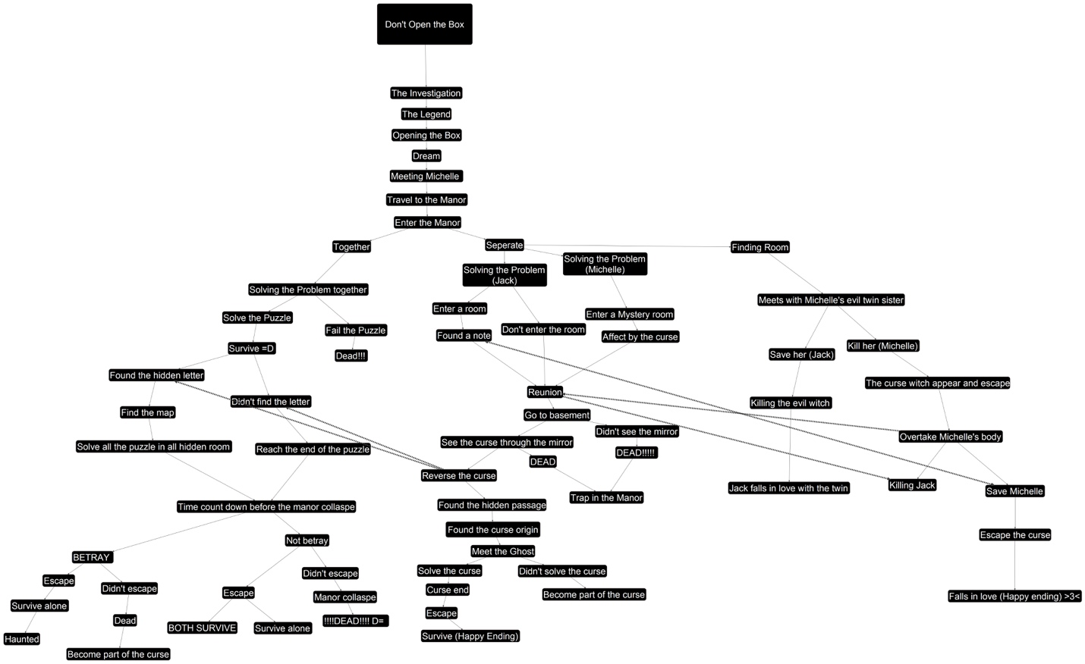

Conceptual Art
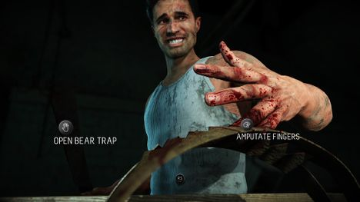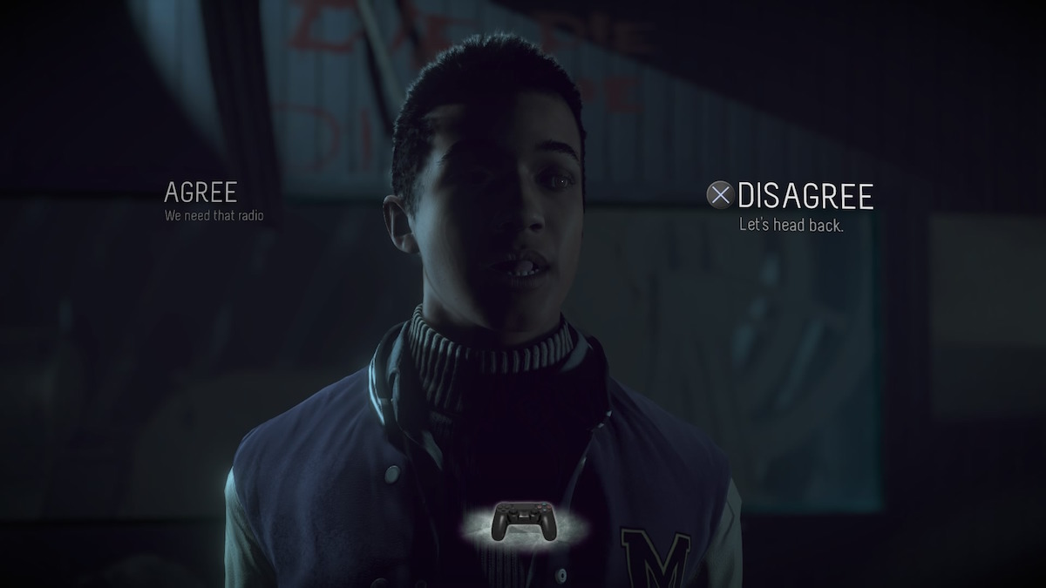
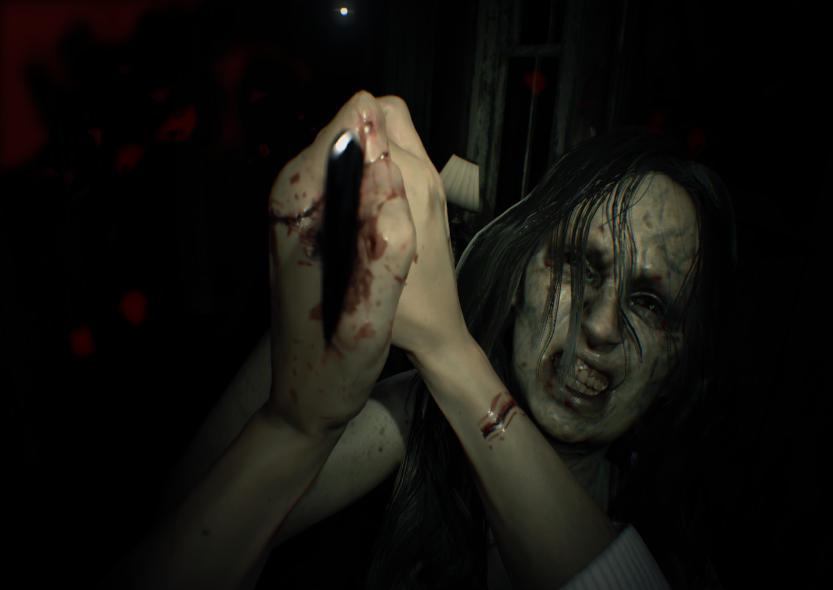
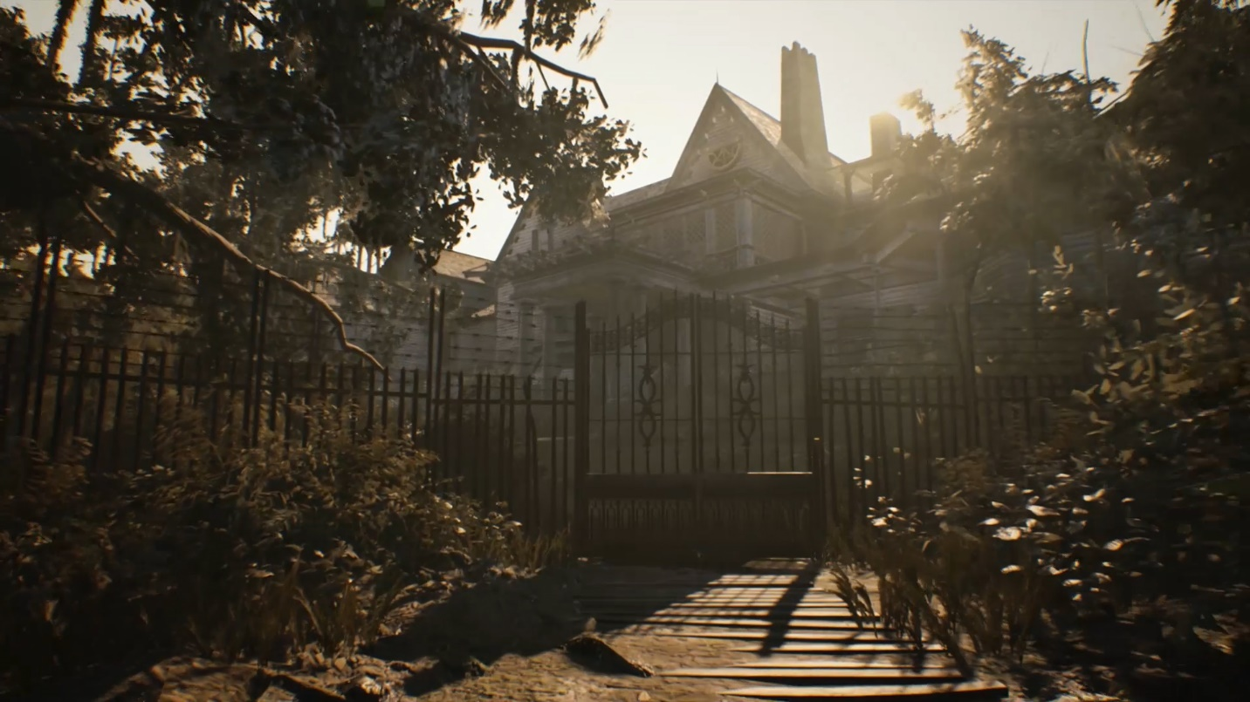

Until Dawn
Life is Strange
Resident Evil 7

