Game Design Document (Due December 15th)
ReSurface
Alenso Labady, Cesivel Sandoval, Rachel Alexander, Rafaela Malavé, Shaquanna Thompson
New York City College of Technology
Analysis
Video Game Narrative
Future New York, year 2220. 50 years ago, the sun released a solar wave that broke the last remnants of the ozone layer. Thank goodness scientists were aware of the impending doom and cities around the world were able to create a solar protectant, a metallic sky to encase the cities in oxygen and solar regulated dome-like systems, before the solar flare killed all life. Unfortunately, the extent of the Metallic Sky was only large enough to encase Manhattan Island. We now live Under, in a city nickname Metal-atten. (Manhattan, get it?) The world we know and grew up with is a layer of metal sky, protecting us by the sun and storing solar energy to run the city. There is projection technology that imitates night and day, towns outside of Metal-attan are usually inhabited by bandits, smugglers, and crazies, and located in the larger subway stations. The subway tunnels are called Subterranean. Apartments are small and minimalistic, with a flow of technology that lives in the hub (truly Google headquarters). Food is vitamin-like at the most, flavorless—protein bars, nutrition drinks, chemically made stuff. Meat is rare, but vegetables still grow in Central Park, now called Greenhouse One. The people are weaker than normal, but gyms are available but highly regulated to prevent excessive muscularity (resource regulation). Those who can survive above ground are contaminated and have a layer of plastic-like skin over their features, small inset eyes like a mole, and robust because they have true food. Plants can still survive but have evolved into predators of their own, and, without government breathing down their backs, cannibalism isn’t frowned upon Above.
You and your classmate, Sabel Hunter, have finally graduated from Police Academy and are ready to begin your career as Enforcement Officers. It is your first day out of the Academy, and you have finally woke up and turned on the TeleComm. The news pops up, showing the front of City Hall. RoboMrG is reporting the news, telling us about the recent developments of MetalHeads, a gang that is gaining strength fairly quickly. After watching that clip, you change the channel and veg out. You glance at the clock, amazed to find that it is already 8:15. Oh no! Sabel will be here in 10 minutes! You rush to the closet and grab the first outfit that appeals to you. [This is where the player gets to pick an outfit. The outfit may affect their status at work, on the street, and interacting with store owners.] Running downstairs with your laces flying, you skid to a halt in front of Sabel’s PuttPutt. Her aviator glasses are firmly pressed against her face and she is tapping information on her DataComm. “Hey [YOU]. What took you so long? We’re supposed to be at base first thing.” As you slide into the car, she turns to you and says “Had breakfast yet?” [This is where you decide if this worth the detour to get breakfast. Your decision may affect how the bosses treat you later].
Later that morning, the two of you are standing in the office awaiting orders. Based on whether you went to get breakfast or not, the director, Frank Bryant, make it to the 34th Street Precinct to pick up the company car, Matador 54, to drive around to check out the city. This year, the crime rate is high. People have to seek shelter from governments & rats. Cops have to be on alert and on call 24 hrs a day. As you are driving, [This is where you pick your starting route: 34th street, or 42nd Street]
If 34th Street-
You come across a commotion in a store. Approximately eight people are yelling at each other, a combination of owner, employees and customers, mainly high school kids, who are trying throw cans at the store. The public is trying to hold them off and someone has a VidTech recorder! We have to step in to stop the commotion. The kids are running away. What You couldn’t believe-- they are in ninja turtle suits and running away with pizza!!!! [This where you decide if you will a) file a report with the owner, b) safely remain in the vehicle, or c) pursue the vagrants. This will affect your business status and may affect your journey later.]
  - You rush to the business owners side, “Sir, are you alright?” You grab the person’s shoulder to assess any physical damage, seeing a bright red stain near the leg. “I’m a woman,” she says. “Oh shit, sorry! Anyway, are you okay?!? They threw garbage at you and you’re bleeding.” She glares at you and says “that’s tomato sauce. They just stole eight pizzas and you’re sitting here like a chump. Aren’t you supposed to apprehend those fuckers?! What’s your badge number, child?” “Ma’am, I do apologize, but I thought you were injured and as a civil citizen, I thought I should check your status first before running off after possibly armed hooligans.” Standing up, you radio in the need for a drone to survey the surrounding buildings in hopes of finding the hooligans.
    - While the report is being filed, the hooligan get away and the department is forced to pay for damages to the window, loss of wages, and a new outfit for the woman. However, you have followed protocol and therefore suffer no bad=mouthing from Commissioner Bryant. In fact, he commends your following the orders and asks to meet you in the office tomorrow morning. (Go to “The Next Morning”)

  - “Matador 54 to base, we have a situation” You say, clicking the doors firmly locked and glancing nervously at Sabel. She nods encouragingly and fumbles for her laser, hands slightly shaking but placed at ten and two as taught.
    - It feels like forever until backup arrives, but it’s truly on 2 minutes. They find yu and Sebel hyperventilating the the locked car,

  - You run after the goons, yelling at Sabel to help the crowd while you teach these fools a lesson.

If 42nd Street-
You and Sabel head to the main two food sources of Metal-atten—M&M Store and Hershey World. You hear a noise from M&M World so You and Sabel rush up the 80 miles per hour escalator. “False alarm” says Sabel, “Let's head back to the Matador”. You say “Olé mutherfucker.” You and Sabel then get a zap from your ToneBox. They have reported sighting horticulturist Brittney Goulash being harassed by the MetalHeads inside the Hershey World. As you both look out the window, these bandits have blocked the entrance and You see Brittney Goulash through the window of Hershey World. Saving Brittney is the first step in Your next adventure. [This is where your choices affect how easy or difficult it will be to convince the director to have you take point on this mission]
- Find secret tunnel in M&M World that leads to Hershey World (Which direction to go? Left or Right)
  - Left- The tunnel slopes down and the evens out to the basement section, storing the plushy giant M&M’s. “It’s like a graveyard” whispers Sabel, trying to squeeze through two
- Throw M&M’s at the Creatures (Boost the Creatures energy. RUN! There has to be a way out)
- Hotwire the car in the store and crash through the window of Hershey World (Oh NO! It’s a toy Hover Hybrid PuttPutt 1X3)

The Next Morning
After returning to base, Brittney speaks with Commissioner Frank Bryant, a surly aged man. “These recruits are invaluable. If they had not been available, I would probably not be here. Commissioner Bryant, please consider them for Mission ReSurface.” Bryant glares menacingly at the two of you, and asks, “What do you think about going Above?”
- “Isn’t that where the Moles live? How can we survive that?!”
i) “And?!” Yells Bryant, shoving his chair back so hard, it knocks into the wall behind him. “We need to find a solution to the problem we are faced with. 50 years ago, we were able to live Above. The plants can survive, and there are species that can survive. What do you expect, to stay in your little hidey-hole forever? You are a disgrace to the force if you want to hide instead of fight!” “You stammer and look down. “I just… I heard they eat flesh.” Sabel jabs you in the rib, “It’s fine. We’re ready. We’ve been training for this since day one, bro. I got you. Let’s get some weapons.” Bryant smiles appreciatively at Sabel and hands a vidcam to Brittney, “Make sure you get some pictures. I need to see all your progress.”
b) “Sounds like the mission I’ve been waiting for!” You bounce on the toes of your boots and grin manically. Sabel rolls her eyes but she looks just as excited.
i) “Excellent! To the weapons room with you then. Make sure you grab a ventilator and enough ammo for a month. We cannot be sure how long this mission will take, but you’ll need to get back.” Bryant taps his pen against the table. “It’s been 50 years since I have seen sunlight directly. Please take a picture for me. Here is my vidcam. Any pictures you take will be directly linked to my account.”
c) “Umm…. I think I need more training first, Mr. Bryant”
i) “Are you serious?! What do you think you’ve BEEN training for, Recruit? Get your ass to the weapons room before I dismiss you for a month.” Frank Bryant throws his pen at you, which you catch, and angrily swivels his chair around. As the three of you reach the door, he says “Brittney, make sure you get some pictures.” And tosses a vidtech at her.
(How does this change the reputation)

In the Weapons room
“Okay,” says Sabel, grabbing her favorite laser, Multi-Zoner 1543. “Three guns each, a couple knives, do you think we need grenades? I’m gonna take a few anyway.” She starts filling her pockets and belt loops, muttering away while you walk the rows and rows of guns. You decide to:
- Take the same things Sabel has chosen
  - Three guns (Multi-zoner 1543, Handheld 3, and Rapid Fire) 3 strings of ammo each,
- Take one gun and a lot of ammo.

Based on intensive research and development, Brittney believes that in the Bronx Botanical Garden lies the solution that can improve the lives of everyone. Above lies mutated wild animals and poisonous plants that resulted from intensive amounts of radiation. A mutated honey badger, one of the most dangerous creatures above ground with metallic armor like skin, is tracking You, Sable and Brittney. You notice the badger has zeroed in on You and You decide if you should run or fight the honey badger. You shoot the badger. The badger has metallic like armor and bullets will deflect off its body. The badger becomes enraged and runs after you with razor like claws. The only way to kill the badger is to throw sulfuric acid. You run to a small lake that contains the acid and lure the badger close to you. As the badger leaps forward with its claws, at the nick of time you duck and roll out of the way as the badger splashes into the lake of acid. Brittney rushes towards you to make sure you are alright. The dying badger leaps out of the acid and comes at you with its final and crushing death blow. Brittney pushes you out of the way and gets slashed across her mid-section. The badger dies, but in its claws were hints of acid.

3A) Best Ending -- Finding a home with food.
You Sabel and Brittney, are driving to the Bronx Botanical Garden in the Putt Putt to drive away from all the Creatures. Brittney, with her window open, smells something strange in the air. She starts looking around thinking that it might be something wrong. What should Brittney do?
- She brings it up to Sabel and YOU or
- She leaves it alone (this leads to her death in 3B)
(If Option A, Brittney yells out “OMG LOOK OVER THERE!” You say “What could that possibly be” Sabel turns her head and sees a peach tree growing in the strangest part of town. She then rushes to the tree, running down all the creatures that are ahead. Once reaching the peach tree, You Sabel and Brittney get out of the car and walked to it. What should you do?
- Pick a peach from the tree and eat it (Gives them nutrition after starving) Side effects-- radiation?
- Walk through the trees (Pathway to the Greenhouse, which is the home)
- Get back in the Putt Putt (this leads to her death in 3B)

3B) Worst Ending -- Brittney Dies
A mutated honey badger one of the most dangerous creatures above ground with metallic armor like skin is tracking you, Sabel and Brittney. You notice the badger is on to you and you decide if you should run or fight the honey badger.
A) - Shoot the badger
The badger has metallic like armor and bullets will deflect off it’s body. The badger becomes enraged and runs after you with razor like claws. The only way to kill the badger is to throw sulfuric acid. You run to a small lake that contains the acid and lure the badger close to you. As the the badger leaps forward with its claws, at the nick of time you duck and roll out of the way as the badger splashes into the lake of acid. Brittney rushes towards you to make sure you are alright. The dying badger leaps out of the acid and comes at you with its final and crushing death blow. Brittney pushes you out of the way and gets slashed across her mid-section. The badger dies, but in its claws were hints of acid.
B) - Run away from the badger
You, Brittney, and Sable start running from the mutated badger. You are able to flee from it but Brittney collapses. As you approach, Sabel notices there is a cut on the left side of Brittney’s arm, and inside the wound is a thorn from a poisonous rose. The poison does have an antidote with a main ingredient plant that lies in the botanical garden, but the poison spreads quickly and you won’t make it in time to save her. Brittney breathes her last breath and apologizes to you and Sabel.

3C) Weird Ending-- It was all a dream. Waking up to your significant other Frank
After tossing and turning all night, YOU smell something strange in the air that seems to be a familiar smell. YOU wonder what could that be, but then YOU start to feel someone tapping YOU continuously on YOUR shoulders. Then suddenly…….. “Honey, Honey wake up it's time to get dress for your big day.” YO open YOUR eyes and suddenly YOU see It's 8am. It's the morning of Law Academy Graduation. It was all just a dream. Whipping the sweat off YOUR forehead YOU begin to get ready for the big day. Once YOU and your significant other Frank arrive to the Graduation suddenly there’s these BIG creatures taken over the ceremony. They have destroyed the school and the p

Target Audience
Our target audience are mobile users looking for a post-apocalyptic text-based adventure game. Many people worry about how the world will end, and this is just one example.

Delivery Platform
Resurface will be available on iOS, Android (Google play), Steam, Microsoft Windows, macOS, and Linux. Being a text based adventure game, it is only natural for it to played on a keyboard and mouse.

Review of Competing Games
Look up at least three existing games that are similar to your group’s game. What do these games do that is similar to your group’s game? Why is your group’s game better? Be sure to include the name of the company, publication year, and software.
Zombie Exodus- Hosted Games, 2011, Steam
- Both Zombie Exodus and Resurface are text based post-apocalyptic games that allow you to choose your own path. They both allow the player to customize their character.
- The difference is in the story and the enemies. Instead of zombies Resurfaces enemies are mutated creatures and other humans.
- Resurface is post-apocalyptic but does have comic relief, and it is better than Zombie Exodus for its immersion and sense of humor in parts of the story.
Heart of the House - Choice of Games, 2017, Steam
- Heart of the House and Resurface are both text based adventure games with character customization. Both stories have an element of searching for an important individual.
Subsurface Circular - Bithell Games, 2017, Steam, Windows, macOS

Design
Player Characteristics

It is a computer game. The player should know that is game is solely based on keyboard and mouse. It is a text- based adventure puzzle game.
Game Mechanics

The player should think himself/ herself as the character in the game and should decide if they were placed in a similar situation and the options are given, what would they decide to do. They should definitely interact with the game’s environment.

Challenge
The goal to win is to find habitable life outside of Metal-attan.
Multiple ending locations-- Bronx Botanical Garden.-- Best- Find a safe place (best ending) Long Island. (good alternative) Brittney dies. (Bad ending)
Project Description
Walkthrough
The goal for the player is to find a habitable location within the city. The choices the player makes about what kind of person they are will affect how quickly they will be assigned to this task, how much help they will receive from their comrades, and whether the mission is a success or failure. If the player decides to be a rebellious, unruly agent, their partner may leave them in an unknown location and they cannot finish the game properly. If they are too much of a straight-edge, they may not get to the destination that will lead to success because they are playing it too safe. If they are a leader, they may have a successful trip as long as they lead their comrades in the right direction, however, they may have to sacrifice certain players as well. Based on the actions taken before the main mission, the player will gain experience, reputation, and possible items that will aid them on the mission later on (but these items may be able to be found later). During the mission, the player may chose to fight, flee or sneak past enemies, and these actions may affect the comrades, the reputation, and the length of the mission.
Visual Map of the Game

Conceptual Art
Metal-attan

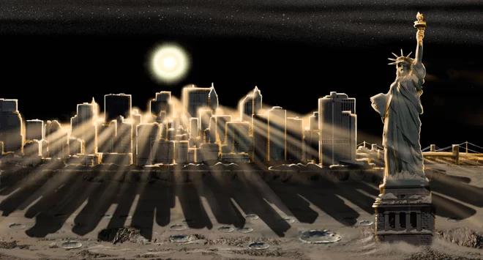

The creatures Above
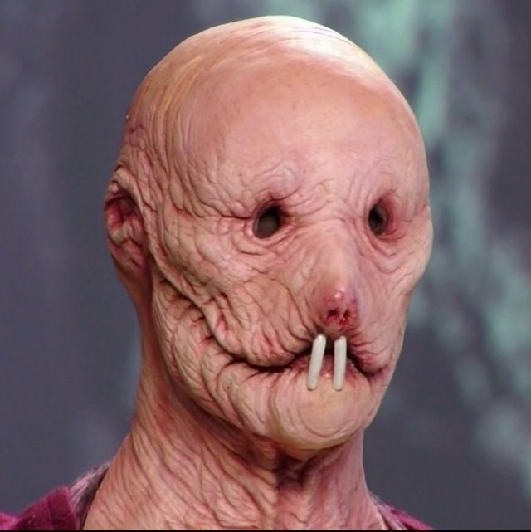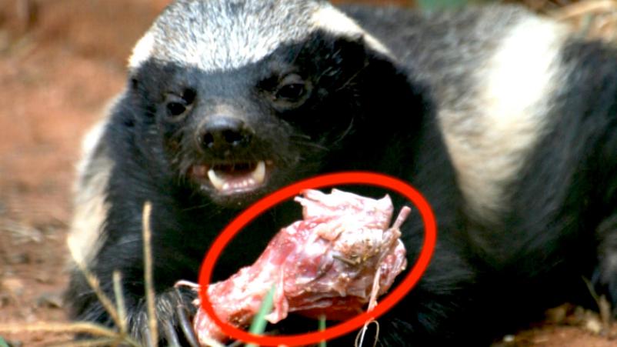

The outfits they may wear
