Veronika Lisetska
Analysis
Video Game Narrative

Dylan wakes up in the orphanage on a typical day. He goes about waking the rest of the kids up. Then he heads to the kitchen and makes omelets. After breakfast he takes the kids out for grocery shopping. After going out for walks Dylan sees children with their family and is eager to find out who he really is. He becomes upset and goes back home without buying groceries. He arrives back at orphanage and runs to the window near the kitchen and starts crying. The caretaker heard crying noises and goes to take care of Dylan. He explains his problem to the caretaker. She told him that he was special and if he really wanted to know the answer to his question then he has to go find the hermit that lives in a cave. Satisfied by this answer he begins making preparation for the journey to the hermit and goes to sleep early. In the middle of the night though a major storm hits the town and destroys the orphanage.
Dylan wakes up with the sun beaming down on him and looks around to see that the orphanage was destroyed. He helps the other kids get out of the disaster safely. He gathers what he can from his preparations and starts is journey. He heads into the forest behind the orphanage and immediately feels someone following him. He looks around and is immediately attacked by a small troll. Dylan uses his paper supply to defeat the small troll, and gathers the trolls paper remains. As soon as he finishes he is immediately attacked by another one. This time it is a medium troll, but he is caught off guard and decided to run instead. While running he encounters a bigger troll. He runs faster towards the mountains. He sees an elderly figure and yells for help. The elderly figure guides Dylan to his house. Dylan interrogates the old man and the old man reveals himself as the hermit. The hermits send Dylan to go see the king in his palace in Paris, France.
Dylan makes his way to Paris and finds the entire city in battle. Determined to find his father he heads into town and encounters a few French army soldiers and they attacked him. Dylan decides to fight them and kills all of them. He picks up the paper from the soldiers remains. He goes further into the city and encounters king’s guards. Dylan explains to the guard that he wants to meet the king. The guards not believing him attacks him. Dylan subdue the guards and heads into the palace. He encounters the king sitting in his throne and reveals who he is. The king and Dylan unites and France wins the revolution.

Target Audience

This game is for age group from 13+
Game has some violence and can not be played by or in front of little children’s because it can damage their mental health.

Delivery Platform

The ideal platform that our group wants the game Fold to come out is Mobile app or Xbox one. Everyone has a smart phone so it will be easy to assess the game. Xbox version can give more details and better graphics of the game.

Waley Guo

Review of Completing Game:
Three similar games to the fold are Paper Mario, Star Wars, and Bravely Second. The world of Paper Mario and the world have the world made entirely of paper. Paper Mario is a game made by Nintendo in August 11, 2000. In Star Wars and the Fold, the main character finally meets their long lost father. In Bravely Second and the Fold, the main character has to go into a forest and battles a troll with a weapon and not experience. Bravely Second is a game made by Square Enix on April 23, 2015.

Player Characteristics:
The game is a text adventure where the player types in either option 1 or option 2.

Darius Freeman
Game Mechanics
This game is based on selecting the various option available to you. That being we will have an inventory in order to keep track of the items the player is currently carrying. This menu can be accessed by typing “I” at anytime.
Challenge
In order to win the game, you have to make the right choices that keep you on the right path. This game is challenging because it is dynamic and changes along with the player’s choices. You have to pay close attention to what you're doing if you want to stay on the right path to the main ending. If not, who knows what could happen.

Amy Lin

Project Description
Walkthrough
In Act I you will find Dylan in the orphanage and he is getting ready to make breakfast for all the kids. For breakfast he has the obtains of choosing French omelets (option 1) or pancakes (option 2) with butter that will leads you to Dylan taking the kids out for grocery shopping, then he sees happy families and goes home sad. The other option is ice cream cake which will lead to the kids stealing food due to hunger. Option 1 and 2 will lead to the caretaker telling Dylan to go to the hermit to find the answer to his questions. During his journey he has three things he can bring with him. The choices are paper clothing, paper backpack, a map, and 50 sheets of paper. Having paper is very important because it is needed to help Dylan fight throughout the game.

Act II:
In Act II Dylan starts his journey by going into the forest. In the forest he encounters a river. His options are to attempt to cross or find another route. If he cross it he will get wet and dies from the cold. If he has paper clothes he will survive. If he finds another route he will be rewarded with paper. In the forest he encounters three trolls. First he is attacked by a small troll. Dylan has the choice to run, attack the troll with a weapon, distract it with food. If he runs Dylan will die, if Dylan attacks the troll with a weapon he will encounter another troll, and if he distracts the troll with food he will have a chance to run away. After dealing with the small one Dylan is attacked by a medium troll. While dealing with the medium troll Dylan has the choice of fighting it, fold a paper horse to run faster, or runs away super fast. If Dylan decides to fight it Dylan dies because it is much bigger than him. If Dylan folds a paper horse, he will be able to escape faster, but encounters a bigger troll. If he tries to fight it he will die because the troll is much bigger than Dylan. If Dylan tries to run away he will catch on fire because paper can cause fire after encountering friction. The last troll he encounters is the big old troll who is a little slower. While dealing with the big troll Dylan has the choice of creating a saw and dropping the tree on the troll or running towards the mountains and is saved by the elderly figure who is the hermit. Alternatively he can use paper to create a net to tangle the troll up or no paper is left Dylan dies. Before going into Act III the hermit tells Dylan to go to the palace where the king is.

Act III

In Act III Dylan is trying to meet the king, but encounters many obstacles on the way due to the French Revolution. He first encounters and is attacked by a pair of French soldiers. Dylan has the choice to pick up a shield to block the bolts and subdue the soldiers. If he does that then he can go deeper into the city. Or he can take the guns from the ground and shoots the soldiers which allows him to collect some papers. After dealing with the soldiers Dylan encounters more guards like the king’s guards. And once again they try to jump Dylan. This time Dylan has the choice of stabbing the king’s guards or taking the shield he used before and throws it at him to knock them out. Both ways will lead Dylan into the palace, but they lead to different types of endings. After getting passed the guards and entering the palace he reveals himself to the king with the factory bar code on his arm. The three endings that the player can end up with are the bad ending (troll, soldiers, and guards were killed), the happy ending where Dylan and the king unites and he becomes the prince (no kill is made), and the neutral ending where Dylan goes back to the orphanage (some killing was done).

Visual Map Of Game
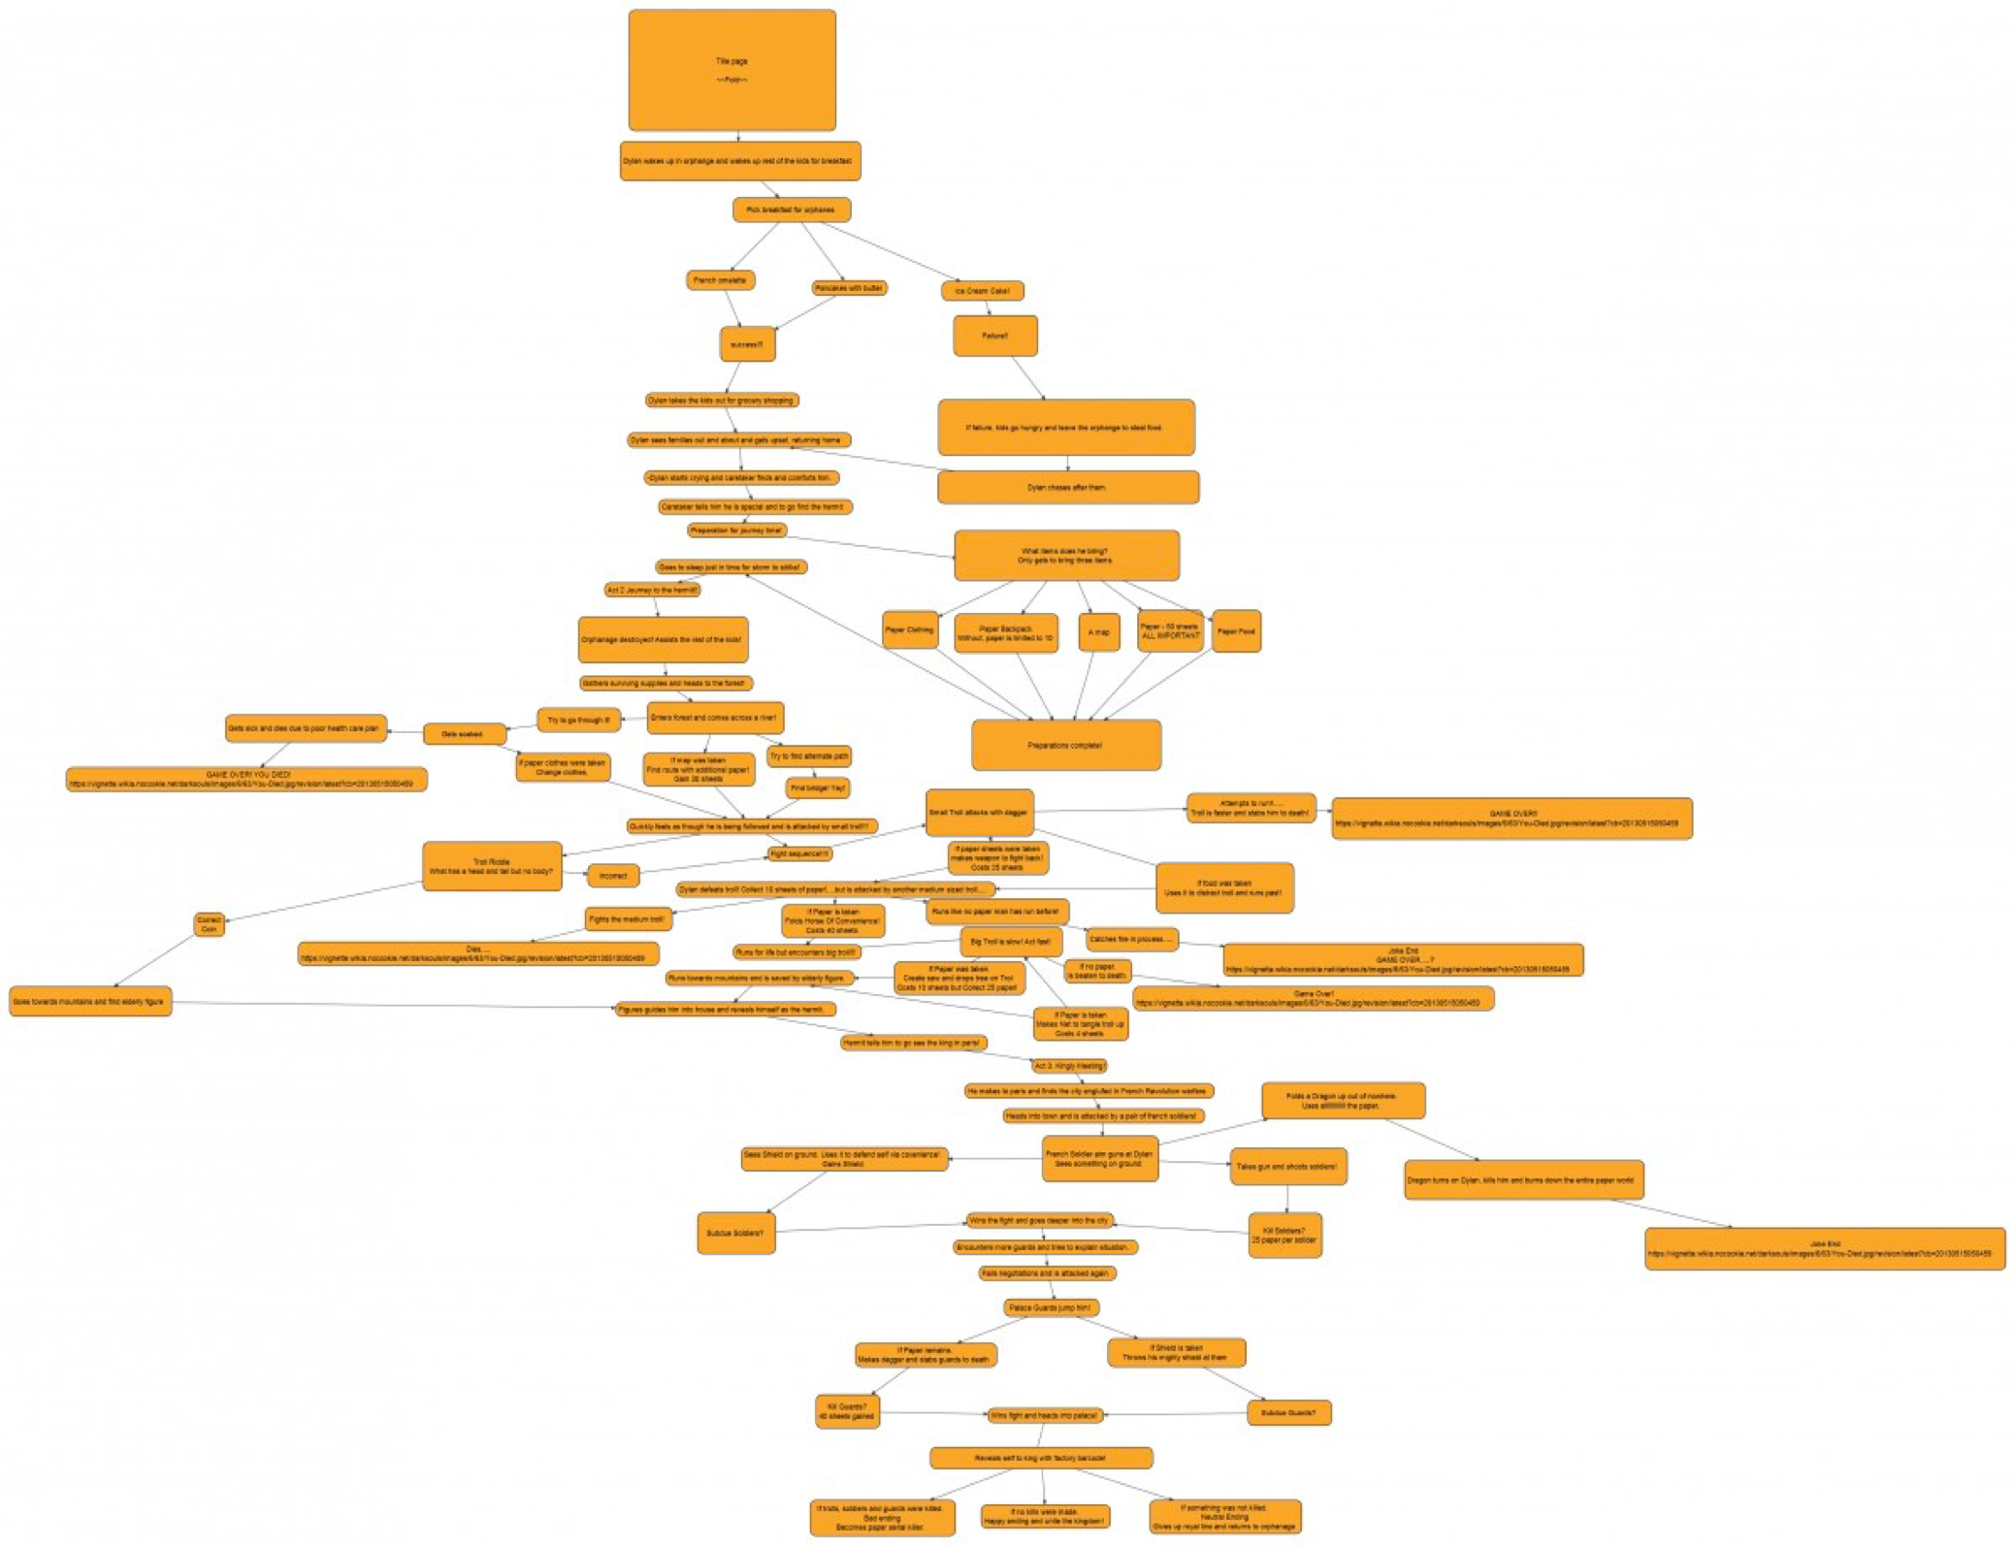

Conceptual Art
