Learning Places Fall 2016
Chin/Swift

SITE REPORT [part 1: place]
name of site report
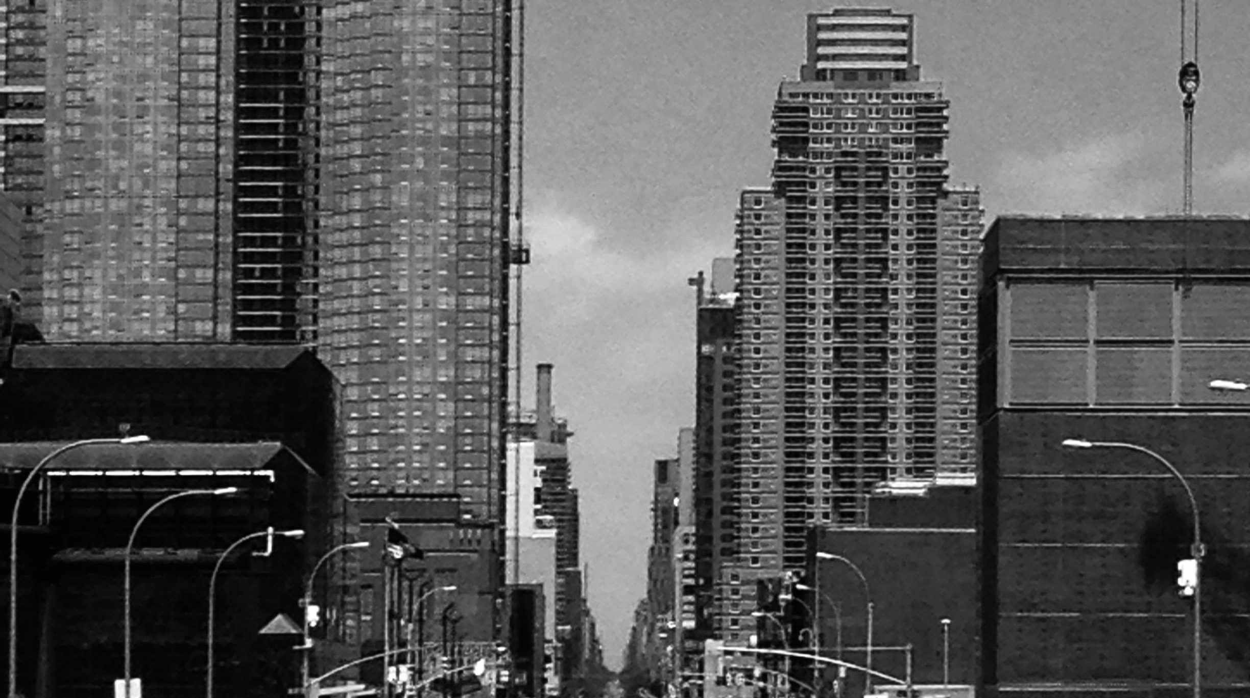

STUDENT NAME
00.00.2016

INTRODUCTION
Describe Scope of Activity Describe Scope of Activity Describe Scope of Activity Describe Scope of Activity Describe Scope of Activity Describe Scope of Activity Describe Scope of Activity Describe Scope of Activity Describe Scope of Activity Describe Scope of Activity Describe Scope of Activity Describe

PRE-VISIT REFLECTION
PRIOR to site visit, reflect on what you anticipate learning or seeing during the visit. PRIOR to site visit, reflect on what you anticipate learning or seeing during the visit. PRIOR to site visit, reflect on what you anticipate learning or seeing during the visit. PRIOR to site visit, reflect on what you anticipate learning or seeing during the visit. PRIOR to site visit, reflect on what you anticipate learning or seeing during the visit. PRIOR to site visit, reflect on what you anticipate learning or seeing during the visit.

SITE DOCUMENTATION (photos/sketches)

Write description of sketch or photo here, explaining why it is important and what it shows

Write description of sketch or photo here, explaining why it is important and what it shows Write description of sketch or photo here, explaining why it is important and what it shows Write description of sketch or photo here, explaining why it is important and what it shows Write description of sketch or photo here, explaining why it is important and what it shows Write description of sketch or photo here, explaining why it is important and what it shows

Write description of sketch or photo here, explaining why it is important and what it shows

Write description of sketch or photo here, explaining why it is important and what it shows Write description of sketch or photo here, explaining why it is important and what it shows Write description of sketch or photo here, explaining why it is important and what it shows Write description of sketch or photo here, explaining why it is important and what it shows Write description of sketch or photo here, explaining why it is important and what it shows

QUALITATIVE SITE OBSERVATIONS
- Neighborhood / Street Character
  - xx
  - xx
- Vitality of Place
  - General Description
    - xx
  - Pedestrian Activity
    - xx
  - Vehicular Traffic
    - xx
- Age of Buildings (provide evidence for prediction)
  - xx
  - xx
  - xx
- Relationship Between Buildings (urbeme)
  - xx
  - xx
- Building Details (historical/architectural styles, morphemes)
  - xx
  - xx
  - xx
- Building Uses
  - xx
  - xx
- Other Observations
  - xx
  - xx
  - xx

QUANTITATIVE DATA for Area of Study
Subject | Data
Street Names
Street Width
Pavement Type
Building Heights
Building Widths (Window Bays)
Building Types/Uses
Empty Lots / Gardens
Shops / Restaurants
Industrial Shops
Other Data
Other Data

QUESTIONS TO RESEARCH FURTHER
QUESTIONS:
- Lorem ipsum dolor sit amet?
- Consectetuer adipiscing elit?
- Sed diam nonummy nibh euismod?
RESEARCH METHOD/SOURCE FOR EACH QUESTION ABOVE:
- Question 1
  - xx
  - xx
  - xx
- Question 2
  - xx
  - xx
  - xx
- Question 3
  - xx
  - xx
  - xx

SUMMARY / POST VISIT REFLECTION
Lorem ipsum dolor sit amet, consectetuer adipiscing elit, sed diam nonummy nibh euismod tincidunt ut laoreet dolore magna aliquam erat volutpat. Ut wisi enim ad minim veniam, quis nostrud exerci tation ullamcorper suscipit lobortis nisl ut aliquip ex ea commodo consequat. Lorem ipsum dolor sit amet, consectetuer adipiscing elit, sed diam nonummy nibh euismod tincidunt ut laoreet dolore magna aliquam erat volutpat. Ut wisi enim ad minim veniam, quis nostrud exerci tation ullamcorper suscipit lobortis nisl ut aliquip ex ea commodo consequat.

