NYC College of Technology, CUNY  THE 1280, History of Physical Theatre | Prof. Christopher Swift  Classroom Assignment
Technology Treasure Hunt
40 minutes:
In assigned groups, disperse through the Atrium and Namm buildings in search of technologies that are similar in SOME WAY to one of the historical stage technologies listed below. The similarity can be in design, structure, or functionality. Do not try to find an exact replica. One functional or stylistic similarity is fine. Take a photo of the item, send it to your email and be prepared to show it to the class when you return.

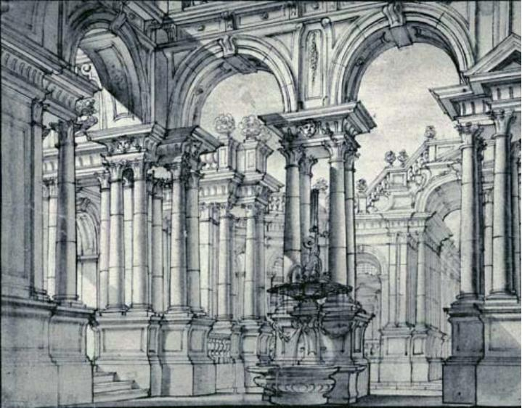
Ferdinando Bibiena, Turin setting, scena per angolo from Architettura civile (1711)

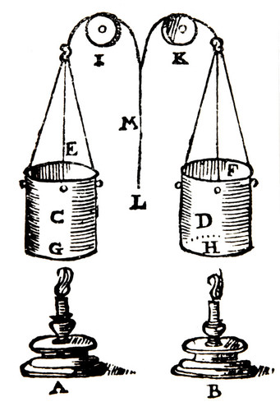
Sabbatini. Candle dimmers (dark for tragedy, light for comedy). 17th cent.

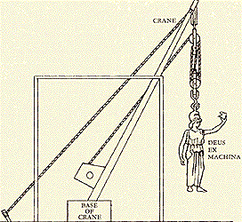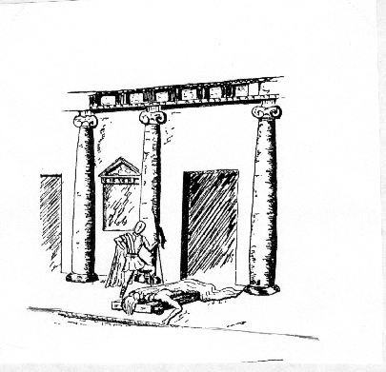
Ancient Greek. Mechane and ekkyklema.

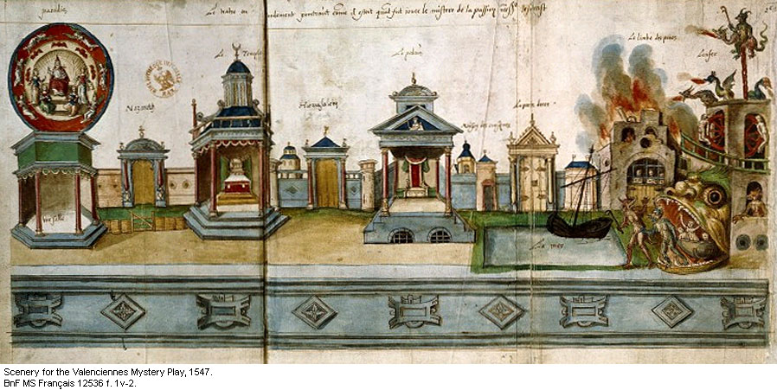
Hell mouth OR mansion. Medieval scenography.

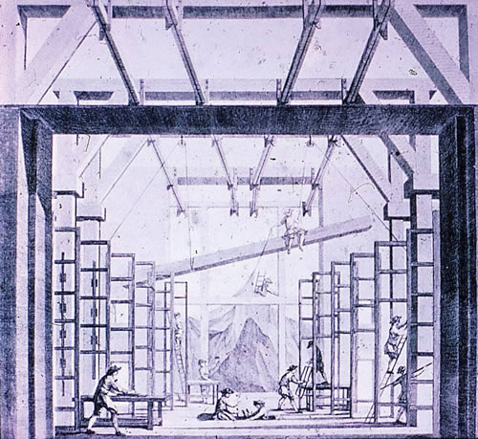
Torelli Chariot and Pole System (17th Cent). Look for Drops, Shutters, and/or Flats (all moveable)

20 minutes:
Each group displays their findings on projection screen.

