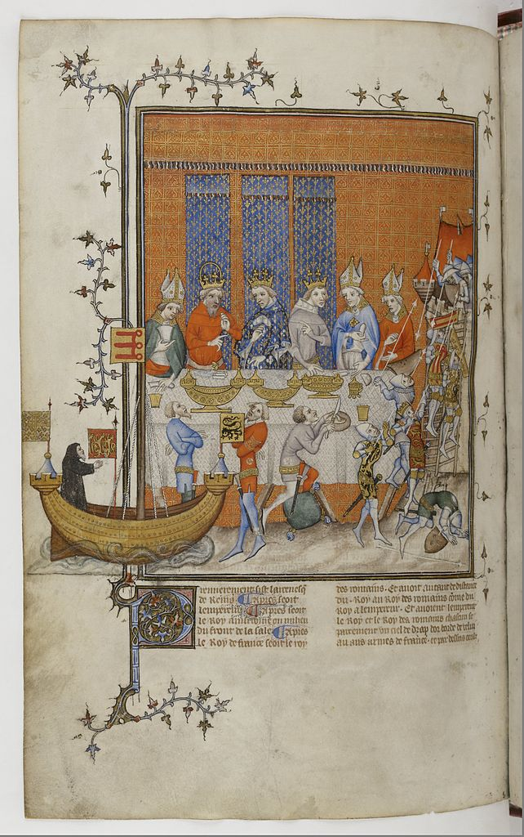
An ‘entremet’ representing the Conquest of Jerusalem performed before the King of France and the Holy Roman Emperor in Paris, 1378. MS. illumination from Chronique de Charles V, MS. Français, 2813, f.473^{v}. Bibliothèque Nationale, Paris.

Premise: This is the only piece of evidence in our possession about a performance of the Conquest of Jerusalem at the court of Charles V. The script at the bottom of the page (Gallic) tells us only the name of the play and that the King was in attendance. This page is from a chronicle (official history, written and illustrated by employees of the court) of Charles’ reign.

Research Question: Based on the information contained in the image and the contextual information provided in the premise, what can we conclude about theatre and performance at the court? What conclusions are we unable to make, based on the available evidence? Where else might we look to fill in the gaps of our understanding? Considering these questions, free write for approximately 7-10 minutes. Don’t edit yourself. At this stage of your research project there are no “bad” ideas.

