Brushing is Cool

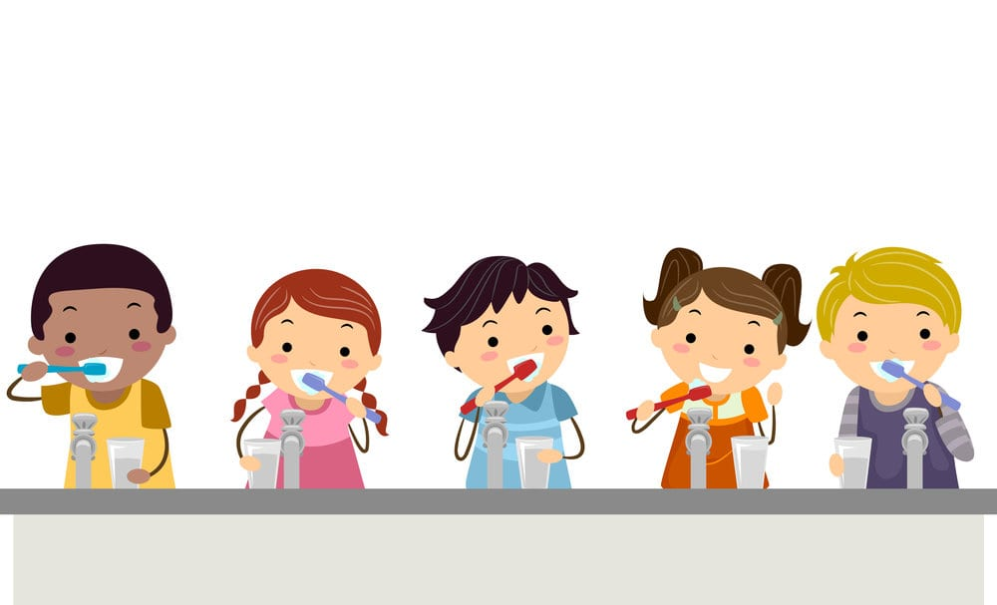

with the Right Tool!

By: Yeny Chong
Saba Haggagi
Lucidania Naranjo
Elizabeth Ramirez
Khadra Shihadeh
Candice Superville

Table of Contents Pgs

Introduction…. 3-4

Assessment…. 4-5

Planning…. 5-6

Implementation…. 6-8

Evaluation…. 8-10

Conclusion…. 10-11

References…. 12

Introduction:
Oral Healthcare can be difficult to maintain with children that have special needs. Our service learning project is based on solely children with Autism. Children with Autism need a different approach to how they learn. As Dr. O. Ivaaar Lovaas; in a biography about the zeitgeist of applied behavior analysis (ABA) in the 1960s states,“If they can't learn the way we teach, we teach the way they learn”(1). Children with Autism often have unmet complex health care needs as well as significant physical and cognitive limitations. Autistic children often come from low-income families, making them particularly at risk with high dental needs and poor access to care. In addition, children with Autism are living longer which means they require continued oral health care. Good oral health is an important component of overall health and implies that teeth, gums, and oral mucosal tissues are intact and free of disease. Alternatively, poor oral health may affect quality of life and a person’s ability to eat, sleep, and function without feeling some level of discomfort and for many children, their smile is their most effective way of interacting with the world. Children with Autism often have limitations, they may have special health care needs as well. Examples include children with autism spectrum disorders, intellectual disability, cerebral palsy, craniofacial anomalies, and other health conditions are considered to be at greater risk of developing dental disease. Use of medicine high in sugar, dependence on a caregiver for oral hygiene, reduced clearance of foods from the oral cavity, impaired salivary function, preference for carbohydrate-rich foods, all contribute to development of dental disease. Child’s attitude towards dental procedures, expenditure and lack of insurance coverage have been acknowledged as the main burdens to oral care delivery for children with ASD by a recent large-scale parent survey. (Bornstein, 2). Children who are unable to meet their fluid and nutritional needs orally and who depend on gastrostomy tube feedings have significantly increased risk of poor oral health. Our research has been done at a local facility, The Shield Institute at Flushing N.Y, one of the oldest leading providers of services for children and adults with developmental disabilities such as Autism. Our research is focused on children from Grades 4 and 5 where we developed a program to educate caretakers as well as the children on the importance of personalized oral hygiene.
Assessment: In order to provide the best and most effective oral health care possible, we first needed to complete some assessments because children with Autism are commonly impacted by numerous oral conditions. As we know, autism is a neurological developmental disorder in which patients may have limited communication or understanding abilities. Working with autistic children from Grades 4 and 5, we wanted to address issues that commonly impact their oral condition. Through visual assessments we can see that these patients are prone to caries, gingivitis, bruxism, xerostomia. Research shows that higher caries prevalence has been previously reported for autistic populations compared to other oral conditions (Bornstein, 2) . Dental caries occur when bacteria in the mouth metabolize carbohydrates to produce acid. The regular exposure of tooth surfaces to acid results in loss of minerals from the tooth leading to cavities. Therefore, if plaque remains in the mouth for an extended period it causes a physical irritation to the gingival tissues, resulting in loss of the attachment of gums to teeth and loss of supporting bone.
Normally, we know that good oral hygiene can address these issues however, based on visual assessments, we can see that these children have inflammation, plaque and cavities. In order to better understand the roots of these issues for these children, we asked the caretakers some questions in addition to the visual assessment. We concluded that because of the struggle with use of a toothbrush and medications that can cause xerostomia, (which is known to reduce oral biofilm clearance) these children are more susceptible to plaque induced inflammation and caries. Furthermore, caretakers struggle to brush teeth for these children because they aren’t sure how to and the children resist it sometimes. These children have many oral healthcare needs and we can address them through tell-show- do methods, nutritional guidance and personalized recommendations as needed to help maintain optimal oral hygiene.
Planning:
Children and adolescents with autism face many physical and intellectual challenges. In many cases, autistic individuals have a high risk of caries and biofilm formation. We will outline our plans to help reach this target population by providing ways to reduce the risk of caries and reduction in biofilm. Our main goal of this service program is to show the students and caregivers how to properly brush their teeth. We can do this in 3 steps. Step 1, showing the children how they can brush their teeth by themselves with specialized toothbrushes, such as radius or 3-sided toothbrushes with the guidance of a caregiver. Step 2, teaching them how to properly accomplish this task through a Tell-Show-Do approach. This is where the tasks are broken down into a detailed step by step plan. Step 3, educating the students, nurses, and caregivers of the importance of sodium fluoride application 2x yearly to reduce the risk of caries. Another goal is to completely stop bottle usage by the age of two. This is done by providing nutrition counseling to prevent Early Childhood Caries (ECC) and suggesting bottle weaning methods.
Some children are sensory avoiders who might be reluctant to brush. This could be due to the taste of the toothpaste, the sensation in and around their mouth, or a combination of these factors. We will suggest a variety of unflavored toothpastes that may be helpful for children where taste is the primary objection. With regards to step 2 of planning, it’s important to remember that every child, regardless of ASD or sensory processing issues, will have their own timeline for mastering each skill and feeling comfortable brushing their teeth on their own. It is also helpful to show your child how you brush your teeth, or brush along with them. It is best to approach brushing in a calm, slow manner and if possible holding a favorite toy or item may help calm the child. Parents can incorporate a sing-along-song the child can hum or listen to while brushing. Also, offer rewards for completed tasks such as stickers or tokens.
To keep the children interested during the presentation process we will employ a few activities such as a video demonstration of tooth brushing. The children will be given pictures of a happy tooth and a sad tooth. The children will be asked what things make the teeth happy or sad and place the sticker on the appropriate tooth. For the tell show do aspect of our exercise we will utilize “Starsmilez Kids Tooth Brushing Buddy Magi Cubby Bear” to show the students and caregiver how to brush. The students will be given a sticker or token for showing how to brush and hold the toothbrush properly.
To check the student biofilm distribution we will use the Plaque Index score sheet, a mirror, and a dim headlight. Sodium fluoride varnish will also be applied with parental consent using a mirror, explorer, and headlight. Our measurable objectives after these community service planning exercises are to see 40% of the students demonstrate the proper way to hold a toothbrush and use the toothbrush. Second, we hope to see a 75% reduction in caries formation after one year. We will demonstrate the circular tooth brushing technique. This technique allows the brush to move in a circular motion with light overlapping strokes.
After concluding the exercises, the students and caregivers will be receiving questionnaires to fill out about the experiences with brushing, fluoride application, and how they felt about the activities. Students would receive pamphlets to take home that provide a step-by-step guide on brushing.

Implementation:
The Implementation Phase is the act of carrying out the dental hygiene plan of care, the phase where the care plan is brought to life. Care should be delivered in a manner that minimizes risk; optimizes oral health; and recognizes issues related to patient comfort including pain, fear, and/or anxiety. In this phase, all the elements are discussed and agreed and must be fulfilled by the patient. This phase is not limited to the debridement, but is meant to introduce other interventions such as: placement of sealants, application of fluoride and oral hygiene education. Through the presentation of the dental hygiene care plan, the dental hygienist creates and sustains a therapeutic and ethical relationship with the patient. Depending on the number of interventions, the dental hygiene care plan may be implemented in one preventive/wellness visit or several therapeutic visits before a continuing or maintenance plan is established. Health promotion and self-care are integral aspects of the care plan that should be customized and implemented according to what's in the best interest of the patient and how the patient can maintain this to the best of their ability and comfort.
Implementation consists of steps beginning with consent, where both patient and hygienist mutually agree on the care plan designed for the caregiver and/or patient themself, modified if needed by prioritizing the patient's needs. The plan is monitored and provides the necessary post-treatment. as results, it will implement the appropriate self-care intervention; adapt as necessary throughout future interventions. One of the common skills that many children with Autism struggle with is personal hygiene. Our implementation for children with Autism is using the right toothbrush method. The #1 method to teach is the “Tell-Show-Do” approach, which helps them visualize a more vivid aid to complete the process. In The Shield Institute, we implement ways and options to go according to the needs of the patient. We introduced ourselves to the children and asked them to introduce themselves in order to gain their confidence. We asked simple questions to the children to know what triggers them; for example, “How do you feel having bright light placed towards you?”, “How do you feel about the sound of an electric toothbrush?”. This allows us to come up with the right implementation that works best for them. After the questionnaire, we teach them the simplest way of brushing their teeth. We used visual aids to help them break down and retain the information easily.
For children with sensory problems, we take into consideration the importance of implementing toothbrushes that will facilitate their work. We looked for a toothbrush with a wider handle, such as a “Radius Brush” because it helps with the struggle of motor skills. Radius toothbrush contains soft bristles effective for plaque removal and gum massage. Or, the “Surround Brush” contains 3 rows of bristles that surround the teeth to clean the front, back & biting surfaces all at the same time. It is designed with an easy-grip handle for unexpected movements.
We recommend to the parents/ caregivers to always assist the children while they brush and help them as it goes. We used the “Tell Show Do” method with these children first. As the other children watched and became less anxious we were then able to approach them. This helped desensitize them by introducing them to everything first and then we slowly brought the toothbrush to them. We first let them hold and look at the toothbrushes and mouth mirrors. Firstly, we stand behind them and help them apply a pea-size amount of toothpaste and guide their hands, making sure to reach all sides of the teeth in front and the back. Then we let them hold our hands or their caregivers' hands and look in a mirror as we directed them in the correct direction of how to brush. This way it makes the brushing process fun and more motivational for the children. We also suggested the parents play or sing the “This is the Way We Brush Our Teeth”, to make sure the children spend enough time brushing their teeth. We advise parents to reinforce brushing at least twice a day to avoid factors that could lead to caries or dental problems. Lastly, based on the children's responses to what triggered them, we advised parents to have a pair of sunglasses to take with them during the dental appointment. By doing this it will reduce their tiggers by avoiding direct light, making their dental visits more comfortable for them.

Evaluation:
The most important component of any program planning is evaluation, because it starts to take place when we are creating the assessment. In order to formulate the plan and the implementation we need to continuously evaluate the process. Our main goal was to show the students and caregivers how to properly brush their teeth. We accomplished this by using visuals and interactive activities such as videos and use of a “Starsmilez Kids Tooth Brushing Buddy Magi Cubby Bear”. Also, a Plaque score index model was used in this process to illustrate the level of plaque of each child, to predict level of plaque and as a health education aid in educating parents/caregiver of these autistic children. The advantage of the plaque score index model is that it detects and defines plaque score level of individuals under precise and constant criteria. It is a useful and easy understandable pedagogic tool, to parents and caregivers; highlighting the necessary steps to improve the red parts or to reduce the plaque score level in near future.
In order to evaluate if the students and the caregiver grabbed the idea explained about plaque index level, we created a chart with 32 teeth and divided each tooth in four parts which means 4 surfaces of each tooth, for a clear understanding. By letting the caregiver and students practice with the toothbrush and the chart we were able to determine if they understood what we demonstrated. Out of 30 students and caregivers, 25 of them (83%) were able to understand the importance of plaque control, proper brushing technique, and the Sodium fluoride varnish application in order to accomplish a good oral healthcare. The other 17% equivalent to the remaining 5 students did not accomplish our goal, this result was from the students that were in the school without a caregiver, which means that a caregiver must be with a child to achieve good oral healthcare.
In order to evaluate even further the toothbrushing technique that we taught to the students and the caregiver, we did a pre-assessment with a plaque score index and post-assessment to compare the differences. During the pre-assessment the plaque score index ranged from 2-3. A week after, during the post-assessment the plaque score ranged from 1-1.5 and the majority of the students had low scores of plaque, which tells us how much the caregiver understood what we taught. We noticed that students with a caregiver had less percentage of plaque score than students without a caregiver. The questionnaires given at the end of the exercises to the students and caregiver were successfully accomplished; we noticed that the caregiver and the students were consuming high sugary food and carbohydrate. Most of the students answered with a thumbs up sign about the pamphlet and how to follow the instructions and pictures step-by-step guide on brushing.
Another one of our goals was to inform mothers of newly born children and/or parents currently trying to conceive to completely stop bottle usage by the age of 2 and that it is important to begin bottle weaning methods at 6 months. Prolonged bottle use increases the chances of tooth decay. Research shows toddlers with late bottle weaning consume more liquids in their diets (milk /juice) causing a lack of nutritional balance in the diet. To prevent ECC, suggestions for bottle weaning include removing the bottle before the baby falls asleep. Babies tend to fall asleep with their bottle, this causes unnecessary exposure to formula/milk. Introducing the sippy cup at 6 months has been shown to encourage weaning at an earlier age. The caregiver is also encouraged to implement serial dilution, this is where the caregiver provides part of the milk in a bottle and the other half is given in a sippy cup. Slowly decreasing the frequency of bottles by the use of sippy cups allows time for the baby to slowly transition. The best time of day to start replacing a bottle for a sippy cup is the middle of the day and always give positive reinforcement whenever your child uses a sippy cup instead of the bottle.

Conclusion:
With more than 24,000 children diagnosed with autism spectrum disorder each year, we find it necessary to inform caregivers how to improve children's oral care. With this program, we have improved 83% of children's smiles at The Shield Institute. Given that children with ASD might not find it easy to cooperate with oral care, we managed to teach simplified ways to go about this.
Through this program, we understand the obstacles caregivers face to provide the best for the children. By informing the caregivers of how the oral cavity works, we've helped them understand the cause and effects of oral decay and plaque. Tell-show-do is proven to be the #1 method of teaching. By taking this approach, the children were more receptive to learn how to brush. Adding on to brushing, the "Radius Brush" and "Surround Brush" have made it easier for children to use. The "Starsmilez Kids Tooth Brushing Buddy Magi Cubby Bear" video has shown positive outcomes in demonstrating the children about brushing entertainingly. Plaque Score Index Model is an approach that works to illustrate where children individually have the most plaque. Studies have proven that methods applied at the early age of 6 months have made it easier for toddlers to let go of their bottle to facilitate bottle weaning. Nutritional counseling, brushing techniques, and a better understanding of caries and plaque formation are great ways to optimize results.
Furthermore, it was essential to those involved in the program that everyone felt respected. A free- judgment zone has let us create these positive results and acknowledging that patience is the key to carry this entire program.

References
- “Applied Behavior Analysis for Children with Autism: What ABA Is and How to Select the Best ABA Service Provider.” The Brown University Child and Adolescent Behavior Letter, vol. 27, no. S1, 2010, doi:10.1002/cbl.20132.
- https://www.ncbi.nlm.nih.gov/pmc/articles/PMC3854078/.14 Nov;Published 2018 Aug 29.Management of children with autism spectrum disorder in the dental setting: Concerns, behavioural approaches and recommendations
- Tantry, Tanya. Weaning Baby off Bottles: A Quick and Easy Way to Get Results, flo.health/being-a-mom/your-baby/baby-care-and-feeding/weaning-baby-off-bottles.
- Morales-Chávez MC. Oral Health Assessment of a Group of Children with Autism Disorder. The Journal of clinical pediatric dentistry. 2017;41(2):147-149. doi:10.17796/1053-4628-41.2.147.
- Clinical Practice of the Dental Hygienist, by Esther M. Wilkins, Lippincott Williams & Wilkins, 2018, pp. 1042–1044.

