Week 12 Blog
Leave a reply

Professor Stewart giving the class a lecture before the cooking begins.
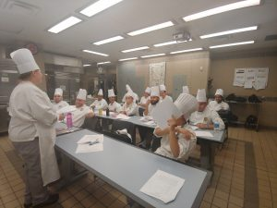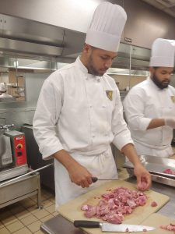
Ahsan and Pedro butchering the meats for our main dishes
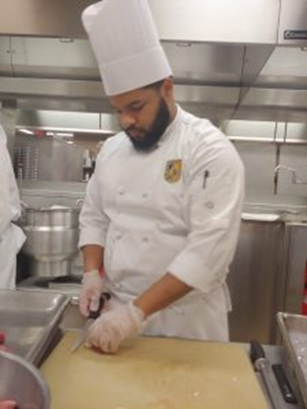Pedro butchering the lamb piece by piece.
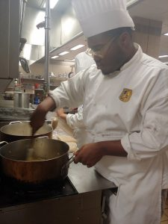Stephon putting in that work on those onions
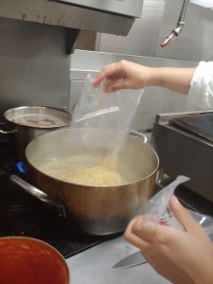Bella throwing that rice in the boiling water
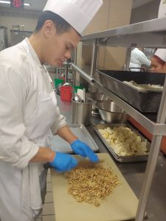Vincent chopping away at the nuts for the stew
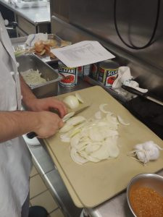Sliced Not Diced by Arturo
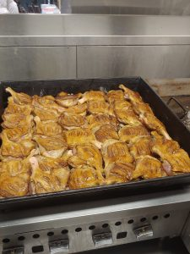That Duck looking good
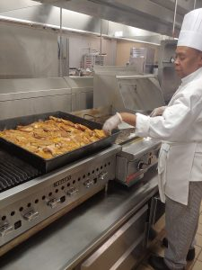
Throwing that duck on the grill
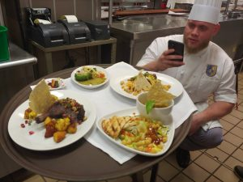
Jesus gets photo bombed by the entire tray
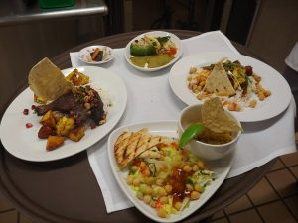
“Hard Work Pays Off” The final products
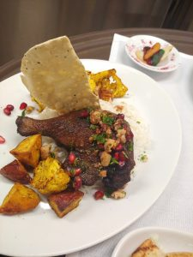Ordak Fesanjan (Iranian Duck w/ Pomegranate & Walnut Stew
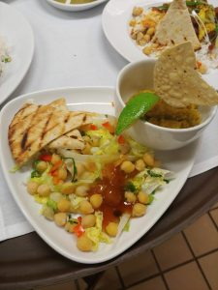
Tok Dal w/ Grilled Naan (Eastern India/Bangladesh Red Lentil)

Gosht Pulao (Pakistani/NW Indian Spiced Lamb) 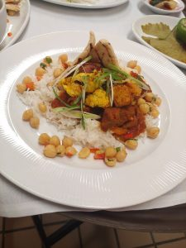

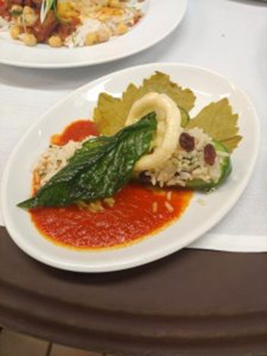
Stuffed Pepper w/ Raisin Mint & Cilantro

