It was a brisk afternoon as I walked into Bogota Latin Bistro along “Brooklyn’s Hottest Dining Strip”. Situated in Park Slope, just a few a minutes from Barclay’s Center, is truly a remarkable restaurant that incorporates the owners Latin values and traditions. Established in 2005, George Fernandez and Farid Ali Lancheros aimed to deliver a Latin experience to the community that was surrounded by an ever evolving restaurant scene. Their menu is made up of recipes inspired by their travels throughout Latin America, George’s mother’s favorite dishes, and cooking classes they have taken at the Institute of Culinary Education in Manhattan. Additionally, they continue to travel internationally to enhance their collective culinary knowledge, skills, and expertise. Finally, they strongly promote ongoing training and development of their team to produce a guest experience like any other. I believe with hardworking owners that they have an established business of 14 years and are still striving to be the best.

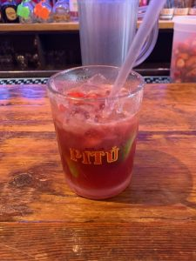
A refreshing “Brazil Sangria”, filled with slices of lime and fresh strawberries.
I was going to order a shot to go along with it since it was happy hour, but I remembered I had a lot of school work to complete.
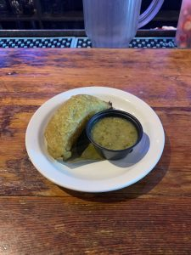
A vegetable empanada with spinach, mushrooms, bell peppers, tomato, and onion. Served with an aji pique (scallion cilantro sauce).
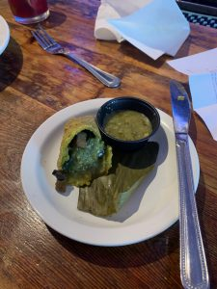
A deep fried spinach shell with a tasty vegetable filling. I wanted to order this since these were made in class. I wanted to taste the seasoning and flavors to see where I can improve my own recipe. The sauce gave the empanada a nice touch of spice that was not overbearing.
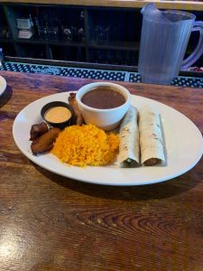
I ordered the Fish Taco entree which was very filling. The taco was made up of deep fried sea bass, pico de gallo, and mescaline salad. Accompanying the taco was yellow rice, red beans, chipotle mayo, and sweet plantains.
Overall, it was a well put together dish as the fish was fried to perfection and the rice was fluffy and tasty. The sweet plantains were as I expected and NOT like the ones we served in class. I believe it was a HORRIBLE idea to pre-peel them a week prior and freeze them as they had no taste to it and when fried it lost its texture and shape.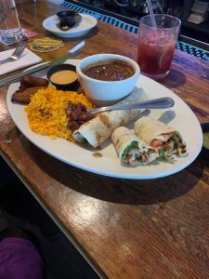

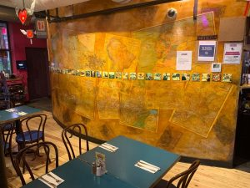
Architect Kate Webb designed the interior of the bistro and colorful murals celebrating Latino culture. The overall decor of the place feels welcoming yet still containing traditional roots. 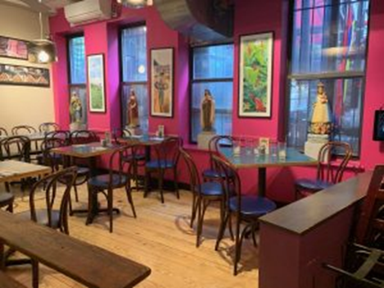
This entry was posted in Uncategorized on November 20, 2019 by Vincent N.
In summary, this was a great place to eat a traditional Latin dish with Colombian roots. It was not packed since I went during lunch hour, and I was truly able enjoy a wonderfully prepared meal.

