Amish Country Delights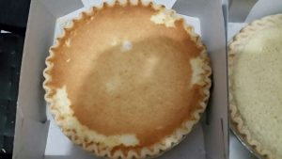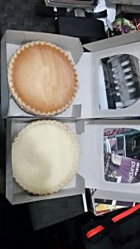
When I was deciding on what to do for regional American cuisine I could not figure out exactly what I wanted. I could have gone multiple different ways from the traditional comfortable food to spice of the south from influences of the Caribbean. My decision to choose Amish cuisine was based off of wanting to try something new and unusual to me and from what I grew up eating. I went to Amish Village Bake Shop Lancaster County Baked Goods located in Allentown Fairgrounds Farmer’s market. When I first entered to fairgrounds I was completing amazed by the different vendors. I had a hard decision from which vendor I should conduct my project on because almost all the vendors were Amish women. There were hot buttery pretzels being served to homemade chicken potpie. I do not have much of a sweet tooth so I went to the bakery after walking the entire fairground market. The bakery had the traditional apple pie and pumpkin pie for the holiday season. There were three pies the caught my eye which included cherry custard pie, coconut custard pie and lemon sponge pie. I ended up purchasing the coconut pie and lemon custard pie because I wanted to compare the flavors. The lemon sponge pie had a flaky buttery crust and crumbed into tiny pieces when you took a fork full. The filling itself was a surprising light lemon flavor that you only tasted lemon towards the end. It was surprising because you first look at the filling it’s a bring lemon color that you think is going to be super tart and blast of lemon when you first taste it. The filling was smooth and soft it reminded me the texture of pudding. The coconut custard pie was completing different in texture from the overload of coconut flakes. The pie was a pale white color not like the tan coloring from the grocery store custard pie. When I first bite into the pie I immediately got the coconut flavor, the coconut was not entirely sweet I assume they used unsweetened coconut. The custard was silky, crunchy from the fresh flakes and creamy. The crust tasted the same as the lemon sponge pie and when I first open the pie I immediately smelled fresh coconut.
https://www.youtube.com/watch?v=CBhFS1_5PCc
This video shows an Amish women making chocolate whoopee pies from starch and only using shortening instead of butter because of the color.
-Vanessa D.

