Practice Pointer: When you evaluate which case/cases to use, remember that cases from the appropriate jurisdiction are essential for binding precedent.

By Ariana Figueroa
This is from Chapter 18 regarding Case Briefs
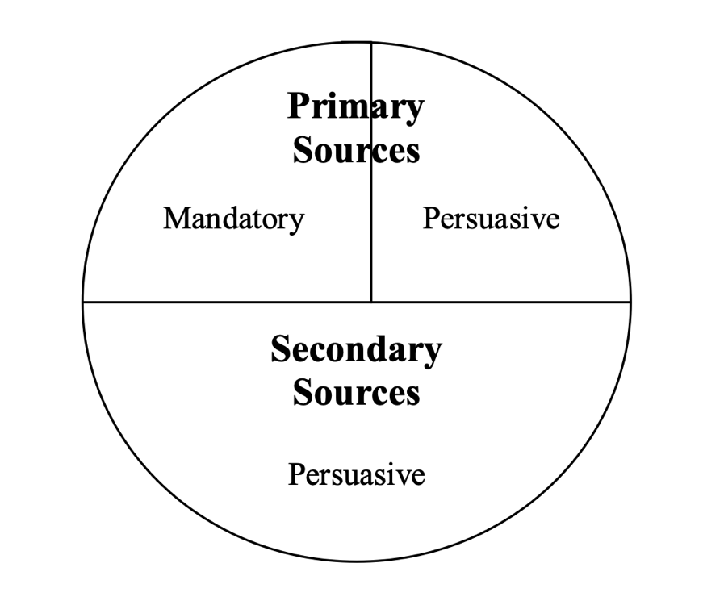
Binding vs Persuasive

Primary Sources “The Law” can be either binding or persuasive depending on the jurisdiction.
These include: constitutions, statutes, court decisions(cases), administrative agency regulations (ICE regulations).

Secondary Sources “About the law”
can ONLY be persuasive
These include: law textbooks, law dictionaries, legal encyclopedias, legal periodicals.

What does this have to do with precedent?
When you are doing research for cases to use, especially in the reasoning part of a case brief you firstly want to find cases that are BINDING that way your case will follow a similar ruling due to the precedent set by the previous case.

How can you figure it out?
Ask yourself…
- Are the legal issues in your case governed by state or federal law?
- What court are you in?

Why should one consider this point?
As a paralegal you are expected to write case briefs, therefore this point is essential in knowing the correct way to explain the reasoning for the case ruling.

