Evens Pierre-Louis

The Judicial Branch

- The Judicial Branch is branch of government that specializes in the interpretation of the law and the administration of justice. (They Interpret the law)

- Common cases that are brought up in the judicial branch are certain cases that deal with criminal, civil & at times cases dealing with bankruptcy.

- Some interesting facts about the judicial branch are that the President of the United States & Congress determines the judicial branch. On average, about 7,500 cases are sent to the Supreme Court every year & about 150 of those cases are looked at on a yearly basis. The Supreme Court Justices can range from 6-9 people

- Some of the Duties of the Judicial Branch include (Interpreting the laws, hearing civil cases, giving out rulings to those who have violated the criminal law’s of a state)

- Some important cases in history that have a link to the Judicial Branch are
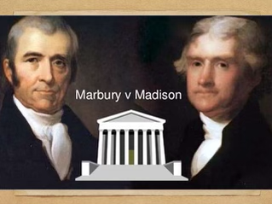

The Marbury V Madison case was a case in which, the US supreme court first declared the act of Congress Unconstitutional. The case set a precedent for establishing the judicial review. In 1803, Chief John Marshall gave the Supreme Courts the right to determine the true meaning of the U.S constitution. Chief Justice John Marshall & his colleagues asserted the rights to the Supreme Court to determine the meaning of the Constitution. The decision in this case established the courts power of the judicial review over act’s of congress.

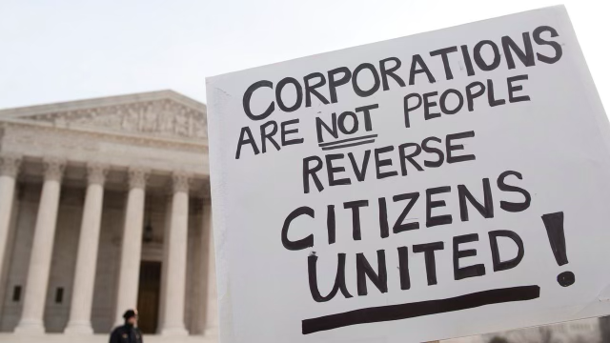
A more recent case was the 2010 case between Citizens United v Federal Election Commission

- In this court case,Citizens United, sought out a demand that the (FEC) Federal Election Commission would prevent the application of BRCA Bipartisan Campaign Reform Act to a film that was linked to Hillary Clinton in her 2008 Presidential Campaign. There were questions on whether the movie would make it seem as if Hillary Clinton would make a good president. In this case, The court also used a case that also dealt with the FEC was a case named (McConnell v FEC) that also held that corporations could be banned for ultimately making electioneering communications. In 2008, the film on Hillary Clinton was released, and Citizens United wanted to pay cable companies to make the film available for free on demand. Citizens United had a plan to make the film available to the public within 30 days before the 2008 primary election, but there was fear that the film would expose potential corporate funded electioneering communications. Citizens United argued that Section 203 would violate the first amendment right on the basis of it being applied to the movie & it’s advertisements. In conclusion, the court ruled 5-4 that the first amendment prohibits limits on corporate funding on independent broadcasting in candidate elections.

