Practice Pointer: State and Federal Courts Can decide issues of state or federal law.

Presentation by Mackenzie Bowman

FEDERAL COURTS FORMAT 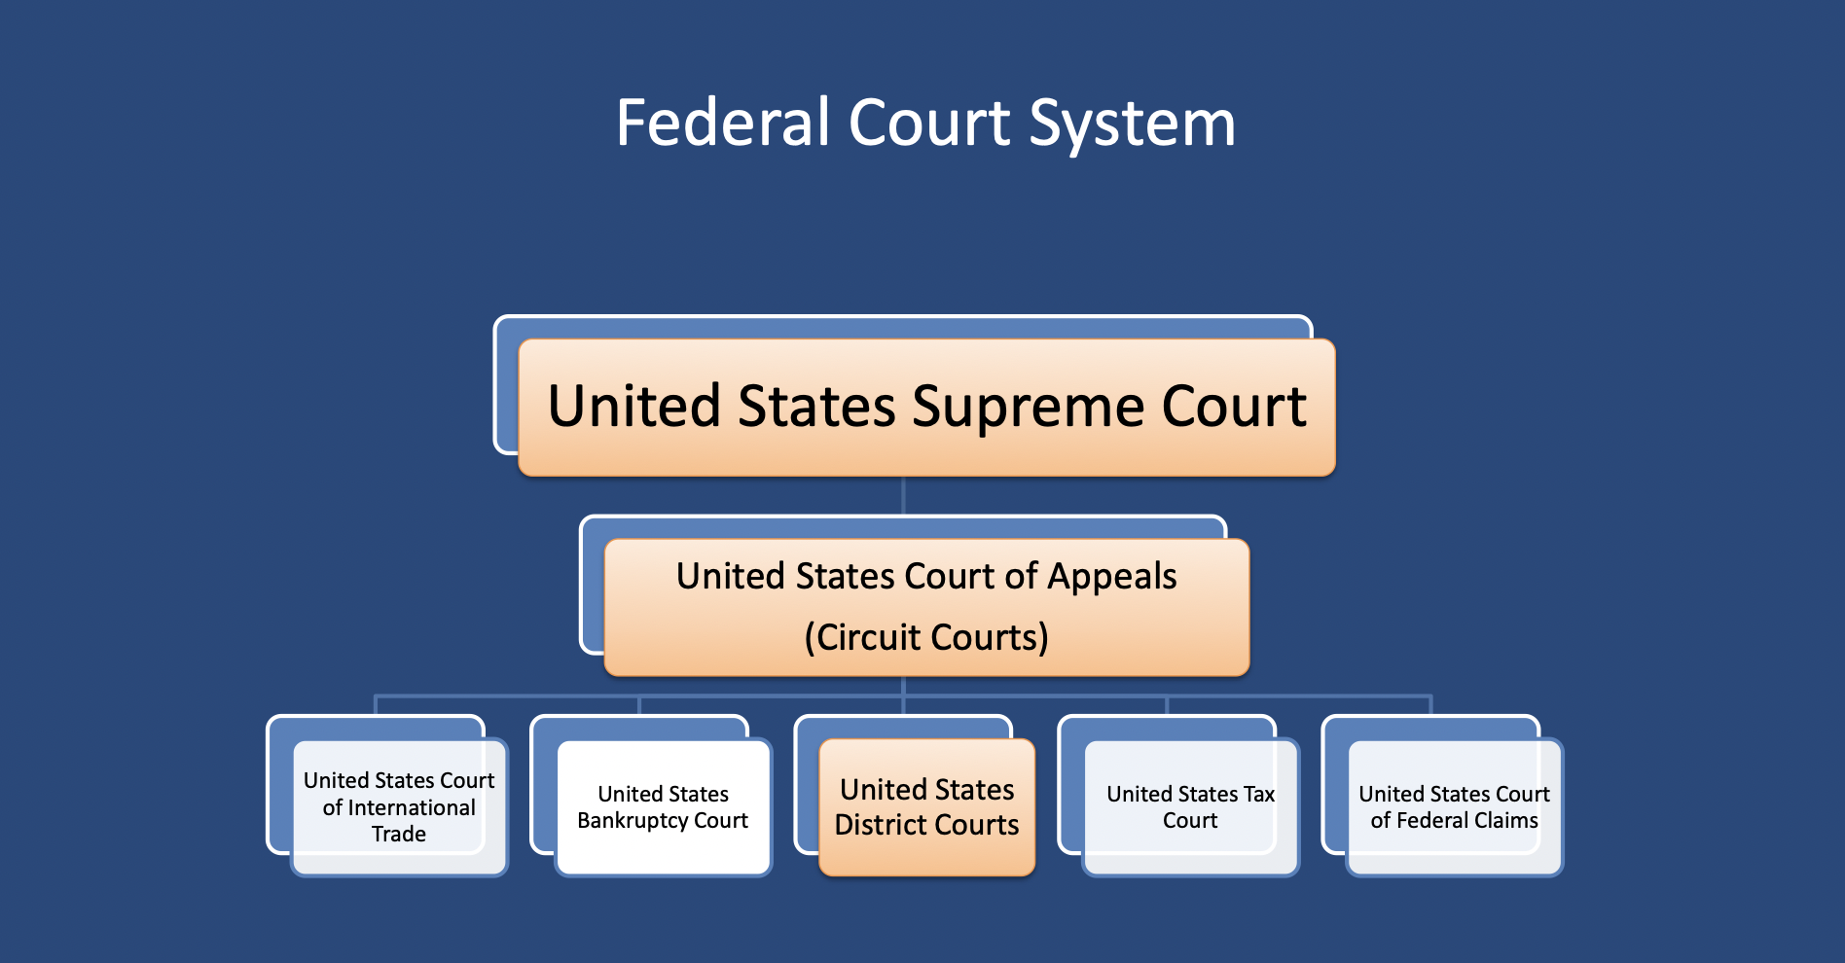

WHEN DO FEDERAL COURTS DECIDE A CASE?
-Federal Courts usually decide a case when there are issues of federal law being considered.
-They also decide diversity cases, which is when the plaintiff and defendant of a cases are citizens of different states (and the amount is over $75,000). Even though cases like these are decided in the federal courts, they decide state issues.
- Issues of supplemental jurisdiction are also decided in federal courts. Supplemental jurisdiction is when the issue in question has a claim that can be applied in a state statute that is similar to the federal one being discussed.

FORUM SHOPPING
When courts have concurrent jurisdiction, when multiple have the ability to hear a certain case, the plaintiff has the ability to choose which court they would like to have their case heard in. This often occurs between state and federal courts, since they have different rules and statutes to go by, and therefore, one might be better for their case. While this is discouraged by courts, it still occurs since plaintiffs can have a better time for their case when they do so.

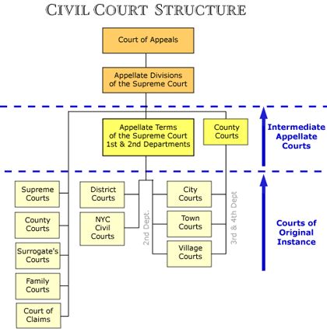
STATE COURTS FORMAT

WHEN DO STATE COURTS DECIDE A CASE?
-The state courts mainly decide cases that involve issues of state law.
-If an issue is within their subject-matter jurisdiction, they can decide a case of federal law.
-Essentially, its “everything else,” the default if there is no specified or specialized place for a case to go.

WHAT IF THERE IS A STATE ISSUE IN A FEDERAL COURT, OR VICE VERSA?
Sometimes, cases have multiple issues. In this case, a state court may end up deciding something about a federal issue involved, and a federal court may have to make a decision about a state law. If this happens, state courts will be bound ONLY by the US Supreme Court. Federal courts are bound ONLY by the state’s highest appellate court.

HELPFUL WEBSITE!
UScourts.gov is a great website and research tool that gives helpful and interesting information about all of the United States district and appellate courts, and even the Supreme Court. It has information such as the locations of courts, and details about the judges.

