Practice Pointer: The United States Court of Appeals for the Ninth Circuit.
Presentation by Nasser Amadou
- The United States Federal Court system includes 13 intermediate appellate courts known as "Circuit Courts of Appeals" divided among the states throughout the country as well as territories like Puerto Rico and Guam.

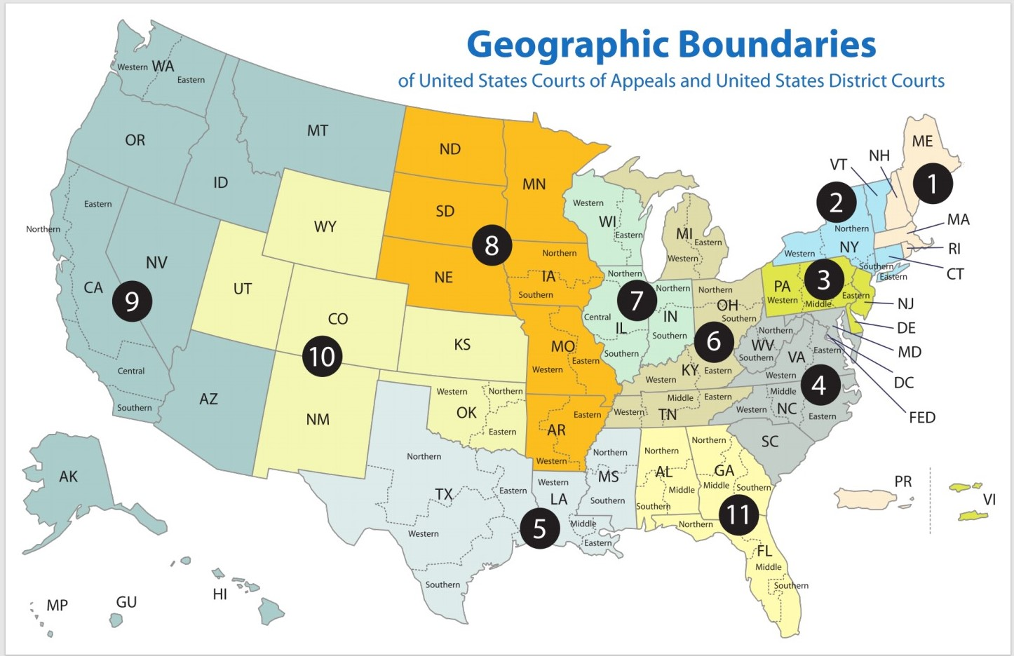

- In the United States federal Court system, Circuit Courts serve as intermediate appellate courts (they have appellate jurisdiction). They hear cases, in appeals, from district courts.
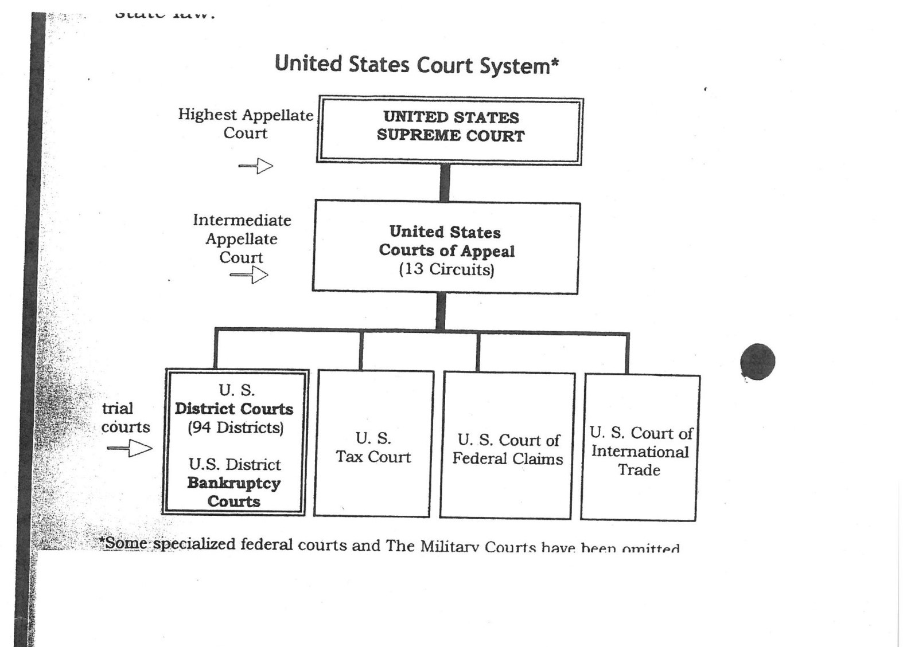

- The 9th Circuit Court of Appeals has appellate jurisdiction over the District of Alaska, The District of Arizona, The Central District of California, The Eastern District of California, The Northern District of California, The Southern District of California, The District of Hawaii, The District of Idaho, The District of Montana, The District of Nevada, The District of Oregon, The Eastern District of Washington, The Western District of Washington, The territorial courts of The District of Guam and The District of the Northern Mariana Islands and.

- Why it is important to understand the Ninth Circuit Court of Appeals ? It is important to understand the 9th Circuit because as the Ninth Circuit currently exists, its decisions are binding on almost a third of the country geographically, and a greater number of states than any Circuit, including some very highly populated states.

