**Image 2** – To be used to demonstrate how to replay and forward messages.

**Image 1** – To be used to demonstrate how to create and send new messages**.**

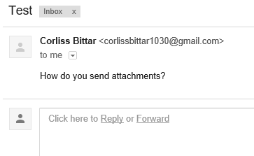

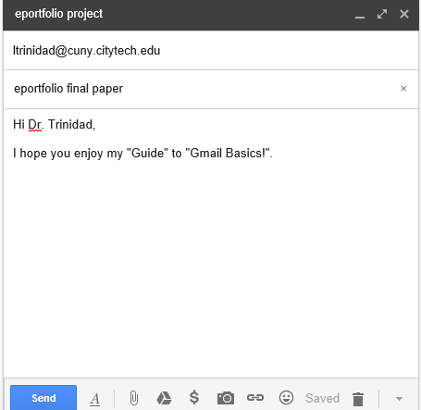

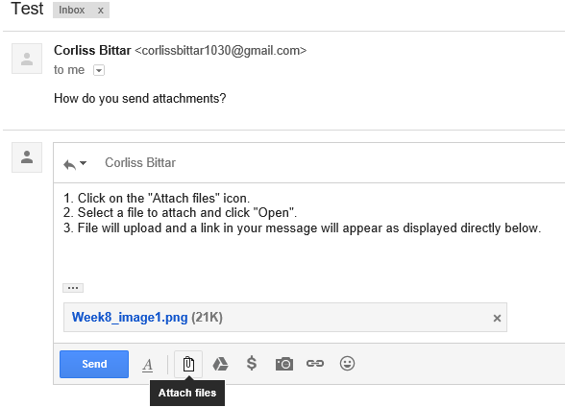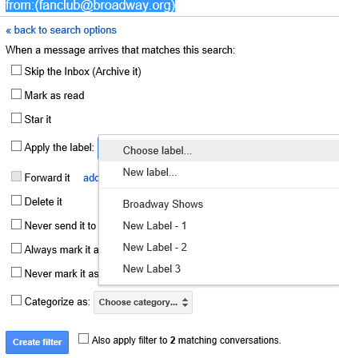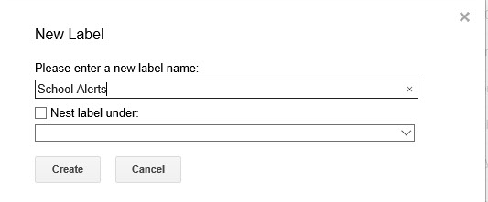

**Image 3** – To be used to demonstrate to Adding Attachments and images

**Image 4** – To be used to demonstrate how to organize, create labels, move, create filters.