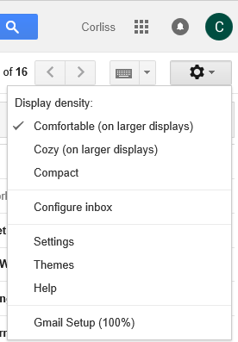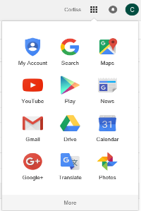

**Image which displays the Settings and Themes.**

**Image which displays the Navigation Window.**

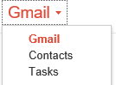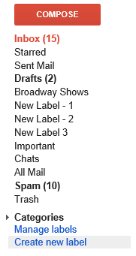

**Image of Gmail dropdown button, which displays; Gmail, Contacts and Tasks.**

**Image which displays the Inbox and folders and labels.**