Why “Good” Students Do Bad’ in College: Impactful Insights
Imagine that you’re a professional who has performed your duties well by your and your supervisor’s standards. In fact, you have received outstanding performance reviews from your supervisor. Additionally, your work is held in high regard by your peers.
Now imagine that you take a new job in which you are essentially performing the same duties. However, these duties carry greater weight. You understand that this new job demands more time and effort, and you work with increased energy and diligence.
The time arrives for your first project review. You are confident. You’ve invested more time and worked more conscientiously than you ever did in your previous job. However, your supervisor deems the quality of your work unacceptable. Even worse, for the first time in your life, your effort is questioned. Shocked, as you received only stellar reviews in your prior position, you meet with your supervisor to obtain insights about what went wrong and guidance concerning her expectations for the next project. You take her suggestions to heart and double down on your efforts for your next project. However, she still judges your work as inadequate. This cycle repeats itself until you eventually disengage from the job. Ultimately, you divest your efforts from your work and put your energy into something that provides a greater return, such as your family or a hobby. Over time, you become the average employee your supervisor accused you of being months earlier.
Over the past few years, the phenomenon of college student academic underperformance has received considerable attention. Media outlets have covered the issue extensively, and the topic is now being addressed in the learning assistance and general higher education literature. This is a pivot from the ever-mentioned “at-risk” population, namely, those students whose pre-college academic background suggests that they may need additional support in college. The underperforming population consists of “good” students, namely, students whose academic background suggests that they should do well and even excel at the collegiate level.
Who are the “good” students?
“Good” students are the studious, serious-minded, hard-working college students whose grades lag behind their capabilities and efforts. These students enter college with strong academic backgrounds and exhibit solid work ethics, yet their sincerest efforts produce only mediocre grades. Good students may not perform so poorly as to trigger institutional academic alerts. Their solid academic backgrounds and sheer work ethics are typically enough to keep them from failing courses, but they aren’t enough to lift them above mediocrity and up to their personal standards.
Students who enjoyed pre-college academic success enter institutions of higher learning with a high academic self-image. They believe they are excellent students and expect to earn grades that reflect their effort and are consistent with their image. Like the employee who was unable to continue building upon her success as she transitioned to her new job, good students are unable to make the transition from their pre-college learning environment into the college environment. They invest themselves fully in preparation for their exams, only to have their learning outcomes judged as inadequate. Their effort is also called into question, and over time they divest themselves from academics and reinvest in other areas. At best, good students who don’t receive proper academic assistance will get by but never live up to their capabilities in college; at worst – and increasingly more common – they will become retention casualties.
Why should we care?
Good students are the overwhelmingly largest student cohort. Yet, they are unidentified by most colleges and universities and often lumped into the significantly smaller, more easily identified “at-risk” population. In class, good students exhibit the studious habits of their more successful peers, whom I call “great learners.” However, their performance on tests often resembles that of poor students who skip class or show up unprepared and who don’t seem at all serious about their academic performance.
Three reasons why we should care about the good students:
1) They make up about 80% of the student population. By helping them, institutions produce the greatest return on their investments. Colleges and universities are currently “resourced” for the extremes. Students in the top 10% are awarded scholarships and fellowships, while students in the bottom 10% have an army of academic “life-support” resources devoted to them. By shifting to a paradigm designed to boost the middle, institutions generate the greatest academic and monetary return for their investments.
2) They may be the next funding source. During the July 2011 annual meeting of the National Governors Association, which took place in Utah, best-selling author Thomas Friedman implored state leaders to focus their educational efforts on “pulling the average way up.”
3) They hold the key to transforming the academic culture. When the average is boosted, more good students will become great learners, and some poor students will become good students, thus shifting academic performance upward while shrinking the poor student population.
For the past ten years, I’ve been researching the factors that distinguish good students from great learners. I’ve developed several insights and strategies that have proven highly effective at helping good students live up to their capabilities and efforts. Below are three reasons why these students struggle in college.
Reason # 1: 80/20; 20/80 Rule
This rule is listed as number one because it is perhaps the most important concept students must grasp about the collegiate learning environment. More importantly, once they grasp it, they must fully understand its implication in their everyday study routine. For the past ten years, I have asked students to identify their main source of information in preparing for tests in their pre-college learning experience. Students quickly listed their teacher as this source. I began calling this the 80/20 rule.
What is the 80/20 rule? This rule says that practically all (or 80%) of the information students needed to know to be successful on their pre-college exams came from one source, their teacher. The teacher dispensed this information via classroom lessons, then reinforced it through homework assignments and perhaps further by reviewing homework assignments during classes and in test study guides. (Many consider this process “spoon-feeding,” though I reject the term when used as a pejorative.) More than preparing students for tests, this routine has conditioned students to view the teacher as the primary agent of test preparation. This is the main reason students ask professors if what they are talking about in class is going to be on the test. The conditioning process of their high school environment has trained them to believe that if they pay close attention in class, record all things that the teacher writes on the board, memorize what is handed out, and just stay on the conveyor of activities in high school, they will earn A’s. That is the 80% or the majority of their learning. The 20% consists of a brief review a day or so before tests.
When these students, the ones whose efforts and capabilities have been repeatedly affirmed and rewarded by high marks and praise, go to college, they take this approach to learning with them. However, they, like the professional who takes the weightier job, know that to excel at the next level they must apply greater effort. And, like the professional, their work is deemed inadequate despite their increased efforts. No matter how much they attempt to rectify their learning problems, they can’t produce above-average work.
The 20/80 Rule
In college, students must reverse the 80/20 rule and begin operating according to a 20/80 rule. This means they should consider the information the professor provides in class via lectures and study guides as roughly 20% of the content needed to be successful on exams. They must generate the other 80% by synthesizing, grounding, and expounding upon the class information. This work is done outside of class. This is what college is all about! In fact, I made up the 80/20; 20/80 rule many years ago after counseling hundreds of students who were experiencing the same academic problems. The percentages were ways of communicating a larger point. However, recent researchers have found that 85% of all college learning is done independently outside of the class and usually involves some type of text (Caverly D.C., 2009). This means to students that success in class has significantly more to do with their reading outside of class.
Daily Implications
The 20% the professor provides is incredibly important, but it is insufficient for test preparation. Unlike the pre-college teacher, the college professor sees his role as that of a guide. Therefore, he does not expect to provide students information to pass tests. He expects to guide students as they learn the content. However, students enter college still under the “spell” of their previous learning environment. They reflexively attempt to apply the no-longer-sufficient 80/20 rule. This means that they attempt to absorb 80% of knowledge out of 20% of information. This is impossible and it is a recipe for insanity! Students are essentially only obtaining 40% of the information (a critical 20% from the professor and the 20% they’re accustomed to getting by their own efforts). The 40% equals many students’ raw exam scores without a curve (a little humor here, but not too much).
Solution
So how do we move students from an 80/20 mindset to a 20/80 attitude?
Show them their past. It is imperative that we provide some context to students’ pre-college learning experiences. As I say in each workshop, high school is an extremely salient era in our learning skills development because it is the period in which we either develop or solidify our study approach. By default, college students will implement the approaches and strategies that worked for them in high school – just with greater effort. These strategies and approaches got them into college, and they expect them to get them through college. Besides, these tools are all they know. They don’t have another set of unused, more appropriate learning tools at their disposal.
I’ve gone through many boxes of tissues over the years, explaining to students why their strategies worked in high school but are ineffective in college. Their tears of despair are transformed into tears of hope as they gain insight into their problem and optimism rises within them.
Tell them their present. Once students have insight into one of the primary roots of their problem, they are in a position to change their mindset. The gift – or present – you will provide them (pun fully intended) is an opportunity to make a quality choice. They can choose to continue operating on the 80/20 rule and continue underperforming, or they can adopt the 20/80 rule and begin capitalizing on their capabilities and efforts.
Present a brighter future. Put on your salesperson’s hat! It’s time to sell the students on what learning can be like if they move to a level playing field. The adoption of the 20/80 rule will put them on that field. It is important to increase their feeling of pleasure enough that it will overcome the discomfort that will accompany change. Drill in the notion that they have been playing the “game” differently from their more successful peers, and that they can enjoy success as well if they develop a 20/80 mindset.
Reason #2: Immobile Thinking
The term “mobility” refers to an ability and freedom to move from one place to another. It is one of the ubiquitous intrinsic metrics by which we measure satisfaction. In relationships, it is the sense that the union is taking the partners to increasingly satisfying states. The opposite is stagnation, whereby a couple does the same things repeatedly with dissatisfying results. Immobility in relationships is a sign of a lack of growth and typically results in relationship problems.
In society, mobility refers to our vertical movement (up or down) from one socioeconomic level to another. It is considered one of the key indicators of a healthy economy and is a primary determinant of people’s life satisfaction. People are driven to advance socioeconomically. In fact, many people experience various forms of depression when they sense that they are no longer achieving upward social mobility.
Mobility is also a key aspect of learning. Whenever students learn something, they achieve mobility. This mobility is manifested in the fact that they have moved from one level of knowledge to another level. There are two types of mobility that I have found in learning: horizontal mobility and vertical mobility.
Horizontal mobility is an accumulation of knowledge on the same thinking level. Typically, the knowledge is accumulated on a lower thinking level, and it is insufficient for rigorous college coursework. Therefore, I classify horizontal mobility as immobile thinking because it does not take students where they need to go in their learning in order to reach sufficient outcome. When students engage in horizontal thinking, they accumulate knowledge that is the proverbial “mile wide and an inch deep.” This occurs because their thoughts about the content are underdeveloped, and their knowledge did not deepen throughout their learning.
Students who think horizontally will reach the same lower-level learning outcomes regardless of their thinking capabilities or the time they invest. One example of this was presented during a conversation with a student from an elite, private prep school. He was struggling to perform up to expectations in college. The student was known for devoting exorbitant hours to his studying, but he was unable to produce grades consistent with his intelligence and efforts. When asked why he thought he was unable to produce high grades, he stated, “In my high school, they didn’t teach us how to learn; we just learned how not to be outworked by anyone.”
Vertical mobility is the key to college student learning; specifically, downward mobility is the goal. Higher-level thinking skills, according to Bloom’s Taxonomy, are correlated with deep learning outcomes. Therefore, as students engage in high-level thinking, they produce deeper learning outcomes, and deep learning outcomes are more consistent with rigorous tests. (See the Thinkwell-Learnwell™ Diagram below for a visual depiction of this relationship.)
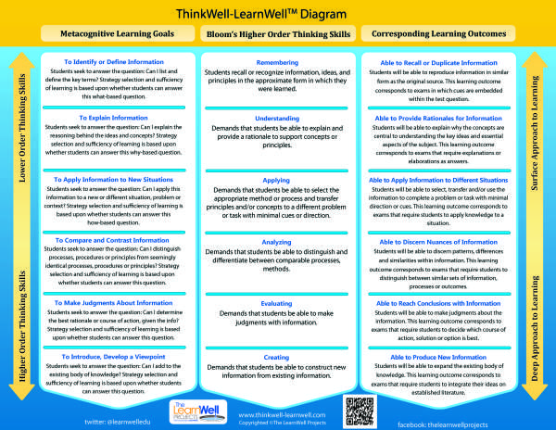
To achieve vertical mobility, students must interact with the content or subject matter differently. This difference in interaction is what separates the good students from the great learners. Great learners achieve vertical mobility during their study activities, whereas good students may invest an equal amount of time studying the same material, but their interaction only produces horizontal mobility. This distinction underlies the vast difference in academic performance between good students and great learners.
Reason #3: Studying in “Hope-So Land”
Great learners are like great investors; they work in ways that ensure they will get a return on their investments. Great learners study in ways that align with their tests. They are much surer that what they study will be reflected on tests because they line up the needed learning outcome (or what they are expected to know for the tests, and more importantly, the level at which they need to know it) with their pre-studying learning goals. They study in “know-so land.” This is the place where students have a pretty sound idea that what they learned while studying will be sufficient for their tests.
Good students, on the other hand, are rarely aware of the learning outcomes that are expected for their tests; therefore, they cannot have any assurance that they are learning the right stuff for their tests. They just repeatedly punch the ole studying time clock and hope that the time spent studying will lead to a great test performance. More often than not, however, they perform far below their standards. They repeat the process again without an inkling that their great learning peers, who may even be studying alongside them, are studying in know-so land.
How can we move students from hope-so land to know-so land?
Increase students’ metacognitive awareness. There are three levels of studying: behavioral (the observable tasks for studying), cognitive/domain-level (the information or content with which students interact), and metacognitive/meta-level (the processing that occurs between the lines of the cognitive activity). Of these three, metacognition is where good students and great learners differ most. In fact, research shows that students who are not metacognitively aware will struggle in college (Caverly D.C., 2009).
The image below depicts the three levels of activity that are present throughout the learning process. Good students and great learners exhibit virtually the same habits and characteristics on the behavioral and cognitive levels. On the cognitive level, all students have access to the same materials – textbooks, class time, etc. And on the behavioral level, research affirms that good students and great learners spend the same amount of time studying. The activities that occur on the metacognitive level are the ones that transform students’ quantity of studying into quality learning.
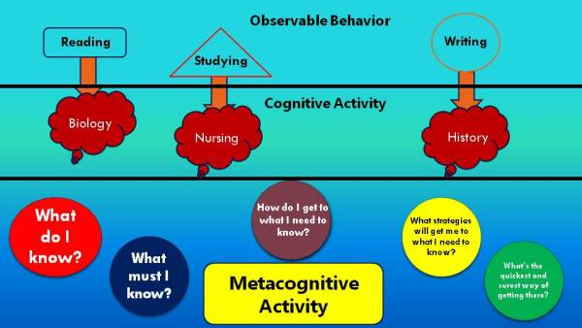
Teach students that a variety of learning outcomes can be reached with the same content. Typically, good students are unaware that multiple outcomes can be reached with the same information. Simply taking a relatively easy segment of content and demonstrating that different outcomes can be reached with that content is immeasurably valuable to students. For example, the laws of thermodynamics can be contemplated on different thinking levels: remembered, explained, applied, analyzed, etc. Each thinking skill will yield different learning outcomes from the same segment of information.
Once students become aware of their metacognitive activity, the first goal of metacognition, they can move toward controlling their learning, which is the ultimate goal of metacognition. The ability to deliberately set and reach sufficient learning outcomes is the fine line that distinguishes good students from great learners.
The ThinkWell-LearnWell™ Diagram was created to enable students to successfully navigate their way from hope-so to know-so land. It is a metacognitive tool that has been effective at helping good students capitalize on their abilities and efforts. When students use it, they typically state that they feel as if they are studying less but getting more out of the process and that they can predict what’s going to be on the test. These qualitative changes are indicators that they are evolving as learners. The statements are students’ ways of articulating that they are becoming more adept at ascertaining the most salient content and are no longer overwhelmed by the information. It is a sign of metacognitive control. It is also measurable evidence of growth because, to accomplish this, they must successfully evaluate information, and evaluation is one of the highest possible thinking skills. Students are often amazed to realize that they have progressed from lower-level thinking to high-level thinking in a relatively short period of time.
So we now know a few reasons why good students do “bad” in college. We’ve also explored some solutions to help them evolve into great learners. Let’s continue the discussion. Please add your feedback, comments, ideas, and/or questions below.
Works Cited
Caverly D.C., F. R. (2009). Handbook of College Reading and Study Strategy Research, 2nd Edition. New York: Routledge.

To view the blog and original article refer to:
http://thewelledu.com/2012/02/06/why-good-students-do-bad-in-college-proven-insights-2/

