Homework 1 –Finding your voice
Gloria Rosario
Dawoud Bey is an American photographer, born in New York City known for his numerous collections and his ability to express a strong existence in his subjects. For Mr. Bey , the subject and the way he presents the information, are equally important in order for people to understand the emotional meaning behind his work. He is also known for taking portraits of individuals in their date-to-date life in correlation to their community. In addition, in his photographs, he connects the past with the present moment. In other words, showing how history resonates today. His famous project “ The Birmingham Project “ (A tribute to the victims of the 16th street Baptism church bombing in Birmingham, Alabama). In this project, he makes a connection between the past and the present to show the ongoing issues of racism in America. Dawoud Bey wanted to create a work that reflected Birmingham today by comparing images side by side of the young children in the 1963 Birmingham attack and what they would look like as adults 50 years later. This series consist of 32 pair photos and shot all over Birmingham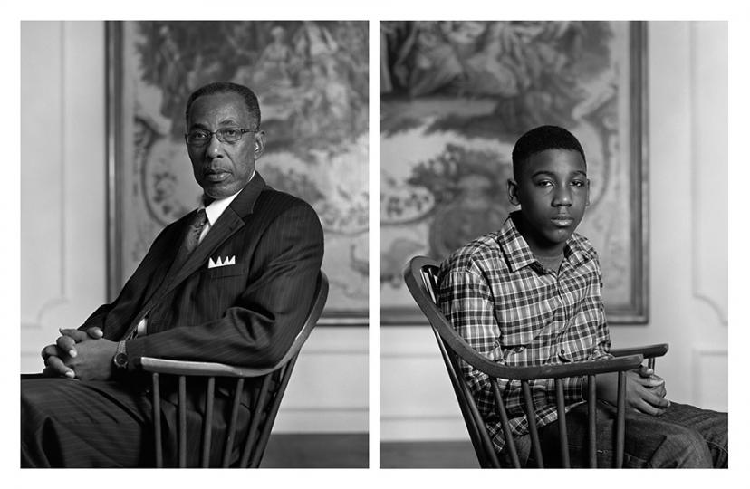
This is one of the photos from The Birmingham project. On the left Don Sledge (1953) and on the right Moses Austin (2012)

Carrie mae Weens is an American contemporary artist best known for her work in photography. Through her work she show us female experiences and a very personal view to a woman’s life. “The kitchen table” was done in her home because she wanted to show what she was capable to do from her own surroundings and the powerful message about woman’s day-to-day life at home. As well as, the difference in roles that man and woman play. This work was produced in 1990 and it consist of 20 images he main subjects she wanted to show with these works is the role that woman play in the world. In these images we can see the roles that woman play as a mother, wife, daughter and friend.
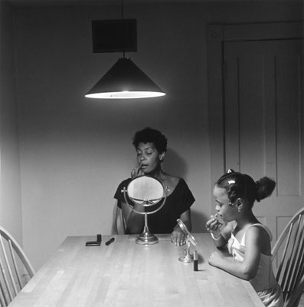

This image is from the “ The Kitchen table “ collection in 1990.
This is one of my favorite images from this collection because it shows the powerful relationship between a mother and daughter and from a very early age the bond we create with woman.

Both Carrie Mae Weens and Dawoud Bay use photography to show us a very deep and real side of important issues that affect our lives like racism and Sexism.

I think that what Mr. Bay means when he says to “ reshape the world “ is that when we talk about this issues that still affect our society today and In his case as photographer he is able to show this message in such a deep and personal way in order to bring consciousness to these issues that we sill face. Therefore, I think that these messages create awareness and with that the hope that people will understand these issues and with that there could be changes in the world for the better.

