Sajjadul Alam
Comd1100
Prof. Alvarez
I’m going to talk about two artists I chose and their paintings. The two artists I chose are Karel Appel, and Giacomo Balla. Karel Appel was born in April 25 1921 and died May 3rd 2006. He is known for painting, drawing, sculpting, and wall painting. The first painting is by Karel Appel which interested me. This first painting interested me because you can tell what the focal point of the piainting is. The focal point of the painting is you can see the faces and its showing the different colors on the faces as well. You can also see the three primary colors in the painting as well which are red, blue, and yellow. You can also see some warm colors as well in the painting which are a little bit of red and a little bit of yellow. Theres also a shade of black in the painting as well. Overall you can see in the painting that it is a painting of faces.
Another artist I chose is Giacomo Balla. Giacomo Balla was born in July 18, 1871 in Italy and died March 1st 1958 in Italy. I found one painting from him that I liked and that interests me It is a painting called Dynamic Sequences. This first painting interested me because the composition of the painting consists of a lot of lines with RGB coloring. It is also reminding me of broken glass. You can see a lot of abutting shapes. It is also asymmetrical. This painting has an asymmetrical balance to eachother.
The second painting I found which is by Karel Appel, it interests me because the focal point is a painting which seems to be 2 faces and in the painting it also has the three primary colors which are red, green and blue. It has the balance of the two faces that are sticking together

In the painting which in my opinion I like. The two paintings also looks like It is spray painted on a wall which I really like. The painting is also 2 dimensional. The second painting I found by Giacomo Balla is a painting of a street light with fire works. I chose this second painting by him because I found it to be very interesting to see a painting of a simple street light with fireworks painted around. In this painting you can also see the three primary colors in the subtractive painting model which also means you can see a little bit of red, a little bit of yellow, and a little bit of blue in the painting. All four of these paintings are very interesting to see. There are a lot of these amazing paintings you can find online and In those sites I was very interested in seeing a lot of there paintings and I chose the paintings that had caught my eyes and I really liked these paintings a lot. There are some relationships through all of these paintings two paintings by Karel Appel that relates to the faces. The two paintings by Giacomo Balla relates to a lot of lines with different colors and the first painting looks also like broken glass but it’s actually painted it is not broken glass. Also about this painting it looks like it has a border around the painting which is standing out. With the border painted it looks like a window which it is really not a window. On the border it also has lines around it as well.

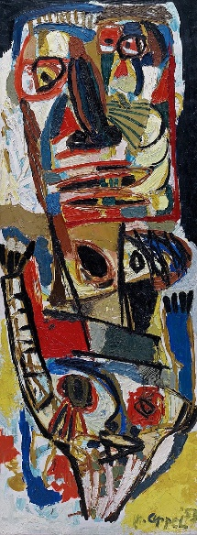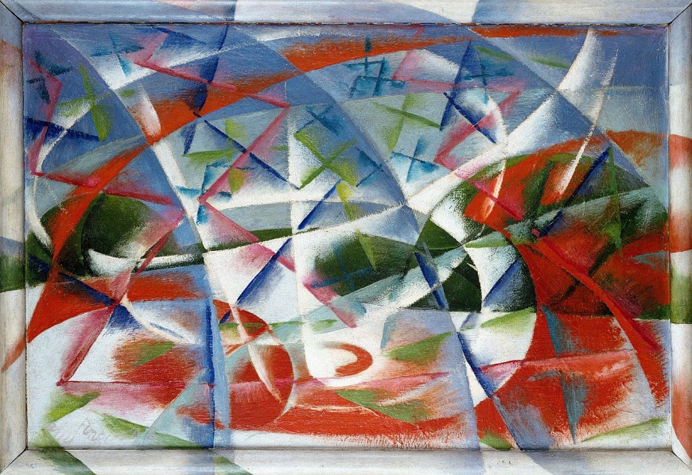
First Painting by: Karel Appel First Painting by Giacomo Balla

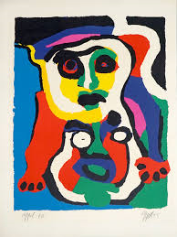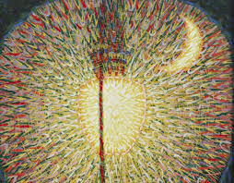
Second Painting by Karel Appel Second Painting by Giacomo Balla

