Surrealism:

Surrealism is an art movement that started in the 20th century. Andre Breton, a French writer founded this movement. During his early career, he was very interested in mental illness and poetry, which led to his interested in surrealism as art and form of writing. Surrealism’s main concept is to reunite conscious and unconscious so that this two experiences would become one.

Surrealism in writing:

Surrealism in writing brings together reality and imagination to highlight the connection between the conscious and unconscious mind. Haruki Murakami is a very famous Japanese writer of our time that writes in surrealism. On of his most famous work is the surrealist novel “ IQ84”. This is a novel about a young woman that begins to discover strange things about the world and enters a parallel stage after following a taxi driver’s suggestions, which led her to discover a dystopian world.

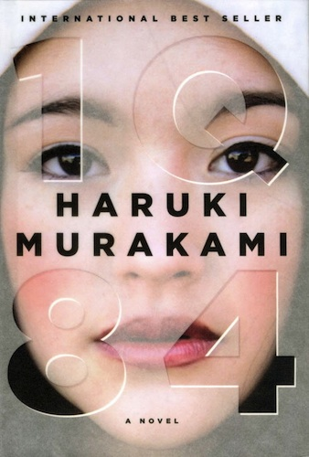

Surrealism in Paintings:
Throughout the years Surrealism paintings have range from fascinating landscapes to strange arrangements and the contrast and balance between humans and animals. Salvador Dali is one of the most famous names in the Surrealism world. He is well known for creating a dreamlike, hallucinating sight. Salvador Dali was Spanish surrealistic artists well know for his bizarre and fascinating paintings. “ The Accommodations of Desire” is a surrealist painting by Salvador Dali painted on 1929. This painting represents Dali’s affair with a married woman, this woman was Gala (Dali’s longtime partner) each pebble represents the emotions he was feeling at the time.

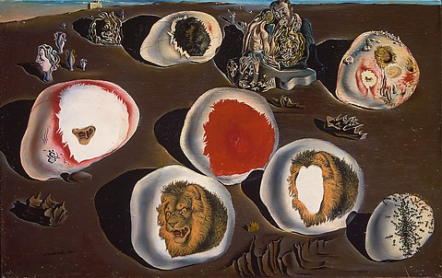

Surrealism in the world of Advertisement today:

This manipulation of images works in advertising; it helps by displaying the product in a different way, which makes it easier to sell. Luisa Via Roma Home Campaign is Barbie shot by photographer Diego Diaz is inspired by Salvador Dali’s work in surrealism. In this frame image he illustrates the playful world of fashion by using a range of hue colors with Blue as the dominant color.
