NEW ACADEMIC MINOR AND COURSE PROPOSAL

**Title of Proposal1:** Academic Minor in Hispanic Serving Health Professionals

**Title of Proposal2:** SPA 3203Spanish Medical Interpretation and Healthcare Communication

**Proposers’ Names:** Dr. David Sánchez-Jiménez and Dr. Noemí Rodríguez

**Department:** Humanities

# TABLE OF CONTENTS

Curriculum Modification Proposal Form….…………………………………………………….………………1

All Proposal Checklist……………………………….……………………………......................................................3

Proposal for an Academic Minor in Hispanic Serving Health Professionals Sponsored by the Humanities Department…………………………….………………………………………………………………….4

Curriculum Modification Proposal Form………………………………………………………………………15

All Proposal Checklist……………………………………………………………....................................................16

New Course Proposal Form……………………….………………………………………………………...………17

New Course Proposal Checklist………………….………………………………………………..……………....20

New Course Proposal Course Outline………………………………………………………………………..…21

Library Resources and Information Literacy Form…………………………………………………....….30

Section AIII: Changes in Degree Programs….…………………………………………………………..…….34

Course Need Assessment…………………………….……………………………………………………………….36

Course Design…………………………………………………………….……………………………………………….41

Chancellor’s Report Form………………….………….…………………..…………………...…………………….43

CUNY Common Core Course Submission Form…………………………….……………………………….45

Sample Syllabus……………………………………………….………………………………….………………………51

Appendix A, B, C & D.……………….………….……………..…………………………………………………….…..62

New York City College of Technology, CUNY

# CURRICULUM MODIFICATION PROPOSAL FORM

This form is used for all curriculum modification proposals. See th[e Proposal Classification Chart](http://openlab.citytech.cuny.edu/collegecouncil/files/2014/08/2013-10-09-Proposal_Classification_Chart.pdf) for information about what types of modifications are major or minor. Completed proposals should be emailed to the Curriculum Committee chair.

|  |  |  |  |
| --- | --- | --- | --- |
| **Title of Proposal** | Academic Minor in Hispanic Serving Health Professionals | | |
| **Date** |  | 9-26-2024 |  |
| **Major or Minor** | Major | | |
| **Proposer’s Name** | Dr. David Sánchez Jiménez and Dr. Noemí Rodríguez | | |
| **Department** | Humanities | | |
| **Date of Departmental Meeting in which proposal was approved** | October 10, 2024 | | |  |
| **Department Chair Name** | Dr. Ann Delilkan | | |
| **Department Chair Signature and Date** | 12-5-2024 | | |
| **Academic Dean Name** | Dr. Justin Vazquez-Poritz | | |
| **Academic Dean Signature and Date** | 12/5/24 | | |
| **Brief Description of Proposal**  (Describe the modifications contained within this proposal in a succinct summary. More detailed content will be provided in the proposal body. | Proposal for the creation of a 12-credit academic minor in Hispanic Serving Health Professionals using existing courses. Also, the proposal includes a new course, “Spanish Medical Interpretation and Healthcare Communication”, and changes to the electives in the Spanish Language Minor. This course is also included in the list of electives for the BS in Health Communication. | | |
| **Brief Rationale for Proposal**  (Provide a concise summary of why this proposed change is important to the department. More detailed content will be provided in the proposal body). | The Academic Minor in Hispanic Serving Health Professionals will be available to Spanish/English bilingual students[1] enrolled in academic major programs with 12 or more credits available in General Education Flexible Common Core and College Option requirements, specifically targeting students in baccalaureate Health Professions and Health Sciences programs. The academic minor is designed to provide students with specific healthcare knowledge, a broad range of relevant medical Spanish terminology, and medical interpretation skills for Spanish/English bilingual health professional/ health science students to become language-concordant professionals. This initiative has a dual purpose. On the one hand, to eliminate the disparities of native Spanish speakers with limited English proficiency (LEP) in our communities (1,166,777 million in New York State. Source: NYS Office of General Services, 2022 State). On the other hand, it offers new professional opportunities for Spanish/English bilingual students and future healthcare providers.  This proposal supports the efforts of the Humanities Department to improve communication in healthcare settings; the Health Sciences Department to develop a health workforce equipped to promote health equity such as access to language services in NYC health settings; and the HSI Committee by making visible the educational needs of Hispanic bilingual students and offering solutions to improve their employability in the communities in which they live. Although Lehman College offers a general minor in Spanish for the Health Professions, City Tech will be the only CUNY school to offer a minor tailored to serve the LEP Hispanic population and that includes a specific course in Spanish medical interpreting. These features will differentiate City Tech's program and consequently could draw new students or current students from other CUNY schools to our Health Professions and Health Sciences programs.    The 12-credit academic minor consists of two required intermediate and advanced Spanish courses that develop advanced medical terminology in Spanish medical interpreting and translation skills; Spanish communication in health care; cultural knowledge to better advocate for and serve the needs of Spanish speakers in the U.S.; and a basic understanding of the U.S. healthcare industry. The degree will be completed with two courses from a pool of electives from the disciplines of  Communication, Health Sciences, and Latin American Studies that will expand students' knowledge of health-related issues as well as Latine[2] and Latin American cultures.  The project for this proposal was awarded one of 19 Pathways Step Grants from the Modern Language Association (MLA) and funded by the Mellon Foundation to support faculty members in developing new structures, programs, and resources to introduce students to a range of professions in the framework of the humanities. | | |
| **Proposal History**  (Please provide history of this proposal: is this a resubmission? An updated version? This may most easily be expressed as a list). | (9-26-2024) Initial submission  (11-X-2024) Submission with signatures | | |

Please include all appropriate documentation as indicated in the Curriculum Modification Checklist.

For each new course, please also complete the New Course Proposal and submit in this document.

Please submit this document as a single .doc or .rtf format. If some documents are unable to be converted to .doc, then please provide all documents archived into a single .zip file.

**ALL PROPOSAL CHECK LIST**

|  |  |
| --- | --- |
| Completed CURRICULUM MODIFICATION FORM including: |  |
| • Brief description of proposal | X |
| • Rationale for proposal | X |
| • Date of department meeting approving the modification | X |
| • Chair’s Signature | X |
| • Dean’s Signature | X |
| Evidence of consultation with affected departments  List of the programs that use this course as required or elective, and courses that use this as a prerequisite. | X |
| Documentation of Advisory Commission views (if applicable). |  |
| Completed [Chancellor’s Report Form.](http://openlab.citytech.cuny.edu/collegecouncil/files/2014/08/2013-10-09-Chancellor_Report_Quick_Reference_Guide1.doc) | X |

**EXISTING PROGRAM MODIFICATION PROPOSALS**

|  |  |
| --- | --- |
| Documentation indicating core curriculum requirements have been met for new programs/options or program changes. | X |
| Detailed rationale for each modification (this includes minor modifications) | X |

Proposal for an Academic Minor in Hispanic Serving Health Professionals Sponsored by the Humanities Department

Major Curriculum Modification

# **Rationale**

Spanish has maintained its position as the most commonly taught language in the country since 1969 (MLA, 2007). Coupled with the continued growth of Spanish speaking communities and the prominence of Spanish heritage speakers experiencing greater opportunities to access quality higher education at universities such as CUNY, rethinking and restructuring Spanish programs along with their purpose in the U.S. is critically needed in academia and the professions. It is a call to action. In fact, Brown and Thompson (2018) - authors of *The Changing Landscape of Spanish Language Curricula -* advocate for "the creation of courses in Spanish for the professions that empower students with discipline-specific knowledge and linguistic skills, while maintaining intellectual rigor and meaningful culture learning" (Brown and Thompson, 2018: 11). Their productive research agenda for Spanish curriculum design in the twenty-first century highlights pressing curricular and programmatic issues facing Spanish postsecondary education in our time with a consideration of how to convert them into opportunities. To this effect, the academic minor presented here reflects four of the eight reforms necessary to reshape the Spanish curriculum (Brown and Thompson, 2018: 11): (a) mechanisms to institute heritage language courses, (b) experimental learning, (c) Spanish for the professions, and (d) raising student awareness of socioeconomic and sociopolitical realities among Spanish-speaking communities.

Considering the above framework, the Hispanic Serving Health Professionals Academic Minor establishes a comprehensive academic path that incorporates Spanish heritage language courses and provides interpretation skills relevant to health-related professions through a variety of experiential learning activities (e.g., cases, role-plays, and real-life simulations), all while developing students understanding the social contexts encountered by Spanish speakers as they seek care and engage with the U.S. healthcare system. Students who complete the academic minor will be prepared to serve 'limited English proficient' (LEP) Spanish speakers in hospitals, clinics, medical offices, emergency rooms, and other medical facilities.

Knowledge of medical Spanish is no longer an option in the U.S. health delivery system, but a necessity (Martinez, 2016, 2017). Of the 71 million people who speak a language other than English at home, 43 million speak Spanish. Among these, nearly 41% (43.4 million) are 'limited English proficient' (LEP) (US Census Bureau, 2024 – 1-year estimate for 2023). In New York State, there are about 1.2 million native Spanish speakers with limited English proficiency (LEP) (NYS Office of General Services, 2022). The language needs of this population are protected by New York State language access legislation and by Title VI of the Civil Rights Act of 1964, which requires all medical facilities receiving federal funding to accommodate the language needs of their patients.[3] Section 1557 of the Affordable Care Act (ACA) provides clear guidance on the rights of LEP patients and the responsibilities of providers who serve them - the first explicit federal legal interpretation of the Civil Rights Act of 1964 regarding language discrimination (Santos et al., 2023).

Such discrimination is present when there is a lack of or limited language services, which perpetuates health disparities in linguistically minoritized communities. Several studies have highlighted the importance of language-concordant healthcare professionals noting improved disease management (Fernandez *et al*., 2011 and Parker, 2017), increased medication adherence (Traylor *et al*., 2010), shared decision-making (Detz *et al*., 2014), greater patient questioning (Jaramillo *et al*., 2016), increased trust (Schenker *et al*., 2010), and less confusion and frustration (González *et al*., 2010). In light of the evidence, knowing patients' preferred languages is neither an option nor sufficient, but an essential component of quality health care that ensures positive health outcomes through the provision of relevant language services. Yet, despite the evidence, it is still too common for health providers to rely on ad hoc interpreters who have limited knowledge of practice standards, ethical protocols, and medical terminology in a patient’s preferred language (Flores, 2006; Nápoles et al., 2010; Mayo et al., 2016; Tipton & Furmanek, 2016). Other language discordance instances arise from providers overestimating their own second language skills. Like the former scenario, this too is common and dangerous, potentially resulting in tragic consequences for LEP patients (Diamond et al., 2012).

Reliance on unqualified interpreters results from a nationwide shortage of health professionals who can communicate in their patients' native languages (Flores et al., 2003; Diamond et al., 2008, 2012; Martinez, 2015; Brooks et al., 2016), which this proposal aims to address. With a social commitment to educating City Tech’s Spanish-bilingual students to be Latine concordant – particularly those enrolled in health-related programs, the academic minor aligns with the emphasis in our College mission statement to promote applied skills through a shared foundation in general education – such as humanities and languages. Also, the Minor supports City Tech’s contribution to a highly skilled health workforce as it provides students with the knowledge, cultural awareness, and skills needed to become concordant health providers, practicing inclusive care that helps eliminate health communication disparities spurred by language barriers common to LEP Spanish-speaking patients. The goal: develop a health workforce furnished with the skills to protect patients from language discordant misunderstandings that pose health risks, cause harm, and lead to adverse health outcomes. Furthermore, language can create bonds of trust and connection between speakers, which are essential to the patient-provider relationship (Juckett, 2013; Magaña, 2020).

The main objective of this proposal is to create an academic minor that will provide future Spanish/English bilingual health professionals with a foundation in the U.S. healthcare system, a wide range of relevant medical Spanish terminology, and medical interpreting skills along with the professional standard of conduct and code of ethics for medical interpreters. The program is designed to develop a cultural understanding of medicine and illness in the Hispanic world, preparing students to be socially and culturally aware of LEP Spanish-speaking patients' health-seeking approaches and challenges, and enabling them to communicate effectively when serving those patients. These elements will differentiate City Tech’s Spanish bilingual graduate in the marketplace from health professionals who lack language- and Latine-concordant skills, boosting our students’ career opportunities in the country’s multilingual settings and in other parts of the world (see Appendix A for an example of job posting).

To this end, the academic minor will prepare Spanish bilingual students – with a focus on those enrolled in Health-related Professions, Health Sciences, and Health Communication programs – to obtain medical interpreter certification from the Certification Commission for Healthcare Interpreters (CCHI) and from the National Board for Certified Medical Interpreters (CMI). One of the required courses, SPA 3203 *Spanish Medical Interpreting and Healthcare Communication*, meets the 40-hour training requirement to apply for national certification. SPA 3203 provides the introductory knowledge needed to enhance the credentials of students from the aforementioned programs or to begin a new career as medical interpreters.

The Hispanic Serving Health Professionals Academic Minor will be available to Spanish/English bilingual undergraduate students enrolled in baccalaureate degree granting academic majors with 12 or more credits of General Education Flexible Common Core and College Option requirements. It will be targeted to Spanish/English bilingual undergraduate students with an ACTFL Advanced Low proficiency level in Spanish or higher, and to heritage speakers of Spanish who have received academic instruction in the language at the same level or higher. While any qualified student can enroll, there is a focus on students from the Health Professions and Health Sciences BS programs, as well as those pursuing a BS degree in Health Communication within the Department of Humanities. Considering that the Hispanic student population – many of them heritage speakers of Spanish – make up about 34% of the student body at City Tech[4] and that 84.4% (*n*=2,062; Spring 2023) of Health Professions and Health Sciences students belong to communities of color with one out of three being Hispanic (33.15%, *n*=810, Spring 2023),[5] there is a ready audience for an academic minor of this nature. A promising source of students for the academic minor is the BS in Healthcare Policy and Management (HCPM-BS). This relatively new major grew from 71 to 331 enrolled students from its inception in Spring 2022 to Fall 2023 (City Tech Office of Assessment, Institutional Research, & Effectiveness, 2024). The structure of the HCPM-BS degree, along with a new curriculum modification to increase elective credit space, will allow students to easily accommodate the proposed academic minor within their academic plans. Additionally, the BS in Health Communication has agreed to include SPA 3203 in its list of electives, making it a pivot course that allows Health Communication students to more easily adapt their academic schedules to include this Minor.

As City Tech is a Hispanic-serving institution, the project will also contribute to the institution's transition to "servingness" for our Hispanic student population, by providing a culturally relevant curriculum and raising awareness of the importance of improving the on-campus environment and experience. The project aims to expand students' career options and meet the unique curricular needs of Hispanic students, as well as the College's diverse population, by incorporating specific topics on healthcare communication, management, services, medical Spanish, Latin American history and Latine communities in the U.S. The creation of the proposed academic minor seeks to validate students' bilingualism and can help them both broaden their career paths and navigate a competitive job market.

As pointed out in Santos et al. (2023), heritage speakers among our Spanish students are aware of the connection between language and health, because many of them have had direct experience with health disparities in their homes. Therefore, their cultural backgrounds provide a unique set of skills and knowledge that can serve as a base for further preparation for careers as medical interpreters or language-concordant healthcare professionals. This includes the need for friendlier and more attentive service in managing Hispanic patients, as is consistent with Latine cultural constructs that reflect the values this community places on concepts such as *simpatía* and *personalismo* (Magaña, 2020).

To assess receptiveness to this project among City Tech students, a pilot survey was conducted in April 2024 using a convenience sample of 105 students. From a response rate of 28.6% (*n*=30), most respondents were continuing students (83.3%, *n*=25). Disciplines represented included health sciences, social sciences, humanities, technology, engineering, and law. Nearly all respondents had or knew someone who encountered a language barrier in a health setting and believed medical interpretation should be available

across all health services. Furthermore, 70% (*n*=21) of the respondents expressed a high interest in pursuing a medical interpretation certificate, and 60% (*n*=18) were highly interested in obtaining a medical interpretation job.

The survey was revised based on student feedback and disseminated more widely between September and October 2024. A total of 94 students from multiple disciplines[6] completed the survey by October 10, 2024. As a highlight, 84% (*n*=52) expressed interest in enrolling in a Spanish medical interpretation course (from those who reported speaking Spanish [66%, *n*=62]). Among all 94 respondents, 54% (*n*=51) indicated being highly interested in obtaining a medical interpretation certificate and over a third (39%, *n*=37) noted a high interest in being employed as medical interpreters. See Table 1. below for additional results.

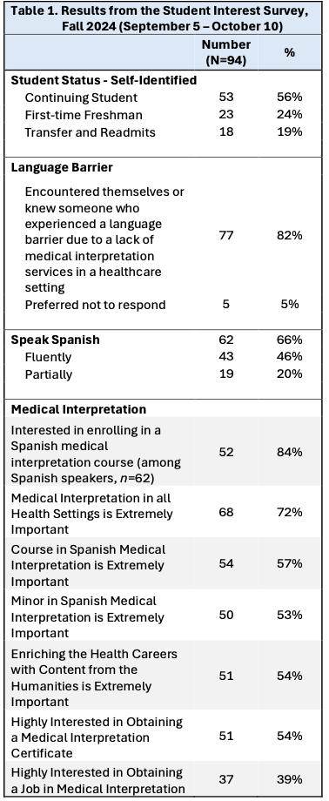

Overall, the results from both surveys (spring and fall 2024) indicate a high recognition for language access in health settings and a firm interest in medical interpretation. See Appendix B for students’ comments.

The 12-credit academic minor consists of two required intermediate and advanced Spanish courses that develop advanced medical terminology in Spanish, medical interpreting and translation skills, Spanish communication in health care, cultural knowledge to better advocate for and serve the needs of Spanish speakers in the U.S., and a basic understanding of the U.S. healthcare industry. The degree is completed with two courses from a pool of electives in Communication, Health Sciences, and Latin American Studies that will expand students' knowledge of health-related issues as well as of Latine and Latin American cultures.

This is the only program of its nature in the CUNY system. Hunter College offers a major in Translation and Interpretation that prepares students for careers in the field of translation and interpretation. At BMCC, an associate's degree in Spanish Translation and Interpretation offers a similar scope as the Translation and Interpretation major at Hunter College, although this degree enables students to specialize in Spanish translation for the health, legal, and business professions. Both programs lack the specificity and focus of the degree we are proposing to serve Hispanic LEP speakers in healthcare settings. Closer to ours is the minor in Spanish for the Health Professions offered at Lehman College. However, students in that program take a combination of Spanish courses at the 100 and 200/300 levels, and differs, therefore, from the design of the Hispanic Serving Health Professionals Minor, which integrates two required medical Spanish courses with electives from other disciplines (Communication, Health Sciences, and Latin American Studies). The latter structure differentiates our minor from other programs and, as a result, may attract new students or current students from other CUNY schools to our Healthcare Professions programs.

REFERENCES:

Brooks, K., Stifani, B., Ramírez Battle, H., Aguilera Nunez, M., Erlich, M., & Diaz, J. (2016). Patient perspectives on the need for and barriers to professional medical interpretation. Rhode Island Medical Journal, 99(1), 30–33.

Brown, A.V. & Thompson, G.L. (2018). The Changing Landscape of Spanish Language Curricula. Washington, D.C.: Georgetown University Press.

City Tech, Office of Assessment, Institutional Research, & Effectiveness. (2024). Enrollment Trends[. https://www.citytech.cuny.edu/aire/data-dashboard.aspx](https://www.citytech.cuny.edu/aire/data-dashboard.aspx)

Detz, A., Mangione, C. M., Nunez de Jaimes, F., Noguera, C., Morales, L. S., Tseng, C. H., & Moreno, G. (2014). Language concordance, interpersonal care, and diabetes self-care in rural Latino patients. Journal of General Internal Medicine, 29(12), 1650–1656.

Diamond, L., Schenker, Y., Curry, L., Bradley, E., & Fernandez, A. (2008). Getting by: Underuse of interpreters by resident physicians. Journal of General Internal Medicine, 24(2), 256–262.

Diamond, L., Tuot, D., & Karliner, L. (2012). The use of Spanish language skills by physicians and nurses: Policy implications for teaching and testing. Journal of General Internal Medicine, 27, 117–123.

Flores, G. (2006). Language barriers to health care in the United States. *New England Journal of Medicine* 355, 229-231.

Flores, G., Barton Laws, M., Mayo, S., Zuckerman, B., Abreu, M., Medina, L., & Hardt, E. (2003). Errors in medical interpretation and their potential clinical consequences in pediatric encounters. Pediatrics, 111(1), 6–14.

González, H. M., Vega, W. A., & Tarraf, W. (2010). Health care quality perceptions among foreign-born Latinos and the importance of speaking the same language. Journal of the American Board of Family Medicine, 23(6), 745–752.

Jaramillo, J., Snyder, E., Dunlap, J. L., Wright, R., Mendoza, F., & Bruzoni, M. (2016). The Hispanic Clinic for Pediatric Surgery: A model to improve parent-provider communication for Hispanic pediatric surgery patients. Journal of Pediatric Surgery, 51(4), 670–674.

Juckett, G. (2013). Caring for Latino patients. American Family Physician, 87(1), 48–54.

Magaña, D. (2020). Local voices on health care communication issues and insights on Latino cultural constructs. Hispanic Journal of Behavioral Sciences, 42(3), 300– 323. https://doi.org/10.1177/0739986320927387

Martinez, G. (2015). La lengua española en el sistema de atención sanitaria de los Estados Unidos. *Informes del Observatorio del Instituto Cervantes en Harvard*. 12 December 2015[, https://cervantesobservatorio.fas.harvard.edu/sites/default/files/013_informes_espanol_sistema_sanitario_us.pdf](https://cervantesobservatorio.fas.harvard.edu/sites/default/files/013_informes_espanol_sistema_sanitario_us.pdf) Martinez, G. (2016). Against Medical Spanish: Spanish in the Health Professions Yesterday, Today, and Tomorrow. *ADFL Bulletin*, 44.1, 9-18.

Mayo, R., Parker, V., Sherrill, W., Coltman, K., Hudson, M., Nichols, C., Yates, A., & Pribonic, A. (2016). Cutting corners: Provider perceptions of interpretation services and factors related to use of an ad hoc interpreter. Hispanic Health Care International, 14(2), 73–80. <https://doi.org/10.1177/1540415316646097>

MLA (Modern Language Association) (2007). Foreign Languages and Higher Education: New Structures for a Changed World. [https://www.mla.org/Resources/Guidelines-and-Data/Reports-and-Professional-Guidelines/Foreign-Languages-and-Higher-Education-New-](https://www.mla.org/Resources/Guidelines-and-Data/Reports-and-Professional-Guidelines/Foreign-Languages-and-Higher-Education-New-Structures-for-a-Changed-World)

[Structures-for-a-Changed-World](https://www.mla.org/Resources/Guidelines-and-Data/Reports-and-Professional-Guidelines/Foreign-Languages-and-Higher-Education-New-Structures-for-a-Changed-World)

Nápoles, A., Santoyo-Olsson, J., Karliner, L., O’Brien, H., Gregorich, S., & Perez-Stable, E. (2010). Clinician ratings of interpreter mediated visits in underserved primary care settings with ad hoc, in-person professional, and video conferencing modes. *Journal of Health Care for the Poor and Underserved*, 21(1), 301–317.

NYC Open Data (2024). Population and Languages of the Limited English Proficient (LEP) Speakers by Community District. <https://data.cityofnewyork.us/City-Government/Population-and-Languages-of-the-Limited-English-Pr/ajin-gkbp/about_data>NYS Office of General Services (2022). Language Access Plan for Limited English Proficient Individuals. New York State Department of Health. <https://ogs.ny.gov/system/files/documents/2024/05/lap-2024_dps.pdf>

Parker, M. M., Fernández, A., Moffet, H. H., Grant, R. W., Torreblanca, A., & Karter, A. J. (2017). Association of patient-physician language concordance and glycemic control for limited-English proficiency Latinos with type 2 diabetes. JAMA Internal Medicine, 177(3), 380–387.

Santos, M., Showstack, R., Martinez, G., Colcher, D, & D. Magaña (2023). Health Disparities and The Applied Linguist”. New York: Routledge.

Schenker, Y., Wang, F., Selig, S. J., Ng, R., & Fernandez, A. (2007). The impact of language barriers on documentation of informed consent at a hospital with on-site interpreter services. *Journal of General Internal Medicine*, 22(Suppl. 2), 294–299.

Tipton, R., & Furmanek, O. (2016). *Dialogue interpreting: A guide to interpreting in public services and the community.* London: Routledge.

Traylor, A. H., Schmittdiel, J. A., Uratsu, C. S., Mangione, C. M., & Subramanian, U. (2010). Adherence to cardiovascular disease medications: Does patientprovider race/ethnicity and language concordance matter? Journal of General Internal Medicine, 25(11), 1172–1177.

U.S. Census Bureau. (2024). American Community Survey: 2023: ACS-1 Year Estimates. https://data.census.gov/table/ACSDP1Y2023.DP02

U.S. Department of Health and HumanServices.(2022). “HHS Takes Action to Break Language Barriers.”, 6 October 2022, <https://www.hhs.gov/about/news/2022/10/06/hhs-takes-action-break-language-barriers.html>

## Description of the Proposed Academic Minor

The Academic Minor in Hispanic Serving Health Professionals will be available to students in academic major programs with 12 or more credits of General Education Flexible Common Core and College Option requirements. Advising for the academic minor will be provided by Prof. David Sánchez Jiménez and Prof. Noemí Rodríguez, full-time faculty in Spanish Applied Linguistics and Health Sciences, respectively, who will serve as coordinators for the minor. The program is designed to provide Spanish/English bilingual students with specific health care knowledge, a wide range of relevant medical Spanish terminology, and medical interpreting skills to become linguistically competent bilingual health professionals. It also aims to develop critical skills that future health providers can use to improve communication with Spanish-speaking patients. In addition, the curriculum is designed to raise awareness of the impact and role of language as it intersects with language access services in healthcare settings.

The academic minor consists of two (2) required courses, SPA 2203 and SPA 3203, and two (2) elective courses. To enroll in SPA 2203 and SPA 3203, students must have previously completed the prerequisites or take a placement test to determine their Spanish language background and proficiency level. The Spanish proficiency level required to enroll in SPA 3203, and therefore to declare this academic minor, is Advanced Low, according to the ACTFL proficiency levels for language learners. Students who pass SPA 2402 or higher at City Tech automatically achieve this proficiency level. Students may also opt to demonstrate this level on a placement test and receive permission from the Humanities Department.

As for the two (2) electives, students may choose from a wide variety of courses listed below in the disciplines of Communication, Health Sciences, and Latin American Studies for which they have completed the prerequisites. These include one interdisciplinary course (COM 2403ID), two writing intensive courses (COM 2406 and COM 3503), and seven courses listed in the flexible common core: two in Individual and Society (IS), two in World Cultures and Global Issues (WLGI), and three in US Experience in its Diversity (USED).

In terms of healthcare content, the Health Sciences courses provide a foundational vision of the U.S. health delivery system, health-related professions, safety in healthcare delivery, and public health. The Spanish, Health Communication, and Latin American Studies courses complement students' understanding of the value of the humanities to their careers. Overall, this project aims to build on these connections and enrich the humanities curriculum by focusing on medical content for bilingual students of Hispanic heritage and other students of Spanish with advanced language skills. To strengthen this interdisciplinary approach, the project will involve faculty from various disciplines and departments across the College.

**Required and Elective Courses for the Academic Minor**

Students must earn a C or above in all academic minor course work in order to be granted an academic minor designation on their transcripts. The table below illustrates the requirements of the Academic Minor in Hispanic Serving Health Professionals.

**REQUIRED COURSES (6 credits)**

SPA 2203 Spanish for Health Professionals (WCGI)

SPA 3203 Spanish Medical Interpretation and Healthcare Communication (USED)*

**ELECTIVE COURSES (6 credits)**

LATS 1461 Latin American History (WCGI)

LATS 2501 Latin Americans in the U.S. (USED)

COM 1403 Introduction to Communication in Healthcare Professions

COM 2403 Health Communication (IS)

COM 2403ID Health Communication (IS) (Interdisciplinary)

|  |  |
| --- | --- |
| COM 2406 Gender and Health Communication (USED) (Writing Intensive)** | |
| COM 3402 | Communicating in Multicultural Healthcare Settings** |
| COM 3403 | Health Communication and Education** |
| COM 3500 | U.S. Health Policy and Communication Advocacy** |
| COM 3501  COM 3503 | Introduction to Healthcare Interpreting**  Health, Media and Communication Technology (Writing Intensive)** |
| HSCI 1101 | Introduction to Health Delivery and Careers |
| HSCI 2200 | Safety for Health Care |
| HSCI 2301 | Health Dynamics |
| HSA 3510 | Health Services Management I |
| HSA 3560 | Legal Aspects of Health Care |

Total credits: 12

* Pending approval.

** Prerequisite for this course is COM 1403.

IS = Individual and Society, Common Core

USED = US Experience in its Diversity, Common Core

WCGI = World Cultures and Global Issues, Common Core

**Programmatic Learning Outcomes**

* Effectively perform different roles in medical simulations;
* Understand the role and responsibilities of a medical interpreter within the context of their professional standard of conduct and code of ethics;
* Identify, understand, and address cultural issues that may affect the intended communication between patient and health provider and that derive from various attitudes, beliefs, expectations and points of views of Hispanic patients living in the United States, as they relate to medical emergencies, illness, folk medicine, and medical procedures;
* Develop cultural sensitivity through an understanding of Spanish-speaking patients´ real-life situations in their country of origin and in the United States;
* Identify legal and ethical responsibilities when interacting with Spanish-speaking patients in the medical setting;
* Be prepared to take national medical interpretation certification exams.

**Assessment statement**

To assess student learning outcomes, an exit survey will be administered for students completing the minor to provide the opportunity to share overall feedback and thoughts with the academic community about the minor and how they benefitted from it. Enrollment trends will also be tracked, as well as rates of completion and grade distributions. Graduation and retention rates, successful completion and time to graduation for students declaring the minor might also be compared with those of the overall student population. Additionally, grade distributions for the classes taken by students declaring the minor could be compared with those of the general population of students who take these classes. Given the intercultural nature of the required medical interpretation course, the minor can be included in the College’s General Education assessment activities.

**Sample Curriculum Map6**

Below are sample curriculum maps for a student majoring in BS in Nursing, BS in Healthcare Policy and Management, and BS in Health Communication with an Academic Minor in Hispanic Serving Health Professionals:

|  |  |
| --- | --- |
| **Gen Ed Requirements for Nursing - BS** | **Courses for Proposed Academic Minor** |
| Flex Core/ WCGI | SPA 2203 |
| Flex Core/ USED | SPA 3203 |
| Interdisciplinary Course (ID) | COM 2403 or COM 2403ID |
| Liberal Arts Elective7 | LATS 1461 |

|  |  |
| --- | --- |
| **Gen Ed Requirements or Electives for Healthcare Policy and Management - BS** | **Courses for Proposed Academic Minor** |
| Flex Core/ WCGI | SPA 2203 |
| Flex Core/ USED or Elective | SPA 3203 |
| Two Electives8 | HSCI 1101, HSCI 2200, HSCI 2301, LATS 2501, LATS 1461, COM 1403, COM 3402, COM 3403,  COM 3500, COM 3501 or COM 3503 |

1. Only three samples are provided here to present examples of how the minor can be completed by baccalaureate-level students.
2. One or two course options for the electives are shown here as examples; however, others noted in the list of possible electives can be considered.
3. Ibid.

|  |  |
| --- | --- |
| **Gen Ed Requirements or Electives for Health Communication - BS** | **Courses for Proposed Academic Minor** |
| Flex Core/ WCGI | LATS 1461 |
| World Language Sequence | SPA 2203 |
| World Language Sequence | SPA 3203 |
| Liberal Arts Elective[7] | LATS 2501 |

As the Sample Curriculum Maps illustrate, an Academic Minor in Hispanic Serving Health Professionals can be completed in some degrees within the required credits of the degree program.

Diversity and Inclusive Education Syllabus Statement

This academic minor welcomes students from all backgrounds, experiences and perspectives. In accordance with the City Tech and CUNY missions, this academic minor intends to provide an atmosphere of inclusion, respect, and the mutual appreciation of differences so that together we can create an environment in which all students can flourish. It is the instructor’s goal to provide materials and activities that are welcoming and accommodating of diversity in all its forms, including race, gender identity and presentation, ethnicity, national origin, religion, cultural identity, socioeconomic background, sexuality and sexual orientation, ability, neurodivergence, age, etc. Your instructor is committed to equity and actively seeks ways to challenge institutional racism, sexism, ableism and other forms of prejudice. Your input is encouraged and appreciated. If a dynamic that you observe or experience in the courses included in the academic minor concerns you, you should feel free to inform your instructor without fear of any negative impact on your grade. Let your instructor know how to improve the effectiveness of the courses for you personally, or for other students or student groups. We acknowledge that NYCCT is located on the traditional homelands of the Canarsie and Lenape people.

### Section AII: Changes in College-Wide Degree Requirements

|  |
| --- |
| **A1.1. Academic Minor in Hispanic Serving Health Professionals** |
| **Learning Outcomes:**  Students will:     * Demonstrate knowledge of medical terminology in both Spanish and English and the corresponding transfer into the opposite language and use it properly in medical interactions; * Understand the role and responsibilities of a medical interpreter within the context of their professional standard of conduct and code of ethics; * Identify, understand, and address cultural issues that may affect the intended communication between patient and health provider and that derive from various attitudes, beliefs, expectations and points of views of Hispanic patients living in the United States, as they relate to medical emergencies, illness, folk medicine, and medical procedures; |

* Develop cultural sensitivity through an understanding of Spanish-speaking patients´ real-life situations in their country of origin and in the United States;
* Identify legal and ethical responsibilities when interacting with Spanish-speaking patients in a medical setting;
* Be prepared to take a national medical interpretation certification exam.

**Progression and Graduation Requirements:**

All courses must be completed with a grade of C or higher.

**Degree Requirements:**

The Spanish proficiency level required to declare this academic minor is Advanced Low according to the ACTFL proficiency levels for language learners, which students acquire by passing SPA 2402 or higher at City Tech, or by demonstrating such a level on a placement test and receiving department permission.

**REQUIRED COURSES (6 credits):**

SPA 2203 Spanish for Health Professionals (WCGI)

SPA 3203 Spanish Medical Interpretation and Healthcare Communication (USED)*

**ELECTIVE COURSES** **(Choose 2):[8]**

LATS 1461 Latin American History (WCGI)

LATS 2501 Latin Americans in the U.S. (USED)

COM 1403 Introduction to Communication in Healthcare Professions

COM 2403 Health Communication (IS)

COM 2403ID Health Communication (IS) (Interdisciplinary)

COM 2406 Gender and Health Communication (USED) (Writing Intensive)**

COM 3402 Communicating in Multicultural Healthcare Settings**

COM 3403 Health Communication and Education**

COM 3500 U.S. Health Policy and Communication Advocacy**

COM 3501 Introduction to Healthcare Interpreting**

COM 3503 Health, Media and Communication Technology (Writing Intensive)**

HSCI 1101 Introduction to Health Delivery and Careers

HSCI 2200 Safety for Health Care

HSCI 2301 Health Dynamics

HSA 3510 Health Services Management I

HSA 3560 Legal Aspects of Health Care

**Total Credits Required for the Academic Minor: 12 credits**

The minor in Hispanic Serving Health Professionals can be completed in all BS degrees and most BTech degrees within the required credits of the degree program.

**Catalog Description:**

The Academic Minor in Hispanic Serving Health Professionals is designed to provide Spanish/English bilingual students with specific healthcare knowledge, a broad range of relevant medical Spanish terminology, and medical interpretation skills for students

to become language-concordant professionals. This program will prepare City Tech students to develop a cultural understanding of medicine and illness in the Hispanic world to enhance the student's skills in serving Spanish-speaking patients with limited English proficiency. In addition, this valuable knowledge will boost students’ career opportunities in the country’s multilingual settings and in other parts of the world. The 12-credit academic minor consists of two required medical Spanish courses, SPA 2203 and SPA 3203, and two courses from a pool of electives in Communication, Health Sciences, and Latin American Studies.

New York City College of Technology, CUNY

## CURRICULUM MODIFICATION PROPOSAL FORM

This form is used for all curriculum modification proposals. See th[e Proposal Classification Chart](http://openlab.citytech.cuny.edu/collegecouncil/files/2014/08/2013-10-09-Proposal_Classification_Chart.pdf) for information about what types of modifications are major or minor. Completed proposals should be emailed to the Curriculum Committee chair.

|  |  |  |  |
| --- | --- | --- | --- |
| **Title of Proposal** | Spanish Medical Interpretation and Healthcare Communication | | |
| **Date** |  | September 26, 2024 |  |
| **Major or Minor** | Major modification | | |
| **Proposer’s Name** | Dr. David Sánchez-Jiménez and Dr. Noemí Rodríguez | | |
| **Department** | Humanities | | |
| **Date of Departmental Meeting in which proposal was approved** | October 10, 2024 | | |  |
| **Department Chair Name** | Dr. Ann Delilkan | | |
| **Department Chair Signature and Date** | **12-5-2024** | | |
| **Academic Dean Name** | Dr. Justin Vazquez-Poritz | | |
| **Academic Dean Signature and Date** | **12/5/24** | | |
| **Brief Description of Proposal**  (Describe the modifications contained within this proposal in a succinct summary. More detailed content will be provided in the proposal body. | This new elective course introduces the principles, guidelines, and standards of professional interpreting as established by the National Council on Interpreting in Healthcare (NCIHC) and the International Medical Interpreters Association (IMIA). This course focuses on medical terminology in English and Spanish, the different modes of interpretation (simultaneous, consecutive, sight, and telephone), the different roles of the interpreter, the NCIHC and IMIA Standards of Practice and Code of Ethics, the importance of cultural awareness for medical interpreters, and a description of national certifications for medical interpreters. | | |
| **Brief Rationale for Proposal**  (Provide a concise summary of why this proposed change is important to the department. More detailed content will be provided in the proposal body). | The course represents a continuation of the efforts initiated with the creation of SPA 2203 *Spanish for Health*  *Professionals* in 2017, which aims to expand the specific knowledge in medical Spanish of City Tech students, particularly those enrolled in Health Professions and Health Sciences programs. This expertise is of paramount importance for these students in the United States, which is the second largest Spanish-speaking country in the world. Moreover, the Department of Health and Human Services[9] issued a final rule in April 2024 that ensures  “nondiscriminatory access to care for all, including […] people with limited English proficiency (LEP).” Therefore, the primary objective of this new course is to provide comprehensive language instruction in medical interpretation to students enrolled in health-related | | |

|  |  |  |  |  |
| --- | --- | --- | --- | --- |
|  | academic programs within the School of Professional Studies, as well as to those pursuing a BS degree in Health Communication within the Humanities Department.  Admission to this course is contingent upon the completion of an advanced proficiency level of Spanish. The content and skills learned in this course will equip Spanish/ English bilingual students with the introductory knowledge needed to pursue a career as qualified medical interpreters, thereby opening a new avenue of professional opportunity for City Tech students. Successful participants may choose to sit for the national medical interpreter certification exams offered by the Certification Commission for Healthcare Interpreters (CCHI) and the National Board for Certified Medical Interpreters (CMI), as this course meets the 40-hour training requirement to apply for the national certification exams offered by these institutions.  Furthermore, the specialized knowledge acquired in this course will enable future professionals to serve as mediators between Spanish-speaking patients with LEP and their health providers to help people connect across language barriers, eliminate disparities, and improve patient outcomes. (LEP population of Spanish origin in NY = 1,166,777. Source: NYS Office of General Services, 2022). To this end, the course will be incorporated into the new *Hispanic Serving Health Professionals* Minor proposed for  Spring 2025. In addition, the course will be included in the Spanish Language Minor for those students who wish to become familiar with the field of Spanish for medical purposes. | | | |
| **Proposal History**  (Please provide history of this proposal: is this a resubmission? An updated version? This may most easily be expressed as a list). |  | 09-26-2024- New course proposal |  | |
| 11-X-2024- Submission with signatures | | s |
|  | |

**ALL PROPOSAL CHECK LIST**

|  |  |
| --- | --- |
| Completed CURRICULUM MODIFICATION FORM including: |  |
| • Brief description of proposal | X |
| • Rationale for proposal | X |
| • Date of department meeting approving the modification | X |
| • Chair’s Signature | X |
| • Dean’s Signature | X |
| Evidence of consultation with affected departments  List of the programs that use this course as required or elective, and courses that use this as a prerequisite. | N/A |
| Documentation of Advisory Commission views (if applicable). | N/A |
| Completed [Chancellor’s Report Form.](http://openlab.citytech.cuny.edu/collegecouncil/files/2014/08/2013-10-09-Chancellor_Report_Quick_Reference_Guide1.doc) | X |
| **EXISTING PROGRAM MODIFICATION PROPOSALS** |  |
| Documentation indicating core curriculum requirements have been met for new programs/options or program changes. | N/A |
| Detailed rationale for each modification (this includes minor modifications) | N/A |

New York City College of Technology, CUNY

# NEW COURSE PROPOSAL FORM

This form is used for all new course proposals. Attach this to th[e Curriculum Modification Proposal Form](http://openlab.citytech.cuny.edu/collegecouncil/files/2014/08/2013-10-10-Curriculum_Modification_Proposal_Form.docx) and submit as one package as per instructions. Use one New Course Proposal Form for each new course.

|  |  |
| --- | --- |
| **Course Title** | Spanish Medical Interpretation and Healthcare Communication |
| **Proposal Date** | September 20, 2024 |
| **Proposer’s Name** | Dr. David Sánchez-Jiménez and Dr. Noemí Rodríguez |
| **Course Number** | SPA 3203 |
| **Course Credits, Hours** | 3 credits, 3 hours |
| **Course Pre / Co-Requisites** | SPA 2402 or higher; or placement test and department permission |
| **Catalog Course Description** | This foundational medical interpretation course provides comprehensive instruction for Spanish/ English bilingual students to serve as language mediators between Spanish-speaking patients with limited English proficiency and their health providers. Students will gain key skills to become effective medical interpreters. The course covers modes of interpretation, medical terminology in English and Spanish, U.S. health systems, legal protocols and requirements in healthcare interpretation, cultural responsiveness, and the roles, responsibilities, codes of ethics, and standards of practice for medical interpreters. |
| **Brief Rationale**  Provide a concise summary of why this course is important to the department, school or college. | The course represents a continuation of the efforts initiated with the creation of SPA 2203 *Spanish for Health Professionals* in 2017, which aims to expand the specific knowledge in medical Spanish of City Tech students, particularly those enrolled in Health  Professions and Health Sciences programs. This expertise is of paramount importance for these students in the United States, which is the second largest Spanish speaking country in the world. Moreover, the Department of Health and Human Services[10] issued a final rule in April 2024 that ensures “nondiscriminatory |

|  |  |
| --- | --- |
|  | access to care for all, including […] people with limited English proficiency (LEP).” Therefore, the primary objective of this new course is to provide comprehensive language instruction in medical interpretation to students enrolled in health-related academic programs within the School of Professional Studies, as well as to those pursuing a BS degree in Health Communication within the Humanities Department. Admission to this course is contingent upon the completion of an advanced proficiency level of Spanish. The content and skills learned in this course will equip Spanish/ English bilingual students with the introductory knowledge needed to pursue a career as qualified medical interpreters, thereby opening a new avenue of professional opportunity for City Tech students.  Successful participants may choose to sit for the national medical interpreter certification exams offered by the Certification Commission for Healthcare Interpreters  (CCHI) and the National Board for Certified Medical Interpreters (CMI), as this course meets the 40-hour training requirement to apply for the national certification exams offered by these institutions.  Furthermore, the specialized knowledge acquired in this course will enable future professionals to serve as mediators between Spanish-speaking patients with LEP and their health providers to help people connect across language barriers, eliminate disparities, and improve patient outcomes. (LEP population of Spanish origin in NY = 1,166,777. Source: NYS Office of General Services, 2022). To this end, the course will be incorporated into the new *Hispanic Serving Health Professionals* Minor proposed for Spring 2025. In addition, the course will be included in the Spanish Language Minor for those students who wish to become familiar with the field of Spanish for medical purposes. |
| **CUNY – Course Equivalencies** Provide information about equivalent courses within CUNY, if any. | Although many CUNY colleges offer general courses in interpreting and translation or specific courses in English/Spanish interpreting, such as Spanish for Legal Studies (John Jay, LaGuardia), only BMCC offers an equivalent course in medical interpreting for bilingual students as part of its Associate in Arts in Modern Languages: TRS 233 *Spanish Translation & Interpretation for Healthcare*. At the graduate level, Hunter offers TRNS  75600 - *Spanish-English Medical Interpreting* in its  Master of Arts in Translation and Interpreting. Many  CUNY campuses (e.g., CSI, BMCC, Lehman College, City College, etc.) offer an equivalent online course in medical interpreting through Continuing Education of 40 hours or more, which prepares students to seek national certification in medical interpreting. |
|  | Within the Humanities Department, this new course shares some content, goals, and values with COM 3501 *Introduction to Healthcare Interpreting*. However, our course is tailored to Spanish/English bilinguals and their needs for medical interpreting in their interactions with Spanish-speaking patients with limited English proficiency.  Our course, SPA 3203, will be the only one of its kind, as it will be part of a minor focused on Spanish Healthcare Communication and Interpreting. It will complement other health-related and Spanish courses to broaden the knowledge acquired by bilingual speakers enrolled in a variety of programs at City Tech, predominantly those in the Health Professions and Health Sciences. |
| **Intent to Submit as Common Core**  If this course is intended to fulfill one of the requirements in the common core, then indicate which area. | Yes. US Experience in its Diversity |
| **For Interdisciplinary Courses:**   * Date submitted to ID Committee for review * Date ID recommendation received * Will all sections be offered as ID? Y/N | N/A |
| N/A |
| N/A |
| **Intent to Submit as a Writing Intensive Course** | No |

Please include all appropriate documentation as indicated in the NEW COURSE PROPOSAL. Combine all information into a single document that is included in the Curriculum Modification Form.

## NEW COURSE PROPOSAL CHECK LIST

Use this checklist to ensure that all required documentation has been included. You may wish to use this checklist as a table of contents within the new course proposal.

|  |  |
| --- | --- |
| **Completed NEW COURSE PROPOSAL FORM** |  |
| • Title, Number, Credits, Hours, Catalog course description | X |
| • Brief Rationale | X |
| • CUNY – Course Equivalencies | X |
| Completed [Library Resources and Information Literacy Form](https://openlab.citytech.cuny.edu/collegecouncil/files/2014/08/curriculum_modification_library_form-rev3F16.doc) | X |
| **Course Outline**  Include within the outline the following. |  |
| Hours and Credits for Lecture and Labs  If hours exceed mandated Carnegie Hours, then rationale for this | X |
| Prerequisites/Co- requisites | X |
| Detailed Course Description | X |
| Course Specific Learning Outcome and Assessment Tables   * Discipline Specific * General Education Specific Learning Outcome and Assessment Tables | X |
| Example Weekly Course outline | X |
| Grade Policy and Procedure | X |
| Recommended Instructional Materials (Textbooks, lab supplies, etc) | X |
| Library resources and bibliography | X |
| **Course Need Assessment.**  Describe the need for this course. Include in your statement the following information. |  |
| Target Students who will take this course. Which programs or departments, and how many anticipated?  Documentation of student views (if applicable, e.g. non-required elective). | X |
| Projected headcounts (fall/spring and day/evening) for each new or modified course. | X |
| If additional physical resources are required (new space, modifications, equipment), description of these requirements. If applicable, Memo or email from the VP for Finance and Administration with written comments regarding additional and/or new facilities, renovations or construction. | N/A |
| Where does this course overlap with other courses, both within and outside of the department? | X |
| Does the Department currently have full time faculty qualified to teach this course? If not, then what plans are there to cover this? | X |
| If needs assessment states that this course is required by an accrediting body, then provide documentation indicating that need. | N/A |
| **Course Design**  Describe how this course is designed. |  |
| Course Context (e.g. required, elective, capstone) | X |
| Course Structure: how the course will be offered (e.g. lecture, seminar, tutorial, fieldtrip)? | X |
| Anticipated pedagogical strategies and instructional design (e.g. Group Work, Case Study, Team Project, Lecture) | X |
| How does this course support Programmatic Learning Outcomes? | X |
| Is this course designed to be partially or fully online? If so, describe how this benefits students and/or program. | No |
| **Additional Forms for Specific Course Categories** |  |
| [Interdisciplinary Form](http://openlab.citytech.cuny.edu/collegecouncil/files/2014/08/Application-for-Interdisciplinary-Course-Designation.docx) (if applicable) | N/A |
| Interdisciplinary Committee Recommendation (if applicable and if received)*  *Recommendation must be received before consideration by full Curriculum Committee | N/A |
| [Common Core (Liberal Arts) Intent to Submit](http://openlab.citytech.cuny.edu/collegecouncil/files/2014/08/CommonCoreCourseSubmissionForm_4.2.12.doc) (if applicable) | X |
| Writing Intensive Form if course is intended to be a WIC (under development) | N/A |
| If course originated as an experimental course, then results of evaluation plan as developed with director of assessment. | N/A |
| **(Additional materials for** [**Curricular Experiments)**](http://www.300jaystreet.com/college-council/curriculum_proposals/curricular-experiments) |  |
| Plan and process for evaluation developed in consultation with the director of assessment. (Contact Director of Assessment for more information). | N/A |
| Established Timeline for Curricular Experiment | N/A |

SPA 3203 Spanish Medical Interpretation and Healthcare Communication

NEW YORK CITY COLLEGE OF TECHNOLOGY

CITY UNIVERSITY OF NEW YORK

HUMANITIES DEPARTMENT

### *Course Outline*

**Spanish Medical Interpretation and Healthcare Communication**

Course code: SPA 3203

Instructor: David Sánchez Jiménez, PhD

Email: dsanchezjimenez@citytech.cuny.edu

Office hours: Tue & Thu from 3:00 pm to 4:00 pm, and by appointment

Office: L630

Credits: 3 credits

Hours: 3 class hours

Prerequisites: SPA 2402 or higher; or placement test and department permission

## Course Description

This foundational medical interpretation course provides comprehensive instruction for Spanish/ English bilingual students to serve as language mediators between Spanish-speaking patients with limited English proficiency and their health providers. Students will gain key skills to become effective medical interpreters. The course covers modes of interpretation, medical terminology in English and Spanish, U.S. health systems, legal protocols and requirements in healthcare interpretation, cultural responsiveness, and the roles, responsibilities, codes of ethics, and standards of practice for medical interpreters.

## Instructional materials

*Textbook:*

* Bancroft, M.A., García-Beyaert, S., Allen, K., Carriero-Contreras, G., & SocarrásEstrada, D. (2016). *The Medical Interpreter: A Foundation Textbook for Medical Interpreting* (M. A. Bancroft, Ed.). Columbia, Maryland: Culture & Language Press. ISBN: 978-0-9966517-3-8

*Suggested Text:*

* Purchase an adequate Spanish/English, English/Spanish bilingual dictionary and English/Spanish medical dictionary.
* Bancroft, M.A., Dallman, H., Little, E., Schrage, S.S. (2019). Medical Terminology for Interpreters .4th ed. Columbia, MD: Culture and Language Press. **ISBN:** 9780996651776
* Additional relevant and timely open-source resources will be provided to students.

## Course Specific Learning Outcomes and Assessment Methods

|  |  |
| --- | --- |
| LEARNING OUTCOMES | ASSESSMENT METHODS |
| Explain the role and professional responsibilities of medical interpreters and their code of ethics. | Lectures, class discussions on relevant topics, homework assignments, in-class activities, research. Content will be incorporated into quizzes and exams with a focus on scenario-based questions. |
| Discuss key aspects of the U.S. healthcare system, workforce and patient safety protocols, legal protocols and requirements for healthcare interpreting, and standards of practice for medical interpreters. | Lectures, class discussions on relevant topics, homework assignments, in-class activities, research. Content will be incorporated into quizzes and exams with a focus on scenario-based questions. |
| Apply code of ethics, different modes of interpreting (simultaneous, consecutive, sight, and telephone), decision-making skills and team skills to medical scenarios. | Role-plays based on clinical case studies provided to students will be discussed in class for them to perform different roles (patient, provider, interpreter) focuses on that specific situation. Scenario-based quiz and exam questions.    Develop a skit or dialogue for a simulation and write narratives for the midterm and final examination. |
| Apply best-practice techniques for responding effectively to interpretational, cultural, and advocacy issues. | Within the framework of legal protocols in healthcare, students will explore techniques for advocating for disadvantaged patients in a healthcare setting. Cases assignments will explore this content, and medical simulations will apply the techniques. Scenario-based quiz and exam questions. |
| Identify and understand the disparities that affect limited English proficient patients. | Through class discussions and research projects, students understand the types of language barriers experienced by limited English proficient patients. |
| Recognize the impact of social, cultural, and religious differences; historical experiences; social/regional contexts and settings; and personal attitudes and experiences on the provider-patient communication relationship. | Class discussions are based on the cultural readings and health-related videos shown in class. The content of these discussions will be incorporated into the quizzes, midterm and final exams (with a focus on scenario-based questions), and the evaluation of the medical simulations and written assignments. |
| Identify the Hispanic linguistic and cultural idiosyncrasies that affect the delivery of healthcare services to Spanish-speaking patients | Class discussions are based on cultural readings and health-related videos shown in class. The content of these discussions will be incorporated into the quizzes, midterm and final exams (with a focus on scenario-based questions), and evaluation of the simulation and written assignments. |
| Be proficient in Spanish and English medical terminology | Exams, quizzes, oral assessments, and roleplay |
| Be prepared to take any one of the national medical interpretation exams | Scenario-based quiz and exam questions. Oral assessments through role plays and simulation |
| Analyze skills gained to be effective medical interpreters and their relevance to real-world application. | Students complete a self-assessment of the skills learned in the course and evaluate the benefits of real-world application of these skills. |

## General Education Learning Outcomes and Assessment Methods

|  |  |
| --- | --- |
| LEARNING OUTCOMES | ASSESSMENT METHODS |
| **KNOWLEDGE:** Through assigned readings and independent research, students will learn historical information related to the development of new policies in the U.S. healthcare system designed to address the needs of patients with limited English proficiency. | Students' reflections on readings and class discussions are assessed through daily class discussions with peers and the instructor, homework assignments, research projects, quizzes, and written exams. |
| **SKILLS:** Students will learn to communicate with providers and patients as medical interpreters, using the different modes of interpretation, specific terminology and medical expressions to successfully mediate between them according to the. interpreter's code of ethics and standards of practice. | Students will be assessed using rubrics that evaluate their performance during medical simulations. Quizzes, homework, and exam questions are used to objectively assess the knowledge behind these skills. |
| **VALUES, ETHICS, AND**  **RELATIONSHIPS (including**  **Intercultural Knowledge and**  **Competence):** Develop informed competency in legal protocols, code of ethics, and standards of practice to work as a medical interpreter, be aware of cultural differences and perspectives from the Latine community, and advocate in response to a patient with language barriers considering existing policies to eliminate disparities in a healthcare setting. | This will be measured in daily class discussions with peers and the instructor, research projects based on primary documents, medical simulations, homework assignments, quizzes, and written exams. |

**Weekly course outline**

The schedule below shows the outline of the class calendar. A more specific, day-by-day schedule of assignments is provided as we go along for each of chapter. Students are to refer to this schedule as they prepare for each class.

|  |  |  |
| --- | --- | --- |
| **WEEK** | **DISCUSSION TOPIC** | **ASSIGNMENTS** |
| **1** | Course introduction. Review of basic interpreting concepts. The medical interpreting profession. Roles of the interpreter. Medical interpreter credentials and certification exams | Course presentation and structure. Reading TBA.  Pre-assessment (sample interpreter exam) |
| **2** | A code of ethics for medical interpreters. Facing ethical challenges. Protocols for medical interpreting | Homework |
| **3** | Stages and steps of the encounter. Modes of interpreting | Homework. Quiz. Medical terminology exercises. Class reflection on difficulties and problem solving in interpreting |
| **4** | Remote interpreting. Note-taking for medical interpreting | Homework. Sight translation of doctor-patient dialogues. Reading TBA |
| **5** | The strategic mediation model. How to perform cultural medication. Techniques for cultural mediation | Medical terminology exercises. Note-taking exercises. Consecutive interpretation exercises |
| **6** | Professional identity. Professional practice. The U.S. Healthcare System | Homework. Quiz. Role-play. Consecutive interpretation exercises |
| **7** | Review. Midterm | Research project outline submission |
| **8** | Language access laws. Legal interpreting in healthcare | Homework. Medical terminology exercises. Consecutive interpretation exercises with note taking |
| **9** | National standards of practice | Quiz. Role play |
| **10** | Communicative autonomy. Intercultural mediators | Reading TBA. Feedback on research project |
| **11** | Interpretation and mediation. Deciding when to intervene | Homework. Reading TBA. Role play. Medical terminology exercises |
| **12** | Advocacy and medical interpreters. Culturally responsive mediation | Quiz. Simultaneous interpretation exercises |
| **13** | Self-care and personal wellness. Professional development and continuing education | Medical terminology exercises. Role play. |
| **14** | Medical Interpretation Simulations. Reviews | Grades discussion |
| **15** | Medical Interpretation Simulations. Final exam | Post-assessment (sample interpreter exam) |

**Grade policy and procedure**

*Breakdown of final grade Grading scale*

10 Quizzes 20% A 93-100

2 Medical simulations 20% A- 90-92.9

Pre- & Post-assessment 5% B+ 87-89.9

Midterm 10% B 83-86.9

Final exam 15% B- 80-82.9

Class participation 15% C+ 77-79.9

Homework 15% C 70-76.9

D 60-69.9

F 59.9 and below

WU Unofficial Withdrawal

WF Withdrew Failing

**Assessments**

1. ***Quizzes***: Quizzes are designed to assess medical terminology, comprehension of course readings, and theoretical concepts discussed in class and in the textbook. Quizzes will also help students assess their own learning and guide them into a daily study habit. **There will be no make-up quizzes for any reason, including tardiness or absences.**
2. ***Medical simulations*:** This strategy involves students responding to the environment in a real-world situation. Simulation often helps students empathize with a patient's perspective or better understand an event. Clinical case studies in medical specialties are provided to contextualize the situation. In these presentations, students demonstrate developed healthcare communication and medical interpretation skills related to the lessons discussed in the course. Videos and role-plays prepare students for this task. The instructor will evaluate the student's performance according to the techniques, vocabulary, and expressions learned during the semester and emphasized by the instructor for each simulation. **Students who fail the medical simulation will NOT BE ALLOWED to make up the simulation or submit additional work.**
3. ***Pre- & Post-assessments*:** Students will take a pre-assessment and a post-assessment (sample interpreter exams) to gauge learning throughout the semester and to be exposed to a sample CCHI exam. The former will be taken at the beginning of the semester and the latter at the end of the semester.
4. ***Midterm and final examination***: Exams cover all aspects of the readings, the lecture and the class discussion. Exams serve to evaluate students’ understanding of the theoretical, linguistic and cultural topics discussed in the course. Both are closed-book/closed-notes examinations.

Make-up policy*:* Examinations must be taken at the time established in the syllabus. When absent on the day of the examination, a student is allowed to take the examination before or on the next class meeting **only in case of documented medical emergencies. Students who contact the instructor after they have missed the class will not be allowed to make up the exam**. If the exam is not taken before or on the next class meeting, the student will receive 0 points for the exam.

1. **Class participation**: Active participation is an essential part of the learning process and it is expected from all enrolled students. Participation means maintaining an active presence in the class by answering questions from the instructor, volunteering for and participating in class activities. There will be a significant deduction of points for students who regularly fail to answer the instructor’s questions or participate in the class activities. **Simply attending class does not constitute participation.** Other aspects considered under class participation include constant demonstration of active listening when others speak, and collaboration with fellow students in in-class activities. An objective way to evaluate student participation will be by providing exit tickets at the end of the session. Exit tickets will ask students to give a brief summary of the topics covered in class.

Working outside the class***:*** Students are also responsible for working each day outside of class to learn as much as possible through readings, assignments and research that you will share in class. Students are expected to invest at least three (3) hours of combined in-class and out-of-class work per week for each academic unit (credit) of coursework; thus, a 3-credit course will typically require a minimum of nine (9) hours of work per week (180 hrs./semester). Plan on spending at least six (6) hours per week outside of class. You will need this time to read the textbook and articles, memorize and practice the vocabulary, complete homework, elaborate essays, and prepare the oral activities assigned. Students should always look for ways (learning strategies) to grow and develop linguistic proficiency in and outside the classroom.

1. **Homework**: Homework is assigned on a regular basis for knowledge reinforcement and further practice class activities. The student is responsible for completing homework every day before class as well as for those activities assigned by the instructor in the textbook and other sources. **No late work is accepted.**

**Bibliography**

*Didactic materials*

* Academy of Interpretation. (2024). *The Professional Medical Interpreter: A Comprehensive 40-hour Medical Interpreting Course.* Independently published.
* Bancroft, M.A., Dallman, H., Little, E., Schrage, S.S. (2019). Medical Terminology for Interpreters. 4th ed. Columbia, MD: Culture and Language Press.
* Bancroft, Marjory, García Beyaert, Sofia, Allen, Katherine, Carriero-Contreras, Gio- vanna & Socarrás-Estrada, Denis. (2015). *The Community Interpreter: An International Textbook*. Columbia, MD: Culture and Language Press.
* Collins, C.E. (2014). *A Short Course in Medical Terminology* (Third ed.). Philadelphia: Wolters Klumer.
* Cotton, Christina E., et al. (2005). *A su salud! Spanish for Health Professionals*. New Haven: Yale UP. (2 DVDs and 1 CDRom).
* Florián, L. & Ruiz, A.M.ª (2005). *Ciencias de la Salud*. Madrid: Universidad de Alcalá de Henares.
* González, E. (2006). Medical Interpreter’s Manual. Ann Arbor: Copley Custom Textbooks.
* González-Lee, T., & H. Simon (2011). *Medical Spanish: Interviewing the Latino patient. A cross-cultural perspective.* Pearson.
* Hill, Ch., Bender, D, Carl, L. Harlan, Ch., Henshaw, R., Lorch, C., Lunsford, E. & E. Tolman (2011). *Interactive Video on DVD for ¡Salud!* Pearson.
* Jarvis, A. & Lebredo, R. (2006). *Spanish for Medical Personnel*. Boston: Houghton Mifflin, 2006.
* Kelz, R. (1999). *Conversational Spanish for Health Professionals.* Albany: Delmar Publishers.
* Ortega Pilar. (2015). *Spanish and the Medical Interview: A Textbook for Clinically Relevant Medical Spanish*, 2nd ed. Philadelphia, PA: Elsevier.
* Reiss-Koncar, Suzanna. (2022). *The Healthcare Interpreter.* Columbia, MD: Culture and Language Press.
* Rosa de Juan, C., de Prada, M., Marcé, P. & Salazar, D. (2009). Temas de salud. Madrid: Edinumen.
* Rush, P. (2003). *Spanish for HealthCare, Textbook and Workbook*. Prentice Hall.
* Schiavo, R. (2007). *Health Communication: From theory to practice.* San Francisco: Jossey Bass.

*General bibliography*

* Anderson L, et. al. (2003). Culturally competent health care systems: A Systematic review. *Am J Prev Med* 24: 68-79
* Armus, D. (2003). *Disease in the History of Modern Latin America: From Malaria to AIDS.* Durham, NC: Duke University Press.
* Armus, D. (2002). *Entre médicos y curanderos. Cultura, historia y enfermedad en la América Latina moderna.* Buenos Aires: Grupo Editorial Norma.
* Becker G. (2004). Deadly inequality in the health care “safety net”: Uninsured ethnic minorities’ struggle to live with lifethreatening illnesses. *Medical Anthropology Quaterly* 18: 258-275.
* Cheng E, A. Chen, & W. Cunningham. (2007). Primary language and receipt of recommended health care among Hispanics in the United States*. J Gen Intern Med* 22 (suppl 2): 283-288.
* Creeze, I. H, M. Holly, & L. Monzon-Storey. (2015). *Introduction to Healthcare for Spanish-speaking Interpreters and Translators.*Amsterdam: John Benjamins.
* Davidson B. (2000). The interpreter as institutional gatekeeper: The social-linguistic role of interpreters in Spanish-English medical discourse. *Journal of Sociolinguistics* 4: 379-405.
* De la Torre, A & A Estrada (2001). *Mexican Americans and Health: ¡Sana, Sana!* Tucson: University of Arizona Press.
* Derose, K, J. Escarce, & N. Lurie. (2007). Immigrants and health care: Sources of vulnerability. *Health Affairs* 26: 1258-1268.
* Flores, G. (2006). Language barriers to health care in the United States. *New England Journal of Medicine* 355: 229-231.
* Frenk, J. (2000). *La salud de la población: Hacia una nueva salud pública*. México: Fondo de Cultura Económico.
* Glanz, K., Rimer, B., & Viswanath, K. (2008). *Health Behavior and Health Education: Theory, research, and practice.* 4th edition. San Francisco: Jossey Bass.
* Gregg J and S Soha. (2007). Communicative competence: A framework for understanding language barriers in health care. *J. Gen Inter Med* 22 (suppl 2): 368-370. *it.* New York: Kaplan.
* Hasnain-Wynia R., J. Yonek, D Pierce, R. Kang & C. Hedges Greising. (2006). *Hospital language services for patients with limited English proficiency: Results from a national survey.* Chicago: Health Research and Educational Trust.
* Institute of Medicine. (2002). *Speaking of Health: Assessing health communication strategies for diverse populations.* Washington, DC: National Academies Press.
* Institute of Medicine. (2004). *Health Literacy: A Prescription to end confusion*. Washington, DC: National Academies Press.
* Karliner L, E. Jacobs, A. H. Chen & S. Mutha. (2007). Do professional interpreters improve clinical care for patients with limited English proficiency? A systematic review of the literature. *Health Services Research* 42: 727-754.
* Ku. L & S. Matani. (2001). Left out: Immigrants’ access to health care and insurance. *Health Affairs* 20: 247-256.
* Mohanty, S. (2006). *Unequal access: Immigrants and US health care.* Washington DC: American Immigration Law Foundation.
* Pochhacker, F. (2004). *Introducing Interpreting Studies*. London and New York: Routledge.
* Roat, C.E. (2014). *Healthcare Interpreting in Small Bites: 50 Nourishing Selections from the “Pacific Interpreters Newsletter” 2002-2012.* Bloomington: Trafford publishing.
* Rudvin, M. & Tomassini, E. (2011). *Interpreting in the Community and Workplace: A practical Guide*. New York. Palgrave Mcmillan.
* Weiss L, T Bauer, C Hill, J Fuld, and J Bergman. (2006). *Language as a barrier to health care for New York City children in immigrant families.* New York: The New York Academy of Medicine.
* Wilson E, A. Chen, K. Grumbach, F. Wang, & A. Fernandez. 2005. Effects of limited English proficiency and physician language on health care comprehension. *J Gen Intern Med* 20: 800-806.

**LIBRARY RESOURCES & INFORMATION LITERACY: MAJOR CURRICULUM MODIFICATION**

Please complete for **all** major curriculum modifications. This information will assist the library in planning for new courses/programs.

Consult with your library faculty subject specialist ([http://cityte.ch/dir)](http://cityte.ch/dir) **3 weeks before the proposal deadline**.

**Course proposer:** please complete boxes 1-4. **Library faculty subject specialist:** please complete box 5.

|  |  |
| --- | --- |
| **Title of proposal**  SPA 3203 Spanish Medical Interpretation and  Healthcare Communication | **Department/Program** Humanities |
| **Proposed by** (include email & phone)  Dr. David Sánchez-Jiménez  (DSanchezjimenez@citytech.cuny.edu)  Dr. Noemí Rodríguez  (NRodriguez@citytech.cuny.edu) | **Expected date course(s) will be offered** Spring 2025  **# of students:**  **25** |

**1**

|  |
| --- |
| **The library cannot purchase reserve textbooks for every course at the college, nor copies for all students. Consult our website (**[**http://cityte.ch/curriculum)**](http://cityte.ch/curriculum) **for articles and ebooks for your courses, or our open educational resources (OER) guide (**[**http://cityte.ch/oer)**](http://cityte.ch/oer)**. Have you considered using a freely-available OER or an open textbook in this course?**    The majority of the texts and materials listed to further enhance the field of medical interpretation, particularly in the context of Spanish medical interpretation, are available for use at the City Tech Library; every attempt will be made to buy items that are not. Additionally, materials are made available to students through Open Educational Resource’s, resource sharing agreements with other CUNY and SUNY schools, as well as other resource sharing partnerships. We propose the acquisition of the materials enumerated below as supplementary resources:     * Academy of Interpretation. (2024). *The Professional Medical Interpreter: A Comprehensive 40-hour Medical*   *Interpreting Course.* Independently published. **ASIN:** B0DD3SX65B   * Bancroft, M.A., Dallman, H., Little, E., Schrage, S.S. (2019). Medical Terminology for Interpreters. 4th ed. Columbia, MD:   Culture and Language Press. **ISBN:** 978-0996651776   * Bancroft, Marjory, García Beyaert, Sofia, Allen, Katherine, Carriero-Contreras, Gio- vanna & Socarrás-Estrada, Denis.   (2015). *The Community Interpreter: An International Textbook*. Columbia, MD: Culture and Language Press. **ISBN:** 9780982316672   * Ortega Pilar. (2015). *Spanish and the Medical Interview: A Textbook for Clinically Relevant Medical Spanish*, 2nd ed.   Philadelphia, PA: Elsevier. **ISBN:** 978-0323371148   * Reiss-Koncar, Suzanna. (2022). *The Healthcare Interpreter.* Columbia, MD: Culture and Language Press. **ISBN:** 9781733249157 |

**2**

28

|  |
| --- |
| A selection of OER materials is available to supplement the content of this course (Ruggiero, D. 2023. A Guide to Medical Interpreting. DEI and Healthcare; Allen, M. & Iranzo, V. 2024. Introducción a la interpretación médica). In addition, the websites listed below offer many free resources for medical interpreters.    International Medical Interpreters Association <https://www.imiaweb.org/resources/links.asp>    National Council of Healthcare Interpretation <https://www.ncihc.org/publications>    Cross-Cultural Communications  <https://www.cultureandlanguage.net/medical-interpreting-resources>    These titles will certainly help students in their research and in learning the language addressed specifically for healthcare professions and medical interpreting. Moreover, it will be beneficial for the instructors to have at their disposal well-tested resources that use different teaching methods. In this sense, these materials will be a good complement for the instructor and students, but insufficient to cover all the content discussed in this comprehensive course. For this reason, it would be useful for the students to have a copy of the textbook selected for this course.    **Bancroft, M.A., García-Beyaert, S., Allen, K., Carriero-Contreras, G., & Socarrás-Estrada, D. (2016).**  ***The Medical Interpreter: A Foundation Textbook for Medical Interpreting*. (M. A. Bancroft, Ed.).**  **Columbia, Maryland: Culture & Language Press. ISBN: 978-0-9966517-3-8**    This foundational research-based textbook provides an overview of the medical interpreting profession and is intended for use in university entry-level curricula to support 40- to 100-hour medical interpreting certificate programs. |

|  |
| --- |
| **Beyond the required course materials, are City Tech library resources sufficient for course assignments? If additional resources are needed, please provide format details (e.g. ebook, journal, DVD, etc.), full citation (author, title, publisher, edition, date), price, and product link.**    The library holds a good collection of materials to supplement the content of this course related to general interpreting and healthcare disciplines. Additional materials such as medical glossaries, journals and newspaper/magazine articles from the sources mentioned above will be provided by the instructor. |

**3**

|  |
| --- |
| **Library faculty focus on strengthening students' information literacy skills in finding, critically evaluating, and ethically using information. We collaborate on developing assignments and customized instruction and research guides. When this course is offered, how do you plan to consult with the library faculty subject specialist for your area? Please elaborate.**    The library subject specialist will liaise with course instructors to provide discipline-specific research practices and information literacy skills, as well as general principles of research. In order to support the teaching and research needs pertinent to medical interpreting and Healthcare communication in Spanish, the subject librarian will select and purchase materials in conjunction with the department. The City Tech Library OER team curates an array of Open Educational Resources (OER) that are shared with the departments to support their course. |

**4**

|  |
| --- |
| **Library Faculty Subject Specialist ______________________________________**  **Comments and Recommendations**    Prof. Nandi Prince, a member of the library faculty, supports the program reference and instructional needs as the subject specialist. The library provides curricular support in the form of databases; tools that transform the way students interact with information; and faculty- librarian collaborations that foster critical thinking among students regarding the connections between digital resources and discipline-based information literacy skills. To complement the course the library provides video streaming databases such as Kanopy, https://libguides.citytech.cuny.edu/kanopy/forFaculty and Academic Video Online (AVON), http://cityte.ch/avon. There is traditional library support provided, such as research techniques to develop students skills in retrieving and using information ethically in a variety of media beyond the traditional written text. Additionally, podcast kits are available to help students express themselves in non-textual media. Other teaching and learning resources offered are monthly updates of Open Educational Resources (OER).      **Date** 10/2/2024 |

**5**

**Section AIII: Changes in Degree Programs**

**AIII.1. The following revisions are proposed for the Health Communication baccalaureate program**

**Program: Health Communication – BS**

**Program code: 40876**

**Effective Date: Spring 2025**

**A change of required courses**

|  |  |
| --- | --- |
| **From** | **TO** |
| **Health Communication – BS**    **Program Elective Courses (15 credits. Choose 5 courses):**  COM 2406: Gender and Health Communication (Writing Intensive) 3  COM 3402: Communicating in Multicultural Healthcare Settings 3  COM 3403: Health Communication and Education 3  COM 3501: Introduction to Healthcare Interpreting 3  COM 3502: Communicating Healthcare Narratives (Writing Intensive) 3  COM 3404: Crisis and Emergency Risk Communication 3  COM 3405: Public Health Campaigns 3  COM 3500: U.S. Health Policy and Communication Advocacy 3  COM 3503: Health, Media and Communication Technology (Writing Intensive) 3  PSY 3405: Health Psychology 3  OR  PSY 3405ID: Health Psychology 3 | **Health Communication – BS**    **Program Elective Courses (15 credits. Choose 5 courses):**  COM 2406: Gender and Health Communication (Writing Intensive) 3  COM 3402: Communicating in Multicultural Healthcare Settings 3  COM 3403: Health Communication and Education 3  COM 3501: Introduction to Healthcare Interpreting 3  COM 3502: Communicating Healthcare Narratives (Writing Intensive) 3  COM 3404: Crisis and Emergency Risk Communication 3  COM 3405: Public Health Campaigns 3  COM 3500: U.S. Health Policy and Communication Advocacy 3  COM 3503: Health, Media and Communication Technology (Writing Intensive) 3  PSY 3405: Health Psychology 3  OR  PSY 3405ID: Health Psychology 3  **SPA 3203: Spanish Medical Interpretation and**  **Healthcare Communication 3** |

**Rationale:** To add new course SPA 3203 to the list of allowed electives.

**Section AIII: Changes in Degree Programs**

**AIII.1. The following revisions are proposed for the Minor in Spanish Language**

**Program: Minor in Spanish Language**

**Effective Date: Spring 2025**

**A change of required courses**

|  |  |
| --- | --- |
| **From** | **TO** |
| **Spanish Language – Minor**    **Required Courses (6-12 credits. Credits depend on initial placement):**  SPA 1101: Elementary Spanish I 3  SPA 1102: Elementary Spanish II 3  SPA 2201: Intermediate Spanish I 3  *OR*  SPA 2401: Spanish for Heritage Speakers 3  SPA 2202: Intermediate Spanish II 3  *OR*  SPA 2402: Spanish Oral and Written Academic  Communication for Heritage Speakers 3    **Elective Courses (6 credits):**  SPA 2203: Spanish for Health Professionals 3  SPA 3301: Introduction to Early Spanish  Literature and Culture 3  SPA 3401: Introduction to Modern Spanish  Literature and Culture 3      **TOTAL CREDITS REQUIRED FOR THE**  **ACADEMIC MINOR 12** | **Spanish Language – Minor**    **Required Courses (6-12 credits. Credits depend on initial placement):**  SPA 1101: Elementary Spanish I 3  SPA 1102: Elementary Spanish II 3  SPA 2201: Intermediate Spanish I 3  *OR*  SPA 2401: Spanish for Heritage Speakers 3  SPA 2202: Intermediate Spanish II 3  *OR*  SPA 2402: Spanish Oral and Written Academic  Communication for Heritage Speakers 3    **Elective Courses (6 credits):**  SPA 2203: Spanish for Health Professionals 3  **SPA 3203: Spanish Medical Interpretation and**  **Healthcare Communication 3**  SPA 3301: Introduction to Early Spanish  Literature and Culture 3  SPA 3401: Introduction to Modern Spanish  Literature and Culture 3    **TOTAL CREDITS REQUIRED FOR THE**  **ACADEMIC MINOR 12** |

**Rationale:** To add new course SPA 3203 to the list of allowed electives.

**Course Need Assessment**

### *1. Support for this project*

This course proposal is part of a larger project to create an academic minor to support Spanish medical interpretation and health communication at City Tech. The project “Spanish Medical Interpretation and Healthcare Communication Curriculum Modifications for Future Language-Concordant Professionals” has been awarded one of the 19 Pathways Step Grants granted by the Modern Language Association (MLA) and funded by the Mellon Foundation “to support faculty members with the development of new structures, programs, and resources that bolster the recruitment, retention, and career readiness of undergraduate students, especially students of color, first-generation college students, and Pell Grant recipients.[11]” The nineteen projects, which come from across the United States, have been selected through a rigorous peer review process and introduce students to an array of professions in the framework of the Humanities.

This initiative was started to respond to the urgent need for enhanced language access services in healthcare given the growing linguistic diversity in New York City, where approximately 22% of the population was limited English proficient (LEP) by 2022 (U. S. Census Bureau, 2020). Migration to NYC dramatically increased since then, creating a pressing demand for language access services. Because of the recent increase in migration, the demand for skilled medical interpreters has never been more critical.

To address this need and supported by the MLA Pathways Step Grants, we created an interdisciplinary team of faculty and students from the Humanities and Health Sciences Departments with the goal of proposing a Medical Interpretation course and minor at City Tech. This initiative aims to equip students with the necessary skills and knowledge to bridge communication gaps in healthcare settings, ensuring that language barriers do not impede access to quality care. This new course and minor will not only prepare students for a vital role in the healthcare system but also contribute to workforce development in an area of increasing demand.

To assess receptiveness to this project among the City Tech students’ population, a pilot survey was conducted in April 2024 among a convenience sample of 105 undergraduate students. From a response rate of 28.6% (*n*=30), most respondents were continuing students (83.3%, *n*=25). Disciplines represented included health sciences, social sciences, humanities, technology, engineering, and law. Nearly all respondents had or knew someone who encountered a language barrier in a health setting and believed medical interpretation should be available across all health services. Furthermore, 70% (*n*=21) of the respondents expressed a high interest in pursuing a medical interpretation certificate, and 60% (*n*=18) were highly interested in obtaining a medical interpretation job. The results indicate a high recognition for language access in health settings and a firm interest in medical interpretation within this small convenience sample.

A new survey has been launched following this pilot in September 2024. The results of both surveys will be shared with the interested academic community in the 2024 American Public Health Association’s (APHA) Annual Meeting, for which event a poster submission has been accepted.

The results of the survey will further inform curricular changes to expand opportunities in medical interpretation for undergraduate students. The goal is to develop a multilingual healthcare workforce capable of improving access to care and health outcomes for limited English proficient New Yorkers. As an extension of this project, we could expand these efforts to launch similar initiatives in other major languages spoken in the country that also have large numbers of limited English proficient populations. Two of these languages, Arabic and Chinese, are represented in City Tech's academic curriculum. Additionally, national bilingual certifications for medical interpreters are offered for both languages.

### *2. Expanded rationale for the proposal*

The United States Hispanic population reached 63.6 million in 2022, representing a significant increase from 50.5 million in 2010. Projections indicate that the number will reach 150 million (Krogstad et al., 2023). Hispanic Americans are undoubtedly the fastest growing ethnic minority in the country. Consequently, the United States is the second largest Spanish-speaking country in the world (Fernández Vítores, 2021).

When the Affordable Care Act came into effect, 2.6 million more Hispanics applied for health insurance coverage (Martinez, 2015). The impact that the ACA brought to the healthcare system signifies an increase in the number of health insurance enrollees from the Spanish-speaking communities. Martinez (2015: 5) suggests that *“the presence of Spanish speakers in the system is likely to increase substantially and that the types of services are likely to shift as well. Given the linguistic and age profiles of those coming under coverage, we would expect to see an increase of Spanish-speaking patients in preventive and chronic care encounters and relatively stable acute care encounters”.*

It is a fact that language barriers in healthcare currently affect 26 million patients in the United States (U.S. Department of Health and Human Services, 2022). The projected growth in these numbers will undoubtedly pose a significant challenge for the healthcare industry. Few healthcare providers can speak Spanish and interpreter services are scarce. On most occasions, they also fail to recognize the cross-cultural subtleties of Spanish-speaking communities (Juckett, 2013; Magaña, 2020). Language barriers or miscommunication between provider and patient can be life-threatening; they can result in harmful effects in patients with limited English proficiency and can even have tragic consequences (Flores, 2006). In clinical encounters, providers frequently rely on the patient’s family members, friends, or even strangers to interpret for them. Without professional interpreters, patients’ lives may be at risk, because of the *ad hoc* interpreters´limited proficiency in medical terminology (Flores, 2006; Nápoles et al., 2010; Mayo et al., 2016; Tipton & Furmanek, 2016).

As experts in the field, it is our responsibility to increase educational opportunities and public understanding of the many ways that language and health are linked. For example, studies have found that speaking a language other than English has been associated with a lower likelihood of receiving eligible treatment (Cheng et al., 2007) and preventative health services (Jacobs et al., 2005). Patients who report “limited English proficiency” have lower rates of vaccination (Haviland et al., 2011), are less likely to participate in health-promoting lifestyle activities (Hulme et al., 2003), are more likely to have extended hospital stays (JohnBaptiste et al., 2004), and less likely to have full informed consent documentation in their medical records (Schenker et al., 2007).

The preceding problem clearly highlights the need of more Spanish/ English bilingual health providers who are language concordant with the patient and medical interpreters. Consequently, there is an increasing demand for targeted specialized Spanish language instruction to meet the needs on these professions (Martinez, 2015, 2016). As Santos et al (2023: 3) state:

“For policy-makers and health equity advocates, an obvious solution to language barriers is used using trained, professional interpreter staff to bridge the information gap between patients and providers. The field of medical interpreting has grown substantially since the 1990s and today constitutes a vital service for patients with non-English language preference in the U.S. health delivery system”

Students in the health professions are also encouraged to develop communicative working skills in Spanish to meet medical needs. Therefore, there is currently a real demand for students in the health professions to develop a working knowledge of Spanish terminology and the necessary cultural competence to serve the rapidly growing Hispanic population. At City Tech, despite the existence of seven Health Professions programs (Dental Hygiene, Health Sciences, Human Services, Nursing, Ophthalmic Dispensing, Radiologic Technology & Medical Imaging, and Restorative Dentistry/ Dental Lab Tech), there is no Spanish degree offered to meet such a need. In Fall 2023, a total of 2,801 students were registered in the Health Professions programs, representing 20.32% of the college (13,784). Considering that the Hispanic students’ population -many of them heritage speakers of Spanish- make up about 35% of the student body at City Tech, and many of them are enrolled in the Health Professions programs, there is a real opportunity for our college to offer a degree of this nature. Of the total of 2,443 students enrolled in Health Professions programs in Spring 2023, 84.4% belong to communities of color, and one of every three (33.15%) are Hispanic (810)[12].

Because City Tech is a Hispanic-serving institution, the project will also contribute to the institution’s transition to “servingness” for our Hispanic student population by providing a culturally relevant curriculum and increasing awareness of the importance of improving the on-campus environment and experience. Our project aims to expand the students’ professional options and match the unique curricular needs of Hispanic students. The creation of the proposed course and academic minor seeks to validate the students’ bilingualism and can help them both broaden their career path and navigate a competitive job market.

Therefore, the proposed course covers the needs outlined above, ensuring that future generations of healthcare workers enrolled in City Tech will have the necessary linguistic, ethical and cultural knowledge to communicate effectively with the Spanish-speaking community in a medical setting. *Spanish Medical Interpretation and Healthcare Communication* addresses the demands of Health Professions and Health Sciences students who wish to improve their medical Spanish and effectively communicate with their patients whose dominant language is Spanish. Moreover, this course prepares futurebilingual healthcare workers with the knowledge and critical skills necessary to opt for national certification as a Spanish medical interpreter. The U.S. Bureau of Labor Statistics[13] states that the number of interpreters and translators was expected to grow 24% from 2020-2030 and that healthcare interpreters earn higher than average wages in New York ($38.73 per hour or $85,680 per year on average).

Beyond this immediate benefit to our students, increased awareness of the role of language in healthcare and action to address its adverse consequences is a step toward serving New Yorkers affected by language barriers and eliminating health disparities.

**References:**

Cheng E, A. Chen, & Cunningham, W. (2007). Primary language and receipt of recommended health care among Hispanics in the United States*. J Gen Intern Med* 22 (suppl 2), 283-288.

Fernández Vítores, D. (2021). El español: una lengua viva. Informe 2021. Instituto Cervantes, [https://cvc.cervantes.es/lengua/espanol_lengua_viva/pdf/espanol_lengua_viva_2 021.pdf](https://cvc.cervantes.es/lengua/espanol_lengua_viva/pdf/espanol_lengua_viva_2021.pdf)

Flores, G. (2006). Language barriers to health care in the United States. *New England Journal of Medicine* 355, 229-231.

Haviland, A. M., Elliott, M. N., Hambarsoomian, K., & Lurie, N. (2011). Immunization disparities by Hispanic ethnicity and language preference. *Archives of Internal Medicine*, 171(2), 158–165.

Jacobs, E. A., Karavolos, K., Rathouz, P. J., Ferris, T. G., & Powell, L. H. (2005). Limited English proficiency and breast and cervical cancer screening in a multiethnic population. *American Journal of Public Health*, 95(8), 1410–1416.

Juckett, G. (2013). Caring for Latino patients. American Family Physician, 87(1), 48–54.

Krogstad, J.M., Passel, J. Moslimani, M. & Bustamante, L.N. (2023). “Key facts about U.S. Latinos for National Hispanic Heritage Month”, *Pew Research Center*, 22 September 2023, [https://www.pewresearch.org/short-reads/2023/09/22/key-facts-about-ushttps://www.pewresearch.org/short-reads/2023/09/22/key-facts-about-us-latinos-for-national-hispanic-heritage-month/latinos-for-national-hispanic-heritage-month/](https://www.pewresearch.org/short-reads/2023/09/22/key-facts-about-us-latinos-for-national-hispanic-heritage-month/)

Magaña, D. (2020). Local voices on health care communication issues and insights on Latino cultural constructs. Hispanic Journal of Behavioral Sciences, 42(3), 300–323. https://doi.org/10.1177/0739986320927387

Martinez, G. (2015). La lengua española en el sistema de atención sanitaria de los Estados Unidos. *Informes del Observatorio del Instituto Cervantes en Harvard*. 12 December

2015,

[https://cervantesobservatorio.fas.harvard.edu/sites/default/files/013_informes_es panol_sistema_sanitario_us.pdf](https://cervantesobservatorio.fas.harvard.edu/sites/default/files/013_informes_espanol_sistema_sanitario_us.pdf)

Martinez, G. (2016). Against Medical Spanish: Spanish in the Health Professions Yesterday, Today, and Tomorrow. *ADFL Bulletin*, 44.1, 9-18.

Mayo, R., Parker, V., Sherrill, W., Coltman, K., Hudson, M., Nichols, C., Yates, A., & Pribonic, A. (2016). Cutting corners: Provider perceptions of interpretation services and factors related to use of an ad hoc interpreter. Hispanic Health Care International, 14(2), 73–80. <https://doi.org/10.1177/1540415316646097>

Nápoles, A., Santoyo-Olsson, J., Karliner, L., O’Brien, H., Gregorich, S., & Perez-Stable, E. (2010). Clinician ratings of interpreter mediated visits in underserved primary care settings with ad hoc, in-person professional, and video conferencing modes. *Journal of Health Care for the Poor and Underserved*, 21(1), 301–317.

Santos, M., Showstack, R., Martinez, G., Colcher, D, & D. Magaña (2023). Health Disparities and The Applied Linguist”. New York: Routledge.

Schenker, Y., Wang, F., Selig, S. J., Ng, R., & Fernandez, A. (2007). The impact of language barriers on documentation of informed consent at a hospital with on-site interpreter services. *Journal of General Internal Medicine*, 22(Suppl. 2), 294–299.

Tipton, R., & Furmanek, O. (2016). *Dialogue interpreting: A guide to interpreting in public services and the community.* London: Routledge.

U.S. Department of Health and HumanServices(2022). “HHS Takes Action to Break

Language Barriers.”, 6 October 2022,

[https://www.hhs.gov/about/news/2022/10/06/hhs-takes-action-break-languagehttps://www.hhs.gov/about/news/2022/10/06/hhs-takes-action-break-language-barriers.htmlbarriers.html](https://www.hhs.gov/about/news/2022/10/06/hhs-takes-action-break-language-barriers.html)

**Target students:** Spanish/ English bilingual students enrolled in Health Professions and Health Sciences will benefit the most. This course will not only offer them a path to a new career as a medical interpreter but will also allow them to develop their skills as a medical concordant in their healthcare discipline. *Spanish Medical Interpretation and Healthcare Communication* will also be offered as an elective course to all students enrolled in the LAA program who wish to become familiar with the field of Spanish for medical purposes. This course will contribute to two academic minors: *Spanish Language* and (upcoming) *Hispanic Serving Health Professionals.*

**Additional physical resources may be required:** A placement test will be given to determine the student's Spanish language background and proficiency level if they have not already taken one of the advanced Spanish courses (SPA 2402, SPA 3301, SPA 3401) offered at City Tech.

**The number of section (s) anticipated:** One section per semester. Depending on the reception of this course, a second and third section may be added in the future.

**Projected headcount:** Class cap is 25, to allow sufficient time for each student to participate in interactive and role-playing exercises.

**Course overlap:** Within the Humanities Department, the course shares some content, goals, and values with COM 3501 *Introduction to Healthcare Interpreting*. However, our course is tailored to Spanish/English bilinguals and their needs for medical interpreting with Spanishspeaking patients with limited English proficiency. Our course, SPA 3203, will be the only one of its kind, as it is part of a minor focused on Spanish Healthcare Communication and Interpreting. It will complement courses of medical Spanish to serve bilingual speakers enrolled in Health Professions and Health Sciences programs at our college.

**Faculty** **qualified** **for** **teaching** **this** **course**: The faculty members of the Humanities Department are experts in Spanish Applied Linguistics, Language for Specific Purposes and Second Language Acquisition. Two full-time faculty members have completed postgraduate studies in these areas. For this particular course, we have been in contact with certified medical interpreters from the Translation and Interpreting Society of Hunter, who advised us and will continue to do so for specific content of this course or even teach with us depending on availability.

**Course Design**

**Course context:** The course is offered as an elective to fulfill three (3) of the nine (9) foreign language requirements for Liberal Arts and Arts (LAA) students and contributes to the academic minors in *Spanish Language* and the forthcoming *Hispanic Serving Health Professionals.* It aims to address the needs of the students enrolled in Health Professions and Health Sciences programs with a prior knowledge in Spanish and with future careers in Dental Hygiene, Health Sciences, Human Services, Nursing, Ophthalmic Dispensing, Radiologic Technology & Medical Imaging, and Restorative Dentistry/ Dental Lab Tech, as well as the Spanish/ English bilingual students enrolled in the Health Communication program in the Humanities Department.

**Course** **structure**: This course meets twice a week for 15 weeks and combines theory and practice in its content design and assessments. Although the course is offered in a lecture format, class performance is essential, based on the constant use of clinical case studies in situational role-plays and class discussions. The goal of these practices is to increase interactivity and collaboration among students in the classroom replicating a real medical setting. Students will be assessed in all of the following areas: active participation through reading analysis and class discussions, translation exercises, homework assignments, medical simulations, written quizzes, pre- and post-assessments utilizing sample interpreter exams, one (1) midterm exam and one (1) final exam.

**Anticipated** **Pedagogical** **Strategies** **and** **Instructional** **Design**: With focus on medical interpretation and healthcare communication, this course integrates theory and practice in classroom activities. Medical terminology from different specialties and content related to the interpreter roles, ethical codes, and standards of practice will be used in daily interactions, medical simulations and written assessments such as quizzes and exams. Homework, written assessments, and interactive class exercises will be used to evaluate students’ translation and interpretations skills and theoretical knowledge of the U.S. healthcare system, cultural issues related to health problems affecting Spanish-speaking patients living in the United States, and other topics related to the profession of medical interpreter.

Practicing students interviewing patients and playing the role of an interpreter in medical simulations will be a major focus of this course. This class activity involves replicating real communication in healthcare settings and will require students to be highly engaged and well prepared (learning specific medical terminology prior to the activity) to perform the task. Supplemental videos, guided dialogues, and *realia* (e.g., patient's medical history, prescriptions, medical reports, medical and healthcare flyers, etc.) will be used for this purpose.

**How does this course support Programmatic Learning Outcomes:** The learning outcomes are met through the continued integration of theory and practice in the classroom, through readings and research, in-class discussions, translation exercises, use of different modes of interpretation in class performances, simulated interpreting sessions with patients and providers, written quizzes and exams. Students are given daily assessment – be it in the form of a quiz, homework, group simulation, class practice or analysis of videos shown and materials used for the day, or in the form of a simple peer-to-peer and peer-to-instructor conversation. Students are expected to work closely and collaborate with both their peers and the instructor.

**CHANCELLOR’S REPORT FORM**

**COURSE PROPOSAL**

**Section AIV: New Course**

|  |  |
| --- | --- |
| **AIV.1. Department** | Humanities |
| **Academic Level** | **[X] Regular [  ] Compensatory [  ] Developmental [  ] Remedial** |
| **Subject Area** | Spanish |
| **Course Prefix** | SPA |
| **Course Number** | 3203 |
| **Course Title** | Spanish Medical Interpretation and Healthcare Communication |
| **Catalog Description** | This foundational medical interpretation course provides comprehensive instruction for Spanish/ English bilingual students to serve as language mediators between Spanish-speaking patients with limited English proficiency and their health providers. Students will gain key skills to become effective medical interpreters. The course covers modes of interpretation, medical terminology in English and Spanish, U.S. health systems, legal protocols and requirements in healthcare interpretation, cultural responsiveness, and the roles, responsibilities, codes of ethics, and standards of practice for medical interpreters. |
| **Prerequisite** | SPA 2402 or higher; or placement test and department permission |
| **Co-requisite** | None |
| **Credits** | 3 credits |
| **Contact Hours** | 3 Class Hours |
| **Liberal Arts** | **[X] Yes [  ] No** |
| **Course Attribute (e.g. Writing Intensive, etc.)** | N/A |
| **Course Applicability** | **[ ] Major**  **[ ] Gen Ed – Required [X] Gen Ed – Flexible [ ] Gen Ed – College Option**  **[ ] English Composition [] World Cultures [ ] Speech**  **[ ] Mathematics and Global Issues [ ] Interdisciplinary**  **[ ] Science [X] US Experience [ ] Advanced Liberal Arts**  **In its Diversity**  **[ ] Creative Expression**  **[ ] Individual and Society**  **[ ] Scientific World** |
| **Effective Term** | Spring 2025 |

**Rationale for proposal:** The course represents a continuation of the efforts initiated with the creation of SPA 2203 *Spanish for Health Professionals* in 2017, which aims to expand the specific knowledge in medical Spanish of City Tech students, particularly those enrolled in Health Professions and Health Sciences programs. This expertise is of paramount importance for these students in the United States, which is the second largest Spanish-speaking country in the world. Moreover, the Department of Health and Human Services [14] issued a final rule in April 2024 that ensures “nondiscriminatory access to care for all, including […] people with limited English proficiency (LEP).” Therefore, the primary objective of this new course is to provide comprehensive language instruction in medical interpretation to students enrolled in health-related academic programs within the School of Professional Studies, as well as to those pursuing a BS degree in Health Communication within the Humanities Department. Admission to this course is contingent upon the completion of an advanced proficiency level of Spanish. The content and skills learned in this course will equip Spanish/ English bilingual students with the introductory knowledge needed to pursue a career as qualified medical interpreters, thereby opening a new avenue of professional opportunity for City Tech students. Successful participants may choose to sit for the national medical interpreter certification exams offered by the Certification Commission for Healthcare Interpreters (CCHI) and the National Board for Certified Medical Interpreters (CMI), as this course meets the 40-hour training requirement to apply for the national certification exams offered by these institutions. Furthermore, the specialized knowledge acquired in this course will enable future professionals to serve as mediators between Spanish speaking patients with LEP and their health providers to help people connect across language barriers, eliminate disparities, and improve patient outcomes. (LEP population of Spanish origin in NYS = 1,166,777. Source: NYS Office of General Services, 2022). To this end, the course will be incorporated into the new *Hispanic Serving Health Professionals* Minor proposed for Spring 2025. In addition, the course will be included in the Spanish Language Minor for those students who wish to become familiar with the field of Spanish for medical purposes.

**CUNY Common Core**

**Course Submission Form**

Instructions: All courses submitted for the Common Core must be liberal arts courses. Courses may be submitted for only one area of the Common Core. All courses must be 3 credits/3 contact hours unless the college is seeking a waiver for another type of Math or Science course that meets major requirements. Colleges may submit courses to the Course Review Committee at any time. Courses must also receive local campus governance approval for inclusion in the Common Core.

|  |  |
| --- | --- |
| **College** | New York City College of Technology |
| **Course Prefix and**  **Number (e.g., ANTH 101, if number not assigned, enter XXX)** | SPA 3203 |
| **Course Title** | Spanish Medical Interpretation and Healthcare Communication |
| **Department(s)** | Humanities |
| **Discipline** | Spanish |
| **Credits** | 3 credits |
| **Contact Hours** | 3 hours |
| **Pre-requisites (if none, enter N/A)** | SPA 2402 or higher; or placement test and department permission |
| **Co-requisites (if none, enter N/A)** | N/A |
| **Catalogue Description** | This foundational medical interpretation course provides comprehensive instruction for Spanish/ English bilingual students to serve as language mediators between Spanish-speaking patients with limited English proficiency and their health providers. Students will gain key skills to become effective medical interpreters. The course covers modes of interpretation, medical terminology in English and Spanish, U.S. health systems, legal protocols and requirements in healthcare interpretation, cultural responsiveness, and the roles, responsibilities, codes of ethics, and standards of practice for medical interpreters. |

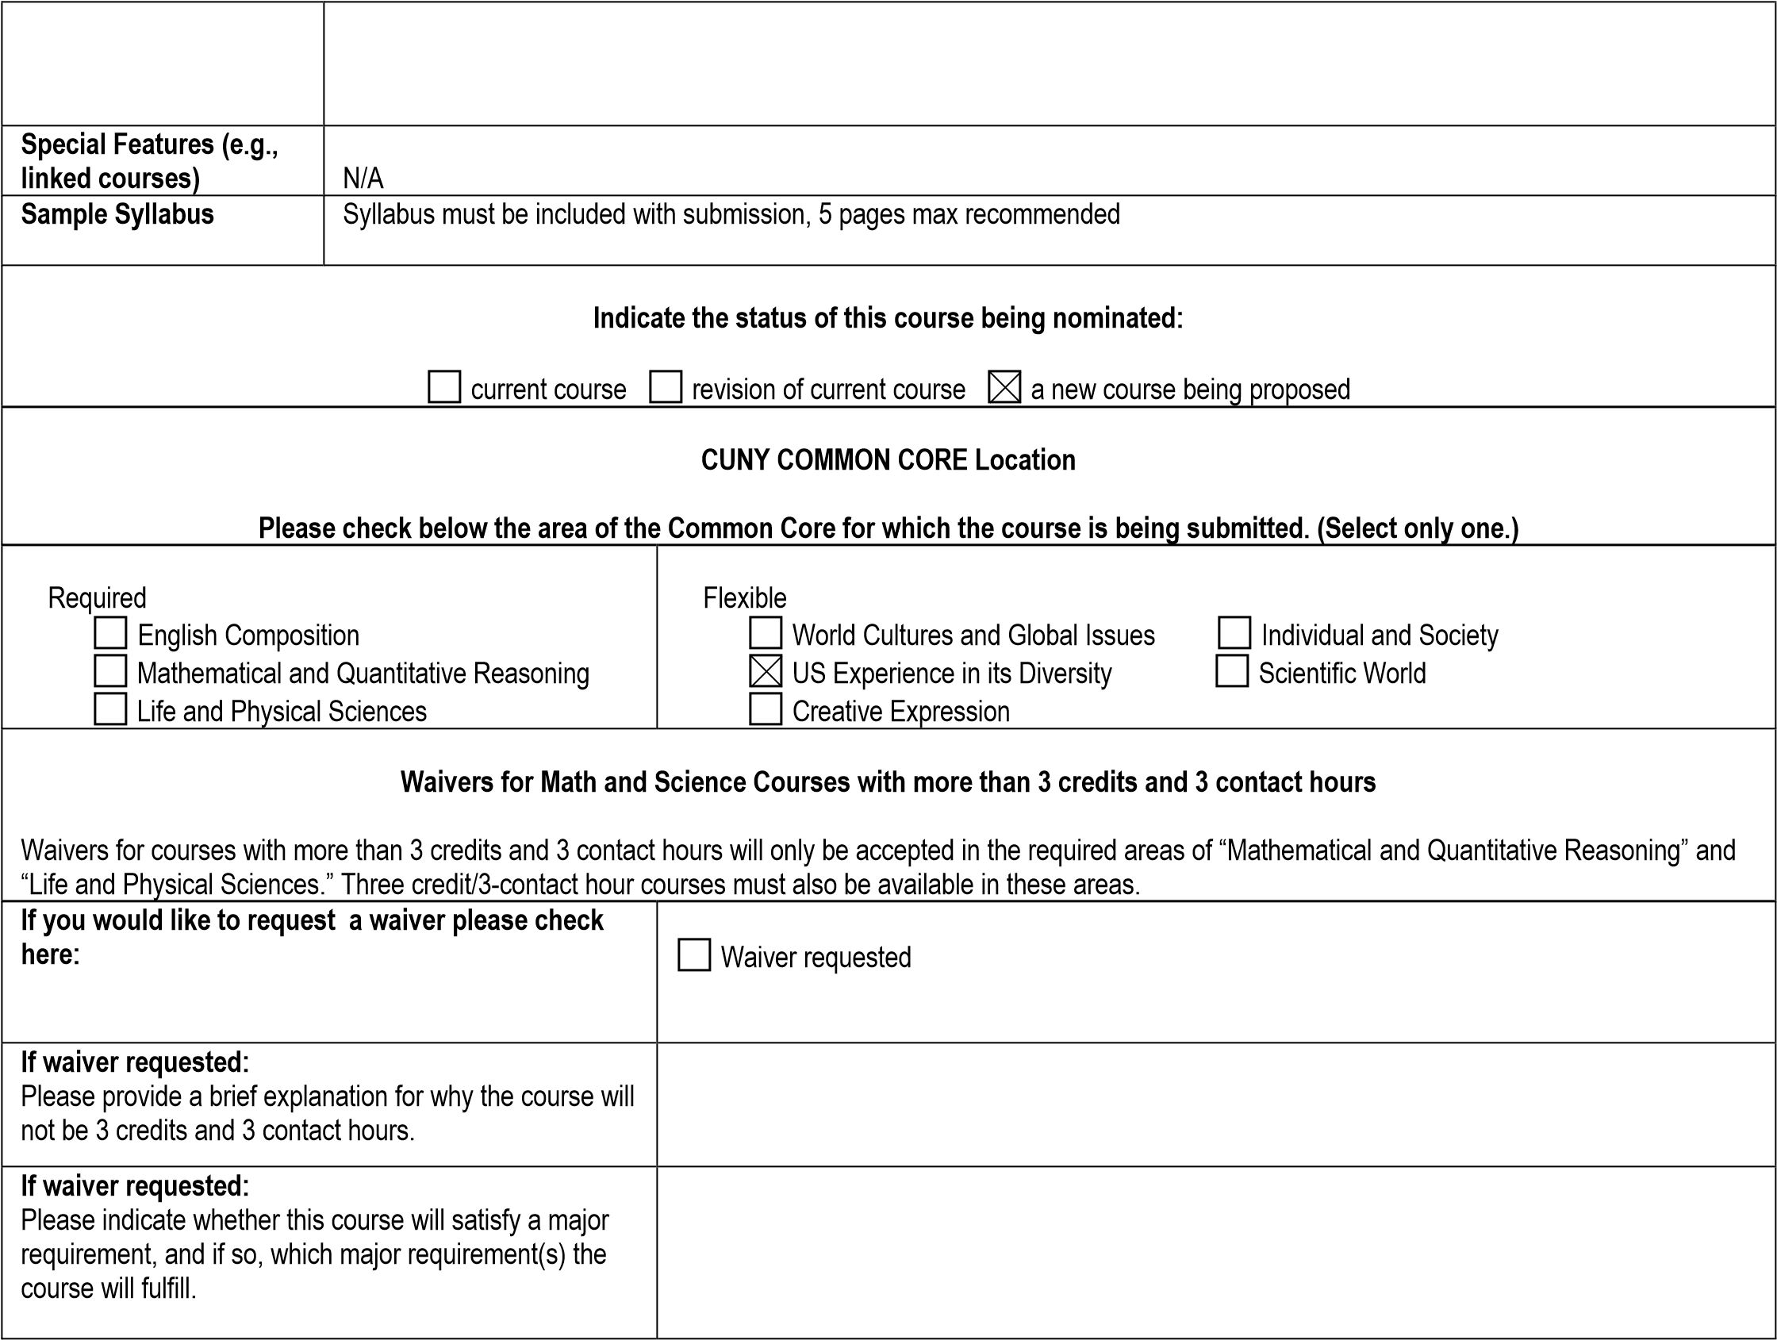

|  |  |
| --- | --- |
| **Learning Outcomes**    **In the left column explain the course assignments and activities that will address the learning outcomes in the right column.** | |
| **II. Flexible Core** **(18 credits)**  Six three-credit liberal arts and sciences courses, with at least one course from each of the following five areas and no more than two courses in any discipline or interdisciplinary field. | |
| **B. U.S. Experience in its Diversity**    A Flexible Core course must meet the three learning outcomes in the right column. | |
| Gather and compare information in homework  assignments and class discussions about different ways in which language barriers affect patients' lives.  Compare and contrast different types of interpreting and use them appropriately in medical simulations.  Analyze and translate different genres (e.g., clinical trial reports, patient consent forms, medical histories, etc.).  Identify differences between standard and non-standard varieties; dialectal varieties of Spanish (e.g., Puerto Rican, Mexican, and Argentinean varieties). | • Gather, interpret, and assess information from a variety of sources and points of view. |
| Debate in class about the different services (language concordant, translation services, in-house interpreters, oncall interpreters, ad hoc interpreters) available to address healthcare disparities related to language access and the appropriateness of their use in different medical situations.  Evaluate, through class discussion and written exams, the differences among legislations, healthcare policies and institutions in the U.S. related to language access services. | • Evaluate evidence and arguments critically or analytically. |
| Negotiate meaning with peers and instructor by developing dialogues for a group simulation to solve the described patient communication problems based on techniques learned in class.  Present different views/perspectives on assigned readings in class that focus on medical practices and cultural beliefs in Spanish-speaking communities.  Justify the role of a medical interpreter (rights and limitations) in advocating for a patient with language barriers in different situations provided by the instructor in the exam, considering the existing policies in the U.S. | • Produce well-reasoned written or oral arguments using evidence to support conclusions. |
| A course in this area (II.B) must meet at least three of the additional learning outcomes in the right column. A student will: | |

|  |  |
| --- | --- |
| Based on statistics, categorize how the Latine population in the U.S. with different levels of English proficiency use language services in the national healthcare system (language concordant, in-house interpreters, on-call interpreters, ad hoc interpreters).  Research how language barriers affect the limited-Englishproficient Latine population, in which U.S. states and cities this is more prevalent, and what solutions and resources are available to these communities to respond to these challenges.  Evaluate the impact of social, cultural, and religious differences; historical experiences; social/regional contexts and environments; and personal attitudes and experiences on the provider-patient communication relationship.  Develop informed competency in legal protocols, code of ethics, and standards of practice to work as a medical interpreter, being aware of cultural differences and perspectives from the Latine community, and advocate in response to a patient with language barriers, considering existing policies to eliminate disparities in a healthcare setting. | • Identify and apply the fundamental concepts and methods of a discipline or interdisciplinary field exploring the U.S. experience in its diversity, including, but not limited to, anthropology, communications, cultural studies, economics, history, political science, psychology, public affairs, sociology, and U.S. literature. |
|  | • Analyze and explain one or more major themes of U.S. history from more than one informed perspective. |
| Evaluate changes in (Spanish) language access in the healthcare system over the past 50 years nationally and by state. Correlate this with the development of undergraduate and graduate medical Spanish and Spanish medical interpretation courses and programs in the U.S.    Measure the impact of the Affordable Care Act (ACA) legislation in the healthcare system in terms of access to health insurance and its consequences for the limited English proficient population vs. English speakers.    Through cultural readings, students learn how Hispanic immigrants have brought their traditions, language, products, and cultural values to form new communities in the U.S. and infuse U.S. culture (e.g., music, traditions such as 5 de mayo or Día de los Muertos, gastronomy, etc.). Students also research the new dynamics in the U.S. economy in which Hispanic immigration plays a significant role. | • Evaluate how indigenous populations, slavery, or immigration have shaped the development of the United States. |
|  | • Explain and evaluate the role of the United States in international relations. |
|  | • Identify and differentiate among the legislative, judicial, and executive branches of government and analyze their influence on the development of U.S. democracy. |
| Measure how healthcare policies and facilities in clinics and hospitals across the U.S. are adapting to the new | • Analyze and discuss common institutions or patterns of life in contemporary U.S. society and how they influence, or are influenced by, race, ethnicity, |
| reality of a multicultural country in which new language, race, and ethnicity must be understood, with the Hispanic being the larger one that is reshaping institutions, education, and commerce across the country.  Students will identify the Hispanic linguistic and cultural idiosyncrasies that affect the delivery of healthcare services to Spanish-speaking patients in the U.S. healthcare system.  Through assigned readings and their own research, students will learn historical information related to the development of new policies in the U.S. healthcare system to respond to the needs of Spanish-speaking patients with limited English proficiency.  Critically interpret readings that discuss cultural awareness (e.g., *personalismo* and *simpatia*) in medical interpreting as it affects Hispanic patients in their communication in English and Spanish, and evaluate the importance of including this knowledge in the educational training of medical interpreters across the country. | class, gender, sexual orientation, belief, or other forms of social differentiation. |

SPA 3203 Spanish Medical Interpretation and Healthcare Communication

NEW YORK CITY COLLEGE OF TECHNOLOGY

CITY UNIVERSITY OF NEW YORK

HUMANITIES DEPARTMENT

***Sample Syllabus***

**Spanish Medical Interpretation and Healthcare Communication**

Course code: SPA 3203

Instructor: David Sánchez Jiménez, PhD

Email: [dsanchezjimenez@citytech.cuny.edu](mailto:dsanchezjimenez@citytech.cuny.edu)

Office hours: Tue & Thu from 3:00 pm to 4:00 pm, and by appointment

Office: L630

Credits: 3 credits

Hours: 3 class hours

Prerequisites: SPA 2402 or higher; or placement test and department permission

**Course Description**

This foundational medical interpretation course provides comprehensive instruction for Spanish/ English bilingual students to serve as language mediators between Spanish-speaking patients with limited English proficiency and their health providers. Students will gain key skills to become effective medical interpreters. The course covers modes of interpretation, medical terminology in English and Spanish, U.S. health systems, legal protocols and requirements in healthcare interpretation, cultural responsiveness, and the roles, responsibilities, codes of ethics, and standards of practice for medical interpreters.

**Instructional materials**

*Textbook:*

* Bancroft, M.A., García-Beyaert, S., Allen, K., Carriero-Contreras, G., & Socarrás-Estrada, D. (2016). *The Medical Interpreter: A Foundation Textbook for Medical Interpreting*. (M. A. Bancroft, Ed.). Columbia, Maryland: Culture & Language Press. ISBN: 978-0-9966517-3-8

*Suggested Text:*

* Purchase an adequate Spanish/English, English/Spanish bilingual dictionary and English/Spanish medical dictionary.
* Bancroft, M.A., Dallman, H., Little, E., Schrage, S.S. (2019). Medical Terminology for Interpreters. 4th ed. Columbia, MD: Culture and Language Press. **ISBN: ‎**978-0996651776

Additional relevant and timely open-source resources will be provided to students.

**Course Specific Learning Outcomes and Assessment Methods**

|  |  |
| --- | --- |
| LEARNING OUTCOMES | ASSESSMENT METHODS |
| Explain the role and professional responsibilities of medical interpreters and their code of ethics. | Lectures, class discussions on relevant topics, homework assignments, in-class activities, research. Content will be incorporated into quizzes and exams with a focus on scenario-based questions. |
| Discuss key aspects of the U.S. healthcare system, workforce and patient safety protocols, legal protocols and requirements for healthcare interpreting, and standards of practice for medical interpreters. | Lectures, class discussions on relevant topics, homework assignments, in-class activities, research. Content will be incorporated into quizzes and exams with a focus on scenario-based questions. |
| Apply code of ethics, different modes of interpreting (simultaneous, consecutive, sight, and telephone), decision-making skills and team skills to medical scenarios. | Role-plays based on clinical case studies provided to students will be discussed in class for them to perform different roles (patient, provider, interpreter) focuses on that specific situation. Scenario-based quiz and exam questions.  Develop a skit or dialogue for a simulation and write narratives for the midterm and final examination. |
| Apply best-practice techniques for responding effectively to interpretational, cultural, and advocacy issues. | Within the framework of legal protocols in healthcare, students will explore techniques for advocating for disadvantaged patients in a healthcare setting. Cases assignments will explore this content, and medical simulations will apply the techniques. Scenario-based quiz and exam questions. |
| Identify and understand the disparities that affect limited English proficient patients. | Through class discussions and research projects, students understand the types of language barriers experienced by limited English proficient patients. |
| Recognize the impact of social, cultural, and religious differences; historical experiences; social/regional contexts and settings; and personal attitudes and experiences on the provider-patient communication relationship. | Class discussions are based on the cultural readings and health-related videos shown in class. The content of these discussions will be incorporated into the quizzes, midterm and final exams (with a focus on scenario-based questions), and the evaluation of the medical simulations and written assignments. |
| Identify the Hispanic linguistic and cultural idiosyncrasies that affect the delivery of healthcare services to Spanish-speaking patients | Class discussions are based on cultural readings and health-related videos shown in class. The content of these discussions will be incorporated into the quizzes, midterm and final exams (with a focus on scenario-based questions), and evaluation of the simulation and written assignments. |
| Be proficient in Spanish and English medical terminology | Exams, quizzes, oral assessments, and role-play |
| Be prepared to take any one of the national medical interpretation exams | Scenario-based quiz and exam questions. Oral assessments through role plays and simulations. |
| Analyze skills gained to be effective medical interpreters and their relevance to real-world application. | Students complete a self-assessment of the skills learned in the course and evaluate the benefits of real-world application of these skills. |

**General Education Learning Outcomes and Assessment Methods**

|  |  |
| --- | --- |
| LEARNING OUTCOMES | ASSESSMENT METHODS |
| **KNOWLEDGE:** Through assigned readings and independent research, students will learn historical information related to the development of new policies in the U.S. healthcare system designed to address the needs of patients with limited English proficiency. | Students' reflections on readings and class discussions are assessed through daily class discussions with peers and the instructor, homework assignments, research projects, quizzes, and written exams. |
| **SKILLS:** Students will learn to communicate with providers and patients as medical interpreters, using the different modes of interpretation, specific terminology and medical expressions to successfully mediate between them according to the interpreter's code of ethics and standards of practice. | Students will be assessed using rubrics that evaluate their performance during medical simulations. Quizzes, homework, and exam questions are used to objectively assess the knowledge behind these skills. |
| **VALUES, ETHICS, AND RELATIONSHIPS (including Intercultural Knowledge and Competence):** Develop informed competency in legal protocols, code of ethics, and standards of practice to work as a medical interpreter, be aware of cultural differences and perspectives from the Latine community, and advocate in response to a patient with language barriers considering existing policies to eliminate disparities in a healthcare setting. | This will be measured in daily class discussions with peers and the instructor, research projects based on primary documents, medical simulations, homework assignments, quizzes, and written exams. |

**Weekly course outline**

The schedule below shows the outline of the class calendar. A more specific, day-by-day schedule of assignments is provided as we go along for each of chapter. Students are to refer to this schedule as they prepare for each class.

|  |  |  |
| --- | --- | --- |
| **WEEK** | **DISCUSSION TOPIC** | **ASSIGNMENTS** |
| **1** | Course introduction. Review of basic interpreting concepts. The medical interpreting profession. Roles of the interpreter. Medical interpreter credentials and certification exams | Course presentation and structure. Reading TBA.  Pre-assessment (sample interpreter exam) |
| **2** | A code of ethics for medical interpreters. Facing ethical challenges. Protocols for medical interpreting | Homework |
| **3** | Stages and steps of the encounter. Modes of interpreting | Homework. Quiz. Medical terminology exercises. Class reflection on difficulties and problem solving in interpreting |
| **4** | Remote interpreting. Note-taking for medical interpreting | Homework. Sight translation of doctor-patient dialogues. Reading TBA |
| **5** | The strategic mediation model. How to perform cultural medication. Techniques for cultural mediation | Medical terminology exercises. Note-taking exercises. Consecutive interpretation exercises |
| **6** | Professional identity. Professional practice. The U.S. Healthcare System | Homework. Quiz. Role-play. Consecutive interpretation exercises |
| **7** | Review. Midterm | Research project outline submission |
| **8** | Language access laws. Legal interpreting in healthcare | Homework. Medical terminology exercises. Consecutive interpretation exercises with note taking |
| **9** | National standards of practice | Quiz. Role play |
| **10** | Communicative autonomy. Intercultural mediators | Reading TBA. Feedback on research project |
| **11** | Interpretation and mediation. Deciding when to intervene | Homework. Reading TBA. Role play. Medical terminology exercises |
| **12** | Advocacy and medical interpreters. Culturally responsive mediation | Quiz. Simultaneous interpretation exercises |
| **13** | Self-care and personal wellness. Professional development and continuing education | Medical terminology exercises. Role play |
| **14** | Medical Interpretation Simulations. Reviews | Grades discussion |
| **15** | Medical Interpretation Simulations. Final exam | Post-assessment (sample interpreter exam) |

**Grade policy and procedure**

*Breakdown of final grade* *Grading scale*

10 Quizzes 20% A 93-100

2 Medical simulations 20% A- 90-92.9

Pre- & Post-assessment 5% B+ 87-89.9

Midterm 10% B 83-86.9

Final exam 15% B- 80-82.9

Class participation 15% C+ 77-79.9

Homework 15% C 70-76.9

D 60-69.9

F 59.9 and below

WU Unofficial Withdrawal

WF Withdrew Failing

**Assessments**

1. ***Quizzes***: Quizzes are designed to assess medical terminology, comprehension of course readings, and theoretical concepts discussed in class and in the textbook. Quizzes will also help students assess their own learning and guide them into a daily study habit. **There will be no make-up quizzes for any reason, including tardiness or absences.**
2. ***Medical simulations*:** This strategy involves students responding to the environment in a real-world situation. Simulation often helps students empathize with a patient's perspective or better understand an event. Clinical case studies in medical specialties are provided to contextualize the situation. In these presentations, students demonstrate developed healthcare communication and medical interpretation skills related to the lessons discussed in the course. Videos and role-plays prepare students for this task. The instructor will evaluate the student's performance according to the techniques, vocabulary, and expressions learned during the semester and emphasized by the instructor for each simulation. **Students who fail the medical simulation will NOT BE ALLOWED to make up the simulation or submit additional work.**
3. ***Pre- & Post-assessments*:** Students will take a pre-assessment and a post-assessment (sample interpreter exams) to gauge learning throughout the semester and to be exposed to a sample CCHI exam. The former will be taken at the beginning of the semester and the latter at the end of the semester.
4. ***Midterm and final examination***: Exams cover all aspects of the readings, the lecture and the class discussion. Exams serve to evaluate students’ understanding of the theoretical, linguistic and cultural topics discussed in the course. Both are closed-book/closed-notes examinations.

Make-up policy*:* Examinations must be taken at the time established in the syllabus. When absent on the day of the examination, a student is allowed to take the examination before or on the next class meeting **only in case of documented medical emergencies. Students who contact the instructor after they have missed the class will not be allowed to make up the exam**. If the exam is not taken before or on the next class meeting, the student will receive 0 points for the exam.

1. **Class participation**: Active participation is an essential part of the learning process and it is expected from all enrolled students. Participation means maintaining an active presence in the class by answering questions from the instructor, volunteering for and participating in class activities. There will be a significant deduction of points for students who regularly fail to answer the instructor’s questions or participate in the class activities. **Simply attending class does not constitute participation.** Other aspects considered under class participation include constant demonstration of active listening when others speak, and collaboration with fellow students in in-class activities. An objective way to evaluate student participation will be by providing exit tickets at the end of the session. Exit tickets will ask students to give a brief summary of the topics covered in class.

Working outside the class***:*** Students are also responsible for working each day outside of class to learn as much as possible through readings, assignments and research that you will share in class. Students are expected to invest at least three (3) hours of combined in-class and out-of-class work per week for each academic unit (credit) of coursework; thus, a 3-credit course will typically require a minimum of nine (9) hours of work per week (180 hrs./semester). Plan on spending at least six (6) hours per week outside of class. You will need this time to read the textbook and articles, memorize and practice the vocabulary, complete homework, elaborate essays, and prepare the oral activities assigned. Students should always look for ways (learning strategies) to grow and develop linguistic proficiency in and outside the classroom.

1. **Homework**: Homework is assigned on a regular basis for knowledge reinforcement and further practice class activities. The student is responsible for completing homework every day before class as well as for those activities assigned by the instructor in the textbook and other sources. **No late work is accepted.**

**Bibliography**

*Didactic materials*

* Academy of Interpretation. (2024). *The Professional Medical Interpreter: A Comprehensive 40-hour Medical Interpreting Course.* Independently published.
* Bancroft, M.A., Dallman, H., Little, E., Schrage, S.S. (2019). Medical Terminology for Interpreters. 4th ed. Columbia, MD: Culture and Language Press.
* Bancroft, Marjory, García Beyaert, Sofia, Allen, Katherine, Carriero-Contreras, Gio- vanna & Socarrás-Estrada, Denis. (2015). *The Community Interpreter: An International Textbook*. Columbia, MD: Culture and Language Press.
* Collins, C.E. (2014). *A Short Course in Medical Terminology* (Third ed.). Philadelphia: Wolters Klumer.
* Cotton, Christina E., et al. (2005). *A su salud! Spanish for Health Professionals*. New Haven: Yale UP. (2 DVDs and 1 CDRom).
* Florián, L. & Ruiz, A.M.ª (2005). *Ciencias de la Salud*. Madrid: Universidad de Alcalá de Henares.
* González, E. (2006). Medical Interpreter’s Manual. Ann Arbor: Copley Custom Textbooks.
* González-Lee, T., & H. Simon (2011). *Medical Spanish: Interviewing the Latino patient. A cross-cultural perspective.* Pearson.
* Hill, Ch., Bender, D, Carl, L. Harlan, Ch., Henshaw, R., Lorch, C., Lunsford, E. & E. Tolman (2011). *Interactive Video on DVD for ¡Salud!* Pearson.
* Jarvis, A. & Lebredo, R. (2006). *Spanish for Medical Personnel*. Boston: Houghton Mifflin, 2006.
* Kelz, R. (1999). *Conversational Spanish for Health Professionals.* Albany: Delmar Publishers.
* Ortega Pilar. (2015). *Spanish and the Medical Interview: A Textbook for Clinically Relevant Medical Spanish*, 2nd ed. Philadelphia, PA: Elsevier.
* Reiss-Koncar, Suzanna. (2022). *The Healthcare Interpreter.* Columbia, MD: Culture and Language Press.
* Rosa de Juan, C., de Prada, M., Marcé, P. & Salazar, D. (2009). Temas de salud. Madrid: Edinumen.
* Rush, P. (2003). *Spanish for HealthCare, Textbook and Workbook*. Prentice Hall.
* Schiavo, R. (2007). *Health Communication: From theory to practice.* San Francisco: Jossey Bass.

*General bibliography*

* Anderson L, et. al. (2003). Culturally competent health care systems: A Systematic review. *Am J Prev Med* 24: 68-79
* Armus, D. (2003). *Disease in the History of Modern Latin America: From Malaria to AIDS.* Durham, NC: Duke University Press.
* Armus, D. (2002). *Entre médicos y curanderos. Cultura, historia y enfermedad en la América Latina moderna.* Buenos Aires: Grupo Editorial Norma.
* Becker G. (2004). Deadly inequality in the health care “safety net”: Uninsured ethnic minorities’ struggle to live with lifethreatening illnesses. *Medical Anthropology Quaterly* 18: 258-275.
* Cheng E, A. Chen, & W. Cunningham. (2007). Primary language and receipt of recommended health care among Hispanics in the United States*. J Gen Intern Med* 22 (suppl 2): 283-288.
* Creeze, I. H, M. Holly, & L. Monzon-Storey. (2015). *Introduction to Healthcare for Spanish-speaking Interpreters and Translators.*Amsterdam: John Benjamins.
* Davidson B. (2000). The interpreter as institutional gatekeeper: The social-linguistic role of interpreters in Spanish-English medical discourse. *Journal of Sociolinguistics* 4: 379-405.
* De la Torre, A & A Estrada (2001). *Mexican Americans and Health: ¡Sana, Sana!* Tucson: University of Arizona Press.
* Derose, K, J. Escarce, & N. Lurie. (2007). Immigrants and health care: Sources of vulnerability. *Health Affairs* 26: 1258-1268.
* Flores, G. (2006). Language barriers to health care in the United States. *New England Journal of Medicine* 355: 229-231.
* Frenk, J. (2000). *La salud de la población: Hacia una nueva salud pública*. México: Fondo de Cultura Económico.
* Glanz, K., Rimer, B., & Viswanath, K. (2008). *Health Behavior and Health Education: Theory, research, and practice.* 4th edition. San Francisco: Jossey Bass.
* Gregg J and S Soha. (2007). Communicative competence: A framework for understanding language barriers in health care. *J. Gen Inter Med* 22 (suppl 2): 368-370. *it.* New York: Kaplan.
* Hasnain-Wynia R., J. Yonek, D Pierce, R. Kang & C. Hedges Greising. (2006). *Hospital language services for patients with limited English proficiency: Results from a national survey.* Chicago: Health Research and Educational Trust.
* Institute of Medicine. (2002). *Speaking of Health: Assessing health communication strategies for diverse populations.* Washington, DC: National Academies Press.
* Institute of Medicine. (2004). *Health Literacy: A Prescription to end confusion*. Washington, DC: National Academies Press.
* Karliner L, E. Jacobs, A. H. Chen & S. Mutha. (2007). Do professional interpreters improve clinical care for patients with limited English proficiency? A systematic review of the literature. *Health Services Research* 42: 727-754.
* Ku. L & S. Matani. (2001). Left out: Immigrants’ access to health care and insurance. *Health Affairs* 20: 247-256.
* Mohanty, S. (2006). *Unequal access: Immigrants and US health care.* Washington DC: American Immigration Law Foundation.
* Pochhacker, F. (2004). *Introducing Interpreting Studies*. London and New York: Routledge.
* Roat, C.E. (2014). *Healthcare Interpreting in Small Bites: 50 Nourishing Selections from the “Pacific Interpreters Newsletter” 2002-2012.* Bloomington: Trafford publishing.
* Rudvin, M. & Tomassini, E. (2011). *Interpreting in the Community and Workplace: A practical Guide*. New York. Palgrave Mcmillan.
* Weiss L, T Bauer, C Hill, J Fuld, and J Bergman. (2006). *Language as a barrier to health care for New York City children in immigrant families.* New York: The New York Academy of Medicine.
* Wilson E, A. Chen, K. Grumbach, F. Wang, & A. Fernandez. 2005. Effects of limited English proficiency and physician language on health care comprehension. *J Gen Intern Med* 20: 800-806.

# Humanities Department Attendance Policy

It is the conviction of the Humanities department that a student who is not in a class for any reason is not receiving the benefit of the education being provided. Missed class time includes not just absences but also lateness, early departures, and time outside the classroom taken by students during class meeting periods. Missed time impacts any portion of the final grade overtly allocated to participation and/or any grades awarded for activities that relate to presence in class.

# Plagiarism and NYCCT Academic Integrity Policy:

“Students and all others who work with information, ideas, texts, images, music, inventions, and other intellectual property owe their audience and sources accuracy and honesty in using, crediting, and citing sources. As a community of intellectual and professional workers, the College recognizes its responsibility for providing instruction in information literacy and academic integrity, offering models of good practice, and responding vigilantly and appropriately to infractions of academic integrity.

Accordingly, academic dishonesty is prohibited in The City University of New York and at New York City College of Technology and is punishable by penalties, including failing grades, suspension, and expulsion.” (See pp. 73-76 in the student handbook). The following are some examples of plagiarism:

* + Copying another person’s actual words without the use of quotation marks and footnotes attributing the words to their source.
  + Presenting another person’s ideas or theories in your own words without acknowledging the source.
  + Using information that is not common knowledge without acknowledging the source.
  + Failing to acknowledge collaborators on homework and laboratory assignments.
  + **Internet Plagiarism** includes submitting downloaded term papers or parts

of term papers, paraphrasing or copying information from the internet without citing the source, and “cutting and pasting” from various sources without proper attribution.

* + Speech assignments must be paraphrased into your own language and properly cited. All major writing speeches and exams will be run through Safe Assign.

**NOTE: In the event that the instructor finds that the results of students’ homework, scripts, and other at home activities do not correspond to their level of proficiency, students may be called to take an extra exam to prove their capacity to solve tasks similar to those normally assigned in class.**

# Policy on In-class use of technology

Students are required to **log into their City Tech emails and Brightspace regularly** (every two to three days) in order to get updated information on course content, download handouts, watch videos, and follow class assignments. Failure to do so is every student’s responsibility and the consequences may affect their final grades. CUNY guidelines state that all communication between students and the instructor must be through your City Tech email address. The professor will use **ONLY** City Tech email addresses as primary means of communication. The instructor will make every effort to answer email messages promptly

Any electronic devices (e. g. cell phones, tablets, computers, etc.) must be turned off when class begins, and remain off when the class is in session, unless otherwise indicated by your instructor. **Any evidence of cell phone use (ringing, buzzing, etc.) and similar equipment use will result in an automatic zero in participation for the day’s session. Using a cell phone during a test will result in a test score of zero.**

Technological issues are not a valid excuse for lack of participation or lack of course work. Students should foresee potential technical problems and should always have a Plan B in place (e.g., use of computers in the campus).

**Accessibility/Medical Accommodations Statement**

City Tech is committed to supporting the educational goals of enrolled students with disabilities in the areas of enrollment, academic advisement, tutoring, assistive technologies and testing accommodations. If you have or think you may have a disability, you may be eligible for reasonable accommodations or academic adjustments as provided under applicable federal, state and city laws. You may also request services for temporary conditions or medical issues under certain circumstances. If you have questions about your eligibility or would like to seek accommodation services or academic adjustments, please contact the Center for Student Accessibility at 300 Jay Street room L-237, 718 260 5143, or <http://www.citytech.cuny.edu/accessibility/> N.B., Students who miss a scheduled presentation or exam due to illness or medically-related emergencies will be referred to the Center for Student Accessibility. The CSA will review any documentation requested and give the student a letter to share with the relevant instructor if accommodations need to be made. Do we need to use only the current Statement, which omits mention of a physical location for the Center?

Students who miss a scheduled presentation or exam due to illness or medically-related emergencies will be referred to the Center for Student Accessibility. The CSA will review any documentation requested and give the student a letter to share with the relevant instructor if accommodations need to be made.

# Humanities Department Commitment to Student Diversity

The Humanities Department complies with the college wide nondiscrimination policy and seeks to foster a safe and inclusive learning environment that celebrates diversity in its many forms and enhances our students’ ability to be informed, global citizens. Through our example, we demonstrate an appreciation of the rich diversity of world cultures and the unique forms of expression that make us human.

Appendix A – Sample Job Posting

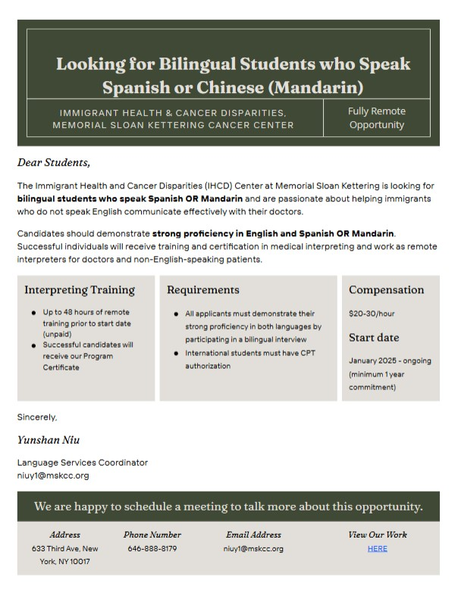

Appendix B – Student Interest and Support (Unsolicited Feedback)

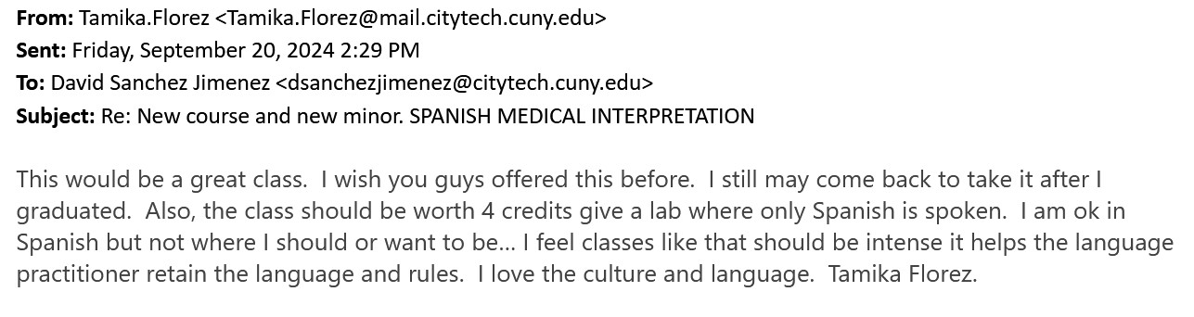

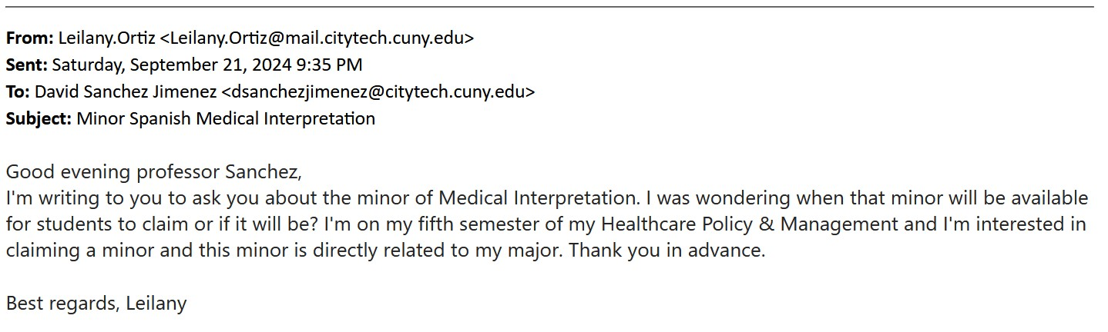

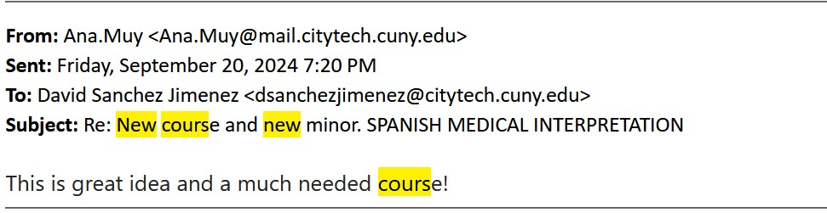

Appendix C **–** Emails in Support of the Proposal

1. Dr. Maureen Archer-Festa, Dean of City Tech School of Professional Studies, September 3, 2024 & October 3, 2024

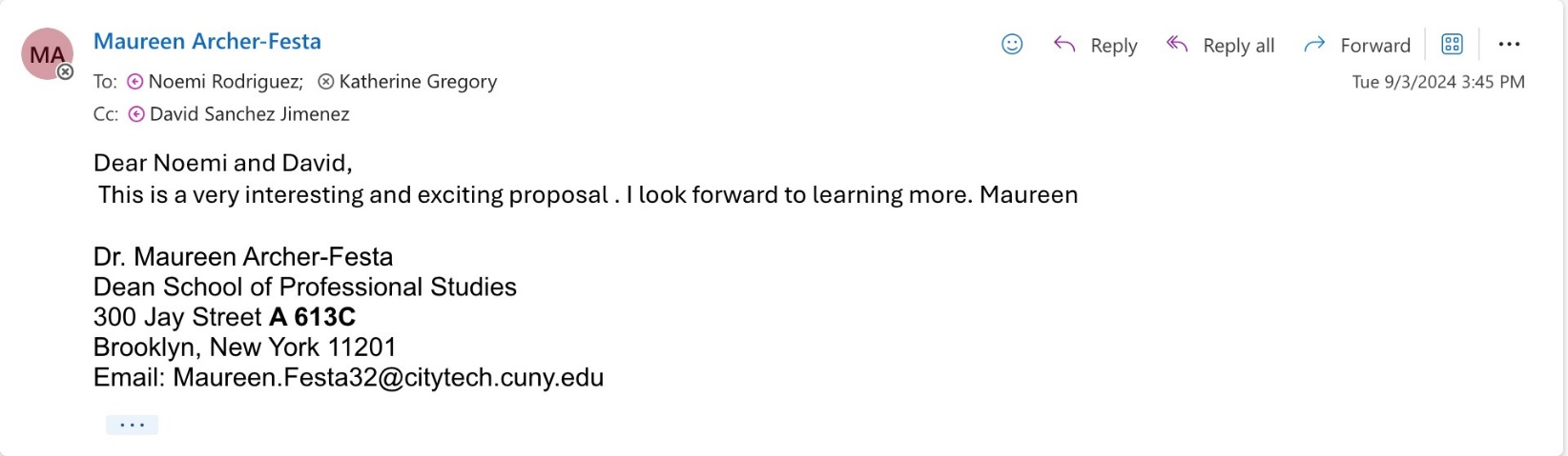

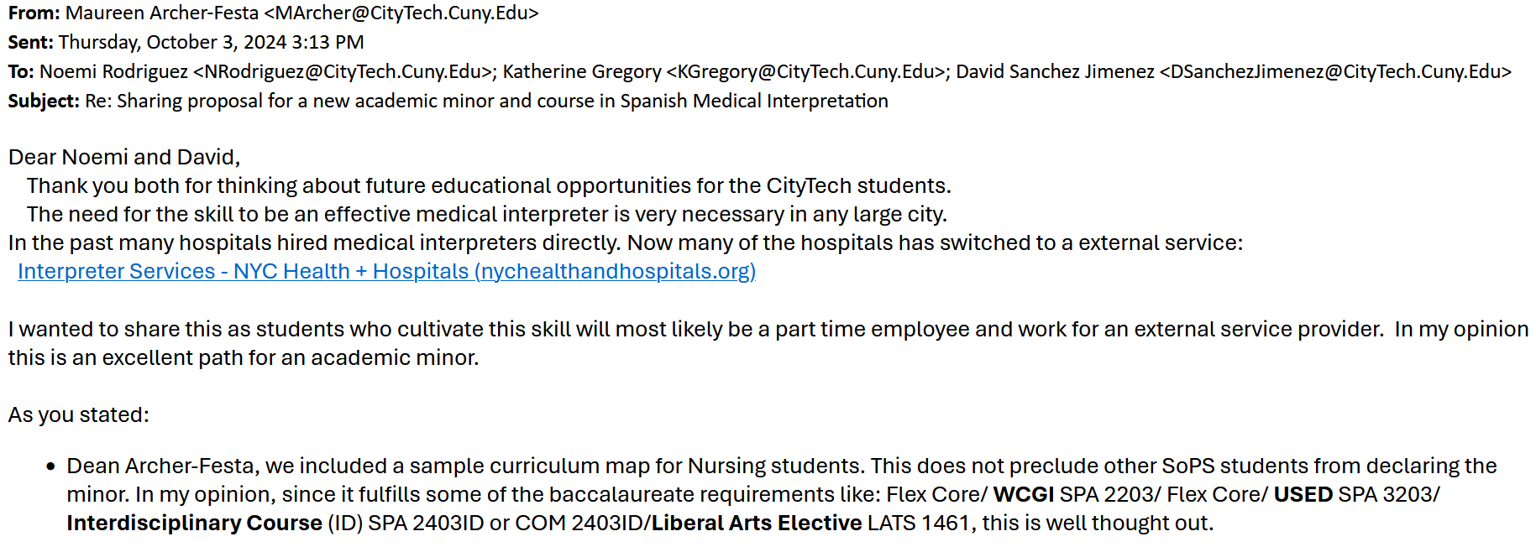

1. Dr. Katherine Gregory, Chair of the Department of Health Sciences, October 5, 2023 & October 3, 2024

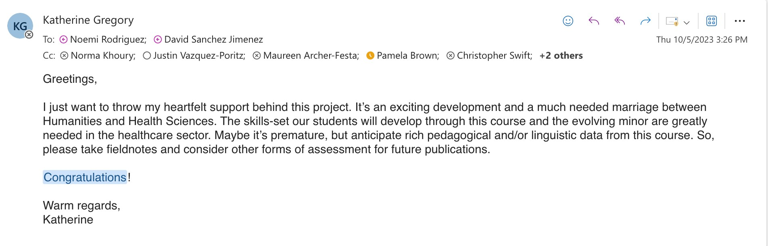

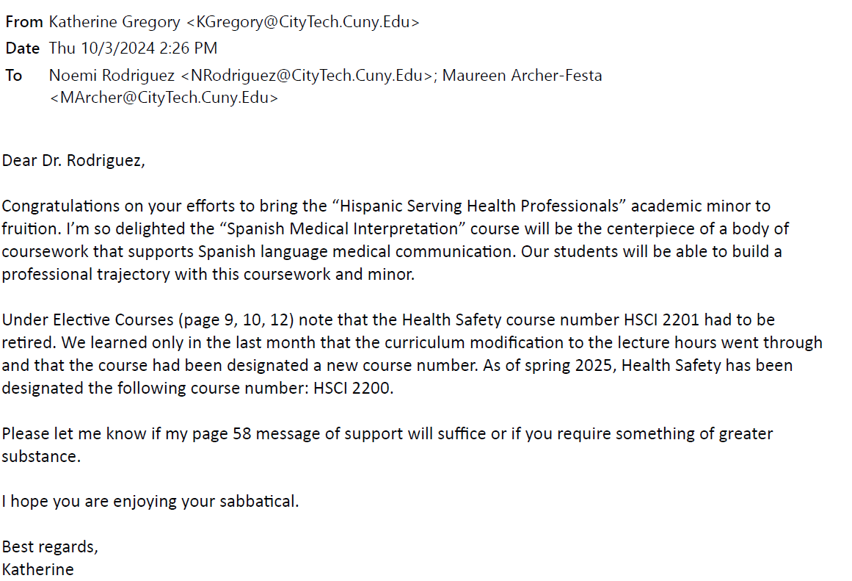

Appendix D **–** Letters in Support of the proposal

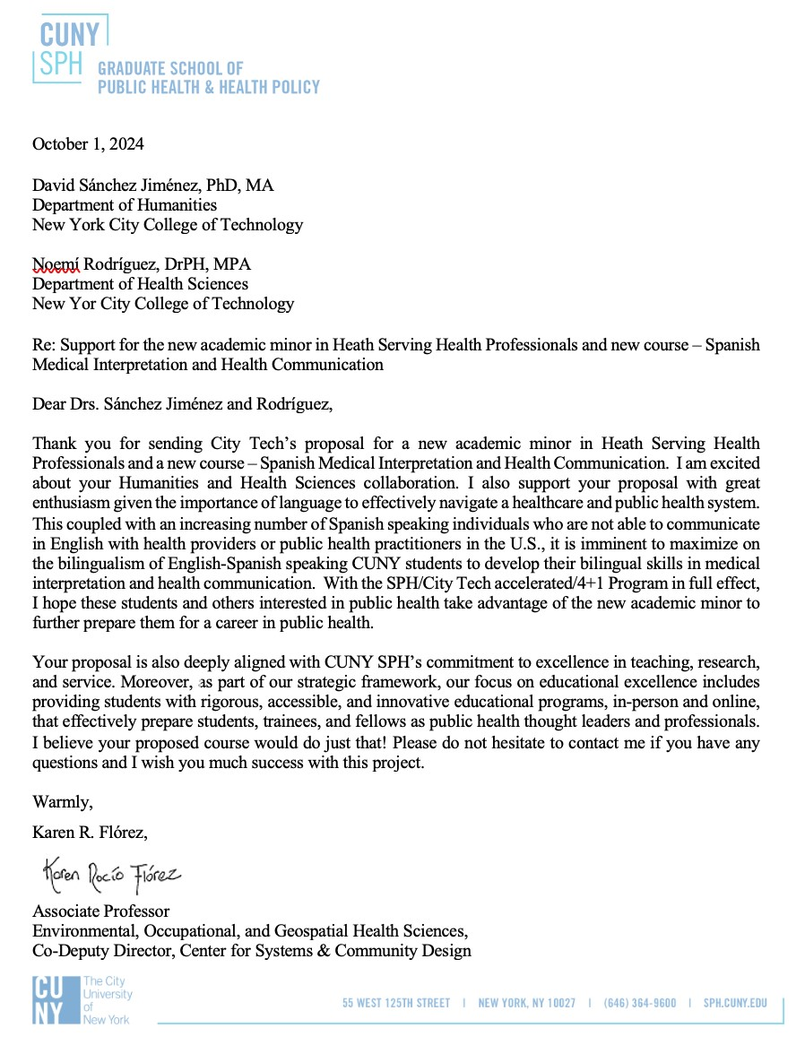

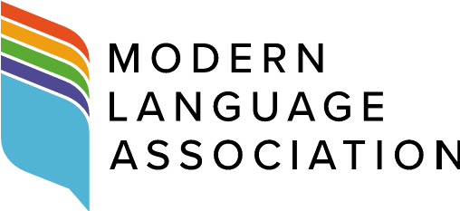

2 October 2024

Dr. Ann Delilkan, Chair

Humanities Department

Curriculum Committee

New York City College of Technology-CUNY

Dear Dr. Ann Delilkan,

I am writing at the request of Dr. David Sánchez Jiménez and Dr. Noemí Rodríguez to offer my support for the proposal to establish an Academic Minor in Hispanic-Serving Health Professionals at City Tech, including the new course “Spanish Medical Interpretation and Healthcare Communication.” This innovative minor leverages existing courses, including those already offered as part of the Spanish minor, along with the general education program while also introducing a new curriculum tailored to the unique needs of City Tech students and the Latine-serving healthcare sector in New York City.

In connection with the Modern Language Association, Dr. Sánchez Jiménez and Dr. Rodríguez have received support for this project through the highly competitive [Mellon-funded MLA Pathways step grant program](https://www.mla.org/Resources/Career/MLA-Grants-and-Awards/MLA-Pathways-Step-Grants) and through the MLA workshop series [“Reimagining Humanities Coursework for Career Readiness,”](https://www.mla.org/Resources/Career/Reimagining-Humanities-Coursework-for-Career-Readiness-A-Workshop) which is funded by the National Endowment for the Humanities (NEH). I had the pleasure of working with Dr. Sánchez Jiménez in the latter, and his action plan, which led to the proposal before you and the committee, was cogent, thoughtful, and thoroughly researched, demonstrating the detailed preparation and foresight that went into developing this new minor and course.

This minor and new course address the growing student interest in combining linguistic proficiency with career readiness and community engagement, and we have seen the creation of similar programs have positive effects on enrollment around the United States; [see case studies](https://www.mla.org/content/download/191449/file/Case-Studies-from-the-2021-Enrollments-Report.pdf) from the 2021 MLA Enrollments Report. Grounded in the American Council on the Teaching of Foreign Languages (ACTFL) standards for proficiency, the proposed program follows established models for developing Spanish courses for professional contexts, particularly for heritage speakers and Spanish/English bilingual learners.

The proposed Academic Minor in Hispanic-Serving Health Professionals at City Tech aligns with several acknowledged good practices, including:

* Meeting the need for courses designed specifically for bilingual students and heritage language learners;
* Offering experiential learning opportunities–I noted particularly the use of simulations and scenario-based assessments in the proposed syllabus for “Spanish Medical Interpretation and Healthcare Communication”;
* Undertaking curricular reform that promotes career readiness in diverse fields, particularly humanities-related fields–it should be observed here that such reform enhances access to the humanities for students from historically and currently underrepresented groups, first-gen students, and Pell-eligible students, as reported in [*Expanding Access to Undergraduate Humanities Education*](https://nhalliance.org/wp-content/uploads/2024/06/Expanding-Access-Report-FINAL.pdf) by the National Humanities Alliance;
* Engaging with the community and fostering equity and access by serving linguistically diverse and linguistically minoritized communities.

In seeking to validate and enhance bilingualism and address enrollment concerns, the proposed program responds directly to student demand while being thoughtfully grounded in the context of City Tech's status as a Hispanic-serving institution. The proposal includes a rigorous landscape scan, ensuring that this minor is not only innovative within the CUNY system and beyond, but also deeply informed by institutional needs and broader healthcare systems and trends in New York City.

I fully endorse the creation of this minor along with its new course, and am confident that it will provide a valuable addition to City Tech’s academic offerings, meeting the needs of students while fostering careerready professionals with the cultural, linguistic, and ethical competencies necessary for today’s healthcare service.

If you have any additional questions, please feel welcome to contact me at jutell@mla.org.

Best,



Janine Utell

Associate Director of Academic Program Services and Professional Development Modern

Language Association [www.mla.org](http://www.mla.org/)

**Modern Language Association of America • 85 Broad Street • New York, NY • 10004 • 646 576-5000 •** [**www.mla.org**](http://www.mla.org/)

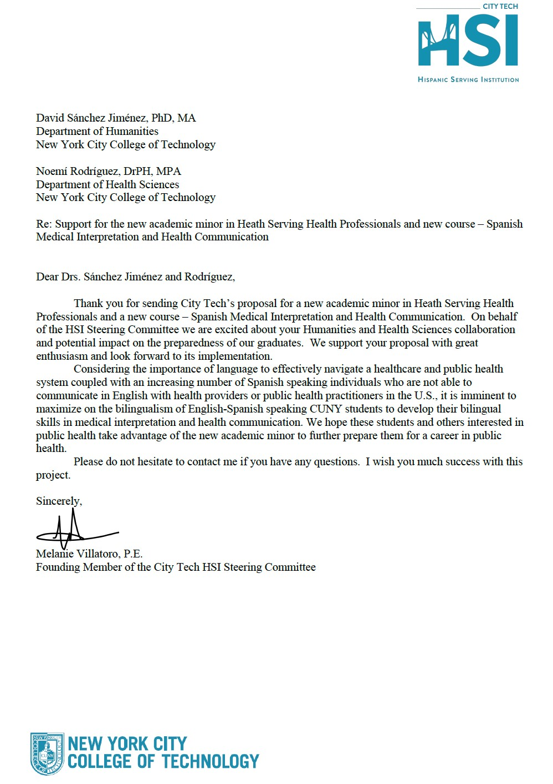

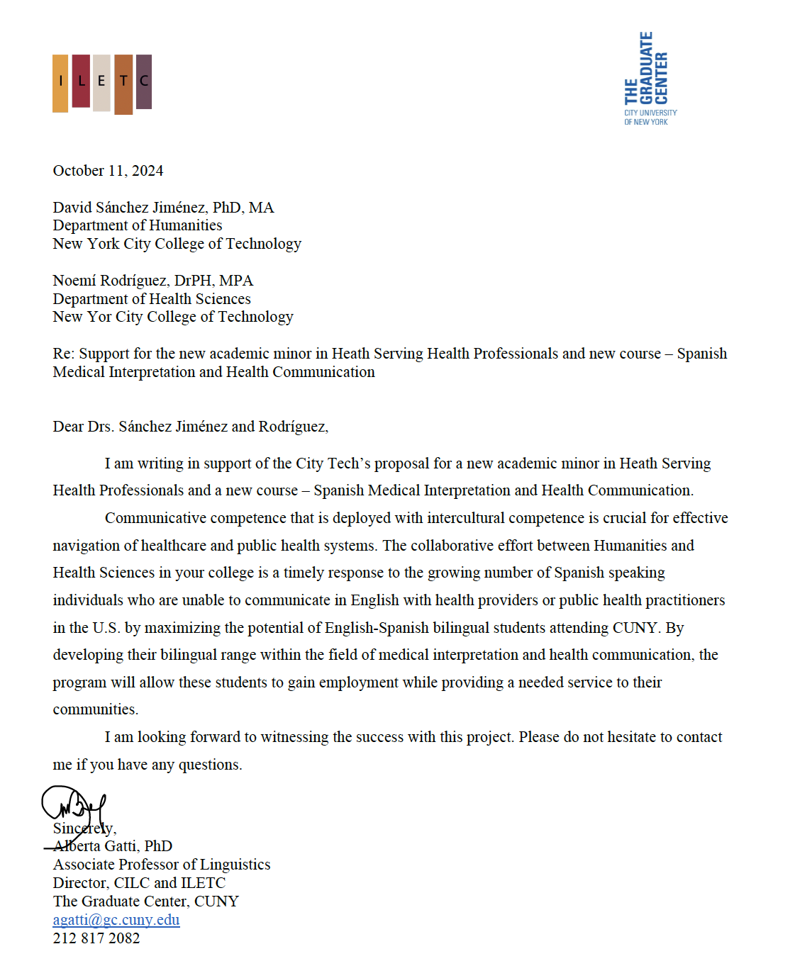

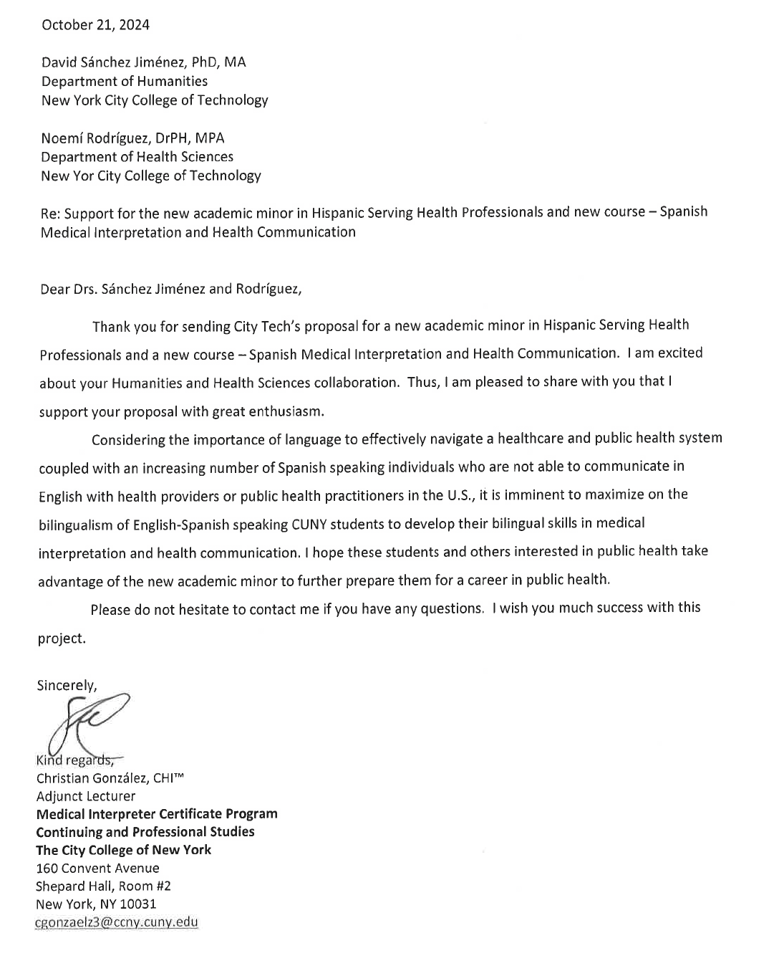

Page left blank intentionally

1. The Spanish proficiency level required to declare this academic minor is Advanced Low according to the ACTFL proficiency levels for language learners, which students acquire by passing SPA 2402 or higher at City Tech, or by demonstrating such a level on a placement test and receiving department permission.
2. Latine is a gender-neutral term and inclusive of all genders, equivalent to Latinx used in the Spanish-speaking communities in the U.S. and abroad. For more information, please se[e https://www.ncbi.nlm.nih.gov/pmc/articles/PMC10988219/,](https://www.ncbi.nlm.nih.gov/pmc/articles/PMC10988219/)  [https://www.nypl.org/blog/2020/09/29/hispanic-heritage-month-terms-bind-us.](https://www.nypl.org/blog/2020/09/29/hispanic-heritage-month-terms-bind-us)
3. Since most healthcare providers receive some form of federal funding (primarily through Medicare and Medicaid reimbursements), they fall under the jurisdiction of Title VI.
4. Spring 2023: Hispanic, 33.5%; Black or African American, 26.5%; Asian, 21.9%; White, 11.7%; Nonresident alien, 3.9%; Two or more races: 1.9%; American Indian or Alaskan Native: 0.4%, Native Hawaiian or Other Pacific Islander: 0.2% (Data usage facilitated by AIRE).
5. Data usage facilitated by AIRE.
6. Architecture, Biomedical Informatics, Business, Communication Design, Computer Engineering, Computer Systems, Dental Hygiene, Education, Engineering, English, Entertainment Technology, Health Communication, Health Science, Health Services Administration, Healthcare Policy and Management, Hospitality, Liberal Arts, Nursing, Radiology, and Undeclared Health
7. Ibid.
8. Students must comply with the pre-requisites for their chosen electives.
9. Department of Health and Human Services: [https://www.hhs.gov/civil-rights/for-individuals/section-1557/1557-facthttps://www.hhs.gov/civil-rights/for-individuals/section-1557/1557-fact-sheet/index.htmlsheet/index.html](https://www.hhs.gov/civil-rights/for-individuals/section-1557/1557-fact-sheet/index.html) 
10. Department of Health and Human Services: [https://www.hhs.gov/civil-rights/for-individuals/section-1557/1557-facthttps://www.hhs.gov/civil-rights/for-individuals/section-1557/1557-fact-sheet/index.htmlsheet/index.html](https://www.hhs.gov/civil-rights/for-individuals/section-1557/1557-fact-sheet/index.html) 
11. Modern Language Association (MLA): [https://news.mla.hcommons.org/2024/04/15/mla-announceshttps://news.mla.hcommons.org/2024/04/15/mla-announces-inaugural-group-of-pathways-step-grant-recipients/inaugural-group-of-pathways-step-grant-recipients/](https://news.mla.hcommons.org/2024/04/15/mla-announces-inaugural-group-of-pathways-step-grant-recipients/)

   
12. Data usage facilitated by AIRE.
13. U.S. Bureau of Labor Statistics[: https://www.bls.gov/oes/current/oes273091.htm#st](https://www.bls.gov/oes/current/oes273091.htm#st) 
14. Department of Health and Human Services: [https://www.hhs.gov/civil-rights/for-individuals/section-1557/1557-facthttps://www.hhs.gov/civil-rights/for-individuals/section-1557/1557-fact-sheet/index.htmlsheet/index.htm](https://www.hhs.gov/civil-rights/for-individuals/section-1557/1557-fact-sheet/index.html)  [l](https://www.hhs.gov/civil-rights/for-individuals/section-1557/1557-fact-sheet/index.html) 