New York City College of Technology, CUNY

CURRICULUM MODIFICATION PROPOSAL FORM
This form is used for all curriculum modification proposals. See the Proposal Classification Chart for information about what types of modifications are major or minor. Completed proposals should be emailed to the Curriculum Committee chair.

Title of Proposal | Addition of ENG1121 English Composition II as a Dental  Hygiene pre-requisite course
Date | 10.10.24
Major or Minor | Minor
Proposer’s Name | Anna Matthews
Department | Dental Hygiene
Date of Departmental Meeting  in which proposal was approved | 10.22.24
Department Chair Name | 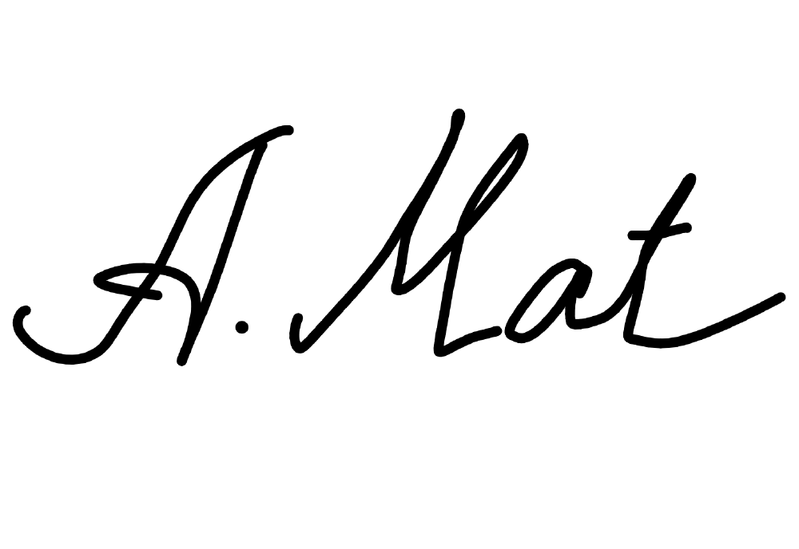  Anna Matthews
Department Chair Signature and  Date | 11.5.2024
Academic Dean Name | Maureen Archer-Festa
Academic Dean Signature and  Date | Dr. Maureen Archer-Festa Digitally signed by Dr. Maureen Archer-Festa    Date: 2024.11.09 08:34:50 -05'00'
Brief Description of Proposal (Describe the modifications contained within this proposal in a succinct summary. More detailed content will be provided in the proposal body. | Add ENG1121 as an alternative to ENG1101 as a DH program pre-requisite
Brief Rationale for Proposal (Provide a concise summary of why this proposed change is important to the department. More detailed content will be provided in the proposal body). | The DH department has reviewed the ENG1101 and ENG1121 course outlines and objectives, which are both in line with the DH program pre-requisite requirements. As such, both courses should qualify for DH consideration/admission. The department will accept the higher grade in either ENG1101 or ENG1121 as a qualifying grade for DH admission consideration.
Proposal History  (Please provide history of this proposal: is this a resubmission? An updated version? This may most easily be expressed as a list). | n/a

Please include all appropriate documentation as indicated in the Curriculum Modification Checklist. For each new course, please also complete the New Course Proposal and submit in this document.
Please submit this document as a single .doc or .rtf format. If some documents are unable to be converted to .doc, then please provide all documents archived into a single .zip file.
ALL PROPOSAL CHECK LIST
Completed CURRICULUM MODIFICATION FORM including:
- Brief description of proposal
- Rationale for proposal
- Date of department meeting approving the modification
- Chair’s Signature
- Dean’s Signature
Evidence of consultation with affected departments
List of the programs that use this course as required or elective, and courses that use this as a prerequisite.
Documentation of Advisory Commission views (if applicable).
Completed Chancellor’s Report Form.

EXISTING PROGRAM MODIFICATION PROPOSALS

Documentation indicating core curriculum requirements have been met for new programs/options or program changes.
Detailed rationale for each modification (this includes minor modifications)

Detailed Rationale:

Many students, especially transfer students, have a credit for ENG1121 on their transcript, available to evaluate and include in the applicant’s GPA. However, some students do not have ENG1101 credited, and no grade is available to review and include in their GPA. Typically, ENG1101 is a pre-requisite to ENG1121, but even within the CUNY system, the transfer credit sometimes is not included. We would like to rectify this by accepting ENG1121, when available, and the grade is posted on the CityTech transcript. We further wish to give students the advantage of being able to choose a higher grade when both ENG1101 and 1121 are available, consistent with our policies regarding equivalent or higher courses in MAT and CHEM.
We therefore propose adding ENG1121 as an alternative to ENG1101, based on a detailed review of the courses learning outcomes and objectives on 10.8.24 in the DH department meeting with ENG Chair Prof. Suzanne Miller and the Director or 1st year writing Prof.
Mazumdar.

Proposed Curriculum Change to Dental Hygiene Program General Education Prerequisite Courses: FROM/TO Table:

From: | To:
ENG1101, English Composition I | ENG1101, English Composition I  OR  ENG1121, English Composition II  If both ENG1101 and ENG1121 are available, the higher grade will be accepted for GPA calculation

