New York City College of Technology, CUNY
CURRICULUM MODIFICATION PROPOSAL FORM
This form is used for all curriculum modification proposals. See the Proposal Classification Chart for information about what types of modifications are major or minor. Completed proposals should be emailed to the Curriculum Committee chair.

Title of Proposal | Minor curriculum change to CST BS in Data Science program elective courses
Date | 10/14/2023
Major or Minor | Minor
Proposer’s Name | Elena Filatova
Department | Computer Systems Technology
Date of Departmental Meeting in which proposal was approved | 10/25/2024
Department Chair Name | Ashwin Satyanarayana
Department Chair Signature and Date
Academic Dean Name | Hong Li
Academic Dean Signature and Date |  11/15/24
Brief Description of Proposal  (Describe the modifications contained within this proposal in a succinct summary. More detailed content will be provided in the proposal body. | Add MAT2675 to the list of the major electives for the BS in Data Science Program.
Brief Rationale for Proposal  (Provide a concise summary of why this proposed change is important to the department. More detailed content will be provided in the proposal body). | MAT2675 is a pre-requisite for MAT3672.  The BS in Data Science Program requires students to take two electives.  MAT3672 is already an elective for the BS in Data Science Program. Adding MAT2675 to the list of BS in Data Science electives allows the BS in Data Science students to take a sequence of two MAT courses as their electives keeping the flexibility in choosing their liberal arts courses. This curriculum update has been discussed with the NYCCT Mathematics department who expressed their support for this curriculum change (Prof. Natov, Prof. Katz, Prof. Zhou).
Proposal History  (Please provide history of this proposal: is this a resubmission? An updated version? This may most easily be expressed as a list). | This is the new submission.

Please include all appropriate documentation as indicated in the Curriculum Modification Checklist.

For each new course, please also complete the New Course Proposal and submit in this document.

Please submit this document as a single .doc or .rtf format. If some documents are unable to be converted to .doc, then please provide all documents archived into a single .zip file.
ALL PROPOSAL CHECK LIST
Completed CURRICULUM MODIFICATION FORM including:
- Brief description of proposal | X
- Rationale for proposal | X
- Date of department meeting approving the modification | X
- Chair’s Signature
- Dean’s Signature
Evidence of consultation with affected departments  List of the programs that use this course as required or elective, and courses that use this as a prerequisite. | X
Documentation of Advisory Commission views (if applicable). | N/A
Completed Chancellor’s Report Form. | X

EXISTING PROGRAM MODIFICATION PROPOSALS

Documentation indicating core curriculum requirements have been met for new programs/options or program changes. | N/A
Detailed rationale for each modification (this includes minor modifications) | X

The following revisions are proposed for the BS in Data Science

Program: Bachelor of Science in Data Science

Program Code:
- Plan Code: DSCI-BS
- HEGIS Code: 5101.00
- NYSED Program Code: 40402 - DSCI-BS
- CIP Code: 30.3001

Effective: Spring 2025

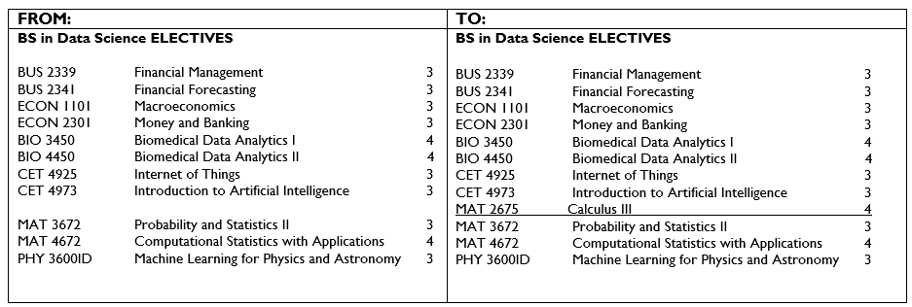

Rationale: To add new course MAT 2675 to the list of allowed electives. This addition allows the Data Science students to take two MAT courses as electives adding the flexibility to the choice to additional liberal arts courses.
