New York City College of Technology, CUNY
CURRICULUM MODIFICATION PROPOSAL FORM
This form is used for all curriculum modification proposals. See the Proposal Classification Chart for information about what types of modifications are major or minor. Completed proposals should be emailed to the Curriculum Committee chair.

Title of Proposal | Change of Prerequisite for MECH 3572 for MET Students
Date | 3/13/2024
Major or Minor | Minor
Proposer’s Name | Andy S. Zhang and Masa Nakamura
Department | MET
Date of Departmental Meeting in which proposal was approved | 8/31/2016
Department Chair Name | AKM Rahman
Department Chair Signature and Date | 9/4/2024
Academic Dean Name | Gerarda M. Shields
Academic Dean Signature and Date | 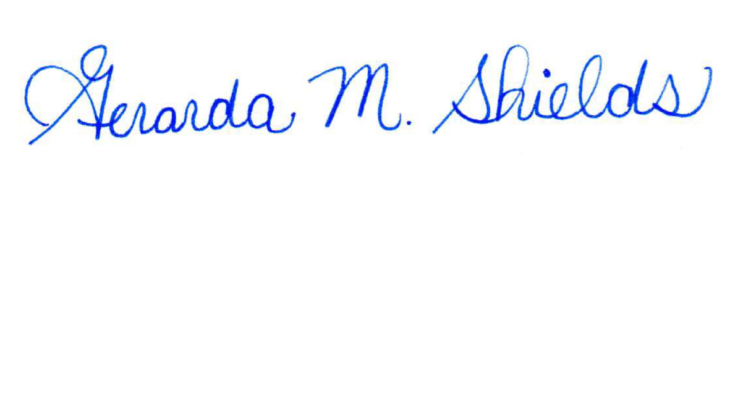  5/10/2024
Brief Description of Proposal  (Describe the modifications contained within this proposal in a succinct summary. More detailed content will be provided in the proposal body. | Change the prerequisite of MECH 3572-( Embedded Systems Fundamentals and Applications in Robotics) from MECH 3501 to MECH 1240.
Brief Rationale for Proposal  (Provide a concise summary of why this proposed change is important to the department. More detailed content will be provided in the proposal body). | Students taking MECH 3572 are required to have some programming skills.  The original prerequisite for MECH 3572 was MECH 3500 which was the department’s second programming course.  In 2016, the department decided to use MECH 1240, the department’s first programming course as the prerequisite for MECH 3572. This has been approved by the college’s curriculum committee. This allowed the department to create a new course called MECH 3501, Quality Control to replace MECH 3500.  But in 2021, when the department proposed to change other requirements for the department’s robotic concentration courses, MECH 3501 was erroneously stated to replace MECH 3500 as the prerequisite of MECH 3572. That was a mistake that no one from the department’s curriculum committee caught.
Proposal History  (Please provide history of this proposal: is this a resubmission? An updated version? This may most easily be expressed as a list). | None
Please include all appropriate documentation as indicated in the Curriculum Modification Checklist.
For each new course, please also complete the New Course Proposal and submit in this document.
Please submit this document as a single .doc or .rtf format. If some documents are unable to be converted to .doc, then please provide all documents archived into a single .zip file.
ALL PROPOSAL CHECK LIST
Completed CURRICULUM MODIFICATION FORM including:
- Brief description of proposal | Y
- Rationale for proposal | Y
- Date of department meeting approving the modification | Y
- Chair’s Signature | Y
- Dean’s Signature | y
Evidence of consultation with affected departments  List of the programs that use this course as required or elective, and courses that use this as a prerequisite. | N/A
Documentation of Advisory Commission views (if applicable). | N/A
Completed Chancellor’s Report Form. | Y

EXISTING PROGRAM MODIFICATION PROPOSALS

Documentation indicating core curriculum requirements have been met for new programs/options or program changes. | N/A
Detailed rationale for each modification (this includes minor modifications) | Y

Section AV: Changes in Existing Courses

Changes to be offered in the Mechanical Engineering Technology department

MECH 3572 Embedded Systems Fundamentals and Applications in Robotics
CUNYFirst Course ID | 47641
FROM: |  | TO:
Department(s) |  | Department(s)
Course |  | Course
Prerequisite |  | Prerequisite | MECH 1240 for MECH students only  CET 3510 for CET students only
Corequisite |  | Corequisite
Pre- or corequisite | MECH 3501 | Pre- or corequisite | EET 3112 for EET students only
Hours |  | Hours
Credits |  | Credits
Description |  | Description
Requirement Designation |  | Requirement Designation
Liberal Arts | [ ] Yes [ ] No | Liberal Arts | [ ] Yes [ ] No
Course Attribute (e.g. Writing Intensive, Honors, etc |  | Course Attribute (e.g. Writing Intensive, Honors, etc
Course Applicability | [ ] Major  [ ] Gen Ed Required  [ ] English Composition  [ ] Mathematics  [ ] Science  [ ] Gen Ed - Flexible  [ ] World Cultures  [ ] US Experience in its Diversity  [ ] Creative Expression  [ ] Individual and Society  [ ] Scientific World  [ ] Gen Ed - College Option  [ ] Speech  [ ] Interdisciplinary  [ ] Advanced Liberal Arts | Course Applicability | [ ] Major  [ ] Gen Ed Required  [ ] English Composition  [ ] Mathematics  [ ] Science  [ ] Gen Ed - Flexible  [ ] World Cultures  [ ] US Experience in its Diversity  [ ] Creative Expression  [ ] Individual and Society  [ ] Scientific World  [ ] Gen Ed - College Option  [ ] Speech  [ ] Interdisciplinary  [ ] Advanced Liberal Arts
Effective Term | Spring, 2025

Rationale: MECH 3501, Quality control, teaches MET students on quality control of products which are not quite related to programming the embedded systems used in MECH 3572, Introduction to Embedded Systems and Applications in Robotics. For MECH 3572, C and C++ were mainly used to program the microcontroller which are typical for embedded systems. MECH 1240 (Computer Applications for Mechanical Engineering Technology) such as data structure and program logic flow concepts, etc. This will provide students with basic computer programming skills and knowledge and allow more students who have interest in robotics to take MECH 3572 without waiting for one more semester.

