New York City College of Technology, CUNY
CURRICULUM MODIFICATION PROPOSAL FORM
This form is used for all curriculum modification proposals. See the Proposal Classification Chart for information about what types of modifications are major or minor. Completed proposals should be emailed to the Curriculum Committee chair.

Title of Proposal | Associate of Science in Biotechnology
Date | 2024-02-05
Major or Minor | Major
Proposer’s Name | Jeremy Seto
Department | Biological Sciences
Date of Departmental Meeting in which proposal was approved | 2024-02-02
Department Chair Name | Andleeb Zameer
Department Chair Signature and Date | Andleeb Zameer 2/6/2024
Academic Dean Name | Justin Vazquez-Poritz
Academic Dean Signature and Date | 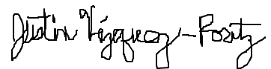 2/6/24
Brief Description of Proposal  (Describe the modifications contained within this proposal in a succinct summary. More detailed content will be provided in the proposal body. | This is a new proposal for a workforce development oriented Associates program in Biotechnology  This proposal includes the modification of X existing courses and the proposal of Y new courses.
Brief Rationale for Proposal  (Provide a concise summary of why this proposed change is important to the department. More detailed content will be provided in the proposal body). | The need for workforce development to fill the role of technologists and technicians in the growing Biotechnology field in the city necessitates a program catering to the local landscape. The Biological Sciences Department in partnership with the DNA Learning Center offers the opportunity for students to receive the appropriate experiential learning opportunities that will bolster their resumes, as well as provide avenues to continued education in Bachelors and Masters programs.
Proposal History  (Please provide history of this proposal: is this a resubmission? An updated version? This may most easily be expressed as a list). | - 2024-02-06 Submitted as a new proposal as a new degree program

Please include all appropriate documentation as indicated in the Curriculum Modification Checklist.

For each new course, please also complete the New Course Proposal and submit in this document.

Please submit this document as a single .doc or .rtf format. If some documents are unable to be converted to .doc, then please provide all documents archived into a single .zip file.

ALL PROPOSAL CHECK LIST
Completed CURRICULUM MODIFICATION FORM including:
- Brief description of proposal | x
- Rationale for proposal | x
- Date of department meeting approving the modification | x
- Chair’s Signature | X
- Dean’s Signature | X
Evidence of consultation with affected departments  List of the programs that use this course as required or elective, and courses that use this as a prerequisite. | x
Documentation of Advisory Commission views (if applicable).
Completed Chancellor’s Report Form. | x

EXISTING PROGRAM MODIFICATION PROPOSALS

Documentation indicating core curriculum requirements have been met for new programs/options or program changes. | x
Detailed rationale for each modification (this includes minor modifications) | x

Program Introduction
The field of biotechnology serves as the keystone of scientific advancement and economic growth. With breakthroughs in genomics, molecular biology, and healthcare, biotechnology is reshaping industries and revolutionizing our approach to solving global challenges. New York City is a major hub for research, healthcare, and technology. This proposal for a Biotechnology Associates Curriculum answers the call of the recent executive order: White House Executive Order on Advancing Biotechnology¹. This proposal underscores the critical importance of biotechnological innovation in addressing national challenges and calls for strategic investments in education with a specific emphasis on local workforce development to address the burgeoning need for technicians and technologists. This curriculum aims to empower individuals with the knowledge and skills needed to navigate the intricacies of biotechnological applications, fostering a new generation of professionals prepared to contribute to the dynamic landscape of the biotech industry.

The biotechnology sector is experiencing unprecedented growth, with a surge in demand for skilled professionals. New York City is already an established hub for healthcare institutions where research is performed. Through the New York State Life Science Initiative², a new skilled labor force will be called upon as new biological research campuses such as the Science Park and Research Campus (Kips Bay)³ and the Brooklyn Navy Yard⁴ begin to attract the biotech start-ups and incubators. There is a noticeable gap between the skills required by the biotech industry and the skills possessed by the workforce. The New York City College of Technology is positioned to capitalize on this demand and become a key player in shaping the future of biotechnological innovation by tending to the training needs of new students in these disciplines. This curriculum is motivated by the imperative to address these gaps, providing students with a comprehensive education that aligns with the evolving needs of employers and to harness this intellectual capital, fostering a culture of innovation, collaboration, and cutting-edge research within the biotech community.

Goals
The Biotechnology Associates Curriculum is designed to provide clear career pathways for students. Whether entering the workforce directly or pursuing further education, graduates will have the skills and knowledge to excel in research laboratories, pharmaceutical companies, and other sectors of the biotech industry.

The motivation behind the Biotechnology Associates Curriculum is rooted in the vision of propelling New York City to the forefront of biotechnological innovation as increased funding of infrastructure and research centers projects an expansion of skilled employment. The curriculum seeks to empower individuals to become catalysts for positive change in the dynamic and multidisciplinary realm of biotechnology.

Leveraging the collaboration with the DNA Learning Center, students undertaking this program will be process-oriented in the production of “big data'' by handling high-throughput sequencing. This will enable students to gain experiential insight from the handling of samples, processing of samples and management of large data to grant them a holistic approach to understanding the practice of research. Through the process of gaining this degree, students will be offered opportunities to enrich their resumes by gaining microcredentialing via the Bioscience Core Skills Initiative⁵ (https://www.coreskillsinstitute.com/credentials). These credentials have been developed in consultation with industry to ensure the appropriate validation of workforce skills. The field of biotechnology is vast and this degree program serves as a starting point to continue in a number of highly skilled subdisciplines as well as gain meaningful employment as technologists.

Needs and Justification
This AS in Biotechnology is proposed in response to the needs of the growing local job market and the students who are looking for technologist roles in the existing biomedical research environment. This new program will significantly increase opportunities to City Tech students who are looking for a more specialized Associates Degree option in the sciences while providing alternative pathways for students leaving other programs. This also provides possible opportunities to articulate into existing University programs in Biotechnology or entrance to Bachelors programs at City Tech in Biomedical Informatics or Applied Chemistry.

The growth of biotechnology opportunities has been remarkable and continues to expand across various sectors, driven by scientific advancements, technological innovation, and increasing demand for solutions to global challenges. Several key factors contribute to the growth of biotechnology opportunities. First are the advances and breakthroughs in molecular biology, genetic editing, synthetic biology, and personalized medicine. Many of these items have advanced in recent times to address the public health crisis caused by the COVID-19 pandemic that have resulted in the transformation of healthcare and pharmaceutical industries. With these transformations to the field came a greater volume of biological data and tools that require specialized understanding in order to analyze and operate.

Government Initiatives and investments like the Presidential executive order to advance biotechnology and biomanufacturing innovation for a sustainable, safe, and secure American bioeconomy and the New York State of Opportunity – Life Science Initiative recognize the potential of biotechnology in driving economic growth and addressing societal challenges that view this as an important sector of economic growth and job creation. Likewise, venture capital firms and biotech companies continue to invest heavily in research and development. This influx of funding supports the growth of startups, accelerates product development, and creates job opportunities.

Philanthropic organizations like the Bill & Melinda Gates foundation have long sought to create social equity through funding of biological research to benefit developing countries. Likewise, the Chan Zuckerberg Initiative will invest $3 billion over the next decade through Chan Zuckerberg Science to establish Biohubs⁶ in major cities like New York to fight disease (https://www.czbiohub.org/ny/).

Following the lead of philanthropy, private equity and venture capital firms have heavily invested in biotech; including GV biotech⁷ (https://www.gv.com/portfolio) and Andreesen Horowitz (https://a16z.com/bio-health/)⁸. More directly, Springboard Enterprises⁹ (https://sb.co/programs/life-sciences-innovation-program/) focuses on investment in early-stage biotech companies while providing mentorship in entrepreneurship.

To foster growth in the biotech sectors, incubator spaces within the city have been developed. Alexandria Real Estate has worked with the NYC Economic Development Corporation (NYCEDC) to establish world class laboratories for lease at the Alexandria Center for Life Sciences¹⁰ (https://nyc.are.com/) at Kips Bay, Manhattan and in Long Island City, Queens. SUNY Downstate had also worked with the NYCEDC to open BioBAT¹¹ (https://www.biobat.nyc/), incubators at the Brooklyn Army Terminal. In the pharmaceutical space, Johnson & Johnson has also created an incubator with mentoring at JLABS to offer lab space, resources and industry connections to lessors in SOHO{Updating} and around the country. Investment in this space continues to grow with the upcoming Kips Bay Science Park and Research Center{Updating} as well as the spaces in the Brooklyn Navy Yard{Updating}, all of which foster collaboration and knowledge exchange while serving as focal points for industry growth and talent acquisition in the city.

Likewise, a prototypical collaborative hub is embodied by the New York Genome Center¹² (NYGC) which is a multi-institutional endeavor grown out of the city’s rich higher education ecosystem and healthcare establishments (https://www.nygenome.org/about-us/). Institutional collaboration behind a singular technology of high-throughput DNA sequencing illustrates the urgency of this process that has not only been driving biotechnology innovations but also reflects the difficulty in performing these techniques. While biomanufacturing does not exist in the city proper, the local industry reflects on the process oriented nature of DNA sequencing that calls for skilled labor. Similarly, in the city that can do anything, a lively biohacker community resulted in the establishment of Genspace¹³ (https://www.genspace.org/mission) in order to foster a safe and inclusive environment for anyone outside of standard research paradigms to learn and access biotechnology. The existence and longevity of Genspace is proof alone of the growing biotechnology sector as the person on the street decides to take on biohacking.

Growth of biotechnology opportunities is propelled by a convergence of scientific breakthroughs, technological advancements, and a growing recognition of the sector's potential to address global challenges. Coupled with the established medical facilities? of New York as an employment base, continued growth of incubators and start-ups fuel the need for workforce training. The diverse applications of biotechnology across industries contribute to a dynamic and expanding landscape of opportunities for professionals, researchers, and entrepreneurs alike.

Employment Opportunities
The biotech industry has seen rapid growth and development. Innovation in this field has resulted in a rapid investment in biotechnology companies. In the past 10 years, the NASDAQ Biotechnology Index¹⁴ has shown a median growth of 37%--with a peak of 112% just in the past few years. The average rate of growth is approximately 6.57% per year in this time range.

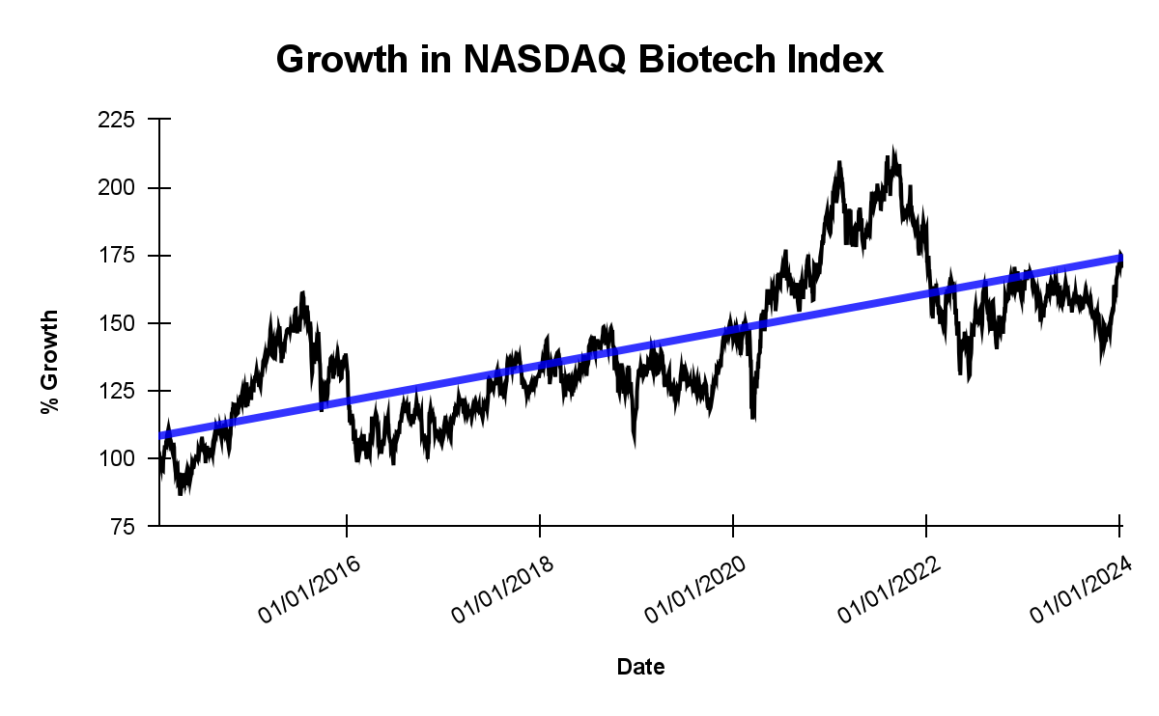
Figure 1. Ten years of growth in Biotechnology

It is estimated that the employment for the field of Biological Technicians is growing fast at a rate of 5% over the current decade¹⁵. According to DataUSA¹⁶, the greatest employment of technicians/technologists in biological fields lies in the Healthcare/Hospital system (473,000) followed by the Universities/Colleges (281,000) in 2021. The 5th most common employment came from Research and Development (130,000). Despite this number, a greater proportion of employment has come from this field since 2014 (88,000). This represents a steady growth in employment across the country at a rate of 6,000 people a year from 2014, but a more rapid rate of growth has occurred in the past few years at 9,000 people/year.
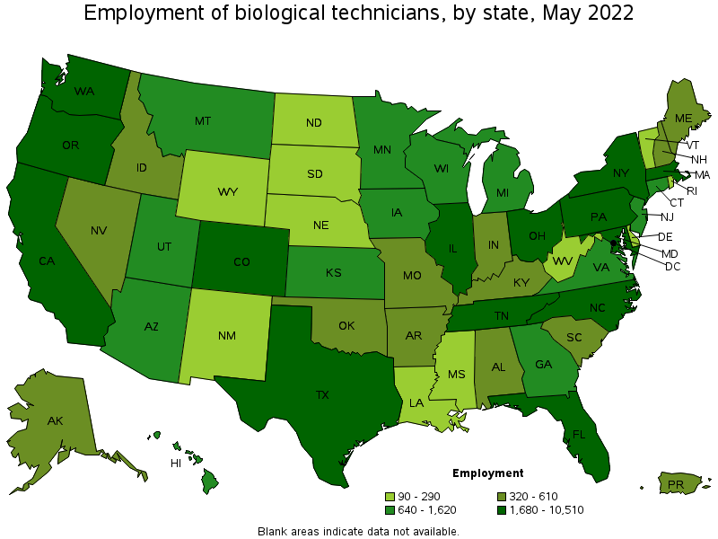
Figure 2. Bureau of labor statistics stats on employment of biological technicians in 2022(source: https://www.bls.gov/oes/current/oes194021.htm#st)

In 2022, the U.S. Bureau of Labor Statistics¹⁷ (https://www.bls.gov/oes/current/oes194021.htm) reports that New York was the fifth highest in employing biological technicians at 4,100. Furthermore, the highest levels have been found in scientific R&D and Colleges/Universities, followed by pharmaceutical manufacturing, hospitals and medical diagnostics labs.

Table 1. U.S. Bureau of Labor Statistics (https://www.bls.gov/oes/current/oes194021.htm)
Industry | Employment | % of industry employment | Hourly mean wage | Annual mean wage
Scientific Research and Development Services | 22,280 | 2.57 | $ 27.55 | $ 57,310
Colleges, Universities, and Professional Schools | 15,040 | 0.50 | $ 23.33 | $ 48,530
Federal Executive Branch (OEWS Designation) | 8,170 | 0.39 | $ 22.50 | $ 46,800
Pharmaceutical and Medicine Manufacturing | 7,890 | 2.38 | $ 31.73 | $ 65,990
General Medical and Surgical Hospitals | 5,380 | 0.10 | $ 26.52 | $ 55,150
Specialty (except Psychiatric and Substance Abuse) Hospitals | 1,110 | 0.41 | $ 27.46 | $ 57,120
Medical and Diagnostic Laboratories | 1,270 | 0.40 | $ 25.76 | $ 53,570

More regionally, the New York State Department of Labor¹⁸
(https://dol.ny.gov/2021-significant-industries-new-york-city) reports that the city’s largest industry is in the professional, scientific and technical services, based on employment. These include a wide variety of services ranging from legal/accounting to engineering and scientific research. This is owing to the well-established healthcare sector as evidenced by the large hospital networks tied to universities. A cursory review of salary ranges in the metropolitan area from Indeed, Monster and Glassdoor show salary ranges for biotechnology specific job titles from $37,000-$78,000 at the entry level.

Table 2. Aggregate salary data from Indeed, Monster and Glassdoor
Employment Title | Salary range (in NYC)
Biological Technician | $37,000-$78,000
Biomanufacturing Technician | $40,000-$50,000
Cell Culture Technician | $40,000-$50,000

Biotechnology jobs accepting employment with community college credentials can be found currently clustered in New Jersey with a handful of New York City locations (https://biotech-careers.org/careers)¹⁹. However, these job prospects are expected to grow. The Kips Bay Science Park and Research Center (SPARC), sponsored through the New York State of Opportunity – Life Science Initiative creates a fertile ground for prospective employment opportunities in the field of biotechnology in the immediate future. The initiative, aimed at advancing the life sciences sector, aligns with the mission of the Biotech Careers platform (biotech-careers.org), providing a dedicated space for individuals and employers to connect in the biotech industry.

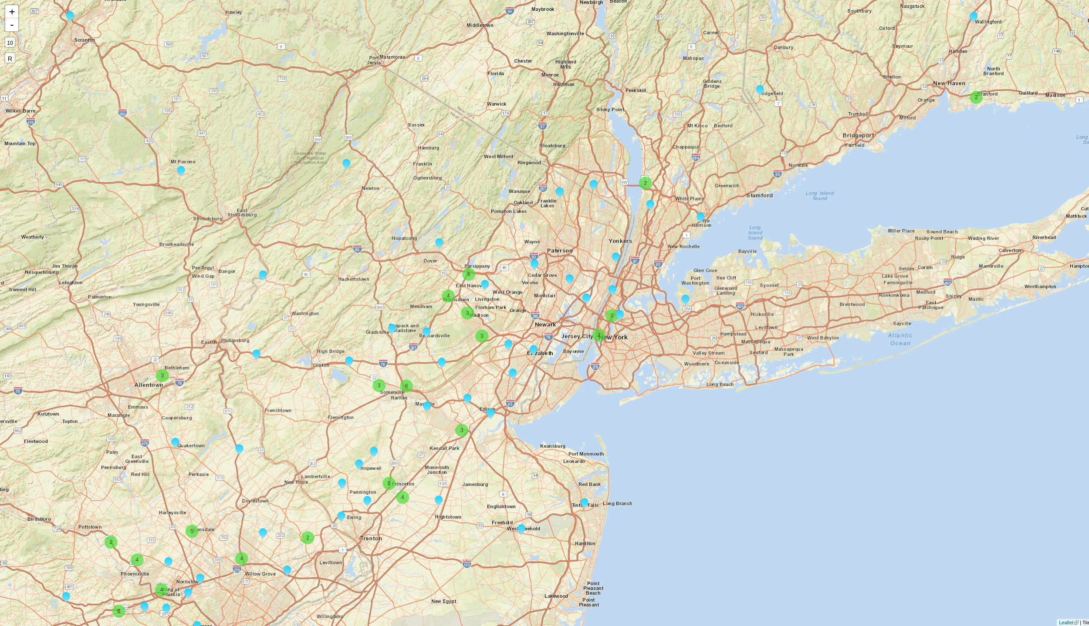
Figure 3. Biotech Jobs in the NYC area hiring with Community College credentials¹⁹ (source: https://biotech-careers.org/careers)

Furthermore, the significant investment of $800,000 by the NYCEDC in Aanika Biosciences and at the Brooklyn Navy Yard underscores the city's commitment to propelling the life sciences industry forward. The Biotech Center at the Brooklyn Navy Yard emerges as a pivotal hub, fostering cutting-edge biotechnological advancements and contributing to the growth of employment opportunities in the sector. This strategic investment not only supports research and innovation but also enhances the prospects for job creation and talent acquisition within the biotechnology field.

In summary, the integration of the SPARC and the Biotech Center at the Brooklyn Navy Yard creates a robust ecosystem for biotech employment in New York City. These initiatives collectively grow upon BioBAT and Alexandria Center to stimulate research, innovation, and economic development while augmenting the already rich healthcare landscape, positioning the city as a hub for biotechnological advancements and career opportunities.

City Tech is well-positioned to offer a first-rate Biotechnology degree to our students, utilizing our available academic expertise, state-of-the-art DNA Learning Center, and industrial connections. This program will prepare students for jobs in the biotechnology industry with the practical knowledge that the industry demands for entry-level positions and academic preparation that allows them to further their studies in Biomedical Informatics or other related bachelor degree programs.

Related Degree Programs
While a number of degree programs exist within CUNY at various levels, the degree programs identified outside of CUNY in the metropolitan area are at the graduate level. Competing Associates programs in CUNY are designed for direct articulation into existing Bachelor’s programs and often appear as standard Associates degrees in sciences with an emphasis on Biology/Chemistry. The program proposed for City Tech is in partnership with the Cold Spring Harbor Laboratory - DNA Learning Center, which acts as the Center for Genomics Education as a part of InnovATEBIO - the National Biotechnology Education Center (https://innovatebio.org/about). This collaboration focuses on workforce development in biotechnology.

Associates Degrees at CUNY
A handful of Associate’s programs in Biotechnology exist in CUNY community colleges. Like the LaGuardia Community College “track”, they are often biology- and chemistry-enriched curricula of standard Associate’s in Sciences degrees that are not tailored specifically towards workforce skills.

Table 3. Biotechnology Associates Programs at CUNY
College | Department | Degree or Track Offered
Queensborough Community College (QCC) | Biological Sciences & Geology | Associate of Science (AS) in Biotechnology Laboratory Technology
Bronx Community College (BCC) | Biological Sciences | Associate of Science (AS) in Biotechnology
Borough of Manhattan Community College (BMCC) | Science | Associate of Science (AS) in Biotechnology Science
Kingsborough Community College (KBCC) | Biological Sciences | Associate of Science (AS) in Biotechnology
LaGuardia Community College (LaGCC) | Natural Sciences | Associate of Science (AS) in Biology:Biotechnology Track

Bachelors Programs at CUNY
Senior colleges at CUNY offer a Bachelor’s in Biotechnology or Biology with Biotechnology concentration. While not directly biotechnology, City Tech offers a degree in the subdiscipline of Biomedical Informatics, which focuses on the very specific themes of integrating computational and data sciences with Biology. These programs offer a path of continuation upon completion of the Associate’s degree proposed here.

Table 4. Biotechnology and Related
Bachelors Programs at CUNY
College | Department | Degree Offered
City College (CCNY) | Division of Science | Bachelor of Science in Biotechnology
Hunter College | Department of Biological Sciences | Bachelor of Arts in Biotechnology
Brooklyn College | Department of Biology | Bachelor of Science in Biology with Biotechnology Concentration
Lehman College | Department of Biological Sciences | Bachelor of Science in Biology with Biotechnology Concentration
New York City College of Technology | Department of Biological Sciences | Bachelor of Science in Biomedical Informatics

Graduate Programs at CUNY
A Master’s program for Biotechnology exists at City College (CCNY) while other colleges offer Biotechnology tracks/concentrations within a Biology Master’s. A related discipline of Medical Lab Management also exists in a program at Hunter College. These are all possibilities of continuation for students.

Table 5. Graduate Programs in Biotechnology at CUNY
College | School or Department | Degree Offered
City College (CCNY) | Grove School of Engineering | Master of Science in Biotechnology
Hunter College | School of Health Professions | Master of Science in Biomedical Laboratory Management
Queens College | School of Earth and Environmental Sciences | Master of Arts in Biology with Biotechnology Concentration
Lehman College | Department of Biological Sciences | Master of Science in Biology with Biotechnology Concentration
College of Staten Island | Department of Biology | Master of Science in Biology with Biotechnology Track

Programs outside of CUNY in the metropolitan area
Within the metropolitan area, additional Master’s programs exist. Expanding outwards, additional programs exist in biotechnology that focus on entrepreneurship, illustrating the faith in the growing sector to stimulate jobs creation in this field.

Table 6. Graduate Biotechnology Programs in the metropolitan area
University | Program | Department | Website
Columbia University | MS in Biotechnology | Department of Biomedical Engineering | https://bme.columbia.edu/ms-biotechnology
New York University (NYU) | MS in Biotechnology and Entrepreneurship | Department of Biology | https://biology.as.nyu.edu/object/biology.msbiotech
Stevens Institute of Technology | MS in Biotechnology and Bioinformatics | Department of Chemical Engineering | https://www.stevens.edu/schaefer-school-engineering-science/departments/chemical-engineering-and-materials-science/graduate-studies/ms-chemical-biotechnology-and-bioinformatics
Fordham University | MS in Biotechnology | Department of Biological Sciences | https://www.fordham.edu/info/21056/programs/3312/biotechnology_ms

Student Interests & Enrollment Projection

Student Interest
Recent surveys were conducted by Professor Susan Davide (Dental Hygiene). These surveys took place within courses in the Biological Sciences Department in order to assess the interest in seeking out alternative studies. Most sections were at the introductory level while a few sections of specialized courses within the Biomedical Informatics (BIB) major were also included. Overall, these surveys revealed that 18% of students surveyed were interested or very interested in majoring in Biotechnology if it were available. When looking at the details of the breakdown, 50% of respondents in BIB stated an interest in a Biotechnology Associate’s, while only 10% Health students (Health Sciences or Undeclared Health) and 21% LAS students showed this interest.

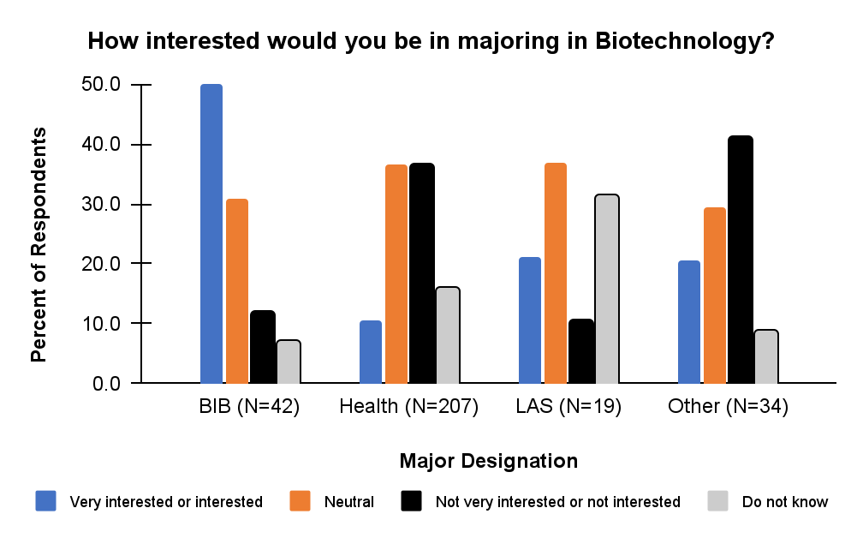
Figure 3. Interest survey

When asked about entering into a Biotechnology Associate’s Program at the beginning of their tenure at City Tech, 64.5% BIB students, 13.5% Health Sciences, 26% LAS and 17.6% Other Majors responded with interest.

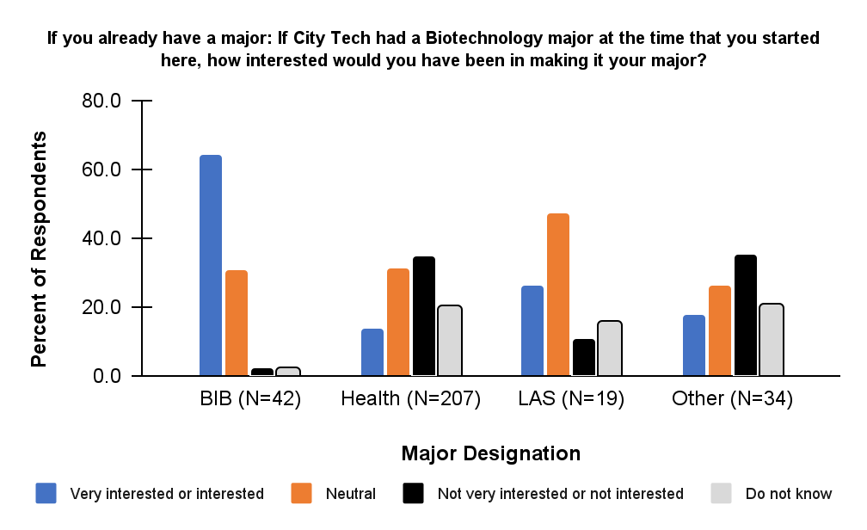
Figure 4. Alternative major interest survey

Some students who have entered the BIB major did so as an alternative to allied health majors. Unsurprisingly, 66.7% of the BIB students stated they would choose Biotechnology as a major if they had not successfully entered an Allied Health major. Focusing on the other majors, 20.9% Health students (43) and 36.8% LAS students (7) showed interest in a Biotechnology Associate’s as a fallback to an Allied Health major. The amount of Health Sciences students who responded with interest (43) were greater than the total number of BIB students surveyed.

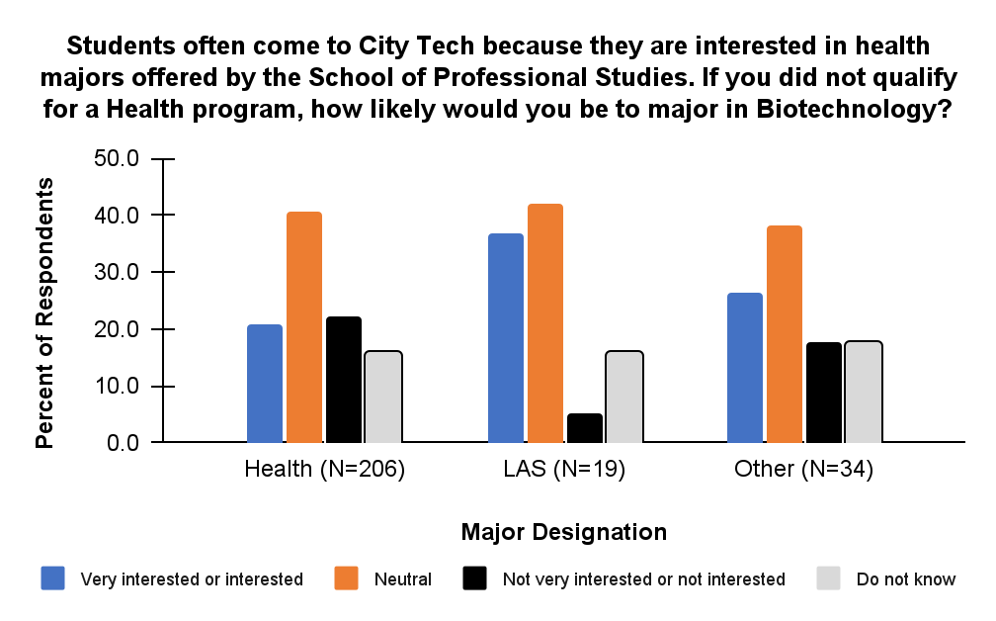
Figure 5. Fallback major survey

Unsurprisingly, 78.6% of BIB students responded that they would have chosen a Biotechnology Associate’s if it was a pathway to a Bachelor's degree in Biomedical Informatics. Additionally, 24.9% Health Students (51) and 42.1% LAS (8) showed interest in a Biotech AS if it was a pathway to a Bachelor’s Degree in Biomedical Informatics.

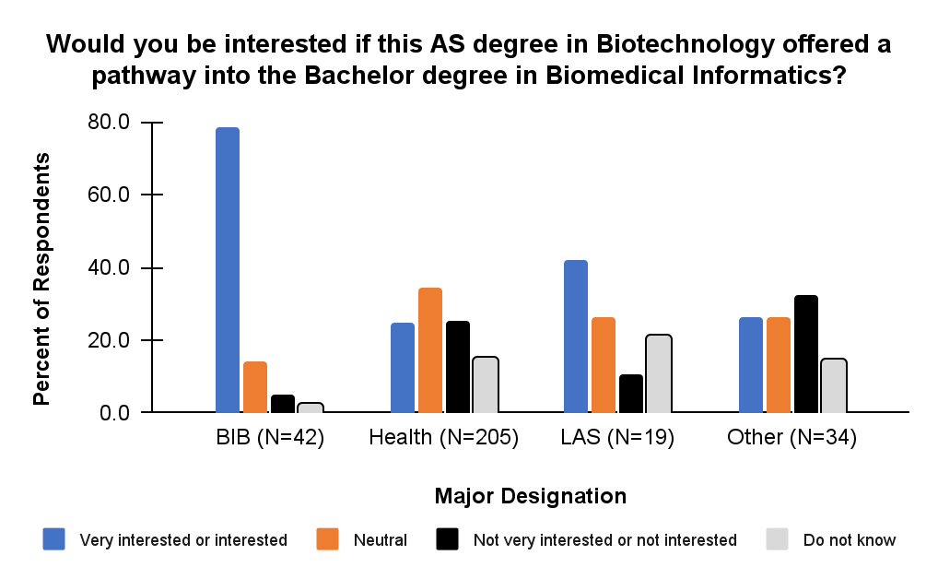
Figure 6. Pathway to Bachelors survey

Enrollment Projections
The Biology Department currently offers a BS in Biomedical Informatics (BIB), which launched in the Fall 2013 semester. The major serves about 200 students each semester, in addition to offering a variety of biology courses for students in other programs. Given student interest and anticipated workforce needs, we expect encouraging enrollment growth with an opportunity to articulate into another established Biotechnology Bachelor’s program at York College or continuation within City Tech towards Biomedical Informatics or Applied Chemistry (CHB). Given the relatedness to the existing majors in BIB, CHB, and the AS in Chemistry, a review of student retention from 2012-2021 revealed a mean retention of 63%, 58%, and 67%, respectively²⁰.

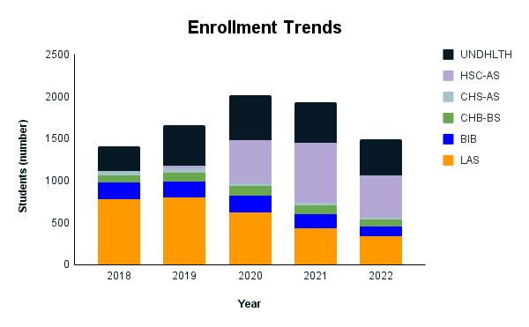
Figure 7. Enrollment Trends 2018-2022. Undeclared Health (UNDHLTH), Health Sciences (HSC-AS), Chem Tech (CHS-AS), Applied Chemistry (CHB-BS), Biomedical Informatics (BIB), Liberal arts and Sciences (LAS)²⁰

Early cohorts in BIB were recruited primarily from LAS but also from call-outs to former students who had not completed degrees at City Tech who were attempting to enter competitive allied health majors. Many of these students were readmitted to enter BIB with a new path to a degree. Likewise, the Health Science Associates (HSC-AS) program was born out of addressing a similar cohort and the large remaining undeclared/unclassified health (UNDHLTH) designation. Upon HSC-AS initiation, the number of students enrolled had stabilized to an average over 500 students each year with a small decline in UNDHLTH and a steady decline in LAS. Given the stability of enrollment/retention in BIB, CHB and Chem-AS along with the impact of HSC-AS and the survey responses, enrollment in Biotechnology is expected to show a steady increase in the next 5 years.

Table 7. Enrollment Projections for Biotechnology AS
Academic Year | Estimated Freshman Enrollment | Estimated Transfer Students | Annual New Enrollment
2025-2026 | 20 | 15 | 35
2026-2027 | 25 | 15 | 40
2027-2028 | 30 | 20 | 50
2028-2029 | 30 | 25 | 55
2029-2030 | 30 | 30 | 60

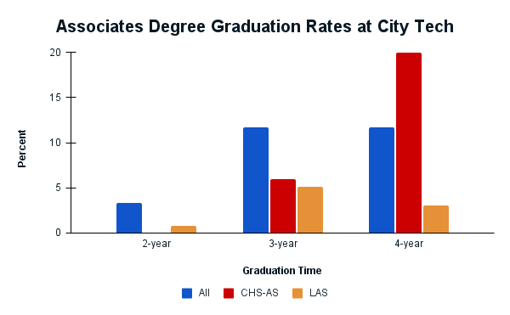
Figure 8. Associates Graduation Rates at City Tech. Chem Tech, LAS and All Associates degree programs at City Tech.²⁰

City Tech has shown a 3.3% 2-Year Graduation rate, 11.7% 3-Year Graduation rate and 11.7% 4-Year graduation rate in 2018 across Associate’s programs²⁰. These numbers track well with university-wide rates. However, the largest pool of transfer students are expected to come from LAS with much lower rates of 0.8% (2-year), 5.1%(3-year) and 3% (4 year)²⁰. The most closely related Associate’s program of Chemistry at City Tech also shows an extended time to graduation or degree completion with 0% (2-year), 5.9% (3-year) and 20% (4-year)²⁰.

Table 8. Retention and Graduation Projections. Percentages based on LAS, Chem Tech and overall trends.
Academic Year | Annual New Enrollment | Retention | Graduation | Total Students in the Program
2025-2026 | 35 | – – | – – | 35
2026-2027 | 40 | 28 (80%) | – – | 68
2027-2028 | 50 | 48 (70%) | 2 (3%) | 96
2028-2029 | 55 | 67 (70%) | 7 (7%) | 115
2029-2030 | 60 | 78 (67.5%) | 18 (15%) | 120

Graduation rates are estimated based on average numbers and reflect the nature of students enrolled within Associate’s programs where roughly half of the students are enrolled part-time. The part-time population adds to the increased length of stay along with the drops in retention. The sudden increase in graduations in the 4th year are emblematic of these types of degrees and the abundance of the part-time students.

Curriculum

Anticipated Program Education Objectives
Within a few years of graduation,

Table 9. Summary of Educational Objectives
Theme | Statements
Hard Skills | Students who progress through coursework will be granted the ability to gain meaningful micro-credentials for industry-consulted skills through the Bioscience Core Skills Initiative (https://www.coreskillsinstitute.com/credentials)
Experiential Learning | Students will have undertaken the internship/externship to provide meaningful insight from beginning to end of applying coursework to laboratory preparation and research. The collaboration with the DNA Learning Center and InnovATEBIO enables students to take part in process-oriented work within the local biotech ecosphere.
Employment | Graduates of the program are expected to achieve sustained employment with the basic skills and capacity to grow with the dynamic nature of the field
Continued Education | Graduates who desire to continue their education through articulations with the potential for graduate programs.
Soft Skills | Graduates of the program are expected to demonstrate professionalism,  ethical principles, continue lifelong learning, and commit to contribute to their  fields, community and the society

Anticipated Student Outcomes
Anticipated learning outcomes include an ability to:

- Apply the knowledge, techniques, skills, and modern tools of the discipline of biotechnology.
- Understand and apply the fundamentals of biological principles, concepts and theories, through problem-solving strategies, critical thinking, and analytical reasoning to assess existing and emergent biotechnology techniques, protocols and applications.
- Show proficiency in performing investigative and routine molecular biology laboratory procedures, including PCR, protein and DNA electrophoresis, cloning and DNA preparation, as well as running routine biochemistry assays including Western Blotting and RT-PCR.
- Apply written, oral, and graphical communication in broadly-defined technical and non-technical environments; and an ability to identify and use appropriate technical literature
- Demonstrate the ability to conduct standard tests and measurements, and other technical activities associated with research activities.
- Exemplify professional and laboratory etiquette in written, oral, and graphical communication skills used to conduct, analyze, interpret, and convey results effectively in both technical and non-technical environments.
- Conduct standard tests, measurements, and experiments and to analyze and interpret the results to improve processes
- Demonstrate an understanding of professional and ethical responsibilities, including how ethical concerns influence the biotechnology industry, respect for diversity, and continuous professional development.

Overview of Curriculum
Following the lead of InnovATEBIO - The National Biotechnology Education Center (https://innovatebio.org/programs), the design of this program is meant to address workforce development. The plethora of sample programs that exist within this network and consultation of the related Careers in Biotech website (https://biotech-careers.org/careers) have driven the design process to meet localized needs. Along with these considerations, integration of credentialing of core skills (https://www.coreskillsinstitute.com/credentials) into the courses strengthens the employability of the students.

To meet these criteria, the curriculum includes:
- 34 credits of the CUNY Pathways general education requirements (required core, flexible core) which will help students develop a solid liberal arts education.
- 23 credits in the discipline
- 3 credits of Internship for experiential learning

Courses Required to Complete the Program

Table 10. Gen Ed Requirements
Required Core
English Composition I  English Composition II  Mathematical and Quantitative Reasoning  Life and Physical Sciences | ENG1101  ENG1121  MAT1275☤ or higher  CHEM1110☤ | 3  3  4  4
Flexible Core
World Culture and Global Issues  US Experience in Its Diversity  Creative Expression  Individual and Society  Scientific World  Additional | Any  Any: ECON1101 recommended  Any  Any: PHIL2203 recommended  BIO1101☤  BIO1201☤ | 3  3  3  3  4  4
 | Subtotal | 34

☤Math, Biology and Chemistry courses prescribed as part of the common and flexible core are required in order for students to take BTEC courses within the 60 credit limit which contribute to learning outcomes that are critical for the proposed program.

Table 11. Major Requirements
Discipline Content
Introduction to Biotechnology  Chemistry II  Bioinformatics I  Genetics  Biotechnology Instrumentation  Serology and Cell Culture  Biotechnology Internship | BTEC1201  CHEM1210  BIO3350  BIO2450  BTEC2000  BTEC2100  BTEC3000 | 4  4  4  4  4  3  3
 | Subtotal | 26

Sample Degree Map (2-Year Course of Study)
Table 12. Semester 1
Course Name | NYCCT | Credits | Core Designation
Biology I | BIO 1101 | 4 | SW
English Composition I | ENG 1101 | 3 | EC
College Algebra and Trigonometry | MAT 1275 | 4 | MQR
General Chemistry I | CHEM 1110 | 4 | LPS
 |  | 15

Table 13. Semester 2
Course Name | NYCCT | Credits | Core Designation
Introduction to Biotechnology | BTEC 1210 | 4
Biology II | BIO 1201 | 4 | Flex
English Composition II | ENG 1121 | 3 | EC
General Chemistry II | CHEM 1210 | 4
 |  | 15

Table 14. Semester 3
Course Name | NYCCT | Credits | Core Designation
Genetics | BIO 2450 | 4
Biotechnology Instrumentation | BTEC 2000 | 4
Macroeconomics | * ECON 1101 | 3 | *USED recommended
Healthcare Ethics | * PHIL 2203 | 3 | *IS recommended
 |  | 14

Table 15. Semester 4
Course Name | NYCCT | Credits | Core Designation
Bioinformatics I | BIO 3350 | 4
Serology & Cell Culture | BTEC 2100 | 3
Biotechnology Internship | BTEC 3000 | 3
CE | CE | 3 | CE
WCGI | WCGI | 3 | WCGI
 |  | 16

Admission Requirements
Freshman criteria
- Students must be eligible to enroll in MAT1275 or higher.

Transfer Criteria
- Must be CUNY proficient (reading, writing, and math)
- Must have a minimum cumulative GPA of 2.0
- Must have completed prerequisites for taking MAT 1275 or higher

Catalog Description of the New Courses
Table 16. New Courses
BTEC 1210 Introduction to Biotechnology 4 credits: 3 lecture hours, 3 lab hours
An introduction to the field of biotechnology including applications of biotechnology in molecular biology, biochemistry, research, bioethics, and laboratory safe practices in a regulated environment. The course is supplemented with exciting hands-on laboratory exercises, and real-world research and industry applications which enable the student to master basic skills in working in a biotechnology lab; solution preparation, safe handling of hazardous material, nucleic acid isolation, recombinant DNA cloning, PCR and ELISA. The course concludes with bioscience career exploration, including applied research, biomanufacturing, biomedical devices, and clinical trials.
BTEC 2000 Biotechnology Instrumentation 5 credits: 3 hours lecture with 1 hour recitation, 3 hours lab
This course is a rigorous one that helps students develop problem-solving skills necessary for success doing wet-lab research while exploring in depth the chemistry of biological molecules. Knowledge in this area is directly applicable to the biotechnology fields of pharmaceuticals, environmental processes and remediation, as well as bioinstrumentation.
Students enrolled in this course will be well-versed in assays for fluorescent quantitation and biomanufacturing procedures of protein production and purification.
BTEC 2100 Serology and Cell Culture 3 credits: 3 lab hours
Theory and applications of cell culture techniques. Laboratory emphasis on the principles and practices of initiation, cultivation, maintenance, preservation of cell lines and applications. A study of cell culture techniques, the laboratory emphasizes the principles and practices of initiation, cultivation, maintenance, and the preservation of cell lines including applications such as transfection and project management. Basic immunology with serology including ELISAs and Western Blots are also taught.
BTEC 3000 Biotechnology Internship 90 field work hours
Provides the student with an opportunity to gain knowledge and skills from an apprenticeship or work experience in Biotechnology. The purpose of the Internship is to provide each student practical experience towards exercising professionalism and etiquette in a work environment. Assignment to field-work/study situations of a minimum of eight hours per week. Supervision will be provided by faculty and by the job supervisor. Internship provides entry-level, career-related experience, and workplace competencies that employers value when hiring.

Faculty

New York City College of Technology
Ehab M. Abo-Ali

Education: PhD (degree conferral in May 2024) in Pharmaceutical Sciences with a concentration in Toxicology, St. John's University, College of Pharmacy and Health Sciences, Queens, NY; MS in Biology (Molecular and Cellular), CUNY-City College, New York, NY; MS in General Biology, New York University (NYU), New York, NY; BA in Biology (with Chemistry minor), New York University (NYU), New York, NY

- Research Interests: diabetes, insulin resistance, post-translational modifications, cell signaling and metabolism, xenobiotic-induced toxicity
- Courses Taught at City Tech: BIO 1101-Biology I, BIO 2311-Anatomy and Physiology I, BIO 2312-Anatomy and Physiology II, BIO 3620-Molecular and Cell Biology

Ralph R. Alcendor
Education: PhD in Cell and Molecular Biology, UMDNJ-Graduate School of Biomedical Sciences, Newark, NJ; BS in Biology, University of the Virgin Islands, St. Thomas, USVI
- Research Interests: Longevity factors, Stress resistant mechanisms and Cell signaling molecules
- Courses Taught at City Tech: BIO 1101-Biology I, BIO 2311-Anatomy and Physiology I, BIO 2312-Anatomy and Physiology II, BIO 3302-Microbiology
Christopher Blair
Education: PhD in Ecology and Evolutionary Biology from University of Toronto and Royal Ontario Museum, MA in Ecology and Environmental Science from Central Connecticut State University, BA in Coastal Studies/Marine Science form University of Connecticut
- Research Interests: Phylogenomics and speciation, Historical biogeography, Landscape genomics, eDNA metabarcoding
- Courses Taught at City Tech: BIO 1201-Biology II
Isaac Barjis
Education: MS in Engineering from State University of Illinois, Chicago; B.Sc. (Hons) in Biomedical Sciences and Nutrition form University of North London, UK
- Research Interests: Modeling of Biological and Molecular processes, Petri Net
- Courses Taught at City Tech: BIO 1101-General Biology 1, BIO 1201- General Biology 2, BIO 2311-Anatomy and Physiology 1, BIO 2312-Anatomy and Physiology 2, BIO 3524-Nutrition, BIO 3526-Pathophysiology
Sanjoy Chakraborty
Education: PhD in Biochemistry; MS in Biochemistry and Molecular Biology from University of Calcutta, India
- Research Interests: Endocrinology
- Courses Taught at City Tech: BIO 2311-Anatomy and Physiology I, BIO 2312-Anatomy and Physiology II, BIO 3526-Pathophysiology
Honamattie Rena Dabydeen
Education: PhD Equivalency from City University of new York (CUNY), NY; Master’s in Medical Microbiology from Long Island University, NY; Master’s in Business administration (MBA) from Long Island University, NY; BS in Medical Technology from Pace University, NY
- Courses Taught at City Tech: BIO 3302-Microbiology
Eugenia G. Giannopoulou
Education: PhD in Computer Science-Bioinformatics from University of Peloponnese, BSc in Computer Science from Athens University of Economics and Business
- Research Interests: Bioinformatics/Computational Biology, Analysis of high-throughput sequencing data, Methylation in Cancer, Epigenomics landscape of rheumatic diseases, Regulatory Network Inference, Information Visualization in genomics and proteomics, Ontologies in biology and Data Mining
- Courses Taught at City Tech: BO 3352-Bioinformatics II, BIO 3354-Computational Genomics
Niloufar Haque
Education: PhD in Neurochemistry; MSc in Organic Chemistry; BSc in Chemistry from Aligarh Muslim University, India
- Research Interests: Tau pathology in Alzheimer’s disease, Microbial diversity in Gowanus canal and its relevance to human disease
- Courses Taught at City Tech: BIO 2311- Anatomy and Physiology I, BIO 2312-Anatomy and Physiology II, BIO 1101-Biology II, BIO 1201-Biology II
Laina Karthikeyan
Education: PhD in Neuroscience from New York University School of Medicine, NY; MS in Molecular Biology from Boston University, MA. MS in Zoology majoring in Cytogenetics from Bangalore University, India.
- Research Interests: Molecular Basis of Dystonia and Parkinson’s Disease, Anti-viral activities of cranberry juice, proanthocyanidin extracts and epigallocatechin gallate from green tea
- Courses Taught at City Tech: BIO 1101-Biology I, BIO 3524-Nutrition
Pegah Khosravi
Education: PhD in Bioinformatics from University of Tehran, Iran; MSc in Plants Breeding from University of Mazandaran, Iran; BSc in Agronomy and Plants Breeding from Shahid Bahonar University of Kerman, Iran.
- Research Interests: Artificial Intelligence, Bioinformatics/Computational Biology, Cancer Research, Deep Learning, Machine Learning, Medical Data Analysis, Pathology and Radiology Image Analysis
- Courses Taught at City Tech: BIO 3450: Biomedical Data Analysis I, BIO 4450: Biomedical Data Analysis II, BIO 4550: Biomedical Informatics Colloquium
Vasily Kolchenko
Education: Master’s in Mathematics from Kiev State University, Ukraine, M.D. in Internal Medicine and PhD in Cardiovascular Physiology from Kiev Medical University, Ukraine
- Research Interests: Human Physiology, Human Biology, Bioinformatics; Biosensor development and single nanoparticle detection (virus and protein); Science education
- Courses Taught at City Tech: BIO 2311-Anatomy and Physiology I, BIO 2312-Anatomy and Physiology II, BIO 3350-Bioinformatics I, BIO 3526-Pathophysiology
Zongmin Li
Education: PhD in Molecular, Cellular and Developmental Biology from CUNY Graduate Center, NY; MD in Clinical Medicine from China Medical University, China
- Research Interests: Intracellular protein degradation pathway and their role in the pathogenesis of neurodegenerative disorders like Parkinson’s and Alzheimer’s disease.
- Courses Taught at City tech: BIO 1100-Human Biology, BIO 1101-Biology I, BIO 3302-Microbiology
Juan Rivera-Correa

Education: PhD in Immunology and Inflammation, New York University, NY, NY.B.S. in Molecular and Cell Biology, University of Puerto Rico at Rio Piedras, San Juan, PR
- Research interests: Immunology, Malaria, B-cells, Antibodies, Infectious diseases, Tropical infections
- Courses taught at City Tech: BIO 3302: Microbiology Lecture, BIO 3302L: Microbiology Laboratory
Walied Samarrai
Education: PhD in Biological Sciences, MPhil in Biological Sciences and BA in Biological Sciences from City University of New York, NY
- Research Interests: Adaptive evolution under adverse conditions in Bacillus subtilis; Differential response of Bacillus subtilis ribosomal RNA promoters to nutritional stress
- Courses Taught at City Tech: BIO 1100-Human Biology, BIO 1101- Biology I, BIO 2311-Anatomy and Physiology I, BIO 3302-Microbiology
Jeremy Seto
Education: PhD in Neuroscience from Weill Graduate School of Medical Sciences of Cornell University, BA in Biological Sciences/BA in Psychology from Rutgers University, NJ
- Research Interests: Neuropsychoimmunology- The interface of immunology, infection and inflammation with Psychiatric disorders and neurodevelopment, Urban Ecology- The unique interaction of human populations in an urban space on the environment and ecosystems
- Courses Taught at City Tech: BIO 1101-Biology I, BIO 3620-Molecular and Cell Biology
Olufemi Sodeinde
Education: PhD in Animal Ecology from University of Ibadan, Nigeria; MS in Fisheries and Wildlife from Michigan State University; BSc in Zoology from University of Lagos, Nigeria
- Research Interests: Genetic variations in different populations of grasshopper; Biology, ecophysiology, and ecology of non-human terrestrial vertebrates
- Courses Taught at City Tech: BIO 1100-Human Biology, BIO 1101-Biology I, BIO 2311-Anatomy and Physiology I, BIO 2312-Anatomy and Physiology II
Armando D. Solis
Education: PhD in Biomedical Sciences from Mount Sinai School of Medicine of New York University, NY; MPhil in Biomedical Sciences from Graduate Center at City University of New York; MS in Chemical Engineering from Yale University; BS in Agricultural and Biological Engineering from Cornell University
- Research Interests: Protein Structure Bioinformatics, Information-Theoretic Approaches to Protein Structure Prediction, Information Theory in Molecular Biology
- Courses Taught at City Tech: BIO 1101- Biology I, BIO 3350- Bioinformatics I
Tatiana Voza
Education: PhD in Biology and Parasitology from University of Paris XII & Museum of Natural History of Paris, France; Masters in Toxic Interactions in Ecosystems & Biotechnologies related to toxins from Museum of Natural History of Paris, France; Bachelors in General Biology, Animal and Ecosystems Biology from University of Paris VI & VII, France
- Research Interests: Malaria parasite biology in the skin, Anti-malarial drugs, Biology of Parasites, Intra-vital microscopy
- Courses Taught at City Tech: BIO 1101-Biology I, BIO 1201-Biology II
Mai Zahran
Education: PhD in Biology from Ruprecht-Karls-Univeritat Heidelberg, Germany; MSc in Computational Molecular Biology and Bioinformatics from University of Paris VII, Paris, France; BSc in General Biology and Bioinformatics from University of Paris VI and University of Evry, France
- Research Interests: Computational molecular modeling, Protein-DNA interaction, Molecular recognition, Structure prediction, Understanding the mechanism of action of restriction and repair enzymes
- Courses Taught at City Tech: BIO 1101-Biology I, BIO 3350-Bioinformatics I, BIO 3352-Bioinformatics II, BIO 3356-Molecular Modeling in Biology
Andleeb Zameer
Education: PhD in Neuroimmunology from Arizona State University, Arizona; MSc in Biotechnology, BSc in Chemistry from Aligarh Muslim University, India
- Research Interests: Neuroimmunology-Understanding how immune system can alter nervous system functioning in autoimmune diseases like Multiple Sclerosis (MS) and systemic lupus erythematosus (SLE), Neurodegenerative diseases- Antibody based therapeutics for treating diseases like Alzheimer’s disease
- Courses Taught at City Tech: BIO 1101-Biology I, BIO 1201-Biology II, BIO 3302-Microbiology, BIO 3620-Molecular and Cell Biology

DNA Learning Center (NYC)
Educators at the DNALC in Brooklyn will serve as guest instructors

Kelsie Anson
Education: Ph.D. in Biochemistry from University of Colorado in Boulder; BS in Molecular Biology from Colgate University
- Research Interests: Fluorescent sensors to measure fluctuations of zinc ions and determine the role these ions play in crucial cell signaling pathways

Anna Feitzinger
Education: Ph.D. in Developmental Genetics from University of California - Davis; B.A. in Chemistry with Specialization in Bioinformatics from Hunter College
- Research Interests: Quantitative and developmental biology

Allison Mayle
Education: PhD Molecular and Human Genetics from Baylor College of Medicine; B.S. in Biochemistry and Molecular Biology, Genomics and Molecular Genetics from Michigan State University
- Research Interests: Stem cell homeostasis and malignancy

David Micklos
Education: D.Sc. in Biological Sciences (Honoris causa) from Cold Spring Harbor Laboratory; M.A. in Journalism form University of Maryland - College Park; B.S. in Biology from Salisbury University

Christina Newkirk
Education: M.A. in Environmental Conservation Education from New York University; B.A. in English Literature/Letters from University of Iowa

Cost Assessment
The Department of Biological Sciences is currently equipped with much of the basic equipment to run the first new course in Biotechnology. Subsequent investment into equipment for additional courses are expected to be derived from Perkins funding. Some equipment is also available at the DNA Learning Center in the Pearl Building where additional laboratory space exists to run courses. Major instrumentation required for this curriculum involve Nanopore Sequencers that are purchased at $11,000 each with additional reagent cost per semester, as well as re-usable flow cells. Other major equipment involve a tissue culture hood, 6 sets of micropipettors, additional fluorescence microscopes, UV/Visible plate reader, fluorescence plate reader and an additional laptop cart. Maintenance on an existing flow cytometer and other equipment will be required. Perkins funding will also be requested for the examination of microcredentials through the Biosciences Core Skills Institute.

With the increase of lab based courses, an additional full-time CLT will be required with support from existing part-time staff.

Acknowledgements
Within City Tech:
- Pamela Brown, Provost and Vice President of Academic Affairs
- Justin Vazquez-Poritz, Dean of the School of Arts & Sciences
- Susan Davide, Professor of Dental Hygiene
- Ivana Jovanovic, Chairperson of Dept. of Chemistry

Outside of City Tech:
- Dave Micklos, Executive Director of the DNA Learning Center of Cold Spring Harbor Laboratory
- Allison Mayle, Assistant Director of the DNA Learning Center of Cold Spring Harbor Laboratory
- Anna Feitzinger, Assistant Director of the DNA Learning Center of Cold Spring Harbor Laboratory
- Louis Levinger, Professor of Biology - York College
- Ivica Arsov, Chairperson of Biology - York College

References
1. The White House (2022). Executive Order on Advancing Biotechnology and Biomanufacturing Innovation for a Sustainable, Safe, and Secure American Bioeconomy. White House. https://www.whitehouse.gov/briefing-room/presidential-actions/2022/09/12/executive-order-on-advancing-biotechnology-and-biomanufacturing-innovation-for-a-sustainable-safe-and-secure-american-bioeconomy/.
2. Biotech and Life Sciences | Empire State Development (2016). https://esd.ny.gov/industries/biotech-and-life-sciences.
3. SPARC Kips Bay | NYCEDC https://edc.nyc/project/sparc-kips-bay.
4. Get Stuff Done https://www1.nyc.gov/content/getstuffdone/pages/.
5. Credentials - Bioscience Core Skills Institute Biosci. Core Ski. Inst. https://www.coreskillsinstitute.com/credentials.
6. Chan Zuckerberg Biohub New York CZ Biohub N. Y. https://www.czbiohub.org/ny/.
7. Synchronized GV - Portfolio. https://www.gv.com/portfolio.
8. Bio & Healthcare Tech Investments & Thesis | a16z Andreessen Horowitz. https://a16z.com/bio-health/.
9. Life Sciences Innovation | Springboard Springboard Enterp. Help. Women Raise Rise. https://sb.co/programs/life-sciences-innovation-program/.
10. Alexandria Life Sciences Center http://nyc.are.com.
11. BioBAT BioBAT. https://www.biobat.nyc.
12. Homepage - New York Genome Center https://www.nygenome.org/, https://www.nygenome.org/.
13. Genspace: About the Lab Genspace. https://www.genspace.org/the-lab.
14. Overview for NBI https://indexes.nasdaqomx.com/index/overview/NBI.
15. Philippidis, A. (2021). Top 10 Life Sciences Jobs Most in Demand over the Next Decade. GEN - Genet. Eng. Biotechnol. News. https://www.genengnews.com/a-lists/top-10-life-sciences-jobs-most-in-demand-over-the-next-decade-2/.
16. Data USA https://datausa.io/search/?q=biotechnology.
17. Bureau of Labor Statistics BLS: Biological Technicians. https://www.bls.gov/oes/current/oes194021.htm#st.
18. Significant Industries Dep. Labor. https://dol.ny.gov/significant-industries.
19. Careers in Biotechnology | Biotech Careers https://biotech-careers.org/careers.
20. Data Dashboard - AIRE https://www.citytech.cuny.edu/aire/data-dashboard.aspx.

New Courses
NEW COURSE PROPOSAL: BTEC 1210 Introduction to Biotechnology
New York City College of Technology, CUNY
NEW COURSE PROPOSAL FORM

This form is used for all new course proposals. Attach this to the Curriculum Modification Proposal Form and submit as one package as per instructions. Use one New Course Proposal Form for each new course.

Course Title | Introduction to Biotechnology
Proposal Date | January 2024
Proposer’s Name | Jeremy Seto
Course Number | BTEC 1210
Course Credits, Hours | 4 credits: 3 lecture hours, 3 lab hours
Course Pre / Co-Requisites | Pre:BIO 1101 and Co-req: CHEM 1110
Catalog Course Description | An introduction to the field of biotechnology, including applications of biotechnology in molecular biology, biochemistry, research, bioethics, and laboratory-safe practices in a regulated environment. The course is supplemented with exciting hands-on laboratory exercises, and real-world research and industry applications that enable students to master basic skills in working in a biotechnology lab. Solution preparation, safe handling of hazardous material, nucleic acid isolation, recombinant DNA cloning, PCR and ELISA are also explored. The course concludes with bioscience career exploration, including applied research, biomanufacturing, biomedical devices, and clinical trials.  Students enrolled earn the ability to take part in Bioscience Core Skills Initiative microcredentialing in Small Volume Metrology and Numeracy.
Brief Rationale  Provide a concise summary of why this course is important to the department, school or college. | This course is designed to provide a practical and hands-on exploration into the field of biotechnology. In support of AAC&U core skills of “life-long learning”, this course will challenge students to apply critical thinking skills to their readings, class activities, laboratory exercises, and classroom discussions about current topics in biotechnology.  Although an emphasis is placed on each student’s personal responsibility for constructing their  new knowledge, opportunities for working collaboratively with groups will also be provided.  This course is the first course in the Biotechnology Program and also a biology science elective.
CUNY – Course Equivalencies  Provide information about equivalent courses within CUNY, if any. | BI 453 Biotechnology(QCC)  BTE 201 Introduction to Biotechnology (BMCC)  SCB 252: Fundamentals of Biotechniques (LaGCC)
Intent to Submit as Common Core  If this course is intended to fulfill one of the requirements in the common core, then indicate which area. | No
For Interdisciplinary Courses:  - Date submitted to ID Committee for review  - Date ID recommendation received  - Will all sections be offered as ID? Y/N | Not Applicable
Intent to Submit as a Writing Intensive Course | No

Please include all appropriate documentation as indicated in the NEW COURSE PROPOSAL Combine all information into a single document that is included in the Curriculum Modification Form.
NEW COURSE PROPOSAL CHECKLIST
Use this checklist to ensure that all required documentation has been included. You may wish to use this checklist as a table of contents within the new course proposal.
Completed NEW COURSE PROPOSAL FORM
- Title, Number, Credits, Hours, Catalog course description | x
- Brief Rationale | x
- CUNY – Course Equivalencies | X
Completed Library Resources and Information Literacy Form | X
Course Outline
Include within the outline the following.
Hours and Credits for Lecture and Labs  If hours exceed mandated Carnegie Hours, then rationale for this | x
Prerequisites/Co- requisites | x
Detailed Course Description | x
Course Specific Learning Outcome and Assessment Tables  - Discipline Specific  - General Education Specific Learning Outcome and Assessment Tables | x
Example Weekly Course outline | x
Grade Policy and Procedure | x
Recommended Instructional Materials (Textbooks, lab supplies, etc) | x
Library resources and bibliography | x
Course Need Assessment.
Describe the need for this course. Include in your statement the following information.
Target Students who will take this course. Which programs or departments, and how many anticipated?  Documentation of student views (if applicable, e.g. non-required elective). | x
Projected headcounts (fall/spring and day/evening) for each new or modified course. | x
If additional physical resources are required (new space, modifications, equipment), description of these requirements. If applicable, Memo or email from the VP for Finance and Administration with written comments regarding additional and/or new facilities, renovations or construction. | x
Where does this course overlap with other courses, both within and outside of the department? | x
Does the Department currently have full time faculty qualified to teach this course? If not, then what plans are there to cover this? | x
If needs assessment states that this course is required by an accrediting body, then provide documentation indicating that need. | NA
Course Design
Describe how this course is designed.
Course Context (e.g. required, elective, capstone) | x
Course Structure: how the course will be offered (e.g. lecture, seminar, tutorial, fieldtrip)? | x
Anticipated pedagogical strategies and instructional design (e.g. Group Work, Case Study, Team Project, Lecture) | x
How does this course support Programmatic Learning Outcomes? | x
Is this course designed to be partially or fully online? If so, describe how this benefits students and/or program. | x
Additional Forms for Specific Course Categories
Interdisciplinary Form (if applicable)
Interdisciplinary Committee Recommendation (if applicable and if received)*
*Recommendation must be received before consideration by full Curriculum Committee
Common Core (Liberal Arts) Intent to Submit (if applicable)
Writing Intensive Form if course is intended to be a WIC (under development)
If course originated as an experimental course, then results of evaluation plan as developed with director of assessment.
(Additional materials for Curricular Experiments)
Plan and process for evaluation developed in consultation with the director of assessment. (Contact Director of Assessment for more information).
Established Timeline for Curricular Experiment

Chancellor’s Report Section AIV: New Courses

AIV.1. Department

Department(s) | Biological Sciences
Academic Level | Undergraduate
Subject Area | Biotechnology
Course Prefix | BTEC
Course Number | 1210
Course Title | Introduction to Biotechnology
Catalog Description | An introduction to the field of biotechnology, including applications of biotechnology in molecular biology, biochemistry, research, bioethics, and laboratory-safe practices in a regulated environment. The course is supplemented with exciting hands-on laboratory exercises, and real-world research and industry applications that enable students to master basic skills in a biotechnology lab: solution preparation, safe handling of hazardous material, nucleic acid isolation, recombinant DNA cloning, PCR, and ELISA are also explored. The course concludes with bioscience career exploration, including applied research, biomanufacturing, biomedical devices, and clinical trials.  Students enrolled earn the ability to take part in Bioscience Core Skills Initiative microcredentialing in Small Volume Metrology and Numeracy.
Prerequisite | BIO 1101
Corequisite | CHEM 1110
Credits | 4 credits: 3 lecture hours, 3 lab hours
Liberal Arts | N/A
Course Attribute (e.g. Writing Intensive, etc) | N/A
Course Applicability | _X___ Major  ____ Gen Ed Required  ____ English Composition  ____ Mathematics  ____ Science  ____ Gen Ed - Flexible  ____ World Cultures  ____ US Experience in its Diversity.  ____ Creative Expression  ____ Individual and Society  __X__ Scientific World  ____ Gen Ed - College Option
Effective Term | Spring 2026

Rationale:
This course is designed to provide a practical and hands-on exploration into the field of biotechnology. In support of AAC&U core skills of “life-long learning”, this course will challenge students to apply critical thinking skills to their readings, class activities, laboratory exercises, and classroom discussions about current topics in biotechnology. Although an emphasis is placed on each student’s personal responsibility for constructing their new knowledge, opportunities for working collaboratively with groups will also be provided. This course is the first course in the Biotechnology Program and also a biology science elective
LIBRARY RESOURCES & INFORMATION LITERACY: MAJOR CURRICULUM MODIFICATION

Please complete for all major curriculum modifications. This information will assist the library in planning for new courses/programs.

Consult with your library faculty subject specialist (http://cityte.ch/dir) 3 weeks before the proposal deadline.

Course proposer: please complete boxes 1-4. Library faculty subject specialist: please complete box 5.

1 | Title of proposal  BTEC 1210 Introduction to Biotechnology | Department/Program  Biological Sciences/AS in Biotechnology
 | Proposed by (include email & phone)  Jeremy Seto  jseto@citytech.cuny.edu 718-260-5088 | Expected date course(s) will be offered Spring 2026  # of students 24

2 | The library cannot purchase reserve textbooks for every course at the college, nor copies for all students. Consult our website (http://cityte.ch/curriculum) for articles and ebooks for your courses, or our open educational resources (OER) guide (http://cityte.ch/oer). Have you considered using a freely-available OER or an open textbook in this course?  - Biotechnology: Science for the New Millennium, 2E. (2022) Ellyn Daugherty. 978-0-7638-6806-2  - Introduction to Biotechnology Laboratory Manual & Exercise Workbook.(2016) Jack O'Grady.  Textbook is commercially available. Over time, this may be adapted into an OER. Laboratory resources are distributed freely as OER.

3 | Beyond the required course materials, are City Tech library resources sufficient for course assignments? If additional resources are needed, please provide format details (e.g. ebook, journal, DVD, etc.), full citation (author, title, publisher, edition, date), price, and product link.  Other existing resources within the library are sufficient as reference materials for course assignments outside of those assigned.  - https://www.labxchange.org/library?t=Language%3Aen&t=ItemType%3Ainteractive&q=biotechnology&page=1&size=24&order=relevance  - https://www.ncbionetwork.org/educational-resources

4 | Library faculty focus on strengthening students' information literacy skills in finding, critically evaluating, and ethically using information. We collaborate on developing assignments and customized instruction and research guides. When this course is offered, how do you plan to consult with the library faculty subject specialist for your area? Please elaborate.  Information Literacy is highlighted in this course and students will be referred to the library for help in literature review and resources.

5 | Library Faculty Subject Specialist Cailean Cooney  Comments and Recommendations  Library resources to support information literacy include subject specific library guides, research intros and tutorials, and citation guides. Faculty can also consult with the subject liaison on identifying primary and supplementary OER course materials, and consider proposing the course for future OER faculty development programming which may include creation or adoption of zero-cost, openly-licensed resources. Faculty are encouraged to share a bibliography of related texts with the library to help support monograph and online resource procurement as budget allows. I also I recommend that required course materials that need to be purchased by students should be requested and placed on reserve in the library via this request form: https://library.citytech.cuny.edu/services/faculty/teaching/course/reserveForm.php  Date 2/1/24

BTEC 1210 Introduction to Biotechnology
(4 credits: 3 hours Lecture,3 hours Lab)

Required Materials
- Textbook: Biotechnology: Science for the New Millennium, 2E. (2022) Ellyn Daugherty
- Lab Manual: Introduction to Biotechnology Laboratory Manual & Exercise Workbook. (2016) Jack O’Grady and documents provided by instructor.
- Personal Protective Equipment: Lab Coat
- Email: School email MUST be used. All communications with the instructor must be performed through the official school email.

Prerequisites
BIO1101 Biology 1 and Pre/Co-req CHEM 1110

Course Description
An introduction to the field of biotechnology including applications of biotechnology in molecular biology, biochemistry, research, bioethics, and laboratory-safe practices in a regulated environment. The course is supplemented with exciting hands-on laboratory exercises, and real-world research and industry applications that enable students to master basic skills in working in a biotechnology lab. Solution preparation, safe handling of hazardous material, nucleic acid isolation, recombinant DNA cloning, PCR and ELISA are also explored. The course concludes with bioscience career exploration, including applied research, biomanufacturing, biomedical devices, and clinical trials.
Students enrolled earn the ability to take part in Bioscience Core Skills Initiative microcredentialing in Small Volume Metrology and Numeracy.

Learning outcomes
Upon completion of this course students will be able to
- demonstrate understanding of basic principles of molecular biology, microbiology, genetics, cell biology, biochemistry, and other areas that form the scientific basis of biotechnology
- apply biotechnological theory towards solving problems in medicine, agriculture and other industries
- create an appropriate survey of the field and prepare a resume and cover letter for applying to careers

Gen-Ed Objectives
- Communication: Students will communicate in written and oral forms and by employing visual means
- Inquiry & Analysis: Students will apply the process of science to formulate hypotheses while analyzing results to draw conclusions
- Information Literacy: Students will perform a review of the field and conduct research into employment profiles in order to create working resumes, cover letters and engage in interview questioning

Instructional Methodology
There is a laboratory and lecture component to this course, both of which must be taken together. There will be required readings from the textbooks, as well as occasional additional reading assignments from the literature. Both the lecture and laboratory components will require the use of the Internet and Brightspace, CUNY’s new Learning Management System. An emphasis is placed on active learning strategies for content mastery.

Course Rationale
This course is designed to provide a practical and hands-on exploration into the field of biotechnology. In support of AAC&U core skills of “life-long learning”, this course will challenge students to apply critical thinking skills to their readings, class activities, laboratory exercises, and classroom discussions about current topics in biotechnology. Although an emphasis is placed on each student’s personal responsibility for constructing their new knowledge, opportunities for working collaboratively with groups will also be provided. This course is the first course in the Biotechnology Program.

Schedule
Week | Lecture Reading | Week | Lab
1 | Chapter 1: What is Biotechnology? | 1 | Lab Safety
 | Chapter 2: The Raw Materials of Biotechnology |  | Lab 1 Introduction to Biotech
2 | Lecture: Quality in Biotechnology | 2 | Lab 2 Basic Tools in Biotechnology Lab
 | Chapter 3: Basic Skills of the Biotech Workplace |  | Notebooks Using Open Science Framework
3 | Practice Basic calculations | 3 | Lab 3 Calculations
 | Practice Preparation of Solutions |  | Lab 3 Preparing Solutions
4 | Lecture Graphing and Data Presentation | 4 | Lab 3 Data Analysis
 | Chapter 4: Introduction to DNA |  | Introduction to DNA Barcoding
5 | Exam 1 | 5 | Quiz 1
 | Chapter 7: Spectrophotometers & NanoDrop |  | Lab 4 DNA Barcoding - DNA Isolation & Lab 5 PCR
6 | Chapter 5: Introduction to Studying Proteins | 6 | Lab 4 & Lab 5 DNA analysis
 | Chapter 6: Identifying Biotech Products |  | Lab 13 ELISA design
7 | Chapter 7: Spectrophotometers & Assays | 7 | Lab 13 ELISA
 | Lecture Graphing and Data Analysis |  | Data Analysis
8 | Catch-up/Review | 8 | Quiz 2
 | Exam 2 |  | Create Starter Culture & Notebook Review
9 | Lecture: Microbial & Bacterial Culturing | 9 | Lab 9 Plasmid Isolation
 | Chapter 8: Producing Recombinant Products |  | Lab 8 Pour Plates
10 | Recombinant Technology (continued) | 10 | Lab 10 Restriction Digestion Analysis of Plasmid
 | Chapter 9: Bringing Biotech Products to Market |  | Lab 8 Transformation
11 | Biotech in Market (continued) | 11 | Lab 6 DNA Barcoding Analysis & Sequencing
 | Chapter 10: Plant Biotechnology |  | Notebook Review & Inoculating cultures
12 | Chapter 11: Biotechnology in Agriculture | 12 | Lab 11 GFP Purification
 | Chapter 12: Medical Biotechnology |  | Lab 7A PCR of Human VNTR
13 | Chapter 13: DNA Technologies | 13 | Lab 7B Analysis of VNTR Loci PCR Amplicons
 | Chapter 14: Biotechnology Research & Application |  | Lab 12 SDS-PAGE of GFP
14 | Lecture: Creating a great presentation | 14 | Lab 14 Preparing for a career in Biotechnology
 | Lecture: Effective communication for employment
15 | Semester Review | 15 | Quiz 3
 | Exam 3 |  | Class Presentations

Grading
This class has both a lecture and laboratory component. The Lecture will account for 50% of the grade with the remaining 50% from the lab. Students must pass both sections in order to pass the course.
Lecture Grade (50%) | Lab Grade (50%)
Exams 70% | Quizzes 50%
Homework 20% | Homework 20%
 | Presentation 5%
 | Notebook 20%
 | Job Application Profile 5%

Policies

Attendance
CUNY does not hold mandatory attendance; however, participation with in-class assignments and quizzes are mandatory. Failure to participate in class-based work may result in penalties based on the grading criteria explained at the onset of the course. Prompt arrival to class is a professional attribute and tardiness may be penalized based on missing class work.

Scholastic Dishonesty
Students have the responsibility to submit coursework that is the result of their own thought, research, or self-expression. Students must follow all instructions given by faculty or designated college representatives when taking examinations, placement assessments, tests, quizzes, and evaluations. Actions constituting scholastic dishonesty include, but are not limited to, plagiarism, cheating, fabrication, collusion, and falsifying documents.
Penalties for scholastic dishonesty will depend upon the nature of the violation and may range from lowering a grade on one assignment to an “F” in the course and/or expulsion from the college. See the Student Standards of Conduct and Disciplinary Process and other policies at: https://www.citytech.cuny.edu/academic-integrity/

Statement on Students with Disabilities
Students with disabilities who need classroom, academic or other accommodations must request them through the Center for Student Accessibility. Students are encouraged to request accommodations when they register for courses or at least three weeks before the start of the semester; otherwise, the provision of accommodations may be delayed.
Students who have received approval for accommodations from CSA for this course must provide the instructor with the ‘Notice of Approved Accommodations’ from CSA before accommodations will be provided. Arrangements for academic accommodations can only be made after the instructor receives the ‘Notice of Approved Accommodations’ from the student.
Students with approved accommodations are encouraged to submit the ‘Notice of Approved Accommodations’ to the instructor at the beginning of the semester because a reasonable amount of time may be needed to prepare and arrange for the accommodations. Additional information about Center for Student Accessibility is available at: https://www.citytech.cuny.edu/accessibility/

Statement of Diversity and Inclusion
This course welcomes students from all backgrounds, experiences and perspectives. In accordance with the City Tech and CUNY missions, this course intends to provide an atmosphere of inclusion, respect, and the mutual appreciation of differences so that together we can create an environment in which all students can flourish. It is the instructor’s goal to provide materials and activities that are welcoming and accommodating of diversity in all of its forms, including race, gender identity and presentation, ethnicity, national origin, religion, cultural identity, socioeconomic background, sexuality and sexual orientation, ability, neurodivergence, age, and etc. Your instructor is committed to equity and actively seeks ways to challenge institutional racism, sexism, ableism and other forms of prejudice. Your input is encouraged and appreciated. If a dynamic that you observe or experience in the course concerns you, you may respectfully inform your instructor without fear of how your concerns will affect your grade. Let your instructor know how to improve the effectiveness of the course for you personally, or for other students or student groups.

Assessment Methods
General Education Learning Outcomes | Assessment Methods
Communication: Students will communicate in written and oral forms and by employing visual means | Homework, Presentation, Job Application Profile
Inquiry & Analysis: Students will apply the process of science to create hypotheses while analyzing results to draw conclusions | Notebook serves as an intermediary of formal lab reports while enforcing documentation of operating procedures
Information Literacy: Students will perform a review of the field and conduct a research into employment profiles in order to create working resumes, cover letters and engage in interview questioning | Job application profile will consist of CV and Cover Letter demonstrating research into job posting

Course Specific LearningOutcomes | Assessment Methods
Demonstrate understanding of basic principles of molecular biology, microbiology, genetics, cell biology, biochemistry, and other areas that form the scientific basis of biotechnology | Homework, Quiz, Exam
Apply biotechnological theory towards solving problems in medicine, agriculture and other industries | Homework, Lab
Create an appropriate survey of the field and prepare a resume and cover letter for applying to careers | Presentation, Job Application Profile

Course Needs Assessment
This course will be offered to freshman students in the new Biotechnology AS degree proposed by the Department of Biological Sciences. This is a required course for the major. It is expected to have a maximum capacity of 24 students each semester in Spring and Fall. This maximum is set for the lab spaces. The content of this course has some partial overlap with the more advanced and theoretically focused BIO3620 Molecular and Cell Biology.

Course Design
The course is structured as a combination of didactic lectures with accompanying lab sessions. The lecture will not only introduce students to some of the theoretical aspects of biotechnology that will be covered in lab sessions but also steer towards a survey of the field for employment. The laboratory sessions will focus on the hands-on application of molecular biology and microbiology, focusing on hard skills for workforce development. Completion of the course also enables students to take micro-credentialing examinations to ensure that they have solid items to place on their resumes.

Most full-time faculty are capable of teaching this course as well as a number of returning adjunct instructors. Lectures and Labs will be held in-person only. Adequate space is available for the lab within the New Academic Building as well as two labs at the DNA Learning Center dedicated for CUNY use.

Existing equipment for the course currently exists with additional equipment being purchased through Tech Fee and Perkins funding in the future.

NEW COURSE PROPOSAL: BTEC 2000 Biotechnology Instrumentation
New York City College of Technology, CUNY
NEW COURSE PROPOSAL FORM

This form is used for all new course proposals. Attach this to the Curriculum Modification Proposal Form and submit as one package as per instructions. Use one New Course Proposal Form for each new course.

Course Title | Biotechnology Instrumentation
Proposal Date | January 2024
Proposer’s Name | Jeremy Seto
Course Number | BTEC 2000
Course Credits, Hours | 4 credits: 3 lecture, 3 lab
Course Pre / Co-Requisites | Pre:BTEC1210 and CHEM1110
Catalog Course Description | This course is a rigorous one that helps students develop problem-solving skills necessary for success doing wet-lab research while exploring in depth the chemistry of biological molecules. Knowledge in this area is directly applicable to the biotechnology fields of pharmaceuticals, environmental processes and remediation, as well as bioinstrumentation.  Students enrolled in this course will be well-versed in assays for fluorescent quantitation and biomanufacturing procedures of protein production and purification.  The course concludes with a presentation of documentation of protocols. Students enrolled earn the ability to take part in Bioscience Core Skills Initiative microcredentialing in Safety: Hazard Assessment and Documentation and SOP.
Brief Rationale  Provide a concise summary of why this course is important to the department, school or college. | In support of AAC&U skills for “life-long learning”, this course will challenge students to apply critical thinking skills to their readings, class activities, and classroom discussions about topics in biochemistry and in biotechnology. Although an emphasis is placed on each student’s resourcefulness and personal responsibility for constructing their new knowledge, opportunities for working collaboratively with groups will also be provided. This course serves as a survey of biotechnology equipment towards understanding the process of biomanufacturing.
CUNY – Course Equivalencies  Provide information about equivalent courses within CUNY, if any. | None
Intent to Submit as Common Core  If this course is intended to fulfill one of the requirements in the common core, then indicate which area. | No
For Interdisciplinary Courses:  - Date submitted to ID Committee for review  - Date ID recommendation received  - Will all sections be offered as ID? Y/N | Not Applicable
Intent to Submit as a Writing Intensive Course | No

Please include all appropriate documentation as indicated in the NEW COURSE PROPOSAL Combine all information into a single document that is included in the Curriculum Modification Form.
NEW COURSE PROPOSAL CHECK LIST
Use this checklist to ensure that all required documentation has been included. You may wish to use this checklist as a table of contents within the new course proposal.
Completed NEW COURSE PROPOSAL FORM
- Title, Number, Credits, Hours, Catalog course description | x
- Brief Rationale | x
- CUNY – Course Equivalencies | X
Completed Library Resources and Information Literacy Form | X
Course Outline
Include within the outline the following.
Hours and Credits for Lecture and Labs  If hours exceed mandated Carnegie Hours, then rationale for this | x
Prerequisites/Co- requisites | x
Detailed Course Description | x
Course Specific Learning Outcome and Assessment Tables  - Discipline Specific  - General Education Specific Learning Outcome and Assessment Tables | x
Example Weekly Course outline | x
Grade Policy and Procedure | x
Recommended Instructional Materials (Textbooks, lab supplies, etc) | x
Library resources and bibliography | x
Course Need Assessment.
Describe the need for this course. Include in your statement the following information.
Target Students who will take this course. Which programs or departments, and how many anticipated?  Documentation of student views (if applicable, e.g. non-required elective). | x
Projected headcounts (fall/spring and day/evening) for each new or modified course. | x
If additional physical resources are required (new space, modifications, equipment), description of these requirements. If applicable, Memo or email from the VP for Finance and Administration with written comments regarding additional and/or new facilities, renovations or construction. | x
Where does this course overlap with other courses, both within and outside of the department? | x
Does the Department currently have full time faculty qualified to teach this course? If not, then what plans are there to cover this? | x
If needs assessment states that this course is required by an accrediting body, then provide documentation indicating that need. | NA
Course Design
Describe how this course is designed.
Course Context (e.g. required, elective, capstone) | x
Course Structure: how the course will be offered (e.g. lecture, seminar, tutorial, fieldtrip)? | x
Anticipated pedagogical strategies and instructional design (e.g. Group Work, Case Study, Team Project, Lecture) | x
How does this course support Programmatic Learning Outcomes? | x
Is this course designed to be partially or fully online? If so, describe how this benefits students and/or program. | x
Additional Forms for Specific Course Categories
Interdisciplinary Form (if applicable)
Interdisciplinary Committee Recommendation (if applicable and if received)*
*Recommendation must be received before consideration by full Curriculum Committee
Common Core (Liberal Arts) Intent to Submit (if applicable)
Writing Intensive Form if course is intended to be a WIC (under development)
If course originated as an experimental course, then results of evaluation plan as developed with director of assessment.
(Additional materials for Curricular Experiments)
Plan and process for evaluation developed in consultation with the director of assessment. (Contact Director of Assessment for more information).
Established Timeline for Curricular Experiment

Chancellor’s Report Section AIV: New Courses

AIV.1. Department

Department(s) | Biological Sciences
Academic Level | Undergraduate
Subject Area | Biotechnology
Course Prefix | BTEC
Course Number | 2000
Course Title | Biotechnology Instrumentation
Catalog Description | This course is a rigorous one that helps students develop problem-solving skills necessary for success doing wet-lab research while exploring in depth the chemistry of biological molecules. Knowledge in this area is directly applicable to the biotechnology fields of pharmaceuticals, environmental processes and remediation, as well as bioinstrumentation.  Students enrolled in this course will be well-versed in assays for fluorescent quantitation and biomanufacturing procedures of protein production and purification.  The course concludes with a presentation of documentation of protocols. Students enrolled earn the ability to take part in Bioscience Core Skills Initiative microcredentialing in Safety: Hazard Assessment and Documentation and SOP.
Prerequisite | BTEC 1210: Introduction to Biotechnology and CHEM 1110: Chemistry I
Corequisite | N/A
Pre- or Corequisite | Pre-requisites: BTEC1210 and CHEM1110
Credits | 4 credits: 3 hours lecture, 3 hours lab
Liberal Arts | N/A
Course Attribute (e.g. Writing Intensive, etc) | N/A
Course Applicability | _X___ Major  ____ Gen Ed Required  ____ English Composition  ____ Mathematics  ____ Science  ____ Gen Ed - Flexible  ____ World Cultures  ____ US Experience in its Diversity  ____ Creative Expression  ____ Individual and Society  ____ Scientific World  ____ Gen Ed - College Option
Effective Term | Fall 2026

Rationale:
In support of AAC&U skills for “life-long learning”, this course will challenge students to apply critical thinking skills to their readings, class activities, and classroom discussions about topics in biochemistry and in biotechnology. Although an emphasis is placed on each student’s resourcefulness and personal responsibility for constructing their new knowledge, opportunities for working collaboratively with groups will also be provided. This course serves as a survey of biotechnology equipment towards understanding the process of biomanufacturing.
LIBRARY RESOURCES & INFORMATION LITERACY: MAJOR CURRICULUM MODIFICATION

Please complete for all major curriculum modifications. This information will assist the library in planning for new courses/programs.

Consult with your library faculty subject specialist (http://cityte.ch/dir) 3 weeks before the proposal deadline.

Course proposer: please complete boxes 1-4. Library faculty subject specialist: please complete box 5.

1 | Title of proposal  BTEC 2000 Biotechnology Instrumentation | Department/Program  Biological Sciences/AS in Biotechnology
 | Proposed by (include email & phone)  Jeremy Seto  jseto@citytech.cuny.edu 718-260-5088 | Expected date course(s) will be offered Fall 2026  # of students 24

2 | The library cannot purchase reserve textbooks for every course at the college, nor copies for all students. Consult our website (http://cityte.ch/curriculum) for articles and ebooks for your courses, or our open educational resources (OER) guide (http://cityte.ch/oer). Have you considered using a freely-available OER or an open textbook in this course?  - Basic Laboratory Methods for Biotechnology: Textbook & Laboratory Reference, 2nd edition. Seidman & Moore, 2009. Prentice Hall. ISBN: 0321570146  Textbook is commercially available. Lab manual will be created as an OER to fit the changing needs of the course.

3 | Beyond the required course materials, are City Tech library resources sufficient for course assignments? If additional resources are needed, please provide format details (e.g. ebook, journal, DVD, etc.), full citation (author, title, publisher, edition, date), price, and product link.  Other existing resources within the library are sufficient as reference materials for course assignments outside of those assigned.

4 | Library faculty focus on strengthening students' information literacy skills in finding, critically evaluating, and ethically using information. We collaborate on developing assignments and customized instruction and research guides. When this course is offered, how do you plan to consult with the library faculty subject specialist for your area? Please elaborate.  Documentation and Standard Operating Procedures are highlighted in this course and students will be referred to the library for help in identifying technical documents as models.

5 | Library Faculty Subject Specialist Cailean Cooney  Comments and Recommendations  The current required text listed is an earlier edition (2009) which may present an issue as to which edition is most readily available for potential student purchase.  Faculty are encouraged to share a bibliography of related texts with the library to help support monograph and online resource procurement as budget allows. I also recommend that required course materials that need to be purchased by students should be requested and placed on reserve in the library via this request form: https://library.citytech.cuny.edu/services/faculty/teaching/course/reserveForm.php  Faculty can also consult with the subject liaison on identifying primary and supplementary OER course materials, and consider proposing the course for future OER faculty development programming which may include creation or adoption of zero-cost, openly-licensed resources.  Date 2/2/24

BTEC 2000 Biotechnology Instrumentation
(4 credits: 3 hours lecture, 3 hours lab)

Required Materials
- Textbook: Basic Laboratory Methods for Biotechnology: Textbook & Laboratory Reference, 2nd edition. Seidman & Moore, 2009. Prentice Hall. ISBN: 0321570146
- Lab Manual: OER by Seto
- Personal Protective Equipment: Safety glasses with a rating of Z87 and close-toed shoes. Lab coat

Course Prerequisites
CHEM1110 Chemistry I and BTEC1210 Introduction to Biotechnology

Course Description
This course is a rigorous one that helps students develop problem-solving skills necessary for success doing wet-lab research while exploring in depth the chemistry of biological molecules. Knowledge in this area is directly applicable to the biotechnology fields of pharmaceuticals, environmental processes and remediation, as well as bioinstrumentation.
Students enrolled in this course will be well-versed in assays for fluorescent quantitation and biomanufacturing procedures of protein production and purification.
The course concludes with presentation of documentation of protocols. Students enrolled earn the ability to take part in Bioscience Core Skills Initiative microcredentialing in Safety: Hazard Assessment and Documentation and SOP.

Learning Outcomes
By the end of this course students will be able to:
- Keep standard Operating Procedures and Documentation of protocols
- Understand the mechanisms underlying instrumentation and maintenance
- Implement good manufacturing procedures to quality control the products of biomanufacturing
- Utilize quantitative methods in analyzing bioactivity

Gen-Ed Objectives
The competency outcomes for this course reflect skills necessary in the biotechnology workforce which emphasize communication skills, punctuality, a work ethic, and teamwork in addition to laboratory skills.
- Oral Communication: Students will communicate orally in a presentation and utilize visual means to create persuasive narratives
- Inquiry & Analysis: Students will apply the process of science to create hypotheses while analyzing results to draw conclusions
- Integrative Learning: Students will call upon the multidisciplinary nature of this field by integrating mathematics, chemistry and prior courses in biology/biotechnology towards quality assurance in biomanufacturing
- Information Literacy: Students will perform research into the types of jobs utilizing experimental protocols and equipment within the course as well as historical perspectives in development
- Teamwork: Students will work in groups and change roles within those groups to bring about results in the biomanufacturing process
- Writing: Through fastidious record keeping, students will employ technical writing to create standard operating procedures and document their findings in these technical reports

Instructional Methodology
This is a laboratory course, with short didactics coupled to laboratory activities. There will be required readings from the textbooks, as well as occasional additional reading assignments from the literature. This course will require the use of the Internet and Brightspace. An emphasis is placed on active learning strategies for content mastery.

Course Rationale
In support of AAC&U skills for “life-long learning”, this course will challenge students to apply critical thinking skills to their readings, class activities, and classroom discussions about topics in biochemistry and in biotechnology. Although an emphasis is placed on each student’s resourcefulness and personal responsibility for constructing their new knowledge, opportunities for working collaboratively with groups will also be provided. This course serves as a survey of biotechnology equipment towards understanding the process of biomanufacturing.

Schedule
Week | Lecture Topic | Lab Exercise
1 | Intro and review of Manufacturing | Lab Safety & Establishment of Lab Notebook
2 | High Throughput DNA Sequencing Technology | DNA preparation
3 | DNA Metabarcoding | DNA Data Analysis
4 | Fluorescence microscopy and plate readers | Measuring Fluorescence Spectra
5 | ELISA & Development of ELISA | Strip ELISA
6 | Enzymatic Assays | Kinetic Analysis
7 | Chromatography | Size-exclusion Chromatography
8 | Protein Purification | Protein expression Parameters
9 | Protein Interactions in Chromatography | FPLC
10 | HPLC | HPLC
11 | Gas Chromatography | Validation of HPLC
12 | Flow Cytometry | Flow Cytometry set-up
13 | Flow Cytometry | Flow Cytometry Analysis
14 | Presentations | Notebook Reviews
15 | Final Exam | Practical

Grading
This class consists of a Lecture and Lab. Lecture accounts for 50% of the grade while 50% of the grade comes from Lab. Students must pass both portions in order to pass the course overall.
Lecture 50% | Lab 50%
Exams 70% | Notebook 15%
Homework 30% | Homework 15%
 | Practical 15%
 | Presentation 25%
 | Quizzes 25%
 | Peer Review 5%

Policies

Attendance
CUNY does not hold mandatory attendance however, participation with in-class assignments and quizzes are mandatory. Failure to participate in class-based work may result in penalties based on the grading criteria explained at the onset of the course. Prompt arrival to class is a professional attribute and tardiness may be penalized based on missing class work.

Scholastic Dishonesty
Students have the responsibility to submit coursework that is the result of their own thought, research, or self-expression. Students must follow all instructions given by faculty or designated college representatives when taking examinations, placement assessments, tests, quizzes, and evaluations. Actions constituting scholastic dishonesty include, but are not limited to, plagiarism, cheating, fabrication, collusion, and falsifying documents.
Penalties for scholastic dishonesty will depend upon the nature of the violation and may range from lowering a grade on one assignment to an “F” in the course and/or expulsion from the college. See the Student Standards of Conduct and Disciplinary Process and other policies at: https://www.citytech.cuny.edu/academic-integrity/

Statement on Students with Disabilities
Students with disabilities who need classroom, academic or other accommodations must request them through the Center for Student Accessibility. Students are encouraged to request accommodations when they register for courses or at least three weeks before the start of the semester, otherwise the provision of accommodations may be delayed.
Students who have received approval for accommodations from CSA for this course must provide the instructor with the ‘Notice of Approved Accommodations’ from CSA before accommodations will be provided. Arrangements for academic accommodations can only be made after the instructor receives the ‘Notice of Approved Accommodations’ from the student.
Students with approved accommodations are encouraged to submit the ‘Notice of Approved Accommodations’ to the instructor at the beginning of the semester because a reasonable amount of me may be needed to prepare and arrange for the accommodations. Additional information about Center for Student Accessibility is available at: https://www.citytech.cuny.edu/accessibility/

Statement of Diversity and Inclusion
This course welcomes students from all backgrounds, experiences and perspectives. In accordance with the City Tech and CUNY missions, this course intends to provide an atmosphere of inclusion, respect, and the mutual appreciation of differences so that together we can create an environment in which all students can flourish. It is the instructor’s goal to provide materials and activities that are welcoming and accommodating of diversity in all of its forms, including race, gender identity and presentation, ethnicity, national origin, religion, cultural identity, socioeconomic background, sexuality and sexual orientation, ability, neurodivergence, age, and etc. Your instructor is committed to equity and actively seeks ways to challenge institutional racism, sexism, ableism and other forms of prejudice. Your input is encouraged and appreciated. If a dynamic that you observe or experience in the course concerns you, you may respectfully inform your instructor without fear of how your concerns will affect your grade. Let your instructor know how to improve the effectiveness of the course for you personally, or for other students or student groups.

Assessment Methods

General Education Learning Outcomes | Assessment Methods
Oral Communication | Students will communicate orally in a presentation and utilize visual means to create persuasive narratives
Inquiry & Analysis | Students will apply the process of science to create hypotheses while analyzing results to draw conclusions as they document the variables surrounding the output of their biomanufacturing and bioactivity assays as reported in their lab notebook and lab practical
Integrative Learning | Students will call upon the multidisciplinary nature of this field by integrating mathematics, chemistry and prior courses in biology/biotechnology towards quality assurance in biomanufacturing with. This will be assessed by their lab notebook and lab practical
Information Literacy | Students will perform research into the types of jobs utilizing experimental protocols and equipment within the course as well as historical perspectives in development. This will be assessed by the homework.
Teamwork | Students will work in groups and change roles within those groups to bring about results in the biomanufacturing process. This will be evaluated through the peer review process within the groups.
Writing | Through fastidious record keeping, students will employ technical writing to create standard operating procedures and document their findings in these technical reports

Course Specific Learning Outcomes | Assessment Methods
Compose Standard Operating Procedures and Documentation of protocols | Lab Notebook
Recognize the mechanisms underlying instrumentation and the upkeep | Lab, Homework, Practical
Implement good manufacturing procedures to quality control the products of biomanufacturing | Lab, Practical, Homework, Presentation
Utilize quantitative methods in analyzing bioactivity | Lab, Practical, Lab Notebook

Course Needs Assessment
This course will be offered to sophomore students in the new Biotechnology AS degree proposed by the Department of Biological Sciences. This is a required course for the major.

It is expected to have a maximum capacity of 24 students each semester in Spring and Fall. This maximum is set for the lab spaces. The content of this course has some partial overlap with the more advanced and theoretically focused BIO3620 Molecular and Cell Biology and BIO3601 Biochemistry.

Course Design
The course is structured as a didactic lecture and a separate lab session. The lab sessions will focus on hands-on molecular biology and biochemistry techniques in biomanufacturing and enable students to dissect problems in the instrumentation required of the industry. The important aspects of recording Standard Operating Procedures (SOP) for Good Manufacturing Practice (GMP) while maintaining safety is emphasized. Microcredential examination for SOP and Safety upon completion of course will provide solid skills to place on resumes.

Existing faculty within the Biological Sciences Department as well as some adjuncts who work in the industry are capable of teaching this course. Lectures are expected to run in a completely in-person or hybrid manner while the lab sessions will run in-person only. Adequate space is available for the lab within the New Academic Building as well as two labs at the DNA Learning Center dedicated for CUNY use.

Existing equipment for the course currently exists with additional equipment being purchased through Tech Fee and Perkins funding in the future.

NEW COURSE PROPOSAL: BTEC 2100 Serology and Cell Culture
New York City College of Technology, CUNY
NEW COURSE PROPOSAL FORM

This form is used for all new course proposals. Attach this to the Curriculum Modification Proposal Form and submit as one package as per instructions. Use one New Course Proposal Form for each new course.

Course Title | Serology and Cell Culture
Proposal Date | January 2024
Proposer’s Name | Jeremy Seto
Course Number | BTEC 2100
Course Credits, Hours | 3 credits: 3 lab hours
Course Pre / Co-Requisites | Pre:BIO 2000 Biotechnology Instrumentation
Catalog Course Description | Theory and applications of cell culture techniques. Laboratory emphasis on the principles and practices of initiation, cultivation, maintenance, preservation of cell lines and applications. A study of cell culture techniques, the laboratory emphasizes the principles and practices of initiation, cultivation, maintenance, and the preservation of cell lines including applications such as transfection and project management. Basic immunology with serology including ELISAs and Western Blots are also taught.  Students enrolled earn the ability to take part in Bioscience Core Skills Initiative microcredentialing in Aseptic Technique.
Brief Rationale  Provide a concise summary of why this course is important to the department, school or college. | This course is designed to prepare students to work in the biotechnology industry, so students are required to model “good employee characteristics”, which means they are expected to be proactive about their learning, gathering information, plan and execute the experiments, learn from their mistakes, be a good teammate, and keep the laboratory clean while focusing on the aseptic technique and application of cytological techniques.
CUNY – Course Equivalencies  Provide information about equivalent courses within CUNY, if any. | BI 203: Cell Biology (QCC)  BIO 260: Cell Biology (BMCC)  SCB 255: Cell Biology (LaGCC)  BIO 491: Cell Biology (MEC)  BIO 237: Cell Biology (CSI)  BIO 2040: The Biology of Cells (Baruch)  BIOL 286: Principles of Cell Biology/BIOL 363: Laboratory Techniques in Cellular Biology (Queens)  BIOL 30300: Cell Biology
Intent to Submit as Common Core  If this course is intended to fulfill one of the requirements in the common core, then indicate which area. | No
For Interdisciplinary Courses:  - Date submitted to ID Committee for review  - Date ID recommendation received  - Will all sections be offered as ID? Y/N | Not Applicable
Intent to Submit as a Writing Intensive Course | No

Please include all appropriate documentation as indicated in the NEW COURSE PROPOSAL Combine all information into a single document that is included in the Curriculum Modification Form.
NEW COURSE PROPOSAL CHECK LIST
Use this checklist to ensure that all required documentation has been included. You may wish to use this checklist as a table of contents within the new course proposal.
Completed NEW COURSE PROPOSAL FORM
- Title, Number, Credits, Hours, Catalog course description | x
- Brief Rationale | x
- CUNY – Course Equivalencies | X
Completed Library Resources and Information Literacy Form | X
Course Outline
Include within the outline the following.
Hours and Credits for Lecture and Labs  If hours exceed mandated Carnegie Hours, then rationale for this | x
Prerequisites/Co- requisites | x
Detailed Course Description | x
Course Specific Learning Outcome and Assessment Tables  - Discipline Specific  - General Education Specific Learning Outcome and Assessment Tables | x
Example Weekly Course outline | x
Grade Policy and Procedure | x
Recommended Instructional Materials (Textbooks, lab supplies, etc) | x
Library resources and bibliography | x
Course Need Assessment.
Describe the need for this course. Include in your statement the following information.
Target Students who will take this course. Which programs or departments, and how many anticipated?  Documentation of student views (if applicable, e.g. non-required elective). | x
Projected headcounts (fall/spring and day/evening) for each new or modified course. | x
If additional physical resources are required (new space, modifications, equipment), description of these requirements. If applicable, Memo or email from the VP for Finance and Administration with written comments regarding additional and/or new facilities, renovations or construction. | x
Where does this course overlap with other courses, both within and outside of the department? | x
Does the Department currently have full time faculty qualified to teach this course? If not, then what plans are there to cover this? | x
If needs assessment states that this course is required by an accrediting body, then provide documentation indicating that need. | NA
Course Design
Describe how this course is designed.
Course Context (e.g. required, elective, capstone) | x
Course Structure: how the course will be offered (e.g. lecture, seminar, tutorial, fieldtrip)? | x
Anticipated pedagogical strategies and instructional design (e.g. Group Work, Case Study, Team Project, Lecture) | x
How does this course support Programmatic Learning Outcomes? | x
Is this course designed to be partially or fully online? If so, describe how this benefits students and/or program. | x
Additional Forms for Specific Course Categories
Interdisciplinary Form (if applicable)
Interdisciplinary Committee Recommendation (if applicable and if received)*
*Recommendation must be received before consideration by full Curriculum Committee
Common Core (Liberal Arts) Intent to Submit (if applicable)
Writing Intensive Form if course is intended to be a WIC (under development)
If course originated as an experimental course, then results of evaluation plan as developed with director of assessment.
(Additional materials for Curricular Experiments)
Plan and process for evaluation developed in consultation with the director of assessment. (Contact Director of Assessment for more information).
Established Timeline for Curricular Experiment

Chancellor’s Report Section AIV: New Courses

AIV.1. Department

Department(s) | Biological Sciences
Academic Level | Undergraduate
Subject Area | Biotechnology
Course Prefix | BTEC
Course Number | 2100
Course Title | Serology and Cell Culture
Catalog Description | Theory and applications of cell culture techniques. Laboratory emphasis on the principles and practices of initiation, cultivation, maintenance, preservation of cell lines and applications. A study of cell culture techniques, the laboratory emphasizes the principles and practices of initiation, cultivation, maintenance, and the preservation of cell lines including applications such as transfection and project management. Basic immunology with serology including ELISAs and Western Blots are also taught.  Students enrolled earn the ability to take part in Bioscience Core Skills Initiative microcredentialing in Aseptic Technique.
Prerequisite | BIO 2000: Biotechnology Instrumentation
Corequisite | N/A
Pre- or Corequisite | Prerequisite: BIO 2000: Biotechnology Instrumentation
Credits | 3 credits: 3 lab hours
Liberal Arts | N/A
Course Attribute (e.g. Writing Intensive, etc) | N/A
Course Applicability | _X___ Major  ____ Gen Ed Required  ____ English Composition  ____ Mathematics  ____ Science  ____ Gen Ed - Flexible  ____ World Cultures  ____ US Experience in its Diversity.  ____ Creative Expression  ____ Individual and Society  ____ Scientific World  ____ Gen Ed - College Option
Effective Term | Spring 2027

Rationale: This course is designed to prepare students to work in the biotechnology industry, so students are required to model “good employee characteristics”, which means they are expected to be proactive about their learning, gathering information, plan and execute the experiments, learn from their mistakes, be a good teammate, and keep the laboratory clean while focusing on the aseptic technique and application of cytological techniques.
LIBRARY RESOURCES & INFORMATION LITERACY: MAJOR CURRICULUM MODIFICATION

Please complete for all major curriculum modifications. This information will assist the library in planning for new courses/programs.

Consult with your library faculty subject specialist (http://cityte.ch/dir) 3 weeks before the proposal deadline.

Course proposer: please complete boxes 1-4. Library faculty subject specialist: please complete box 5.

1 | Title of proposal  BTEC 2100 Serology and Cell Culture | Department/Program  Biological Sciences/AS in Biotechnology
 | Proposed by (include email & phone)  Jeremy Seto  jseto@citytech.cuny.edu 718-260-5088 | Expected date course(s) will be offered Fall 2026  # of students 24

2 | The library cannot purchase reserve textbooks for every course at the college, nor copies for all students. Consult our website (http://cityte.ch/curriculum) for articles and ebooks for your courses, or our open educational resources (OER) guide (http://cityte.ch/oer). Have you considered using a freely-available OER or an open textbook in this course?  - Text Book: Culture of Animal Cells, 6th Ed. (2010) R. Ian Freshney ISBN 9780470528129  - Lab Manual: Basics of Cell Culture. Golnar Afshar  Textbook is commercially available and can be supplemented by additional online OER, simulation or free resources/videos. Lab manual is freely distributed https://www.dropbox.com/s/0dnybxz78arecez/BITC2431%20lab%20manual%202018.pdf?dl=0 .

3 | Beyond the required course materials, are City Tech library resources sufficient for course assignments? If additional resources are needed, please provide format details (e.g. ebook, journal, DVD, etc.), full citation (author, title, publisher, edition, date), price, and product link.  Other existing resources within the library are sufficient as reference materials for course assignments outside of those assigned. A reference book can be found freely accessible on the NCBI https://www.ncbi.nlm.nih.gov/books/NBK21054/ .

4 | Library faculty focus on strengthening students' information literacy skills in finding, critically evaluating, and ethically using information. We collaborate on developing assignments and customized instruction and research guides. When this course is offered, how do you plan to consult with the library faculty subject specialist for your area? Please elaborate.  No library interaction required for this primarily lab based course

5 | Library Faculty Subject Specialist Cailean Cooney  Comments and Recommendations The library currently subscribes to the ebook version of the required textbook, with unlimited access: https://ebookcentral.proquest.com/lib/citytech-ebooks/detail.action?docID=7104162. I recommend that prior to running the course, the library collection is checked to ensure the ebook is still under unlimited access subscription. Additionally, I recommend ascertaining the full copyright and redistribution information for the zero-cost lab manual, and as applicable note the redistribution and copyright information on the syllabus and/or a copy of the text in order to facilitate access and dissemination.  Faculty are encouraged to share a bibliography of related texts with the library to help support monograph and online resource procurement as budget allows.  Faculty can also consult with the subject liaison on identifying primary and supplementary OER course materials, and consider proposing the course for future OER faculty development programming which may include creation or adoption of zero-cost, openly-licensed resources.  Date 2/2/24

BTEC 2100 Serology and Cell Culture
(3 credits: 3 lab hours)

Required Materials
- Text Book: Culture of Animal Cells, 6th Ed. (2010) R. Ian Freshney ISBN 9780470528129
- Lab Manual: Basics of Cell Culture (https://atecentral.net/downloads/1163/Basics_of_Cell_Culture_students_manualv7.pdf). Golnar Afshar
- Personal Protective Equipment: Lab coat

Course Prerequisites
BTEC 2000: Biotechnology Instrumentation

Course Description
Theory and applications of cell culture techniques. Laboratory emphasis on the principles and practices of initiation, cultivation, maintenance, preservation of cell lines and applications. A study of cell culture techniques, the laboratory emphasizes the principles and practices of initiation, cultivation, maintenance, and the preservation of cell lines including applications such as transfection and project management. Basic immunology with serology including ELISAs and Western Blots are also taught.
Students enrolled earn the ability to take part in Bioscience Core Skills Initiative microcredentialing in Aseptic Technique.

Learning Outcomes
This course is designed to provide students with an in depth perspective on biology at the molecular and cellular level. This will be accomplished through a combination of didactic and laboratory exercises providing students with both theory and application. By the end of the course students should:
- Recognize the basic structure and function of the cell and how it interacts with its environment
- Understand the Central Dogma of molecular biology and how it provides a molecular mechanism for genetics and evolution
- Practice the skills required for successful cell culture and utilization of cytology for bioproduction and diagnostics

Gen-Ed Objectives
The competency outcomes for this course reflect skills necessary in the biotechnology workforce which emphasize communication skills, organization, critical thinking, and integrative learning in addition to laboratory skills.
- Oral Communication: Students will communicate orally in a presentation and utilize visual means to create persuasive narratives
- Inquiry & Analysis: Students will apply the process of science to create hypotheses while analyzing results to draw conclusions
- Integrative Learning: Students will call upon the multidisciplinary nature of this field by integrating mathematics, chemistry and prior courses in biology/biotechnology towards scaling cytological assays
- Critical Thinking: Students will apply critical thinking in determining the optimal conditions for different cell types and understand when to utilize them

Instructional Methodology
- Credit Hours: 3; Integrated Lab/Lecture with short didactic followed by lab exercises. The laboratory experience is designed to provide a hands-on context for the topics being presented in the course lectures and in the readings from the course textbook. It also enables the student to gain the skills to be able to do cell culture work on the job. Classes will meet three times a week because of cell culture requirements. Teamwork is an important component and as such, students will work with a lab partner.
- There will be required readings from the textbooks, as well as occasional additional reading assignments from the literature. This course will require the use of the Internet and Brightspace. An emphasis is placed on active learning strategies for content mastery.

Course Rationale
This course is designed to prepare students to work in the biotechnology industry, so students are required to model “good employee characteristics”, which means they are expected to be proactive about their learning, gathering information, plan and execute the experiments, learn from their mistakes, be a good teammate, and keep the laboratory clean while focusing on the aseptic technique and application of cytological techniques.

Schedule
Week | Topic | Lab Exercise
1 | Introduction to Safety and Biosafety Cabinets | Cell Culture Laboratory Equipment
2 | Aseptic Technique | Aseptic Technique and Media Preparation
3 | Cell Growth and subculturing | Microscopy and Thawing of Cells
4 | Factors Influencing Growth in Culture Cell Signaling | Using the hemocytometer & Plating cells
5 | Long-term cell growth | Examination of cytological features
6 | Long-term passaging and maintenance | Routine Cell Culture
7 | Contamination & Cryopreservation | Survival Assay & Freezing Cells
8 | Cell Cycle Cytology | Visualizing Cell Cycle Markers
9 | Midterm Exam | Culturing Insect Cells
10 | Transfection, Selection | Transfection and infection
11 | Separation and Fractionation | Cellular fractionation
12 | Protein Expression and Purification | ELISA and SDS-PAGE
13 | ELISA and Western Blot detection | Western Blot
14 | Flow Cytometry | Staining of cells & Live/Dead Cell assay
15 | Final Exam | Presentation

Grading
The final grade consists of a midterm and final exam along with homework, participation and a final presentation.
- Mid-term 30%
- Final 30%
- Presentation 10%
- Homework 15%
- Participation 15%

Policies

Attendance
CUNY does not hold mandatory attendance however, participation with in-class assignments and quizzes are mandatory. Failure to participate in class-based work may result in penalties based on the grading criteria explained at the onset of the course. Prompt arrival to class is a professional attribute and tardiness may be penalized based on missing class work.

Scholastic Dishonesty
Students have the responsibility to submit coursework that is the result of their own thought, research, or self-expression. Students must follow all instructions given by faculty or designated college representatives when taking examinations, placement assessments, tests, quizzes, and evaluations. Actions constituting scholastic dishonesty include, but are not limited to, plagiarism, cheating, fabrication, collusion, and falsifying documents.
Penalties for scholastic dishonesty will depend upon the nature of the violation and may range from lowering a grade on one assignment to an “F” in the course and/or expulsion from the college. See the Student Standards of Conduct and Disciplinary Process and other policies at: https://www.citytech.cuny.edu/academic-integrity/

Statement on Students with Disabilities
Students with disabilities who need classroom, academic or other accommodations must request them through the Center for Student Accessibility. Students are encouraged to request accommodations when they register for courses or at least three weeks before the start of the semester, otherwise the provision of accommodations may be delayed.
Students who have received approval for accommodations from CSA for this course must provide the instructor with the ‘Notice of Approved Accommodations’ from CSA before accommodations will be provided. Arrangements for academic accommodations can only be made after the instructor receives the ‘Notice of Approved Accommodations’ from the student.
Students with approved accommodations are encouraged to submit the ‘Notice of Approved Accommodations’ to the instructor at the beginning of the semester because a reasonable amount of me may be needed to prepare and arrange for the accommodations. Additional information about Center for Student Accessibility is available at: https://www.citytech.cuny.edu/accessibility/

Statement of Diversity and Inclusion
This course welcomes students from all backgrounds, experiences and perspectives. In accordance with the City Tech and CUNY missions, this course intends to provide an atmosphere of inclusion, respect, and the mutual appreciation of differences so that together we can create an environment in which all students can flourish. It is the instructor’s goal to provide materials and activities that are welcoming and accommodating of diversity in all of its forms, including race, gender identity and presentation, ethnicity, national origin, religion, cultural identity, socioeconomic background, sexuality and sexual orientation, ability, neurodivergence, age, and etc. Your instructor is committed to equity and actively seeks ways to challenge institutional racism, sexism, ableism and other forms of prejudice. Your input is encouraged and appreciated. If a dynamic that you observe or experience in the course concerns you, you may respectfully inform your instructor without fear of how your concerns will affect your grade. Let your instructor know how to improve the effectiveness of the course for you personally, or for other students or student groups.
Assessment Methods

General Education Learning Outcomes | Assessment Methods
Oral Communication | Students will communicate orally in a presentation and utilize visual means to create persuasive narratives
Inquiry & Analysis | Students will apply the process of science to create hypotheses while analyzing results to draw conclusions
Integrative Learning | Students will call upon the multidisciplinary nature of this field by integrating mathematics, chemistry and prior courses in biology/biotechnology towards scaling cytological assays
Critical Thinking | Students will apply critical thinking in determining the optimal conditions for different cell types and understand when to utilize them

Course Specific Learning Outcomes | Assessment Methods
Recognize the basic structure and function of the cell and how it interacts with its environment | Mid-term/Final Exams, Presentation
Understand the Central Dogma of molecular biology and how it provides a molecular mechanism for genetics and evolution | Mid-term/Final Exams, Presentation
Practice the skills required for successful cell culture and utilization of cytology for bioproduction and diagnostics | Homework, Participation

Course Needs Assessment
This course will be offered in the final semester of the proposed AS in Biotechnology curriculum This is a required course for the major.

It is expected to have a maximum capacity of 24 students each semester in Spring and Fall. This maximum is set for the lab spaces. The content of this course has some partial overlap with the more advanced and theoretically focused BIO 3620: Molecular and Cell Biology.

Course Design
The course is designed as an integrated lab/lecture where the class meets for 3 sessions a week with a very short introduction that takes place prior to the labs. It provides the additional hands-on practical experience that is a baseline skill in many biotechnological labs. Successful completion of the course affords students the ability to take part in the examination process for the microcredential of Aseptic Technique for their resumes.

Many faculty in the Biological Sciences Department are capable of teaching this course. The course will run 100% in person and no additional physical space is needed. Existing equipment in the department requires maintenance and recertification. Additional equipment, such as biosafety cabinets, centrifuges and protein electrophoresis equipment must be purchased.

NEW COURSE PROPOSAL: BTEC 2100 Serology and Cell Culture
New York City College of Technology, CUNY
NEW COURSE PROPOSAL FORM

This form is used for all new course proposals. Attach this to the Curriculum Modification Proposal Form and submit as one package as per instructions. Use one New Course Proposal Form for each new course.

Course Title | Serology and Cell Culture
Proposal Date | January 2024
Proposer’s Name | Jeremy Seto
Course Number | BTEC 2100
Course Credits, Hours | 3 credits: 3 lab hours
Course Pre / Co-Requisites | Pre:BIO 2000 Biotechnology Instrumentation
Catalog Course Description | Theory and applications of cell culture techniques. Laboratory emphasis on the principles and practices of initiation, cultivation, maintenance, preservation of cell lines and applications. A study of cell culture techniques, the laboratory emphasizes the principles and practices of initiation, cultivation, maintenance, and the preservation of cell lines including applications such as transfection and project management. Basic immunology with serology including ELISAs and Western Blots are also taught.  Students enrolled earn the ability to take part in Bioscience Core Skills Initiative microcredentialing in Aseptic Technique.
Brief Rationale  Provide a concise summary of why this course is important to the department, school or college. | This course is designed to prepare students to work in the biotechnology industry, so students are required to model “good employee characteristics”, which means they are expected to be proactive about their learning, gathering information, plan and execute the experiments, learn from their mistakes, be a good teammate, and keep the laboratory clean while focusing on the aseptic technique and application of cytological techniques.
CUNY – Course Equivalencies  Provide information about equivalent courses within CUNY, if any. | BI 203: Cell Biology (QCC)  BIO 260: Cell Biology (BMCC)  SCB 255: Cell Biology (LaGCC)  BIO 491: Cell Biology (MEC)  BIO 237: Cell Biology (CSI)  BIO 2040: The Biology of Cells (Baruch)  BIOL 286: Principles of Cell Biology/BIOL 363: Laboratory Techniques in Cellular Biology (Queens)  BIOL 30300: Cell Biology
Intent to Submit as Common Core  If this course is intended to fulfill one of the requirements in the common core, then indicate which area. | No
For Interdisciplinary Courses:  - Date submitted to ID Committee for review  - Date ID recommendation received  - Will all sections be offered as ID? Y/N | Not Applicable
Intent to Submit as a Writing Intensive Course | No

Please include all appropriate documentation as indicated in the NEW COURSE PROPOSAL Combine all information into a single document that is included in the Curriculum Modification Form.
NEW COURSE PROPOSAL CHECK LIST
Use this checklist to ensure that all required documentation has been included. You may wish to use this checklist as a table of contents within the new course proposal.
Completed NEW COURSE PROPOSAL FORM
- Title, Number, Credits, Hours, Catalog course description | x
- Brief Rationale | x
- CUNY – Course Equivalencies | X
Completed Library Resources and Information Literacy Form | X
Course Outline
Include within the outline the following.
Hours and Credits for Lecture and Labs  If hours exceed mandated Carnegie Hours, then rationale for this | x
Prerequisites/Co- requisites | x
Detailed Course Description | x
Course Specific Learning Outcome and Assessment Tables  - Discipline Specific  - General Education Specific Learning Outcome and Assessment Tables | x
Example Weekly Course outline | x
Grade Policy and Procedure | x
Recommended Instructional Materials (Textbooks, lab supplies, etc) | x
Library resources and bibliography | x
Course Need Assessment.
Describe the need for this course. Include in your statement the following information.
Target Students who will take this course. Which programs or departments, and how many anticipated?  Documentation of student views (if applicable, e.g. non-required elective). | x
Projected headcounts (fall/spring and day/evening) for each new or modified course. | x
If additional physical resources are required (new space, modifications, equipment), description of these requirements. If applicable, Memo or email from the VP for Finance and Administration with written comments regarding additional and/or new facilities, renovations or construction. | x
Where does this course overlap with other courses, both within and outside of the department? | x
Does the Department currently have full time faculty qualified to teach this course? If not, then what plans are there to cover this? | x
If needs assessment states that this course is required by an accrediting body, then provide documentation indicating that need. | NA
Course Design
Describe how this course is designed.
Course Context (e.g. required, elective, capstone) | x
Course Structure: how the course will be offered (e.g. lecture, seminar, tutorial, fieldtrip)? | x
Anticipated pedagogical strategies and instructional design (e.g. Group Work, Case Study, Team Project, Lecture) | x
How does this course support Programmatic Learning Outcomes? | x
Is this course designed to be partially or fully online? If so, describe how this benefits students and/or program. | x
Additional Forms for Specific Course Categories
Interdisciplinary Form (if applicable)
Interdisciplinary Committee Recommendation (if applicable and if received)*
*Recommendation must be received before consideration by full Curriculum Committee
Common Core (Liberal Arts) Intent to Submit (if applicable)
Writing Intensive Form if course is intended to be a WIC (under development)
If course originated as an experimental course, then results of evaluation plan as developed with director of assessment.
(Additional materials for Curricular Experiments)
Plan and process for evaluation developed in consultation with the director of assessment. (Contact Director of Assessment for more information).
Established Timeline for Curricular Experiment

Chancellor’s Report Section AIV: New Courses

AIV.1. Department

Department(s) | Biological Sciences
Academic Level | Undergraduate
Subject Area | Biotechnology
Course Prefix | BTEC
Course Number | 2100
Course Title | Serology and Cell Culture
Catalog Description | Theory and applications of cell culture techniques. Laboratory emphasis on the principles and practices of initiation, cultivation, maintenance, preservation of cell lines and applications. A study of cell culture techniques, the laboratory emphasizes the principles and practices of initiation, cultivation, maintenance, and the preservation of cell lines including applications such as transfection and project management. Basic immunology with serology including ELISAs and Western Blots are also taught.  Students enrolled earn the ability to take part in Bioscience Core Skills Initiative microcredentialing in Aseptic Technique.
Prerequisite | BIO 2000: Biotechnology Instrumentation
Corequisite | N/A
Pre- or Corequisite | Prerequisite: BIO 2000: Biotechnology Instrumentation
Credits | 3 credits: 3 lab hours
Liberal Arts | N/A
Course Attribute (e.g. Writing Intensive, etc) | N/A
Course Applicability | _X___ Major  ____ Gen Ed Required  ____ English Composition  ____ Mathematics  ____ Science  ____ Gen Ed - Flexible  ____ World Cultures  ____ US Experience in its Diversity.  ____ Creative Expression  ____ Individual and Society  ____ Scientific World  ____ Gen Ed - College Option
Effective Term | Spring 2027

Rationale: This course is designed to prepare students to work in the biotechnology industry, so students are required to model “good employee characteristics”, which means they are expected to be proactive about their learning, gathering information, plan and execute the experiments, learn from their mistakes, be a good teammate, and keep the laboratory clean while focusing on the aseptic technique and application of cytological techniques.
LIBRARY RESOURCES & INFORMATION LITERACY: MAJOR CURRICULUM MODIFICATION

Please complete for all major curriculum modifications. This information will assist the library in planning for new courses/programs.

Consult with your library faculty subject specialist (http://cityte.ch/dir) 3 weeks before the proposal deadline.

Course proposer: please complete boxes 1-4. Library faculty subject specialist: please complete box 5.

1 | Title of proposal  BTEC 2100 Serology and Cell Culture | Department/Program  Biological Sciences/AS in Biotechnology
 | Proposed by (include email & phone)  Jeremy Seto  jseto@citytech.cuny.edu 718-260-5088 | Expected date course(s) will be offered Fall 2026  # of students 24

2 | The library cannot purchase reserve textbooks for every course at the college, nor copies for all students. Consult our website (http://cityte.ch/curriculum) for articles and ebooks for your courses, or our open educational resources (OER) guide (http://cityte.ch/oer). Have you considered using a freely-available OER or an open textbook in this course?  - Text Book: Culture of Animal Cells, 6th Ed. (2010) R. Ian Freshney ISBN 9780470528129  - Lab Manual: Basics of Cell Culture. Golnar Afshar  Textbook is commercially available and can be supplemented by additional online OER, simulation or free resources/videos. Lab manual is freely distributed https://www.dropbox.com/s/0dnybxz78arecez/BITC2431%20lab%20manual%202018.pdf?dl=0 .

3 | Beyond the required course materials, are City Tech library resources sufficient for course assignments? If additional resources are needed, please provide format details (e.g. ebook, journal, DVD, etc.), full citation (author, title, publisher, edition, date), price, and product link.  Other existing resources within the library are sufficient as reference materials for course assignments outside of those assigned. A reference book can be found freely accessible on the NCBI https://www.ncbi.nlm.nih.gov/books/NBK21054/ .

4 | Library faculty focus on strengthening students' information literacy skills in finding, critically evaluating, and ethically using information. We collaborate on developing assignments and customized instruction and research guides. When this course is offered, how do you plan to consult with the library faculty subject specialist for your area? Please elaborate.  No library interaction required for this primarily lab based course

5 | Library Faculty Subject Specialist Cailean Cooney  Comments and Recommendations The library currently subscribes to the ebook version of the required textbook, with unlimited access: https://ebookcentral.proquest.com/lib/citytech-ebooks/detail.action?docID=7104162. I recommend that prior to running the course, the library collection is checked to ensure the ebook is still under unlimited access subscription. Additionally, I recommend ascertaining the full copyright and redistribution information for the zero-cost lab manual, and as applicable note the redistribution and copyright information on the syllabus and/or a copy of the text in order to facilitate access and dissemination.  Faculty are encouraged to share a bibliography of related texts with the library to help support monograph and online resource procurement as budget allows.  Faculty can also consult with the subject liaison on identifying primary and supplementary OER course materials, and consider proposing the course for future OER faculty development programming which may include creation or adoption of zero-cost, openly-licensed resources.  Date 2/2/24

BTEC 2100 Serology and Cell Culture
(3 credits: 3 lab hours)

Required Materials
- Text Book: Culture of Animal Cells, 6th Ed. (2010) R. Ian Freshney ISBN 9780470528129
- Lab Manual: Basics of Cell Culture (https://atecentral.net/downloads/1163/Basics_of_Cell_Culture_students_manualv7.pdf). Golnar Afshar
- Personal Protective Equipment: Lab coat

Course Prerequisites
BTEC 2000: Biotechnology Instrumentation

Course Description
Theory and applications of cell culture techniques. Laboratory emphasis on the principles and practices of initiation, cultivation, maintenance, preservation of cell lines and applications. A study of cell culture techniques, the laboratory emphasizes the principles and practices of initiation, cultivation, maintenance, and the preservation of cell lines including applications such as transfection and project management. Basic immunology with serology including ELISAs and Western Blots are also taught.
Students enrolled earn the ability to take part in Bioscience Core Skills Initiative microcredentialing in Aseptic Technique.

Learning Outcomes
This course is designed to provide students with an in depth perspective on biology at the molecular and cellular level. This will be accomplished through a combination of didactic and laboratory exercises providing students with both theory and application. By the end of the course students should:
- Recognize the basic structure and function of the cell and how it interacts with its environment
- Understand the Central Dogma of molecular biology and how it provides a molecular mechanism for genetics and evolution
- Practice the skills required for successful cell culture and utilization of cytology for bioproduction and diagnostics

Gen-Ed Objectives
The competency outcomes for this course reflect skills necessary in the biotechnology workforce which emphasize communication skills, organization, critical thinking, and integrative learning in addition to laboratory skills.
- Oral Communication: Students will communicate orally in a presentation and utilize visual means to create persuasive narratives
- Inquiry & Analysis: Students will apply the process of science to create hypotheses while analyzing results to draw conclusions
- Integrative Learning: Students will call upon the multidisciplinary nature of this field by integrating mathematics, chemistry and prior courses in biology/biotechnology towards scaling cytological assays
- Critical Thinking: Students will apply critical thinking in determining the optimal conditions for different cell types and understand when to utilize them

Instructional Methodology
- Credit Hours: 3; Integrated Lab/Lecture with short didactic followed by lab exercises. The laboratory experience is designed to provide a hands-on context for the topics being presented in the course lectures and in the readings from the course textbook. It also enables the student to gain the skills to be able to do cell culture work on the job. Classes will meet three times a week because of cell culture requirements. Teamwork is an important component and as such, students will work with a lab partner.
- There will be required readings from the textbooks, as well as occasional additional reading assignments from the literature. This course will require the use of the Internet and Brightspace. An emphasis is placed on active learning strategies for content mastery.

Course Rationale
This course is designed to prepare students to work in the biotechnology industry, so students are required to model “good employee characteristics”, which means they are expected to be proactive about their learning, gathering information, plan and execute the experiments, learn from their mistakes, be a good teammate, and keep the laboratory clean while focusing on the aseptic technique and application of cytological techniques.

Schedule
Week | Topic | Lab Exercise
1 | Introduction to Safety and Biosafety Cabinets | Cell Culture Laboratory Equipment
2 | Aseptic Technique | Aseptic Technique and Media Preparation
3 | Cell Growth and subculturing | Microscopy and Thawing of Cells
4 | Factors Influencing Growth in Culture Cell Signaling | Using the hemocytometer & Plating cells
5 | Long-term cell growth | Examination of cytological features
6 | Long-term passaging and maintenance | Routine Cell Culture
7 | Contamination & Cryopreservation | Survival Assay & Freezing Cells
8 | Cell Cycle Cytology | Visualizing Cell Cycle Markers
9 | Midterm Exam | Culturing Insect Cells
10 | Transfection, Selection | Transfection and infection
11 | Separation and Fractionation | Cellular fractionation
12 | Protein Expression and Purification | ELISA and SDS-PAGE
13 | ELISA and Western Blot detection | Western Blot
14 | Flow Cytometry | Staining of cells & Live/Dead Cell assay
15 | Final Exam | Presentation

Grading
The final grade consists of a midterm and final exam along with homework, participation and a final presentation.
- Mid-term 30%
- Final 30%
- Presentation 10%
- Homework 15%
- Participation 15%

Policies

Attendance
CUNY does not hold mandatory attendance however, participation with in-class assignments and quizzes are mandatory. Failure to participate in class-based work may result in penalties based on the grading criteria explained at the onset of the course. Prompt arrival to class is a professional attribute and tardiness may be penalized based on missing class work.

Scholastic Dishonesty
Students have the responsibility to submit coursework that is the result of their own thought, research, or self-expression. Students must follow all instructions given by faculty or designated college representatives when taking examinations, placement assessments, tests, quizzes, and evaluations. Actions constituting scholastic dishonesty include, but are not limited to, plagiarism, cheating, fabrication, collusion, and falsifying documents.
Penalties for scholastic dishonesty will depend upon the nature of the violation and may range from lowering a grade on one assignment to an “F” in the course and/or expulsion from the college. See the Student Standards of Conduct and Disciplinary Process and other policies at: https://www.citytech.cuny.edu/academic-integrity/

Statement on Students with Disabilities
Students with disabilities who need classroom, academic or other accommodations must request them through the Center for Student Accessibility. Students are encouraged to request accommodations when they register for courses or at least three weeks before the start of the semester, otherwise the provision of accommodations may be delayed.
Students who have received approval for accommodations from CSA for this course must provide the instructor with the ‘Notice of Approved Accommodations’ from CSA before accommodations will be provided. Arrangements for academic accommodations can only be made after the instructor receives the ‘Notice of Approved Accommodations’ from the student.
Students with approved accommodations are encouraged to submit the ‘Notice of Approved Accommodations’ to the instructor at the beginning of the semester because a reasonable amount of me may be needed to prepare and arrange for the accommodations. Additional information about Center for Student Accessibility is available at: https://www.citytech.cuny.edu/accessibility/

Statement of Diversity and Inclusion
This course welcomes students from all backgrounds, experiences and perspectives. In accordance with the City Tech and CUNY missions, this course intends to provide an atmosphere of inclusion, respect, and the mutual appreciation of differences so that together we can create an environment in which all students can flourish. It is the instructor’s goal to provide materials and activities that are welcoming and accommodating of diversity in all of its forms, including race, gender identity and presentation, ethnicity, national origin, religion, cultural identity, socioeconomic background, sexuality and sexual orientation, ability, neurodivergence, age, and etc. Your instructor is committed to equity and actively seeks ways to challenge institutional racism, sexism, ableism and other forms of prejudice. Your input is encouraged and appreciated. If a dynamic that you observe or experience in the course concerns you, you may respectfully inform your instructor without fear of how your concerns will affect your grade. Let your instructor know how to improve the effectiveness of the course for you personally, or for other students or student groups.
Assessment Methods

General Education Learning Outcomes | Assessment Methods
Oral Communication | Students will communicate orally in a presentation and utilize visual means to create persuasive narratives
Inquiry & Analysis | Students will apply the process of science to create hypotheses while analyzing results to draw conclusions
Integrative Learning | Students will call upon the multidisciplinary nature of this field by integrating mathematics, chemistry and prior courses in biology/biotechnology towards scaling cytological assays
Critical Thinking | Students will apply critical thinking in determining the optimal conditions for different cell types and understand when to utilize them

Course Specific Learning Outcomes | Assessment Methods
Recognize the basic structure and function of the cell and how it interacts with its environment | Mid-term/Final Exams, Presentation
Understand the Central Dogma of molecular biology and how it provides a molecular mechanism for genetics and evolution | Mid-term/Final Exams, Presentation
Practice the skills required for successful cell culture and utilization of cytology for bioproduction and diagnostics | Homework, Participation

Course Needs Assessment
This course will be offered in the final semester of the proposed AS in Biotechnology curriculum This is a required course for the major.

It is expected to have a maximum capacity of 24 students each semester in Spring and Fall. This maximum is set for the lab spaces. The content of this course has some partial overlap with the more advanced and theoretically focused BIO 3620: Molecular and Cell Biology.

Course Design
The course is designed as an integrated lab/lecture where the class meets for 3 sessions a week with a very short introduction that takes place prior to the labs. It provides the additional hands-on practical experience that is a baseline skill in many biotechnological labs. Successful completion of the course affords students the ability to take part in the examination process for the microcredential of Aseptic Technique for their resumes.

Many faculty in the Biological Sciences Department are capable of teaching this course. The course will run 100% in person and no additional physical space is needed. Existing equipment in the department requires maintenance and recertification. Additional equipment, such as biosafety cabinets, centrifuges and protein electrophoresis equipment must be purchased.

NEW COURSE PROPOSAL: BTEC 3000 Biotechnology Internship
New York City College of Technology, CUNY
NEW COURSE PROPOSAL FORM

This form is used for all new course proposals. Attach this to the Curriculum Modification Proposal Form and submit as one package as per instructions. Use one New Course Proposal Form for each new course.

Course Title | Biotechnology Internship
Proposal Date | January 2024
Proposer’s Name | Jeremy Seto
Course Number | BTEC 3000
Course Credits | 3 credits
Contact Hours | 90 field work hours
Course Pre / Co-Requisites | Pre:BTEC 2000: Biotechnology Instrumentation & Permission from Department
Catalog Course Description | Provides the student with an opportunity to gain knowledge and skills from an apprenticeship or work experience in Biotechnology. The purpose of the Internship is to provide each student practical experience towards exercising professionalism and etiquette in a work environment. Assignment to field-work/study situations of a minimum of eight hours per week. Supervision will be provided by faculty and by the job supervisor. Internship provides entry-level, career-related experience, and workplace competencies that employers value when hiring.
Brief Rationale  Provide a concise summary of why this course is important to the department, school or college. | The objective of the internship is to give students the opportunity to interact with knowledgeable and experienced professionals; gain hands-on experience in their chosen field; discuss their professional plans with their internship supervisor; and develop a professional network of relationships.
CUNY – Course Equivalencies  Provide information about equivalent courses within CUNY, if any. | None
Intent to Submit as Common Core  If this course is intended to fulfill one of the requirements in the common core, then indicate which area. | No
For Interdisciplinary Courses:  - Date submitted to ID Committee for review  - Date ID recommendation received  - Will all sections be offered as ID? Y/N | Not Applicable
Intent to Submit as a Writing Intensive Course | No

Please include all appropriate documentation as indicated in the NEW COURSE PROPOSAL Combine all information into a single document that is included in the Curriculum Modification Form.
NEW COURSE PROPOSAL CHECK LIST
Use this checklist to ensure that all required documentation has been included. You may wish to use this checklist as a table of contents within the new course proposal.
Completed NEW COURSE PROPOSAL FORM
- Title, Number, Credits, Hours, Catalog course description | x
- Brief Rationale | x
- CUNY – Course Equivalencies | X
Completed Library Resources and Information Literacy Form | X
Course Outline
Include within the outline the following.
Hours and Credits for Lecture and Labs  If hours exceed mandated Carnegie Hours, then rationale for this | x
Prerequisites/Co- requisites | x
Detailed Course Description | x
Course Specific Learning Outcome and Assessment Tables  - Discipline Specific  - General Education Specific Learning Outcome and Assessment Tables | x
Example Weekly Course outline | x
Grade Policy and Procedure | x
Recommended Instructional Materials (Textbooks, lab supplies, etc) | x
Library resources and bibliography | x
Course Need Assessment.
Describe the need for this course. Include in your statement the following information.
Target Students who will take this course. Which programs or departments, and how many anticipated?  Documentation of student views (if applicable, e.g. non-required elective). | x
Projected headcounts (fall/spring and day/evening) for each new or modified course. | x
If additional physical resources are required (new space, modifications, equipment), description of these requirements. If applicable, Memo or email from the VP for Finance and Administration with written comments regarding additional and/or new facilities, renovations or construction. | x
Where does this course overlap with other courses, both within and outside of the department? | x
Does the Department currently have full time faculty qualified to teach this course? If not, then what plans are there to cover this? | x
If needs assessment states that this course is required by an accrediting body, then provide documentation indicating that need. | NA
Course Design
Describe how this course is designed.
Course Context (e.g. required, elective, capstone) | x
Course Structure: how the course will be offered (e.g. lecture, seminar, tutorial, fieldtrip)? | x
Anticipated pedagogical strategies and instructional design (e.g. Group Work, Case Study, Team Project, Lecture) | x
How does this course support Programmatic Learning Outcomes? | x
Is this course designed to be partially or fully online? If so, describe how this benefits students and/or program. | x
Additional Forms for Specific Course Categories
Interdisciplinary Form (if applicable)
Interdisciplinary Committee Recommendation (if applicable and if received)*
*Recommendation must be received before consideration by full Curriculum Committee
Common Core (Liberal Arts) Intent to Submit (if applicable)
Writing Intensive Form if course is intended to be a WIC (under development)
If course originated as an experimental course, then results of evaluation plan as developed with director of assessment.
(Additional materials for Curricular Experiments)
Plan and process for evaluation developed in consultation with the director of assessment. (Contact Director of Assessment for more information).
Established Timeline for Curricular Experiment

Chancellor’s Report Section AIV: New Courses

AIV.1. Department

Department(s) | Biological Sciences
Academic Level | Undergraduate
Subject Area | Biotechnology
Course Prefix | BTEC
Course Number | 3000
Course Title | Biotechnology Internship
Catalog Description | Provides the student with an opportunity to gain knowledge and skills from an apprenticeship or work experience in Biotechnology. The purpose of the Internship is to provide each student practical experience towards exercising professionalism and etiquette in a work environment. Assignment to field-work/study situations of a minimum of eight hours per week. Supervision will be provided by faculty and by the job supervisor. Internship provides entry-level, career-related experience, and workplace competencies that employers value when hiring.
Prerequisite | BTEC 2000: Biotechnology Instrumentation and Departmental Permission
Corequisite | N/A
Credits | 3 credits
Liberal Arts | N/A
Course Attribute (e.g. Writing Intensive, etc) | N/A
Course Applicability | _X___ Major  ____ Gen Ed Required  ____ English Composition  ____ Mathematics  ____ Science  ____ Gen Ed - Flexible  ____ World Cultures  ____ US Experience in its Diversity.  ____ Creative Expression  ____ Individual and Society  ____ Scientific World  ____ Gen Ed - College Option
Effective Term | Spring 2027

Rationale: The objective of the internship is to give students the opportunity to interact with knowledgeable and experienced professionals; gain hands-on experience in their chosen field; discuss their professional plans with their internship supervisor; and develop a professional network of relationships.

LIBRARY RESOURCES & INFORMATION LITERACY: MAJOR CURRICULUM MODIFICATION

Please complete for all major curriculum modifications. This information will assist the library in planning for new courses/programs.

Consult with your library faculty subject specialist (http://cityte.ch/dir) 3 weeks before the proposal deadline.

Course proposer: please complete boxes 1-4. Library faculty subject specialist: please complete box 5.

1 | Title of proposal  BTEC 3000 Biotechnology Internship | Department/Program  Biological Sciences/AS in Biotechnology
 | Proposed by (include email & phone)  Jeremy Seto  jseto@citytech.cuny.edu 718-260-5088 | Expected date course(s) will be offered Spring 2027  # of students 24

2 | The library cannot purchase reserve textbooks for every course at the college, nor copies for all students. Consult our website (http://cityte.ch/curriculum) for articles and ebooks for your courses, or our open educational resources (OER) guide (http://cityte.ch/oer). Have you considered using a freely-available OER or an open textbook in this course?  No course textbook materials required due to workplace nature of internship.

3 | Beyond the required course materials, are City Tech library resources sufficient for course assignments? If additional resources are needed, please provide format details (e.g. ebook, journal, DVD, etc.), full citation (author, title, publisher, edition, date), price, and product link.  Not Applicable

4 | Library faculty focus on strengthening students' information literacy skills in finding, critically evaluating, and ethically using information. We collaborate on developing assignments and customized instruction and research guides. When this course is offered, how do you plan to consult with the library faculty subject specialist for your area? Please elaborate.  Not Applicable

5 | Library Faculty Subject Specialist Cailean Cooney  Comments and Recommendations  Sharing a reading list or accompanying bibliography will help the library develop the print and online collection relevant to transdisciplinary/professional skills apt for internships.  Date 2/1/24

BTEC 3000 Biotechnology Internship
3 credits: 90 field work hours/minimum 8 hours weekly

Course Prerequisites
- Permission of the Department
- BTEC 2000: Biotechnology Instrumentation
- Bioscience Core Skills Initiative microcredentialing in Small Volume Metrology and Numeracy.

Course Description
Provides the student with an opportunity to gain knowledge and skills from an apprenticeship or work experience in Biotechnology. The purpose of the Internship is to provide each student practical experience towards exercising professionalism and etiquette in a work environment. Assignment to field-work/study situations of a minimum of eight hours per week. Supervision will be provided by faculty and by the job supervisor. Internship provides entry-level, career-related experience, and workplace competencies that employers value when hiring.

Course Outcomes
This experience will result in the following learning outcomes:
- Apply appropriate workplace behaviors in a professional setting.
- Demonstrate content knowledge appropriate to job assignment.
- Exhibit evidence of increased content knowledge gained through practical experience.
- Exercise oral communication in group meetings
- Illustrate written communication through documentation of standard operating procedures and weekly reports
- Apply practical application of theoretical classroom knowledge

Gen-Ed Objectives
The competency outcomes for this course reflect skills necessary in the biotechnology workforce which emphasize communication skills, organization, critical thinking, and integrative learning in a practical setting.
- Life-long Learning: Students will work alongside professionals in the field to gain experience in professionalism and continued acquisition of skills in a mentored and independent manner
- Oral Communication: Students will communicate orally and utilize visual means in presentations of weekly progress to the internship site
- Inquiry & Analysis: Students will apply the process of science to create hypotheses while analyzing results to draw conclusions
- Integrative Learning: Students will call upon the summation of their training by integrating mathematics, chemistry and courses in biology/biotechnology in the workplace.
- Critical Thinking: Students will apply critical thinking in determining the optimal conditions for different cell types and understand when to utilize them
- Teamwork: Students will not be in isolation and will learn to work as a member of a larger group to provide deliverables and assist others

Evaluation methods
 | Faculty Advisor | Work-site Supervisor | % Grade
Workplace Competencies |  | X | 20%
Weekly log of work activities | X | X | 10%
Demonstration of Learning Outcomes in written/oral form | X | X | 60%
Student reflection of work | X |  | 10%
Students will meet with a faculty advisor quarterly to discuss progress and offer drafts of learning gains towards student reflection.

Attendance
Students are required to report to work on time and communicate extenuating circumstances in a timely and professional manner. Students must comply with the workplace safety guidelines or be dismissed at penalty to the student. Students must also complete mandatory Title IX training and receive certification from the New York City College of Technology where the Faculty Advisor will collect and log completion.

Scholastic Dishonesty
Students have the responsibility to submit coursework that is the result of their own thought, research, or self-expression. Students must follow all instructions given by faculty or designated college representatives when taking examinations, placement assessments, tests, quizzes, and evaluations. Actions constituting scholastic dishonesty include, but are not limited to, plagiarism, cheating, fabrication, collusion, and falsifying documents.
Penalties for scholastic dishonesty will depend upon the nature of the violation and may range from lowering a grade on one assignment to an “F” in the course and/or expulsion from the college. See the Student Standards of Conduct and Disciplinary Process and other policies at: https://www.citytech.cuny.edu/academic-integrity/

Statement on Students with Disabilities
Students with disabilities who need classroom, academic or other accommodations must request them through the Center for Student Accessibility. Students are encouraged to request accommodations when they register for courses or at least three weeks before the start of the semester, otherwise the provision of accommodations may be delayed.
Students who have received approval for accommodations from CSA for this course must provide the instructor with the ‘Notice of Approved Accommodations’ from CSA before accommodations will be provided. Arrangements for academic accommodations can only be made after the instructor receives the ‘Notice of Approved Accommodations’ from the student.
Students with approved accommodations are encouraged to submit the ‘Notice of Approved Accommodations’ to the instructor at the beginning of the semester because a reasonable amount of me may be needed to prepare and arrange for the accommodations. Additional information about Center for Student Accessibility is available at: https://www.citytech.cuny.edu/accessibility/

Statement of Diversity and Inclusion
This course welcomes students from all backgrounds, experiences and perspectives. In accordance with the City Tech and CUNY missions, this course intends to provide an atmosphere of inclusion, respect, and the mutual appreciation of differences so that together we can create an environment in which all students can flourish. It is the instructor’s goal to provide materials and activities that are welcoming and accommodating of diversity in all of its forms, including race, gender identity and presentation, ethnicity, national origin, religion, cultural identity, socioeconomic background, sexuality and sexual orientation, ability, neurodivergence, age, and etc. Your instructor is committed to equity and actively seeks ways to challenge institutional racism, sexism, ableism and other forms of prejudice. Your input is encouraged and appreciated. If a dynamic that you observe or experience in the course concerns you, you may respectfully inform your instructor without fear of how your concerns will affect your grade. Let your instructor know how to improve the effectiveness of the course for you personally, or for other students or student groups.

Assessment Methods

General Education Learning Outcomes | Assessment Methods
Life-long Learning | Site Supervisor assesses on a likert scale. Also measured in the student reflection to the faculty supervisor. Students will work alongside professionals in the field to gain experience in professionalism and continued acquisition of skills in a mentored and independent manner
Oral Communication | Quarterly reports to faculty supervisor and weekly reports to the site supervisor
Inquiry & Analysis | Site supervisor measuring workplace competencies and log of work on a likert scale
Integrative Learning | Site supervisor measures the overall work on a likert scale. Faculty supervisor grades student reflection.
Critical Thinking | Site supervisor rates on likert scale based on overall work productivity
Teamwork | Site supervisor rates on likert scale
Writing | Through fastidious record keeping, students will employ technical writing to report to site and faculty supervisors

Course Specific Learning Outcomes | Assessment Methods
Apply appropriate workplace behaviors in a professional setting | Site supervisor rates on likert scale
Demonstrate content knowledge appropriate to job assignment. | Site supervisor rates on likert scale
Exhibit evidence of increased content knowledge gained through practical experience. | Site supervisor rates on likert scale
Exercise oral communication in group meetings | Site supervisor rates on likert scale
Illustrate written communication through documentation of standard operating procedures and weekly reports | Site supervisor rates on likert scale. Faculty supervisor grades student reflection
Apply practical application of theoretical classroom knowledge | Site supervisor rates on likert scale

Course Needs Assessment
This course will be offered to students in the new Biotechnology AS degree proposed by the Department of Biological Sciences. This is a required course for the major and is an experiential learning capstone.

It is expected to have a maximum capacity of 24 students each semester in Spring and Fall. This maximum is set for the lab spaces.

Course Design
Students will have researched the field in prior courses while receiving microcredentials to assist in bolstering resumes. Students will receive assistance from the Professional Development Center as well as faculty in preparing their applications. This course encompasses assignment to field-work/study situations of a minimum of eight hours per week. Supervision is provided by faculty and by the job supervisor. Students keep a weekly log or journal shared and presented via Brightspace.

Several existing Biology Department full-time faculty are qualified and available to supervise this internship course every semester. Some students will be able to work at the DNA Learning Center.

Appendix: Letters of Support
From Louis Levinger, Program Advisor in Biotechnology at York College
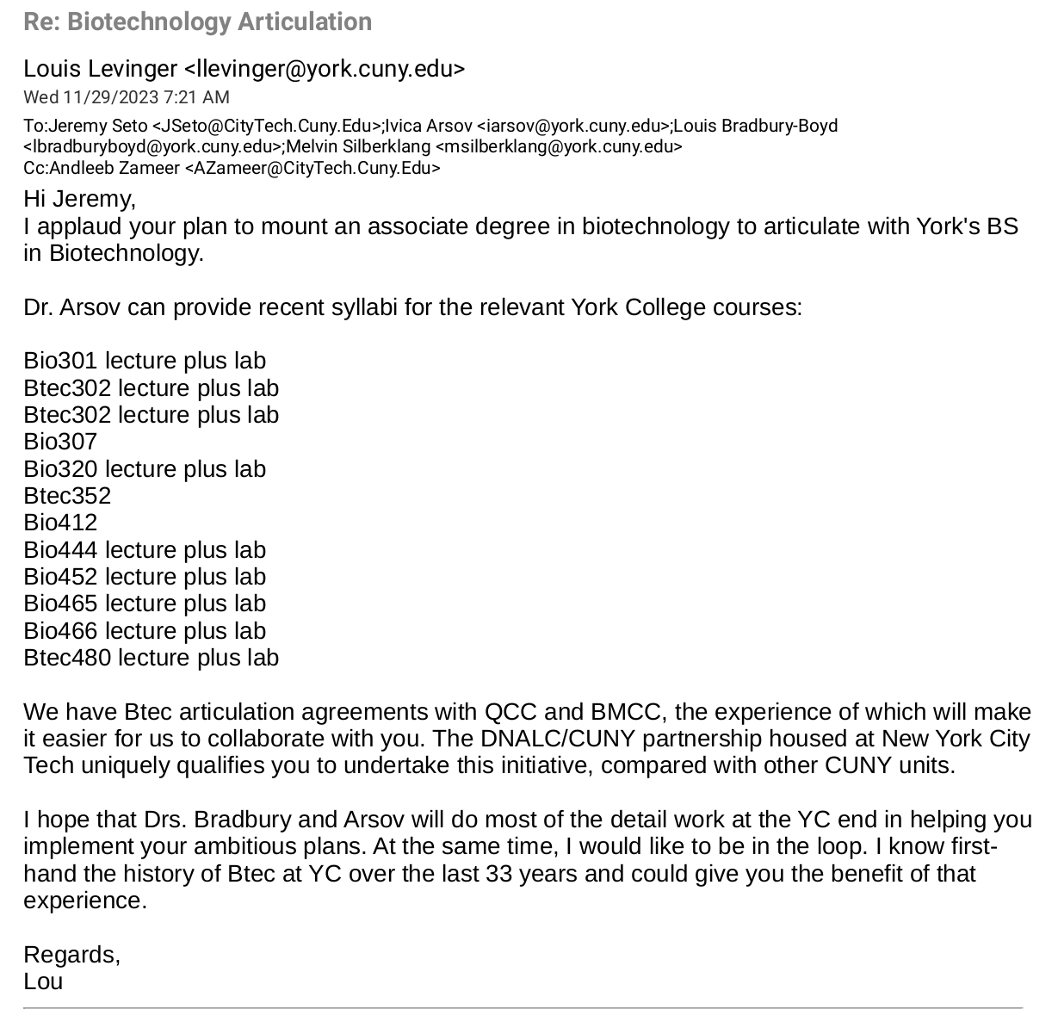

From Ivica Arsov, Chair of Biology at York College

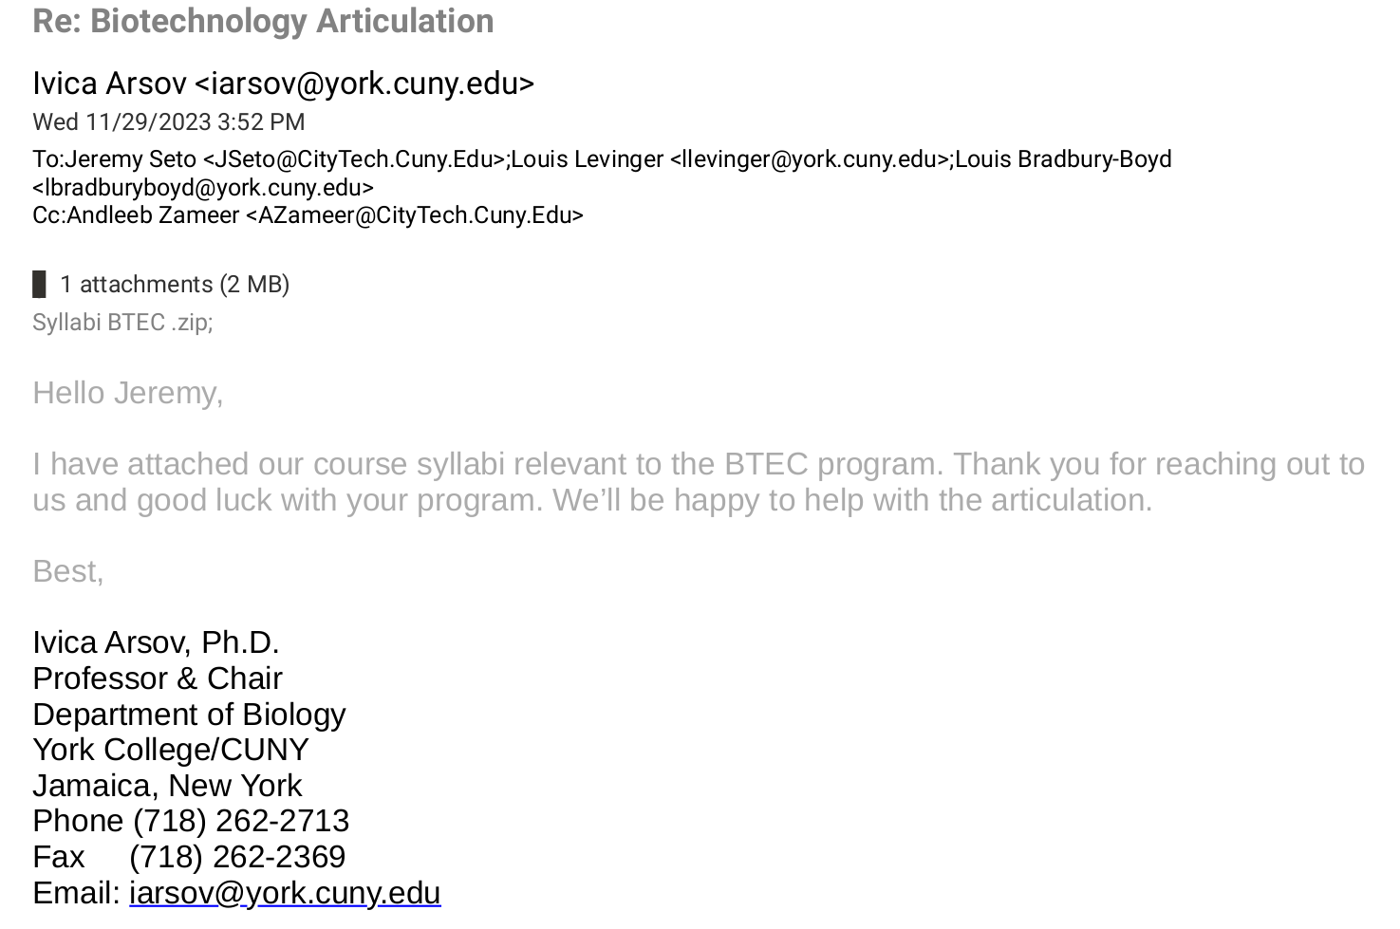

Appendix: Articulation Agreement Draft

Articulation Draft with York BS Biotechnology:
THE CITY UNIVERSITY OF NEW YORK
ARTICULATION AGREEMENT (Draft)
between
New York City College of Technology
and
York College
Effective Date:

A. SENDING AND RECEIVING INSTITUTIONS
Sending Institution: New York City College of Technology (NYCCT)
Department: Biological Sciences
Program:Biotechnology
Degree: Associate of Science (A.S.)

Receiving Institution: York College
Department: Biology
Program: Biotechnology
Degree: Bachelor of Sciences (B.S.)

B. ADMISSION REQUIREMENTS FOR SENIOR COLLEGE PROGRAM
- Overall GPA 2.0 with minimum GPA in science and mathematics courses from NYCCT of 2.75
- Total transfer credits granted toward baccalaureate degree: 60
- Total additional credits required at senior college to complete baccalaureate: 60

C. COURSE-TO-COURSE EQUIVALENCIES AND TRANSFER CREDIT AWARDED

Table 17.
New York City College of Technology |  | York College
Course Number & Title | Credits | Course Number & Title | Credits
Required Core: English Composition
ENG 1101: English Composition I | 3 | ENG 125: Composition I: Introduction to College Writing | 3
ENG 1121: English Composition II | 3 | ENG 126: Composition II: Writing About Literature | 3
Required Core: Mathematical and Quantitative Reasoning
MAT 1275: College Algebra & Trigonometry | 4 | MATH 104: College Algebra | 3
Required Core: Life and Physical Sciences
CHEM 1110: General Chemistry I | 4 | CHEM 108/109: Principles of Chemistry I & Lab | 5
Flexible Core: Scientific World
BIO 1101: Biology I | 4 | BIO 202: Biological Principles II | 4
Flexible Core: Additional Flexible Core
BIO 1201: Biology II | 4 | BIO 201: Biological Principles I | 4
Flexible Common Core
Creative Expression | 3 | Creative Expression | 3
U.S. Experiences in Its Diversity | 3 | U.S. Experiences in Its Diversity | 3
World Cultures and Global Issues | 3 | World Cultures and Global Issues | 3
Individual and Society | 3 | Individual and Society | 3
Discipline Content
BTEC 1201: Introduction to Biotechnology | 4 | BIO 301: Molecular Biology and Biotech | 4
CHEM 1210: General Chemistry II | 4 | CHEM 111/112: Principles of Chemistry II & Lab | 5
BIO 3350: Bioinformatics I | 4 | BTEC 353: Bioinformatics | 3
BIO2450: Genetics | 4 | BIO 444: Genetics | 4.5
BTEC 2000: Biotechnology Instrumentation | 4 | BTEC 480: Theory and Experimentation in Biotechnology | 5
BTEC 2100: Serology and Cell Culture | 3 | BIO 307: Cell Biology | 4.5
BTEC 3000: Biotechnology Internship | 3 | BTEC 489: Special Topics in Biotechnology | 3

Appendix: Sample Job Postings
Sample Jobs

Appendix: Evidence of consultation with other departments
Letter from Ivana Jovanovic, Chair of Chemistry at City Tech
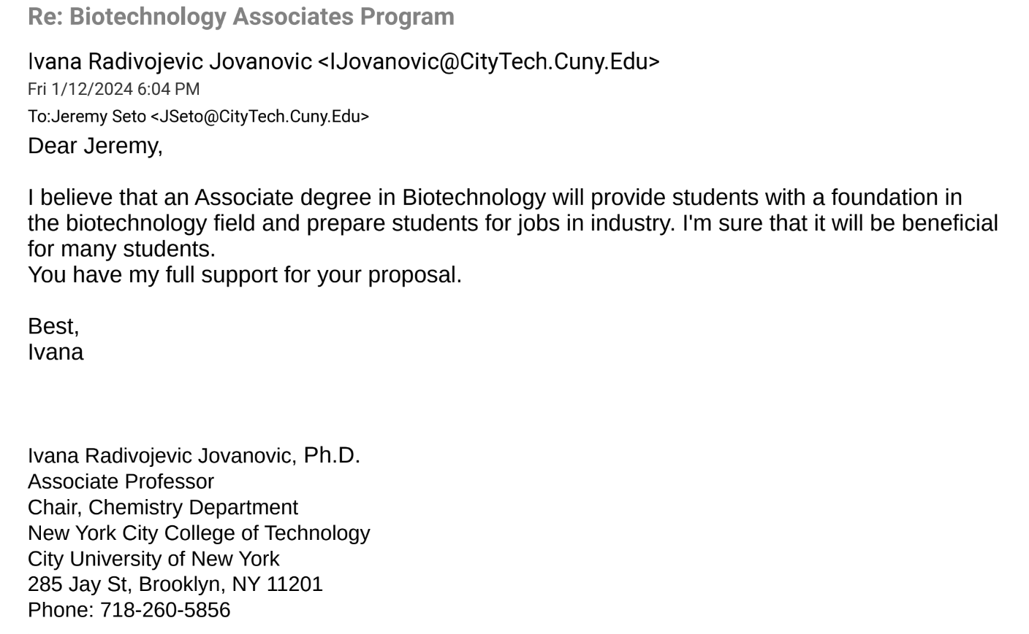

ECON 1101: Macroeconomics recommended
PHIL 2203: Healthcare Ethics recommended

