New York City College of Technology, CUNY
CURRICULUM MODIFICATION PROPOSAL FORM
This form is used for all curriculum modification proposals. See the Proposal Classification Chart for information about what types of modifications are major or minor. Completed proposals should be emailed to the Curriculum Committee chair.

Title of Proposal | Change to Catalog Course Description: ENG 1101
Date | 10/27/2022
Major or Minor | Minor
Proposer’s Name | Carrie Hall, Director of First Year Writing
Department | English
Date of Departmental Meeting in which proposal was approved | Oct 6, 2022
Department Chair Name | Suzanne Miller
Department Chair Signature and Date | 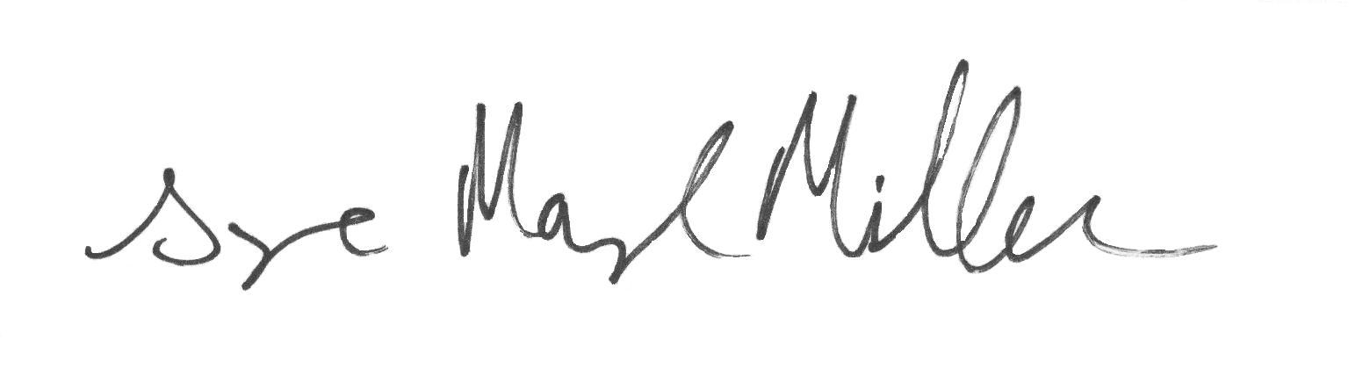  5/8/23
Academic Dean Name | Justin Vazquez-Poritz
Academic Dean Signature and Date | 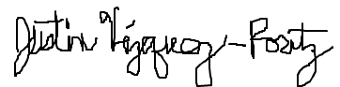 5/8/23
Brief Description of Proposal  (Describe the modifications contained within this proposal in a succinct summary. More detailed content will be provided in the proposal body. | A revised catalog course description for ENG 1101.  1101 Outgoing description: “A course in effective essay writing and basic research techniques including use of the library. Demanding readings assigned for classroom discussion and as a basis for essay writing.”  1101 Proposed description: “The first course in the First-Year Writing sequence. Students read, write, and conduct research in multiple genres to learn genre awareness and transferable writing skills. Through practice and revision of project-based assignments, students increase confidence and develop strategies for composing in contemporary environments.”
Brief Rationale for Proposal  (Provide a concise summary of why this proposed change is important to the department. More detailed content will be provided in the proposal body). | The catalog description for English 1101 has not been changed since 2015, but the course has changed somewhat in the past seven years, due to developments in technology and research in pedagogy and best teaching practices. We also changed the learning outcomes for English 1101 in 2018. We would like the catalog descriptions to reflect the changes in curriculum and pedagogy.
Proposal History  (Please provide history of this proposal: is this a resubmission? An updated version? This may most easily be expressed as a list). | This is the first submission

Please include all appropriate documentation as indicated in the Curriculum Modification Checklist.

For each new course, please also complete the New Course Proposal and submit in this document.

Please submit this document as a single .doc or .rtf format. If some documents are unable to be converted to .doc, then please provide all documents archived into a single .zip file.

ALL PROPOSAL CHECK LIST
Completed CURRICULUM MODIFICATION FORM including:
- Brief description of proposal | X
- Rationale for proposal | X
- Date of department meeting approving the modification | X
- Chair’s Signature | X
- Dean’s Signature | X
Evidence of consultation with affected departments  List of the programs that use this course as required or elective, and courses that use this as a prerequisite. | X
Documentation of Advisory Commission views (if applicable). | n/a
Completed Chancellor’s Report Form. | n/a

EXISTING PROGRAM MODIFICATION PROPOSALS

Documentation indicating core curriculum requirements have been met for new programs/options or program changes. | n/a
Detailed rationale for each modification (this includes minor modifications) | X

