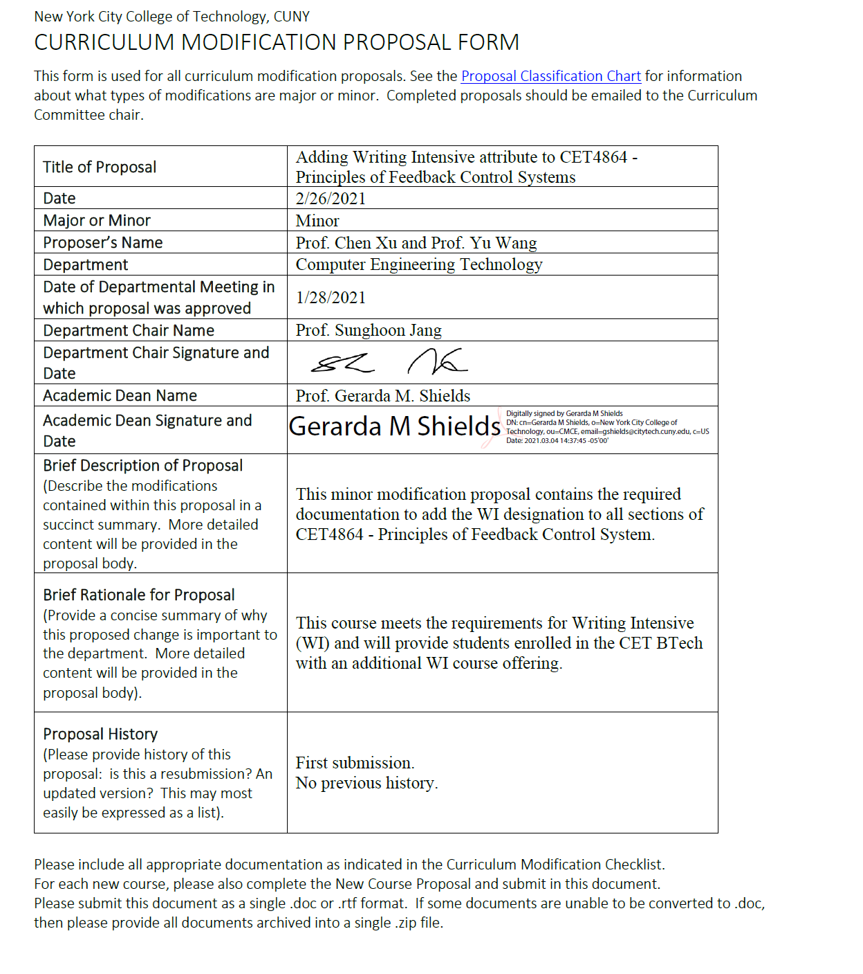

Please submit this document as a single .doc or .rtf format. If some documents are unable to be converted to .doc, then please provide all documents archived into a single .zip file.

ALL PROPOSAL CHECK LIST
Completed CURRICULUM MODIFICATION FORM including:
- Brief description of proposal
- Rationale for proposal
- Date of department meeting approving the modification
- Chair’s Signature
- Dean’s Signature
Evidence of consultation with affected departments  List of the programs that use this course as required or elective, and courses that use this as a prerequisite. | NA
Documentation of Advisory Commission views (if applicable). | N/A
Completed Chancellor’s Report Form.

EXISTING PROGRAM MODIFICATION PROPOSALS
Documentation indicating core curriculum requirements have been met for new programs/options or program changes. | N/A
Detailed rationale for each modification (this includes minor modifications)

CET MINOR MODIFICATION PROPOSAL CONTENTS:
- Chancellor’s Report form
- CET4864 Syllabus
- Minutes from department meeting for approval

CHANCELLOR’S REPORT FORM

Section AV: Changes in Existing Courses
Please include all fields, but only fill in the ones that are changing. Old information on the left should have a strikethrough line (see below), and new information on the right should be underlined.

Changes to be offered in the Computer Engineering Technology department
CUNYFirst Course ID | 037662
Course Number and Title | CET4864 Principles of Feedback Control Systems
FROM: |  | TO:
Department(s) |  | Department(s)
Course Number |  | Course Number
Course Title |  | Course Title
Prerequisite |  | Prerequisite
Corequisite |  | Corequisite
Pre- or corequisite |  | Pre- or corequisite
Hours |  | Hours
Credits |  | Credits
Description |  | Description
Requirement Designation |  | Requirement Designation
Liberal Arts | [ ] Yes [ ] No | Liberal Arts | [ ] Yes [ ] No
Course Attribute (e.g. Writing Intensive, Honors, etc |  | Course Attribute (e.g. Writing Intensive, Honors, etc | Writing Intensive (WI)
Course Applicability | [ ] Major  [ ] Gen Ed Required  [ ] English Composition  [ ] Mathematics  [ ] Science  [ ] Gen Ed - Flexible  [ ] World Cultures  [ ] US Experience in its Diversity  [ ] Creative Expression  [ ] Individual and Society  [ ] Scientific World  [ ] Gen Ed - College Option  [ ] Speech  [ ] Interdisciplinary  [ ] Advanced Liberal Arts | Course Applicability | [ ] Major  [ ] Gen Ed Required  [ ] English Composition  [ ] Mathematics  [ ] Science  [ ] Gen Ed - Flexible  [ ] World Cultures  [ ] US Experience in its Diversity  [ ] Creative Expression  [ ] Individual and Society  [ ] Scientific World  [ ] Gen Ed - College Option  [ ] Speech  [ ] Interdisciplinary  [ ] Advanced Liberal Arts
Effective Term |  |  | Fall 2021
Rationale: Many transfer students in our department don’t have chance to take the writing intensive course in CET major because they took similar courses in their previous institute, but without WI attribute. This modification will give them the chance to fulfill the WI course and bring our degree programs into alignment with college requirement. CET4864 is a required course with both lecture and lab components. Students practice critical reading and logic thinking to process the lab materials and students are encouraged to use different research resources, such as library and other online resources. Upon completing lab experiment, students need to write lab reports following the formal academic writing style in engineering. This course meets the requirements for Writing Intensive (WI), more details in the course syllabus.

CET4864 Syllabus

NEW YORK CITY COLLEGE OF TECHNOLOGY
THE CITY UNIVERSITY OF NEW YORK
Department of Computer Engineering Technology
300 Jay Street, Brooklyn, NY 11201-1909

CET4864 – Principles of Feedback Control Systems

General information: | - 3 Lecture Hours, 3 Lab Hours  - 4 Credits
Course Description: | Introduction to the fundamentals of feedback control using linear transfer function system models. Topics include transient and steady-state analysis using Laplace transforms, Bode plots, stability criteria, and PID controller. Lab work includes the use of mathematical analysis and simulation. This is a writing intensive course.
Prerequisite: | MAT2680, CET3625
Co-requisite: | CET4864L
Course Learning Outcomes | - Demonstrate a basic knowledge about mathematical models of dynamic systems described by time differential equations and transfer function.  - Know important terms like Laplace transform, transfer function, time response, performance specifications, frequency response, block diagram, bode diagram, feedback systems.  - Know what characterize stability in linear systems, and methods to analyze stability in feedback systems with controllers.  - Design/synthesize simple controllers for use on processes with known models.  - Be familiar with the most common controllers in industrial use. Integrate the concepts of feedback control systems with real-time simulation using MATLAB.  - Demonstrate the communication skills in written and oral to discuss the topics related to feedback control system.
General Education Outcomes | SKILLS/Inquiry/Analysis: Employ scientific reasoning and logical thinking.  SKILLS/Inquiry/Analysis: Use critical thinking to solve problems.  SKILLS/Communication: Students will communicate in diverse settings and groups, using written (both reading and writing), oral (both speaking and listening), and visual means.  INTEGRATION/Systems: Understand and navigate systems.  VALUES, ETHICS, AND RELATIONSHIPS/Professional/Personal Development/Demonstrate Intellectual honesty and personal responsibility.  KNOWLEDGE/Lifelong learning/Acquire tools for lifelong learning—how to learn, how they learn, knowledge of resources
Text book: | Feedback Control of Dynamic System, Gene F. Franklin, J. David Powell and Abbas Emami-Naeini, 7th Edition, Pearson, ISBN-13: 978-0-13-349659-8.
References: | Control Systems Engineering, 7th Edition by Norman S. Nise, Wiley Publisher, ISBN-13: 978-1118170519
Lab Text: | Lab manuals posted on the blackboard.
Computer Usage: | Computer and camera are required for synchronous lecture. Matlab is required for homework practice.
Calculator Usage: | MUST have a scientific or engineering calculator
Library Usage: | Students are strongly encouraged to use the library and Internet as a supplement to the lectures and textbook.
Grading Policy | Lecture 70%  Lab 30%  (Note: Department policy states that an “F” in CET4864L fails you for the entire CET4864 Course)  The final grade will be determined as follows:  - Discussion 5%  - Homework 10%  - Quiz 10%  - Midterm exam 20%  - Final exam 20%  - Lab 30%  - Attendance and Participation 5%  A 93 - 100, A- 90 - 92.9,  B+ 87 - 89.9, B 83 - 86.9, B- 80 - 82.9,  C+ 77 - 79.9, C 70 - 76.9,  D 60 - 69.9, F <= 59.90
Discussion | Discussion forum is used in the online class. Certain topics will be explored through the use of a discussion board. Students will be graded on the quality of their own responses to the initial discussion prompt and to their responses to their classmates’ posts. More details in Participation Rubric for Discussions.
Homework | - Homework is assigned on Blackboard. Students are expected to complete their HW, then convert to pdf file and submit on Blackboard.  - Late HW will automatically have 20% deduction.
Quiz | - Quiz is given on Blackboard. Students are expected to complete quiz within given time.  - There will NOT be any make-ups.
Exams | - Exams are given online during the class time.  - More details of exams will be discussion in the class.
Lab Report | - Students write lab reports for every experiment.  - Lab report needs to follow the formal academic format, the requirements and grading rubric are available on Blackboard.  - Lab report is submitted online through blackboard system.  - Lab report submission deadline is exactly one week after the lab session.
Accessibility and accommodations: | The City Tech is firmly committed to making higher education accessible to students with disabilities by removing architectural barriers and providing programs and support services necessary for them to benefit from the instruction and resources of the University. Early planning is essential for many of the resources and accommodations provided. For more update under the Coronavirus pandemic, please see http://www.citytech.cuny.edu/coronavirus/
Academic Integrity Statement: | Students and all others who work with information, ideas, texts, images, music, inventions, and other intellectual property owe their audience and sources accuracy and honesty in using, crediting, and citing sources. As a community of intellectual and professional workers, the College recognizes its responsibility for providing instruction in information literacy and academic integrity, offering models of good practice, and responding vigilantly and appropriately to infractions of academic integrity. Accordingly, academic dishonesty is prohibited in the City University of New York and at New York City College of Technology and is punishable by penalties, including failing grades, suspension, and expulsion. The full academic integrity policy of City Tech can be found at  http://www.citytech.cuny.edu/academics/docs/academic_integrity_policy.pdf
Online etiquette and anti-harassment policy: | The CUNY strictly prohibits the use of University online resources or facilities, including Blackboard, for the purpose of harassment of any individual or for the posting of any material that is scandalous, libelous, offensive or otherwise against the University’s policies.
Video recording consent | Students who participate in this class with their camera on or use a profile image are agreeing to have their video or image recorded solely for the purpose of creating a record for students enrolled in the class to refer to, including those enrolled students who are unable to attend live. If you are unwilling to consent to have your profile or video image recorded, be sure to keep your camera off and do not use a profile image. Likewise, students who un-mute during class and participate orally are agreeing to have their voices recorded. If you are not willing to consent to have your voice recorded during class, you will need to keep your mute button activated and communicate exclusively using the “chat” feature, which allows students to type questions and comments live.

Brief list of topics to be covered
Week 1 | Lecture: Discuss syllabus, use differential equation to describe mechanical system, RLC circuits, Op-Amp circuits. Lab: Matlab Tutorial.
Week 2 | Lecture: Review of math prior knowledge, complex number, Laplace Transform and Inverse Laplace Transform. Lab: Ordinary Differential Equations and Polar/Rectangular Coordinates
Week 3 | Lecture: System modeling, transfer function and introduction to block diagram, model electric motor. Lab: Laplace Transforms
Week 4 | Lecture: LTI system, time response of 1st-order and 2nd-order systems: general forms of output response, second-order under-damped/ undamped/critically-damped/over-damped systems, natural frequency, damping ratio. Lab: Transfer Functions.
Week 5 | Lecture: Time Response of 2nd-order systems: transient response, performance specifications, pole location and system design. Lab: Response Behavior for 1st and 2nd ODE
Week 6 | Lecture: Block Diagram Reduction: obtain transfer function of inter-connected systems.  Lab: Block Diagram
Week 7 | Mid-Semester Exam, Lab: Mid-Term Lab
Week 8 | Lecture: Stability Analysis: by pole locations and by Routh-Hurwitz criteria.  Lab: Transient response for second order system.
Week 9 | Lecture: Root Locus: Introduce root locus and Sketch root locus. Lab: DC Gain and Unity feedback response and designing K value for second order transfer function.
Week 10 | Lecture:. Introduction to Frequency Response, sketch Bode plot of 1st and 2nd order systems. Lab: Stability R-H Criterion.
Week 11 | Lecture: PID controller: effect on system response. Lab: Bode Plots and Root locus
Week 12 | Lecture: Root-Locus-Based Controller Design: PI, PD. Lab: Stability using PID Design
Week 13 | Lecture: Frequency-Response-Based Design: lead, lag  Lab: MATLAB Control System Toolbox, Control System Design: principles and case studies
Week 14 | Review For Final Exam , Lab: Lab make-up day
Week 15 | Final Exam

Department Meeting Minutes

2021-01-28 Faculty Meeting Minutes
Attendance (excused are in bold): Sunghoon Jang, Robert Armstrong, Seymour Blank, Aparicio Carranza, Ohbong Kwon, Xiaohai Li, Lili Ma, Benito Mendoza, Edward Morton, John Razukas, José M. Reyes Álamo, Yu Wang, Chen Xu, Farrukh Zia.
Started at 12:30PM (Meeting held virtually over Zoom)
- Approval of the minutes of the previous CET department meeting.
  - Minutes approved.
- Chair’s statement and report.
  - Update about the classes added and cancelled.
  - Enrollment threshold is about 60%, some sections have slightly less but every effort is being made to preserve as many sections as possible, as well as for faculty to get paid for any extra teaching hours instead of putting them in the bank.
  - Questions about uniform finals, that are usually held in Fall 2020. However due to the pandemic in Fall 2020 they were not held, and we are planning to have them in Fall 2021 when we expect in-person classes will resume.
  - Discussion about the selection of a critical course and whether to keep or change the current ones in the future.
- CET Department's Operating Plan for Spring 2021.
  - The Chair reminded faculty of the plan sent by email earlier. Details about the schedule and the faculty for the workshops were provided. A workshop form was showcased for students to choose their schedule.
  - Question about the safety and cleaning protocols.
- CET department's Writing Intensive Course (WIC) Coordinator.
  - Prof. Xu is interested in being the WIC Coordinator for the Department. Profs. Kwon and Mendoza will provide support.
  - Discussion about adding a new WIC course (CET4864), so more students especially those who transfer have more choices and avoid problems completing the graduation requirements on time. The proposal plan was approved unanimously.
- ABET Visitation of the CET Programs by Professors Zia and Mendoza.
  - Some changes were requested to the website to comply with the ABET evaluators.
  - An IAC meeting is being planned for Friday Feb. 4th @ 5PM. So far, several members of the IAC have confirmed their attendance.
  - A meeting/interview for EMT on Feb 1st with individual members of the faculty with different ranks was requested. A list of possible questions was presented and will be sent by email. Special emphasis was placed in the assessment and how it is used. Faculty to be interviewed are:
    - Assistant: Ma @ PM, Xu @ PM
    - Associate: Wang @ AM, Kwon @ PM, Carranza @ Anytime
    - Professor: Razukas @ AM
  - Discussion about how to raise awareness among students for the ABET visit and how they can be prepared for potential questions from the evaluators. Also, how to help them in case they need equipment for the coming semester.
  - Q/A from faculty about schedule and how to make the best of this effort and motivate students to get familiar with the pertinent information.
  - An ABET meeting might be called if necessary due to the urgency of the evaluation coming in the next few days. Faculty should be prepared in case it becomes necessary.
- AAS in Computer Engineering Program by Professor Kwon.
  - Discussion about the BS in SEW and the AAS in CE and which courses can be transferred between these 2 programs.
  - A mapping of the new courses’ naming and sequence in CET was shown and faculty feedback was requested. Some suggested changes and rearrangements were discussed.
  - Different options for rearrangements of credits and contact hours were presented, to avoid having too many 1 credit courses as the currently curriculum has.
  - Faculty agree with the creation of a new course CET 1101.
  - Feedback requested about the sequence of circuit courses.
  - Discussion about the programming courses and in what semester the electives should be taken/recommended.
  - Discussion about the name of certain courses and how to avoid overlapping with courses offered by other departments.
  - Discussion about the need to change the course numbers based on current course design.
  - Course coordinators agree to make modifications about their courses based on the new course design.

- BS in Software Engineering Program by Professor Li.
  - Update on the courses, the draft proposal, and the double-duty courses for the new BS.
  - Review of the potential shared courses between SE and CET, CET1111, CET1101, CET1250, CET2480, CET2320.
  - Discussion about the inclusion of CET 1150 as a shared course. After discussion, department agrees to include CET1150 as shared course, so two programs share 16 credits and students can have a choice between two programs. Leave cloud base fundamental or network programing as elective course.
  - Prof. Blank suggested to require Physics as most other accredited SE programs includes it. Prof. Li explained that physics courses are parts of general education. Department can advise students to take physics course, students have the option to choose.

- Good and welfare

Meeting adjourned at 5:02 PM
Scribe: José M. Reyes Álamo, Chen Xu

