New York City College of Technology, CUNY
CURRICULUM MODIFICATION PROPOSAL FORM
This form is used for all curriculum modification proposals. See the Proposal Classification Chart for information about what types of modifications are major or minor. Completed proposals should be emailed to the Curriculum Committee chair.

Title of Proposal | Business and Technology of Fashion Minor (BTF Minor)
Date | 1/15/2021
Major or Minor | Major
Proposer’s Name | Nazanin Munroe and Denise H. Sutton
Department | Business
Date of Departmental Meeting in which proposal was approved
Department Chair Name | Lucas Bernard
Department Chair Signature and Date | Lucas Bernard 1/14/2021
Academic Dean Name | David B Smith
Academic Dean Signature and Date | 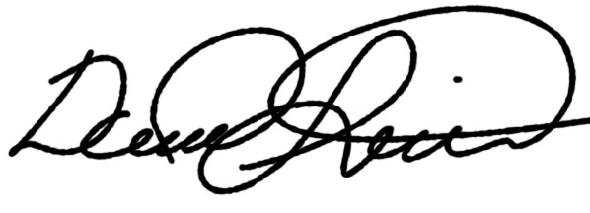2021-01-14
Brief Description of Proposal  (Describe the modifications contained within this proposal in a succinct summary. More detailed content will be provided in the proposal body. | Creation of a BTF Minor using existing courses. This program will allow students throughout the college to add the designation “Minor in the Business and Technology of Fashion” to their transcript.
Brief Rationale for Proposal  (Provide a concise summary of why this proposed change is important to the department. More detailed content will be provided in the proposal body). | This minor consists of four courses: Introduction to the Fashion Industry (BUF 1101), Introduction to Textiles (BUF 2246), Global History of Dress & Textiles (BUF 2204) OR 20th C. Dress & Culture (ARTH 1204); and Gender, Dress & Society (SBS 3201) OR The History of Beauty: Culture, Commerce & Chemistry (interdisciplinary course – under development). The minor is 12-credits, and the required sequence of courses provides a general understanding of the business and technology of fashion. It is designed to provide a fundamental understanding of the key concepts that businesses in the fashion and apparel industry share and will offer students options for alternative careers, leveraging their current majors and interests.
Proposal History  (Please provide history of this proposal: is this a resubmission? An updated version? This may most easily be expressed as a list). | This is the initial submission of this minor curriculum modification proposal.

Please include all appropriate documentation as indicated in the Curriculum Modification Checklist.

For each new course, please also complete the New Course Proposal and submit in this document.

Please submit this document as a single .doc or .rtf format. If some documents are unable to be converted to .doc, then please provide all documents archived into a single .zip file.
ALL PROPOSAL CHECK LIST
Completed CURRICULUM MODIFICATION FORM including:
- Brief description of proposal | X
- Rationale for proposal | X
- Date of department meeting approving the modification | X
- Chair’s Signature | X
- Dean’s Signature | X
Evidence of consultation with affected departments  List of the programs that use this course as required or elective, and courses that use this as a prerequisite. | X
Documentation of Advisory Commission views (if applicable).
Completed Chancellor’s Report Form. | X

EXISTING PROGRAM MODIFICATION PROPOSALS

Documentation indicating core curriculum requirements have been met for new programs/options or program changes.
Detailed rationale for each modification (this includes minor modifications)

Proposal for a Minor in the Business & Technology of Fashion

Introduction
The academic Minor in the Business and Technology of Fashion provides students at City Tech with an opportunity to explore new professional possibilities and a more diverse range of applications for their studies at the college. It delivers a venue for the development of a basic understanding of the business and technology of the global fashion industry, which has a major center in New York City and a market value of over $2 trillion. Students in the program will learn underlying principles and gain competency in analyzing issues that typically arise in fashion and apparel businesses.

City Tech’s baccalaureate degree program in the business and technology of fashion is unique within CUNY. Queens College offers a minor in Fashion and Textiles, with a focus on design. An undergraduate minor with a focus on business is offered at the Laboratory Institute of Merchandising (in Fashion Merchandising). The fashion programs at Pratt and the New School are design-focused and the Fashion Institute of Merchandising does not offer a minor in the business and technology of fashion. This minor is proposed in response to the General Education Committee’s recommendation for the creation of new minors at City Tech.

The set of courses for this academic minor will significantly benefit students from the Chemistry, Communication Design, Entertainment Technology, and Mechanical Technology departments at City Tech. By offering an area of expertise within fashion, students will broaden their prospects for employment within the industry, both globally and locally.

Detailed Description of the Proposed Minor
The Business and Technology of Fashion Minor provides non-Business majors with an opportunity to complement their current fields of study and future career paths. This minor consists of four courses: Introduction to the Fashion Industry (BUF 1101), Introduction to Textiles (BUF 2246), Global History of Dress & Textiles (BUF 2204) OR 20th C. Dress & Culture (ARTH 1204); and Gender, Dress & Society (SBS 3201) OR The History of Beauty: Culture, Commerce & Chemistry (Interdisciplinary course – under development). The minor is 12-credits, and the required sequence of courses provides a general understanding of the business and technology of fashion. It is designed to provide a fundamental understanding of the key concepts that businesses in the fashion and apparel industry share and will offer students options for alternative careers, leveraging their current majors and interests.
The required courses of this minor may fulfill some Writing Intensive (WAC/WI) requirements (Introduction to the Fashion Industry/BUF 1101 is WI) and is aligned with all GenEd and Pathways regulations. Global History of Dress and Textiles fulfills requirements for World Cultures and Global Issues (WCGI) and 20th Century Dress and Culture fulfills a requirement for Creative Expression (CE) in the Flexible Common Core. Gender, Dress & Society (SBS 3201) is part of City Tech's General Education (GenEd) Common Core and enables students to meet CUNY’s Pathways requirements under the US Experience in Its Diversity (USED) and the Liberal Arts (LA) categories. The History of Beauty: Culture, Commerce & Chemistry fulfills an interdisciplinary requirement (ID). See Table A.

The set of courses for this minor will significantly benefit students from any 4-year program at the college, reinforcing majors in areas with a focus on marketing, chemistry, communications/ communication design, mechanical technology, and visual culture, adding an additional dimension to their degree.

Required and Elective Courses for the Minor
Students take four required courses. Students must earn a “C” or better in all minor course work in order to be granted a minor designation on their transcripts.

REQUIRED COURSES
The following is a list of required courses, with flexible common core and other course attributes following in parentheses:
BUF 1101: Introduction to the Fashion Industry (WI)*
BUF 2246: Introduction to Textiles (Lecture/Lab)*
BUF 2204: Global History of Dress & Textiles (WCGI) -or- ARTH 1204: 20th C. Dress & Culture (CE)
SBS 3201: Gender, Dress & Society (USED/Lib Arts) -or- History of Beauty: Culture, Commerce, and Chemistry (ID) (under development)
*These 2 courses are required for all Fashion Minors. Students may customize their final course selection depending on their major and prior experience, and may be eligible for higher level courses in the BTF program. We recommend meeting with an advisor to customize the minor if eligible.

Programmatic Learning Outcomes
Students will:
- Display an understanding of fashion industry issues, and the roles of business and technology within that environment;
- Identify and analyze fashion business and technology problems and opportunities through research to formulate recommendations for courses of action;
- Communicate effectively and professionally in business situations through physical or virtual presence, writing, speaking, listening, and electronic media;
- Demonstrate awareness of economic, environmental, political, ethical, legal and regulatory contexts of global fashion business practices.
- Demonstrate the ability to think and write critically about how fashion and beauty have contributed to globalization in the modern and postmodern eras.

Table A

Required Courses (in sequential order) | Gen Ed Requirements/ Course Attributes
BUF 1101 Introduction to Fashion | WI
BUF 2246 Introduction to Textiles | Lab course
BUF 2204 Global History of Dress -or- ARTH 1204 20th C. Dress | WCGI -or- CE
SBS 3201 Gender, Dress & Society -or- ID History of Beauty course | USED -or- ID

Chancellor’s Report Form

New Minor in the Business & Technology of Fashion

Offered by the Department of Business

From: | To:
No such minor is currently offered. | MINOR in the Business & Technology of Fashion  Creation of a Minor in the Business & Technology of Fashion using existing courses. This program will allow students throughout the college to add the designation “Minor in the Business & Technology of Fashion” to their transcript.
Rationale:
The Business and Technology of Fashion Minor provides non-Business majors with an opportunity to complement their current fields of study and future career paths. This minor consists of four courses: Introduction to the Fashion Industry (BUF 1101), Introduction to Textiles (BUF 2246), Global History of Dress & Textiles (BUF 2204) OR 20th C. Dress & Culture (ARTH 1204); and Gender, Dress & Society (SBS 3201) OR The History of Beauty: Culture, Commerce & Chemistry (Interdisciplinary course – under development). The minor is 12-credits, and the required sequence of courses provides a general understanding of the business and technology of fashion. It is designed to provide a fundamental understanding of the key concepts that businesses in the fashion and apparel industry share and will offer students options for alternative careers, leveraging their current majors and interests.
Effect Outside Department: None
Date of Department Approval: 1/14/2021
Date of College Council Approval:

LETTERS OF SUPPORT

Professor John McCullough

Today, 11:37 AM
Lucas,
A fair number of our students do work in the fashion industry after they graduate, often working on fashion shows, pop-up retail installations, and window displays. The proposed minor in the Business and Technology of Fashion could be of interest for our students who intend to focus on that part of the industry.

Our students commonly take courses in the business department already, including BUS2339, MKT1100 and MKT1102. Would any of those courses be able to find a place in the minor? Perhaps as an option for one of the 'elective' courses? This would make it easier for ENT students interested in the minor to fit all the classes.

I fully support this proposal, and I hope it goes smoothly through the submission process.

-John

John McCullough
Associate Professor/Technical Supervisor
Entertainment Technology Department - Chair
New York City College of Technology
ETCP Certified Rigger-Theatre
Appointments: https://mcculloughadvisement.youcanbook.me

Professor Ann Delilkan

Reply all|
Today, 5:42 PM
Lucas M. Bernard;
Denise Hardesty Sutton;
Nazanin Munroe;
+2 more
Dear All,
This minor sounds like a very nice, pragamatic choice for many students. You have our full support at the Humanities.
All good wishes,
Zhijian and Ann

Ann Delilkan, Ph.D.
Chair and Associate Professor, Department of Humanities
New York City College of Technology, City University of New York
300 Jay Street, Room L630 (formerly A630)
Brooklyn NY 11201
Tel: (718) 260-5018

Professor Reneta Lansiquot

Reply all|
Today, 11:02 AM
Robert Leston;
Lucas M. Bernard;
Denise Hardesty Sutton;
Nazanin Munroe;
Justin Vazquez-Poritz
Hi Lucas,

Our PTW Bachelor of Science degree program has specializations that are similar to minors (see http://www.citytech.cuny.edu/catalog/docs/catalog.pdf#page=88). We currently have a Marketing specialization.

Therefore, when appropriate, we can encourage students to enroll in courses in this Business & Technology of Fashion minor as electives.

Best,
Reneta

Professor Douglas Davis

From: Douglas Davis
Sent: Thursday, January 14, 2021 12:25 PM
To: John McCullough; Lucas M. Bernard
Subject: Re: Course or Minor idea

Absolutely, John, you beat me to this response and the freelancer angle is spot on for the way work is evolving.

Lucas, you may know this already but we are inviting Denise to our annual COMD strategic planning sessions next week to present this to our faculty. We will be searching for ways to identify the ideal COMD student to recommend. Our challenge will be the BFA curricular structure and the level of the required Math etc.

As I said when we first spoke about this, COMD is in full support of this proposal. I hope we can help

Thanks.

Douglas Davis
Strategist, Author, and Professor
/ Principal, The Davis Group
/ Author, Creative Strategy and the Business of Design
/ Chair, BFA in Communication Design,
New York City College of Technology

LIBRARY RESOURCES & INFORMATION LITERACY: MAJOR CURRICULUM MODIFICATION

Please complete for all major curriculum modifications. This information will assist the library in planning for new courses/programs.

Consult with your library faculty subject specialist (http://cityte.ch/dir) 3 weeks before the proposal deadline.

Course proposer: please complete boxes 1-4. Library faculty subject specialist: please complete box 5.

1 | Title of proposal  Academic Minor in Business & Technology of Fashion | Department/Program  Business Dept./ Business & Technology of Fashion
 | Proposed by (include email & phone)  Prof. Denise H. Sutton dsutton@citytech.cuny.edu  Prof. Nazanin Munroe  nmunroe@citytech.cuny.edu | Expected date course(s) will be offered  All courses are existing or forthcoming courses in the Fashion curriculum; Fall 2021 or Spring 2022  # of students  The Minor can accommodate a large number of students, as the department can accommodate multiple sections of the required courses

2 | The library cannot purchase reserve textbooks for every course at the college, nor copies for all students. Consult our website (http://cityte.ch/curriculum) for articles and ebooks for your courses, or our open educational resources (OER) guide (http://cityte.ch/oer). Have you considered using a freely-available OER or an open textbook in this course?  Textbooks for the courses are already in the library collection; some use online textbooks, other include OERs.  Courses required for the Minor:  - BUF 1101: Introduction to the Fashion Industry (WI)  - BUF 2246: Introduction to Textiles (Lecture/Lab)  - BUF 2204: Global History of Dress & Textiles) (WCGI) -or- ARTH 1204: 20th C. Dress & Culture (CE)  - SBS 3201: Gender, Dress & Society (USED/Lib Arts) -or- History of Beauty: Culture, Commerce, and Chemistry (ID) (under development)

3 | Beyond the required course materials, are City Tech library resources sufficient for course assignments? If additional resources are needed, please provide format details (e.g. ebook, journal, DVD, etc.), full citation (author, title, publisher, edition, date), price, and product link.  City Tech library resources are sufficient for course assignments and related research as planned.

4 | Library faculty focus on strengthening students' information literacy skills in finding, critically evaluating, and ethically using information. We collaborate on developing assignments and customized instruction and research guides. When this course is offered, how do you plan to consult with the library faculty subject specialist for your area? Please elaborate.  We would be happy to work with Prof. Wanett Clyde to continue developing text and web resources for the fashion program. Each of our required courses for the Minor includes a scaffolded research component at the first- and second-year levels (BUF 1101 and BUF 2246), and we integrate Library databases and tutorials into these foundational courses. For the second set of options, students will continue to hone their research abilities with online and print sources, using primary and secondary sources to promote scholarship in fashion/textile history (ARTH 1204 or BUF 2204) and in beauty/fashion within cultural contexts (SBS 3201 or History of Beauty ID course, forthcoming).

5 | Library Faculty Subject Specialist __Wanett Clyde___________________  Comments and Recommendations  It has been my pleasure to work in collaboration with Professor Munroe and Professor Sutton to introduce research concepts to their students. I am excited to assist them with their new research component and I look forward to continuing our efforts to ensure that library collections support the goals of the curriculum and our students.  Date 1/15/21

Department Vote for a Minor in Business and Technology of Fashion

Denise Sutton and Nazanin Munroe have created a proposal for a Minor in the Business and Technology of Fashion. After reviewing the proposal, please vote "Yes" or "No" depending on if you think the Business Department should pursue this aim.

Total Vote Tally: Yes (11) No (0) Abstain (1)
See below for Votes

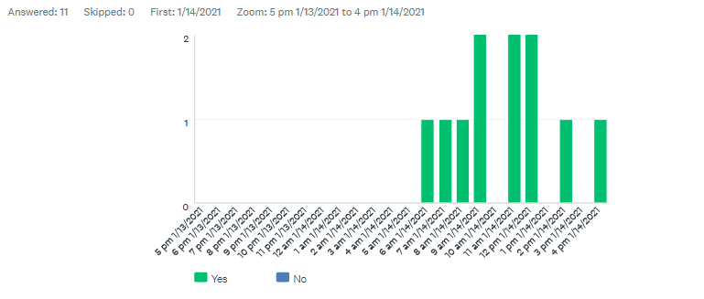

Individual Responses
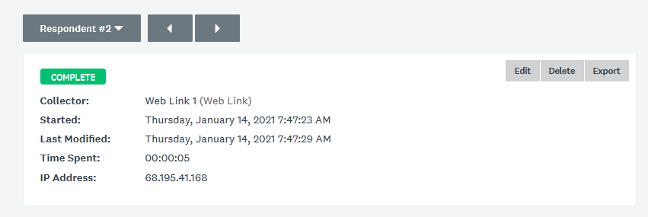
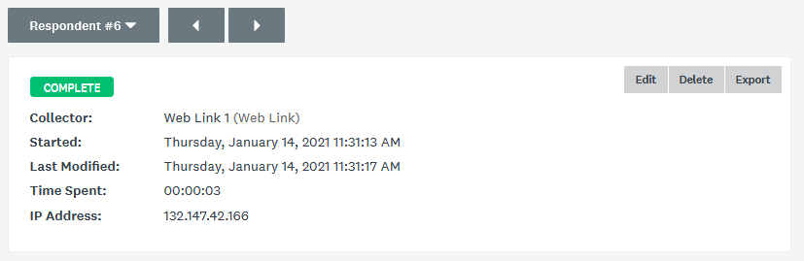
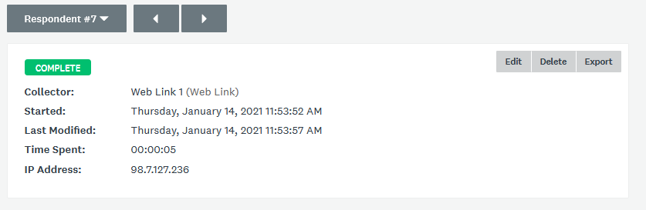
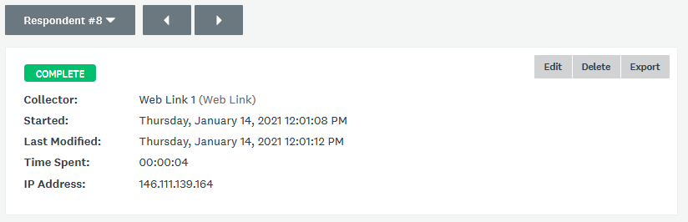
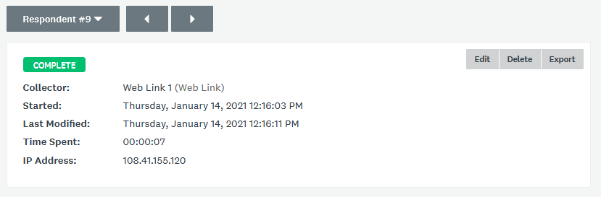
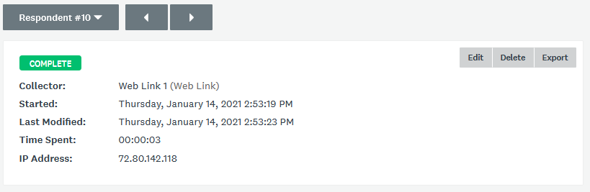

Schmelzer, R., (2019) The Fashion Industry Is Getting More Intelligent With AI, Forbes Magazine, https://www.forbes.com/sites/cognitiveworld/2019/07/16/the-fashion-industry-is-getting-more-intelligent-with-ai/?sh=4521e31d3c74 (accessed 01/14/2021)

