New York City College of Technology, CUNY
CURRICULUM MODIFICATION PROPOSAL FORM
This form is used for all curriculum modification proposals. See the Proposal Classification Chart for information about what types of modifications are major or minor. Completed proposals should be emailed to the Curriculum Committee chair.

Title of Proposal | Catalog Changes to Psychology Course Offerings
Date | April 20, 2020
Major or Minor | Major
Proposer’s Name | Maria Pagano
Department | Social Science
Date of Departmental Meeting in which proposal was approved | April 16, 2020
Department Chair Name | Peter Parides
Department Chair Signature and Date | 4/29/20
Academic Dean Name | Justin Vazquez-Poritz
Academic Dean Signature and Date | 8/25/20
Brief Description of Proposal  (Describe the modifications contained within this proposal in a succinct summary. More detailed content will be provided in the proposal body. | Four changes are requested. The first seeks to create an academic minor in psychology for baccalaureate students.  The second seeks to change the prerequisite restricting students from taking Child Psychology (PSY2301) for credit if they have taken Developmental Psychology (PSY2300) for credit, and vice-versa. It is also requested that the title of Developmental Psychology (PSY2300) be changed to Lifespan Development (PSY2300). The fourth requested change would withdraw Psychology of Adjustment (PSY1100) from the catalog.
Brief Rationale for Proposal  (Provide a concise summary of why this proposed change is important to the department. More detailed content will be provided in the proposal body). | Create an Academic Minor in Psychology: As a diverse discipline that encompasses many fields of inquiry, an academic minor in psychology would not only complement, but add value to many of the baccalaureate degrees available at the college.  Remove the pre-requisite from Developmental Psychology (PSY2300) that restricts students who take PSY2300 for credit from also taking Child Psychology (PSY2301) and change the title of Developmental Psychology (PSY2300) to Lifespan Development (PSY2300): Students who received credit for Development Psychology (PSY2300) either at City Tech or from another college are currently prohibited from taking Child Psychology (PSY2301) for credit, and vice-versa. This restriction negatively impacts students who have taken either of these courses and are then required by their academic major to take the other course. In addition, a modification is requested to change the title of Developmental Psychology (PSY2300) to Lifespan Development (PSY2300), so that the content of the course material is better reflected.  Withdraw Psychology of Adjustment (PSY1100) from the catalog: The original purpose of Psychology of Adjustment (PSY1100) was to provide students who did not meet CUNY entrance standards in Reading and/or Writing with course credits that would contribute toward financial aid credit requirements. Given CUNY’s current mandate toward accelerated learning, many more students will be provided with the opportunity to take credit-bearing courses towards meeting financial aid requirements thereby severely limiting the need for the course. Moreover, the course is not required by any department at the college, can only be used toward elective credits, and does not serve as a prerequisite for any course in psychology.
Proposal History  (Please provide history of this proposal: is this a resubmission? An updated version? This may most easily be expressed as a list). | Updated submission 8/25/2020 based on comments received by Curriculum Committee Chair, Professor Phillip Anzalone. Updated submission 11/8/2020 based on comments from Minors Subcommittee and Provost’s Office.

Please include all appropriate documentation as indicated in the Curriculum Modification Checklist.
For each new course, please also complete the New Course Proposal and submit in this document.
Please submit this document as a single .doc or .rtf format. If some documents are unable to be converted to .doc, then please provide all documents archived into a single .zip file.

ALL PROPOSAL CHECK LIST
Completed CURRICULUM MODIFICATION FORM including:
- Brief description of proposal | X
- Rationale for proposal | X
- Date of department meeting approving the modification | X
- Chair’s Signature | X
- Dean’s Signature | x
Evidence of consultation with affected departments  List of the programs that use this course as required or elective, and courses that use this as a prerequisite. | X
Documentation of Advisory Commission views (if applicable). | N/A
Completed Chancellor’s Report Form. | X

EXISTING PROGRAM MODIFICATION PROPOSALS

Documentation indicating core curriculum requirements have been met for new programs/options or program changes. | N/A
Detailed rationale for each modification (this includes minor modifications) | X

New Academic Minor in Psychology
Offered by the Department of Social Science.
From: | To:
No Academic Minor is currently offered. | Academic Minor in Psychology:  The academic minor consists of the following 5 courses (15 credits in total):  PSY1101 Introduction to Psychology 3 credits (Required)  Any 4 additional psychology courses, totaling 12 credits.  As one of these 4 additional courses, students may also take SBS2000 Research Methods or SBS2000ID toward completion of the academic minor. However, through advisement students will be encouraged to take the course with an instructor who is a psychologist, though it will be made explicit that this is a recommendation and not a requirement.  All courses must be completed with a grade of C or higher.  A minimum of 9 credits must be taken at City Tech.  Students considering an academic minor in psychology should make an appointment to meet with a psychology faculty member during the advisement period of the second semester of their freshman year by contacting the Social Science Department at (718) 260-5080 or socialscience@citytech.cuny.edu. Transfer students should contact the Social Science Department upon acceptance to the college.
Rationale:
A basic understanding of human behavior is an integral part of any career, and as a result an academic minor in psychology would be a valuable supplement to almost any degree path. Students who choose to complete an academic minor in psychology will add to their understanding of how humans think, feel and act, which will benefit as they interact with others both professionally and personally. The breadth and depth of topics offered by completing an academic minor in psychology will not only provide insights into understanding human behavior but will also serve as a complement to a student’s academic major. Since the academic minor in psychology can be adapted to fit almost any degree, it can work well with almost any occupational choice including but not limited to degrees in health care, education, human services, legal studies, and business.
Effect Outside Department: None
Date of Department Approval: April 16, 2020
Date of Senate Approval:

Sample Curriculum Map:

Below is a sample curriculum map for a student majoring in the BTech degree program in Architectural Technology with an academic minor in psychology:

Gen Ed Requirements for Architectural Technology | Courses for Proposed Academic Minor
Individual & Society | PSY 1101
Scientific World | PSY 3407
Additional Liberal Arts | PSY 2301
Additional Liberal Arts (Advanced) | PSY 2401
Interdisciplinary Course | PSY 2404ID

As the Sample Curriculum Map illustrates, an Academic Minor in Psychology can be completed in all BS degrees and most BTech degrees within the required credits of the degree program.

- Section AIII: Changes in Degree Programs

Changes to be offered in the Social Science department
CUNYFirst Course ID | 038711
FROM: |  | TO:
Department(s) |  | Department(s)
Course | PSY 2300 — Developmental Psychology | Course | PSY 2300 Lifespan Development
Prerequisite | PSY 1101; Note: A student who takes and passes PSY 2300 may not take for degree credit PSY 2301, PSY 2302 or PSY 2303. Similarly, any student who takes and passes one or more of these three courses may not obtain degree credit for PSY 2300. | Prerequisite | PSY 1101
Corequisite |  | Corequisite
Pre- or corequisite |  | Pre- or corequisite
Hours |  | Hours
Credits |  | Credits
Description |  | Description
Requirement Designation |  | Requirement Designation
Liberal Arts | [ ] Yes [ ] No | Liberal Arts | [ ] Yes [ ] No
Course Attribute (e.g. Writing Intensive, Honors, etc |  | Course Attribute (e.g. Writing Intensive, Honors, etc
Course Applicability | [ ] Major  [ ] Gen Ed Required  [ ] English Composition  [ ] Mathematics  [ ] Science  [ ] Gen Ed - Flexible  [ ] World Cultures  [ ] US Experience in its Diversity  [ ] Creative Expression  [ ] Individual and Society  [ ] Scientific World  [ ] Gen Ed - College Option  [ ] Speech  [ ] Interdisciplinary  [ ] Advanced Liberal Arts | Course Applicability | [ ] Major  [ ] Gen Ed Required  [ ] English Composition  [ ] Mathematics  [ ] Science  [ ] Gen Ed - Flexible  [ ] World Cultures  [ ] US Experience in its Diversity  [ ] Creative Expression  [ ] Individual and Society  [ ] Scientific World  [ ] Gen Ed - College Option  [ ] Speech  [ ] Interdisciplinary  [ ] Advanced Liberal Arts
Effective Term | Spring 2021

Rationale: Currently, students who have taken either Developmental Psychology (PSY2300) or Child Psychology (PSY2301) may not take the other course for credit. This situation is particularly problematic for students seeking to major in Nursing, where Child Psychology is required for entry into the program. In addition, some students incorrectly take Developmental Psychology (PSY2300) erroneously believe that it is a course like Child Psychology (PSY2301). A review of CUNY’s other 4-year institutions has found that of those colleges who offered both Child Psychology and Lifespan Development all permitted students to take both for credit. Presently, the only solution that addresses this problem has been to provide students with course substitutions. However, since PSY2300 and PSY2301 are distinct courses each should be treated as such. Finally, changing the title of Developmental Psychology (PSY2300) to Lifespan Development (PSY2300) would better reflect the content of the course material.
- Section AVI: Courses Withdrawn

Department Name: Social Science

PSY 1100 Psychology of Adjustment

Rationale: The original intent of Psychology of Adjustment (PSY1100) was to provide students taking remedial courses in Reading and/or Writing with the requisite number of course hours and credits to satisfy financial aid credit hour requirements. However, as both the college and CUNY move towards accelerated learning courses (for example, ENG1101CO) that will provide students who pass those courses with the requisite number of course hours to meet financial aid requirements, this course will no longer be needed. Furthermore, since this course does not require CUNY certification in reading and/or writing, Psychology of Adjustment can only offer students elective credits which do not fulfill any pre-requisite requirements for upper level psychology courses. Presently, only one other college within the CUNY system (Lehman) offers a course of this type.

Addendum to Changes in Psychology
Detailed Rationale for Requested Changes

1. Psychology Academic Minor
Over the past three years, the College has offered approximately 70 sections of Introduction to Psychology a year (including summers). In that same time, approximately 2800 students a year have taken Introduction to Psychology, and at this time 12 baccalaureate programs require at least one upper level course in psychology for degree completion. Based on these data a sizable pool of students does appear to exist who might take an interest in minoring in psychology. In fact, students currently enrolled in baccalaureate degrees at City Tech could easily complete the 15 credits of coursework required by the academic minor with little or no adjustment to their existing degree requirements. For example, a student seeking to obtain a baccalaureate degree in Legal Assistant Studies is required to take 6 credits of psychology (intro and any other 2000 level or higher), which leaves 9 additional credits needed for an academic minor in psychology. Since that same Legal Assistant Studies student must take an additional 12 credits of liberal arts coursework including an ID course to complete the degree, this student could easily fit an academic minor in psychology into his or her existing degree in Legal Assistant Studies. The same possibilities hold true for many other baccalaureate degrees offered at the college, for example, Rad Tech, Human Services, Math Education, Health Services Administration, Business, Physics, Teacher Education, and the new baccalaureate degree in Data Analytics.
Students who choose to complete an academic minor in psychology will add to their training and understanding of how humans think, feel and act, and will benefit as they use these skills to interact with others both professionally and personally. The breadth and depth of topics offered by completing an academic minor in psychology will not only provide insights into understanding human behavior but will also complement a student’s academic major. Since the academic minor in psychology can be adapted to fit almost any degree, it can work well with many of the degree programs offered at City Tech without comprising the student’s need to take other required courses in their academic major.
The American Psychological Association articulates five learning goals and corresponding outcomes and indicators that should be broadly achieved by students majoring in psychology. Since no guidelines appear to be offered for an academic minor, colleges across the country have adapted these goals, outcomes and indicators to fit the needs of their students who seek to minor in psychology. Using the APA Guidelines for the Undergraduate Psychology Major 2.0 (2013), learning outcomes and indicators have been slightly modified to reflect how courses offered for the academic minor will meet the APA’s five learning goals at City Tech.

Goal 1. Knowledge Base of Psychology: Demonstrate familiarity with the major concepts, theoretical perspectives, empirical findings, and historical trends in psychology.
Goal 1: Outcomes and Indicators
1.1 Characterize the nature of psychology as a discipline
a. Explain why psychology is a science with the primary objectives of describing, understanding, predicting, and controlling behavior and mental processes.
b. Interpret behavior and mental processes at an appropriate level of complexity recognizing the power of the context in shaping conclusions about the individual
c. Recognize the power of the context in shaping conclusions about the individual and examination of sociocultural contexts that influence individual differences
d. Compare and contrast the nature of psychology with other disciplines (e.g., biology, economics, political science) including the identification of potential contributions of psychology to interdisciplinary collaboration

1.2 Describe applications of psychology
a. Describe examples of relevant and practical applications of psychological principles to everyday life and predict how individual differences influence beliefs, values, and interactions with others

Goal 2. Scientific Inquiry and Critical Thinking
Goal 2: Outcomes and Indicators
2.1 Use scientific reasoning to interpret psychological phenomena
a. Identify the value and limitations of using theories to explain behavioral phenomena
b. Understand the importance of asking relevant questions to gather more information about behaviors
c. Practice strategies to minimize committing common fallacies in thinking that impair accurate conclusions and predictions

2.2 Demonstrate psychology information literacy
a. Identify and navigate psychology databases and other legitimate sources of psychology information
b. Interpret simple graphs and statistical findings

2.3 Interpret, design, and conduct basic psychological research
a. Describe research methods used by psychologists including their respective advantages and disadvantages
b. Replicate or design and conduct simple scientific studies to support a testable

2.4 Incorporate sociocultural factors in scientific inquiry
a. Analyze potential challenges related to sociocultural factors in a given research study
b. Identify under what conditions research findings can be appropriately generalized to the population

Goal 3. Ethical and Social Responsibility in a Diverse World
Goal 3: Outcomes and Indicators
3.1 Apply ethical standards to evaluate psychological science and practice
a. Describe key regulations in the APA Ethics Code for protection of human or nonhuman research participants
b. Recognize relevant ethical issues that reflect principles in the AP Ethics Code
c. Describe the role of the Institutional Review Board (IRB)

3.2 Build and enhance interpersonal relationships
a. Describe the need for positive personal values (e.g., integrity, benevolence, honesty, respect for human dignity) in building strong relationships with others
b. Explain how individual differences, social identity, and worldviews may influence beliefs, values, and interaction with others
c. Maintain high standards for academic integrity

3.3 Adopt values local, national and global levels
a. Identify aspects of individual and cultural diversity and the interpersonal challenges that often result from diversity and context
b. Explain how psychology can promote civic, social, and global outcomes that benefit others and the importance of accepting opportunities to serve others through civic engagement and volunteer service.
c. Articulate psychology's role in developing, designing, and disseminating public policy

Goal 4. Communication
Goal 4: Outcomes and Indicators
4.1 Demonstrate effective writing for different purposes
a. Recognize writing content and format differ based on purpose (e.g., blogs, memos, journal articles) and audience along with the importance of using expert feedback to revise writing of a draft
b. Write using APA style guidelines
d. Interpret quantitative data displayed in statistics, graphs, and tables, including statistical symbols

4.2 Exhibit effective presentation skills for different purposes
a. Construct plausible written and oral arguments based on a psychological study
b. Deliver brief presentations within appropriate constraints (e.g., time limit, appropriate to audience) using appropriate visual support
c. Anticipate answers to questions about psychological content

4.3 Interact effectively with others
a. Recognize that culture, values, and biases may produce misunderstanding in both written and oral communication and attend to non-verbal cues
c. Generate questions to reduce ambiguous communication
d. Use social media responsibly

Goal 5. Professional Development
Goal 5: Outcomes and Indicators
5.1 Apply psychological content and skills to career goals
a. Recognize the value and application of research and problem-solving skills in providing evidence beyond opinion to support proposed solutions
b. Expect and adapt to the complexity of interactions, including factors related to diverse backgrounds and work organizations.
c. Apply the ethical principles of psychology to non-psychology professional settings

5.2 Exhibit self-efficacy and self-regulation
a. Pursue and respond appropriately to feedback from mentors, supervisors, and others to improve performance
b. Attend to and monitor the quality of their own thinking using metacognitive strategies

5.3 Refine project management skills
a. Describe the processes and strategies necessary to develop a project to fulfill its intended purpose
b. Identify appropriate resources and constraints that may influence completion of a project

5.4 Enhance teamwork capacity
a. Recognize the potential for developing stronger solutions through shared problem solving
b. Recognize strategies used by effective group leaders
c. Describe the importance of working effectively in diverse environments

5.5 Develop meaningful professional direction for life after graduation
a. Recognize the skill sets desired by employers who hire or select people with psychology backgrounds
b. Recognize how rapid social change influences behavior and affects one’s value in the workplace

2. (a)Change of Prerequisite to both Developmental Psychology (PSY 2300) and Child Psychology (PSY2301) and (b)Change of Course Title from Developmental Psychology (PSY2300) to Lifespan Development

(a) Change of Prerequisite to Developmental Psychology (PSY 2300) and Child Psychology (PSY2301)
Currently, students who have taken either Developmental Psychology (PSY2300) or Child Psychology (PSY2301) may not take the other course for credit. This situation is particularly problematic when a student either majoring in Nursing or transferring to the college has taken and completed Developmental Psychology (PSY2300) for credit. Since students may not directly enter the nursing program freshman year, and because Child Psychology (PSY2301) must be taken for consideration into the Nursing program, any student who completes Developmental Psychology (PSY2300) cannot then take Child Psychology (PSY2301) without a course substitution. Moreover, some students take Developmental Psychology in error, thinking that it is the same course as Child Psychology, when in fact the content of each course is significantly different.
While there is some small overlap between the two courses Developmental Psychology (PSY2300) and Child Psychology (PSY2301) are two distinct courses. Child Psychology (PSY2301) covers the periods from prenatal development to late childhood/early adolescence. While Developmental Psychology (PSY2300) does address those two developmental periods, Developmental Psychology (PSY2300) goes further in that it covers all periods of human development from prenatal development to death. Since Developmental Psychology (PSY2300) is such a broad topic the course does not provide the breadth and depth that Child Psychology (PSY2301) does across the developmental periods of prenatal development through late childhood/early adolescence. For example, Developmental Psychology (PSY2300) provides only a cursory review of the theories of Piaget and Vygotsky, (similar to the content that would be found in an Introduction to Psychology course), while Child Psychology (PSY2301) not only covers Piaget and Vygotsky in depth, the course also covers contemporary theories like “Theory of Core Knowledge” that reject some of the core concepts of both Piaget and Vygotsky.
Support for making Developmental Psychology (PSY2300) and Child Psychology (PSY2301) can be found across all CUNY 4-year colleges. A recent review of CUNY’s 4-year institutions found that all offered both Child Psychology and Developmental Psychology, and with the exception of York College, all allowed students to take both for credit. Therefore, we request that the prerequisite, which prohibits students from taking both Developmental Psychology (PSY2300) and Child Psychology (PSY2301) be removed.

3. (a)Change of Prerequisite to both Developmental Psychology (PSY 2300) and Child Psychology (PSY2301) and (b)Change of Course Title from Developmental Psychology (PSY2300) to Lifespan Development

(b) Change of Course Title from Developmental Psychology (PSY2300) to Lifespan Development (PSY 2300)

As the field of developmental psychology began to broaden, so did the selection of courses offered within the field of study. Today, one can look at any CUNY catalog and find courses as general as “Lifespan Development” or “Child Development” being offered alongside courses as specialized as “Personality in Childhood and Adolescence.”, or “Exceptional Childhoods”.
The content of a course titled “Developmental Psychology” typically covers the changes in biological, physiological, and social factors and how these areas interact from conception to death. However, as the field of developmental psychology grew, and as more courses were added to curricula, colleges moved to change the title of “Developmental Psychology” to “Lifespan Development” so that the developmental timeframe and content under study was clearly identified. In fact, except for NYCCT, all other 4-year CUNY colleges that define a course covering human development from conception to death title that course “Lifespan Development.”
Some students at NYCCT who are confused by the title “Developmental Psychology” mistakenly think that because the title contains the word “developmental” this course can be substituted for Child Psychology. However, as discussed in the previous section, these two courses are quite different. Therefore, in order to keep with current practices across CUNY and to reduce student misunderstanding, we are requesting to change the name of Developmental Psychology (PSY2300) to Lifespan Development (PSY2300).

4. Removal of PSY1100 from the Catalog
The original intent of Psychology of Adjustment (PSY1100) was to provide students taking remedial courses in Reading and/or Writing with the requisite number of course hours and credits to satisfy financial aid credit requirements. However, as both City Tech and CUNY move towards accelerated learning courses (for example, ENG1101CO) that will provide students who pass those courses with the requisite number of course hours and credits to meet financial aid requirements, this course will no longer be needed.
When the course was first developed there were two sections offered in the fall and two sections in the spring. As the college shifted to more 4-year programs the enrollment for the classes began to decline, and for the past 5 years only one section of this course has been offered in the fall and one section in the spring. Typically, the course fills each semester, but we also anticipate that as courses like ENG1101CO become more popular fewer students will enroll.
This course has also caused some confusion in that students who are CUNY certified have taken the course not realizing that the course does not fulfill any distribution requirements, but only counts towards elective credit, and is not a pre-requisite for upper level psychology courses. Furthermore, students transferring from City Tech to other CUNY 4-year Colleges will find that only Lehman College has a course such as this. Therefore, we are requesting that PSY1100 be removed from the catalog.
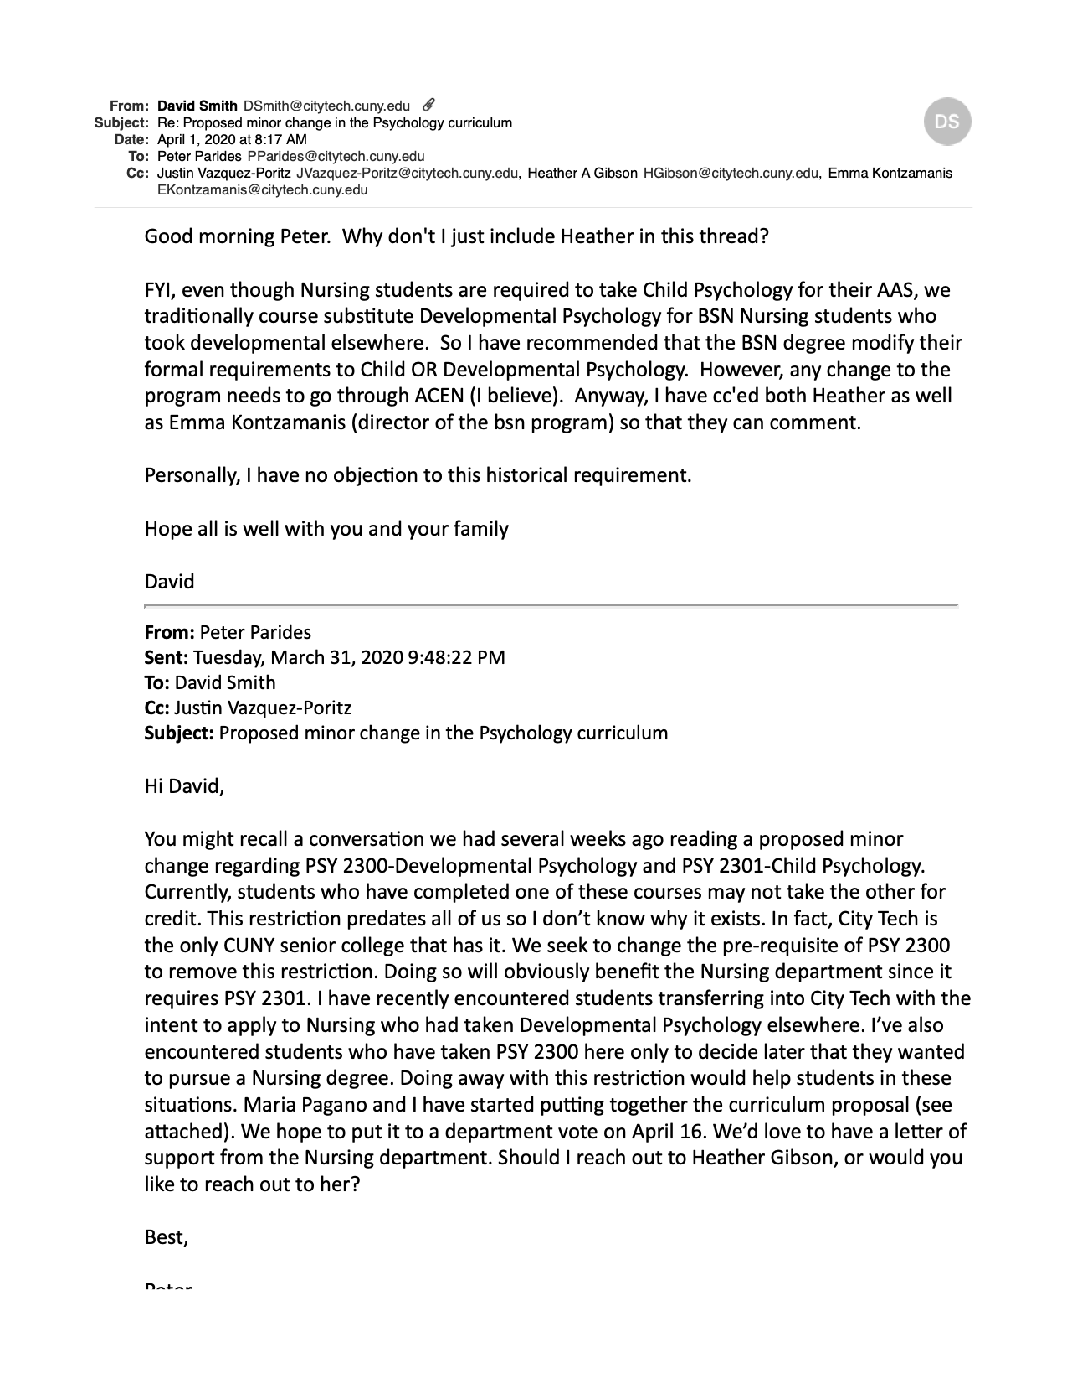

At this time, a student who has taken Developmental Psychology either at City Tech or another college is given a course substitution that replaces Developmental Psychology (PSY2300) with Child Psychology (PSY2301)
While York College is the only other 4-year CUNY that will not allow students to take both Developmental Psychology (Lifespan Development for Health Professions) and Child Psychology for credit, it should be noted that York’s Developmental Psychology course is specialized for health professionals. Consequently, it is not the traditional Developmental Psychology course.

