New York City College of Technology, CUNY
Department of Computer Engineering Technology

Proposal for New Course
CET 4910 Digital Image Processing

April 2nd, 2020

Table of Contents

CURRICULUM MODIFICATION PROPOSAL FORM 1
NEW COURSE PROPOSAL FORM 3
Chancellor’s Report 6
LIBRARY RESOURCES & INFORMATION LITERACY: MAJOR CURRICULUM MODIFICATION 7
RATIONALE……………………………………………………………………………………………………………………………..9
Course Need Assessment 9
Course Design 10
Course Outline 11
RECOMMENDED INSTRUCTIONAL MATERIAL……………………………………………………………………..…12
WEEKLY TOPICS ……………………………………………………………………………………………………………………13
COURSE ASSESSMENT CRITERIA ………………………………………………………………………………….….……14
GENERAL EDUCATION OUTCOMES ASSESSMENT..............................................................…...15
COURSE POLICIES …………………………………………………………………………………………………………………16
BIBLIOGRAPHY………………………………………………………………………………………………………………………17
APPENDIX 18

New York City College of Technology, CUNY

CURRICULUM MODIFICATION PROPOSAL FORM
This form is used for all curriculum modification proposals. See the Proposal Classification Chart for information about what types of modifications are major or minor. Completed proposals should be emailed to the Curriculum Committee chair.

Title of Proposal | Proposal for new course: CET 4910 Digital Image Processing
Date | April 2, 2020
Major or Minor | Major
Proposer’s Name | Chen Xu, Xiaohai Li, Lili Ma
Department | Computer Engineering Technology
Date of Departmental Meeting in which proposal was approved | October 31, 2019
Department Chair Name | Prof. Sunghoon Jang
Department Chair Signature and Date | 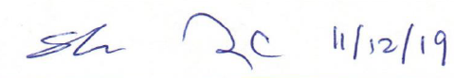
Academic Dean Name | Prof. Gerarda M. Shields
Academic Dean Signature and Date | 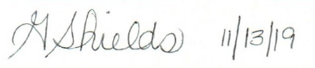
Brief Description of Proposal  (Describe the modifications contained within this proposal in a succinct summary. More detailed content will be provided in the proposal body. | Department of Computer Engineering Technology (CET) proposes a new course, CET 4910 Digital Image Processing, as a new technical elective course in its Computer Engineering Technology BTech (CEB) program curriculum.
Brief Rationale for Proposal  (Provide a concise summary of why this proposed change is important to the department. More detailed content will be provided in the proposal body). | Digital image is one of the most fundamental methods to store information in the modern world. For the last few decades, digital image processing has emerged as an important technology to extract useful information. It is widely used in areas such as industrial automation, medicine, biology, astronomy, law enforcement, defense, and intelligence. It is important for our students to understand the basic concepts of image processing and master the techniques currently used in the industry. This course is designed as a technical elective in the Computer Engineering Technology BTech program. It will prepare students with fundamental knowledge and techniques which will help them successfully extend their careers in related fields.
Proposal History  (Please provide history of this proposal: is this a resubmission? An updated version? This may most easily be expressed as a list). | This is a new proposal.  11/19/2019 submitted to Curriculum Committee.  2/20/2020 Revision submitted, addressed subcommittee’s comments.  4/2/2020 Final revision submitted.

Please include all appropriate documentation as indicated in the Curriculum Modification Checklist.

For each new course, please also complete the New Course Proposal and submit in this document.

Please submit this document as a single .doc or .rtf format. If some documents are unable to be converted to .doc, then please provide all documents archived into a single .zip file.

ALL PROPOSAL CHECK LIST
Completed CURRICULUM MODIFICATION FORM including:
- Brief description of proposal | Y
- Rationale for proposal | Y
- Date of department meeting approving the modification | Y
- Chair’s Signature | Y
- Dean’s Signature | Y
Evidence of consultation with affected departments  List of the programs that use this course as required or elective, and courses that use this as a prerequisite. | Y
Documentation of Advisory Commission views (if applicable). | NA
Completed Chancellor’s Report Form. | Y

EXISTING PROGRAM MODIFICATION PROPOSALS

Documentation indicating core curriculum requirements have been met for new programs/options or program changes. | NA
Detailed rationale for each modification (this includes minor modifications) | NA

New York City College of Technology, CUNY
NEW COURSE PROPOSAL FORM
This form is used for all new course proposals. Attach this to the Curriculum Modification Proposal Form and submit as one package as per instructions. Use one New Course Proposal Form for each new course.

Course Title | Digital Image Processing
Proposal Date | 4/2/2020
Proposer’s Name | Chen Xu, Xiaohai Li, Lili Ma
Course Number | CET 4910
Course Credits, Hours | 3 credits, 2 class hours, 2 lab hours
Course Pre / Co-Requisites | Pre/Co: CET3625, or departmental approval
Catalog Course Description | Introduction to the fundamental concepts and techniques of digital image processing. Topics include image display and image acquisition, sampling and quantization, two-dimensional discrete Fourier transform, spatial and frequency domain linear image filtering, noise model, image restoration, and image compression and segmentation.
Brief Rationale  Provide a concise summary of why this course is important to the department, school or college. | Digital image is one of the most fundamental methods to store information in the modern world. It is widely used in areas such as industrial automation, medicine, biology, astronomy, law enforcement, defense, and intelligence. It is important for our students to understand the basic concepts of image processing and master the techniques currently used in the industry. Proper understanding of the basic principles of digital image processing allows our CET students to obtain jobs in many related technical fields.
CUNY – Course Equivalencies  Provide information about equivalent courses within CUNY, if any. | No
Intent to Submit as Common Core  If this course is intended to fulfill one of the requirements in the common core, then indicate which area. | No
For Interdisciplinary Courses:  - Date submitted to ID Committee for review  - Date ID recommendation received  - Will all sections be offered as ID? Y/N | No
Intent to Submit as a Writing Intensive Course | No

Please include all appropriate documentation as indicated in the NEW COURSE PROPOSAL Combine all information into a single document that is included in the Curriculum Modification Form.
NEW COURSE PROPOSAL CHECK LIST
Use this checklist to ensure that all required documentation has been included. You may wish to use this checklist as a table of contents within the new course proposal.
Completed NEW COURSE PROPOSAL FORM
- Title, Number, Credits, Hours, Catalog course description | y
- Brief Rationale | y
- CUNY – Course Equivalencies
Completed Library Resources and Information Literacy Form | y
Course Outline
Include within the outline the following.
Hours and Credits for Lecture and Labs  If hours exceed mandated Carnegie Hours, then rationale for this | y
Prerequisites/Co- requisites | y
Detailed Course Description | y
Course Specific Learning Outcome and Assessment Tables  - Discipline Specific  - General Education Specific Learning Outcome and Assessment Tables | y
Example Weekly Course outline | y
Grade Policy and Procedure | y
Recommended Instructional Materials (Textbooks, lab supplies, etc) | y
Library resources and bibliography | y
Course Need Assessment.
Describe the need for this course. Include in your statement the following information.
Target Students who will take this course. Which programs or departments, and how many anticipated?  Documentation of student views (if applicable, e.g. non-required elective). | y
Projected headcounts (fall/spring and day/evening) for each new or modified course. | y
If additional physical resources are required (new space, modifications, equipment), description of these requirements. If applicable, Memo or email from the VP for Finance and Administration with written comments regarding additional and/or new facilities, renovations or construction. | y
Where does this course overlap with other courses, both within and outside of the department? | N
Does the Department currently have full time faculty qualified to teach this course? If not, then what plans are there to cover this? | y
If needs assessment states that this course is required by an accrediting body, then provide documentation indicating that need. | NA
Course Design
Describe how this course is designed.
Course Context (e.g. required, elective, capstone) | y
Course Structure: how the course will be offered (e.g. lecture, seminar, tutorial, fieldtrip)? | y
Anticipated pedagogical strategies and instructional design (e.g. Group Work, Case Study, Team Project, Lecture) | y
How does this course support Programmatic Learning Outcomes? | y
Is this course designed to be partially or fully online? If so, describe how this benefits students and/or program. | NA
Additional Forms for Specific Course Categories | NA
Interdisciplinary Form (if applicable)
Interdisciplinary Committee Recommendation (if applicable and if received)*
*Recommendation must be received before consideration by full Curriculum Committee
Common Core (Liberal Arts) Intent to Submit (if applicable)
Writing Intensive Form if course is intended to be a WIC (under development)
If course originated as an experimental course, then results of evaluation plan as developed with director of assessment.
(Additional materials for Curricular Experiments) | NA
Plan and process for evaluation developed in consultation with the director of assessment. (Contact Director of Assessment for more information).
Established Timeline for Curricular Experiment

Section AIV: New Courses
New courses to be offered in the School of Technology and Design
Department(s) | School of Technology and Design
Academic Level | [ X ] Regular [ ] Compensatory [ ] Developmental [ ] Remedial
Subject Area | Computer Engineering technology
Course Prefix | CET
Course Number | CET 4910
Course Title | Digital Image Processing
Catalog Description | Introduction to the fundamental concepts and techniques of digital image processing. Topics include image display and image acquisition, sampling and quantization, two-dimensional discrete Fourier transform, spatial and frequency domain linear image filtering, noise model, image restoration, and image compression and segmentation.
Prerequisite
Corequisite
Pre- or corequisites | Pre/Co: CET3625, or departmental approval
Credits | 3 credits
Contact Hours | 2 hours lectures, 2 hours lab
Liberal Arts | [ ] Yes [ X] No
Course Attribute (e.g. Writing Intensive, etc)
Course Applicability | [ X] Major  [ ] Gen Ed Required [ ] Gen Ed – Flexible [ ] Gen Ed - College Option  [ ] English Composition [ ] World Cultures [ ] Speech  [ ] Mathematics [ ] US Experience in its Diversity [ ] Interdisciplinary  [ ] Science [ ] Creative Expression [ ] Advanced Liberal Arts  [ ] Individual and Society  [ ] Scientific World
Effective Term | Fall 2020
Rationale: This course is designed as a technical elective in the Computer Engineering Technology BTech program. This course will provide students both basic and in-depth coverage of digital image processing techniques which will help them successfully extend their careers in related fields.

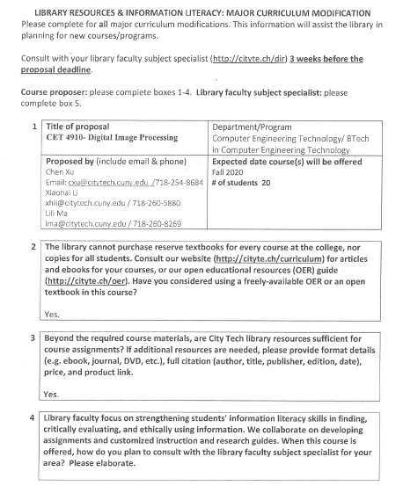

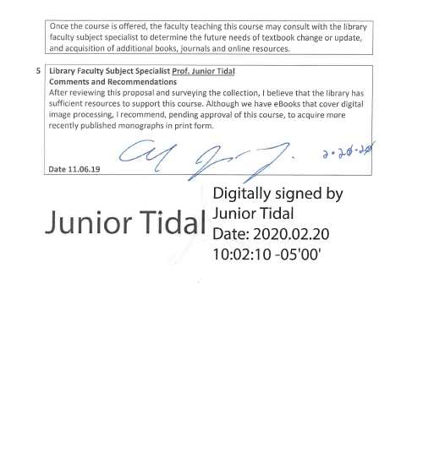

rationale

Because digital image is one of the most fundamental methods to store information, digital image processing is already integrated to different industries in the modern world. According to data from job searching website, glassdoor.com, as of 2019, the average salary for image processing engineer is $74.8K/year. The companies hiring image processing engineer range from manufacturing, health care, IT service, pharmaceutical and biotech company, transportation, hospital and research institute, insurance company, etc. The need to offer a course on Digital Image Processing is presented by the current technology trend and job market. This course provides students with fundamental knowledge and techniques in digital image processing. It will help the students be better prepared for the competition in job market and the technical challenge they may encounter in their career. It directly supports the mission of CET department, which is to prepare graduates for immediate employment and continued educational opportunities through a quality technical and experience-based education.

Because digital image processing is an important topic in computing-related fields, there are some courses with similar names in other CUNY colleges. However, other courses are all offered for BS degree with three credits and three lecture hours. Our proposed course is the only one offered for BTech degree with three credits and two lecture hours and two lab hours. Even though other courses are not exactly equivalent to this course, we will consider possible credit transfer if requested.

Course NEED Assessment

This course will be a technical elective for students in Computer Engineering Technology Department. CET students are required to take two technical elective courses before obtaining their CEB degrees. This proposed course will provide another option for the students and offer another choice of a three-credit technical elective course.

It is expected that a section of 20 students will take this course every time when it is offered. The course will be offered in both Spring and Fall semesters every academic year.

No additional physical resources are required since students will take this course in lieu of existing courses in the CEB program. Adequate equipment and resources in the CET Department are available for the hands-on components (lab experiments and course project) of this course.

Three existing CET full-time faculty who have extensive experiences in Digital Image Processing are qualified and available to teach this course every semester.

This course has no overlap with any other courses offered in the CET Department or courses offered in other departments.

Course Design

This course will be a technical elective course in CET BTech program.

The course is structured as a combination of lecture sessions and hands-on lab sessions. The lecture focuses on the theory and principles of digital image processing. The labs provides students with the opportunity to apply the theory in practical ways to practice and visualize by using real world examples. The team project helps students to participate in class and to interact with fellow students.

To support programmatic learning outcome, this course requires satisfactory completion of individual assignments, lab reports, two major exams, and a final team project. Assignments and exams are designed for proper understanding of theories; lab reports and team projects are designed for hands-on practices and programming skills.

This course is not designed to be online.

Course Outline

CET4910: Digital Image Processing
New York City College of Technology
Computer Engineering Technology Department
BTech Program in Computer Engineering Technology

Prepared by | Chen Xu, Xiaohai Li, Lili Ma | Revision date | 4/2/2020
Course No. & Title | CET 4910 Digital Image Processing
Course Description | Introduction to the fundamental concepts and techniques of digital image processing. Topics include image display and image acquisition, sampling and quantization, two-dimensional discrete Fourier transform, spatial and frequency domain linear image filtering, noise model, image restoration, and image compression and segmentation.
Hours / Credits | 2 class hours, 2 lab hours / 3 credits
Pre- / Co-requisite | CET 3625 or departmental approval
Course Objectives | Over the duration of this course, students are required to  - Understand general terminology of digital image;  - Identify various types of images, intensity transformations and spatial filtering;  - Apply Fourier transform for image processing in frequency domain;  - Analyze the basic algorithms and techniques in image enhancement and image restoration;  - Practice basic image processing algorithms in practical applications and apply ethical standards to case studies related to digital image processing.

Recommended Instructional Materials

Textbook and Reference Books
Text book (required) | Digital Image Processing | 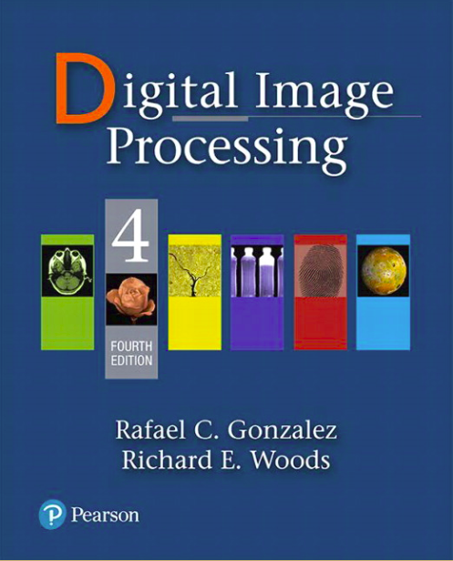
Author | Rafael C. Gonzalas and Richard .E. Woods
Publisher | Pearson; 4th edition, 2017
ISBN | ISBN-13: 978-0133356724  ISBN-10: 9780133356724

Reference book (optional) | Digital Image Processing using Matlab | 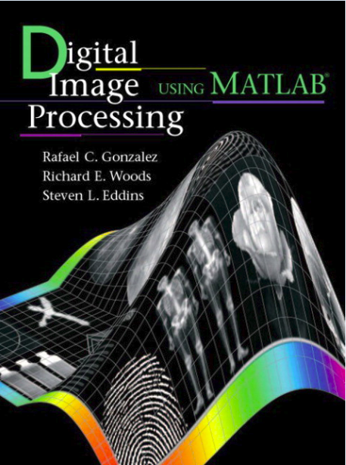
Author | Rafael C. Gonzalez, Richard E. Woods, Steven L. Eddins
Publisher / Year | Gatesmark Publishing; 2nd edition (2009)
ISBN | ISBN-13: 978-0982085400  ISBN-10: 0982085400

Reference book (optional) | The Image Processing Handbook | 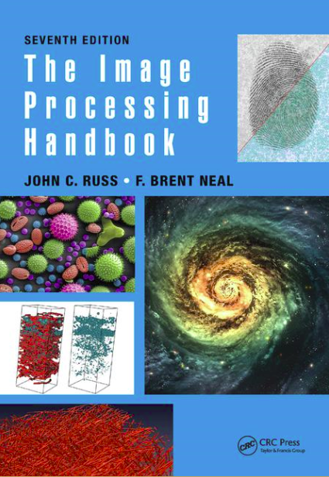
Author | John C. Russ and F. Brent Neal
Publisher | CRC Press; 7th edition, 2015
ISBN | ISBN-13: 978-1498740265  ISBN-10: 149874026X

- Additional reading and reference materials will be provided on Blackboard as needed.
- Lab manuals will be provided on Blackboard.

 | Weekly Topics
Wk | Lecture | Lab
1 | Course outline, classroom conduct, academic integrity, attendance, and grading policy. Introduction to the course, the origins of digital image processing, examples of fields that use digital image processing. Chapter 1, P1-P30 | Introduction to Matlab, and related function in image processing. Introduction to course project (examples, ideas, and requirements).
2 | Elements of digital image processing systems, Image formation, image sampling and quantization. Chapter 2, P31-P62 | Reading, displaying, writing images using Matlab.
3 | 2D discrete signal in spatial domain, some basic relationships like neighbors, connectivity, and distance measures between pixels. Chapter 2, P63-P90 | Image types and data classes, matrix representation with Matlab.
4 | Image translation, scaling, rotation and perspective projection of image. Chapter 2, P93-P128 | Basic matrix operation, scaling, rotation, and projection of image.
5 | Intensity transformation functions, histogram processing. Chapter 3, P134-P174 | Histograms and stretches.
6 | Spatial Filtering, smoothening and sharpening. Chapter3, P177-P240 | Smoothening and sharpening spatial filter.
7 | 2D Fourier transform and frequency domain.  Chapter4, P250-P303 | Computing and visualizing the 2D DFT.
8 | Midterm Exam | Midterm project report.
9 | Basic steps in DFT filtering, smoothing frequency domain filter. Chapter4, P306-P328 | Smoothening frequency domain filter.
10 | Sharpening frequency domain filter, selective filtering. Chapter4, P330-P360 | Sharpening frequency domain filter.
11 | Image restoration, noise models, inverse filtering. Chapter5, P366-P400 | Restoration with spatial filtering in the presence of noise only.
12 | Image compression model.  Chapter 8, P596-P649 | JPEG compression.
13 | Image Segmentation, edge detection, thresholding.  Chapter 10, P762-P838 | Image edge detection.
14 | Course project demonstration and presentation.
15 | Final exam.

COURSE ASSESSMENT CRITERIA
Upon successful completion of this course, students shall be able to | Evaluation methods and criteria
Understand general terminology of digital image. | Analysis of student performance on quiz, lab reports, homework, exams and final project presentation.
Identify various types of images, intensity transformations and spatial filtering | Analysis of student performance on short answer questions on quizzes, midterm exam, and final exam, and the role in a lab project within a group.
Apply Fourier transform for image processing in frequency domain | Analysis of student performance in quiz, hand-on lab experiments, lab reports, exams and final project.
Analyze the basic algorithms and techniques in image enhancement and image restoration. | Analysis of student performance in quiz, hand-on lab experiments, lab reports, exams and final project.
Practice basic image processing algorithms in practical applications and apply ethical standards to case studies related to digital image processing. | Students will select and apply appropriate tools through different stages of the project. Analysis of student performance in project exercises, and final demonstration/presentation of project.

GENERAL EDUCATION OUTCOMES AND ASSESSMENT

Learning Outcomes | Assessment Method
SKILLS/Inquiry/Analysis: Students will employ scientific reasoning and logical thinking. Students will gather, interpret and evaluate information from a variety of sources, and acquire discipline-specific knowledge. | Students will at minimum, demonstrate knowledge of basic technical terms related to digital image processing such as those found in a job interview in the technology field. Students who excel will be able to use logic and reasoning to find answers to new questions. This will be demonstrated by homework, exams and final project presentation.
SKILLS/Communication: Students will communicate in diverse settings and groups, using written (both reading and writing), oral (both speaking and listening), and visual means. | Effective reading will be demonstrated by accurate interpretation of reading/reference materials and weekly lab procedures. Effective writing will be demonstrated in lab reports, and lab project. In their final project, each group of students will give a brief oral presentation on their project at the end of the semester.
INTEGRATION/Integrate learning: Students will resolve difficult issues creatively by employing multiple tools. | Two to three students will form a team. They will pick up a technical problem, and present the algorithms they chose to solve the problem.
VALUES, ETHICS, RELATIONSHIPS / Professional/Personal Development: Students will work with teams, including those of diverse composition. Build consensus. Respect and use creativity. | Students will work together in groups to design, build and demonstrate/present a research project. Teamwork rubrics will be used for the assessment.

Course Policies

Grading Policy:

Quizzes, homework | 15%
Class Midterm Exam | 15%
Lab report | 20%
Project presentation, midterm report, and final report | 20%
Final Examination | 20%
Attendance, Class and Group Participation | 10%

Letter Grade | Numerical Grade | Ranges Quality
A | 93-100 | 4.0
A- | 90-92.9 | 3.7
B+ | 87-89.9 | 3.3
B | 83-86.9 | 3.0
B- | 80 -82.9 | 2.7
C+ | 77-79.9 | 2.3
C | 70-76.9 | 2.0
D | 60-69.9 | 1.0
F | 59.9 and below | 0.0

Lab Reports:
- Lab reports must be in Doc or PDF file format.
- All lab reports must be submitted through Blackboard – Assignments section.
- Each lab report is due one week after the lab work is performed. Lab reports must be submitted on time. For every week that report is late, 10 points will be deducted from the report grade.
- Additional requirements on lab report’s content and format will be posted on Blackboard.

Project:
- 2~3 students form a team to propose, develop and finish a project during the semester. The project needs to be approved by the instructor before proceeding.
- The optional topics include, but not limited, image processing for environmental surveillance, contour recognition in ultrasound image, image processing for remote sensing, and automatic sorting with image processing, etc.
- Final project demonstration/presentation will be done on the last week of the class. All team members in a team need to be present for the demonstration/presentation except emergencies.

Classroom Decorum:
- Attendance is taken at the beginning of each class. Coming in 5 minutes or later after the beginning of the class is considered as being late. Excessive absences may affect the final grade.
- Students are expected to do their own work on all graded course assignments. Any activity that threatens the college academic integrity will result in a disciplinary action.
- Cell phone usage not related to the course and any other distracting and disruptive behaviors such as talking loudly without permission are prohibited.

Library Usage:
- Students are encouraged to use the eBooks in library in support of the lectures and labs.
- Students are encouraged to access IEEE related journals through the subscription of library when working on their team project.

Bibliography:
  - A.K.Jain, Fundamentals of Digital Image Processing, Pearson, 1988.
  - Stephane Marchand-Maillet, Yazid M. Sharaiha, Binary Digital Image Processing, A Discrete Approach, Academic Press, 2000
  - IEEE Transactions on Image Processing
  - IEEE International Conference on Image Processing (ICIP)
  - www.mathworks.com/access/helpdesk/help/pdf_doc/matlab/getstart.pdf
  - www.imageprocessingplace.com
  - https://www.glassdoor.com/Salaries/image-processing-engineer-salary-SRCH_KO0,25.htm

APPENDIX

Evidence of Contacting CST Departments

Re: CET4910 Digital Image Processing
Hong Li
Fri 3/6/2020 10:44 AM
To: Chen Xu <CXu@citytech.cuny.edu>;
I am very sorry I missed your first email. I will circulate within department and get back to you as soon as possible.

Hong Li, Ph.D.
Professor and Chair
Department of Computer Systems Technology
New York City College of Technology
the City University of New York
300 Jay Street N914
Brooklyn NY 11201
Phone: (718)260-5170
Email: hli@citytech.cuny.edu

From: Chen Xu
Sent: Wednesday, March 4, 2020 3:03:40 PM
To: Hong Li
Subject: Re: CET4910 Digital Image Processing

Dear Dr. Li,

I hope you reviewed the new course proposal I sent last week. Do you support this new course?

Best Regards!

Chen

-----------------------------------------------------------------------------
Chen Xu, Ph. D
Assistant Professor
Department of Computer Engineering Technology
New York City College of Technology (City Tech)
The City University of New York (CUNY)
186 Jay Street, V643
Brooklyn, NY 11201- 2983
cxu@citytech.cuny.edu

From: Chen Xu
Sent: Thursday, February 27, 2020 11:28:12 PM
To: Hong Li; Mohammad Razani
Cc: Sunghoon Jang; Xiaohai Li; Lili Ma
Subject: CET4910 Digital Image Processing

Dear Dr. Li and Dr. Razani,

I am working on a new course proposal, CET 4910, Digital Image Processing. Please see attached proposal. This course will serve as a technical elective in CET department. It is in review under curriculum subcommittee. Please let me know if you have comments about this new course which will be discussed in the next curriculum meeting.

Thank you!

Chen

-----------------------------------------------------------------------------
Chen Xu, Ph. D
Assistant Professor
Department of Computer Engineering Technology
New York City College of Technology (City Tech)
The City University of New York (CUNY)
186 Jay Street, V643
Brooklyn, NY 11201- 2983
cxu@citytech.cuny.edu

Evidence of Contacting ETET department

Re: CET4910 Digital Image Processing
Chen Xu
Wed 3/4/2020 3:02 PM
To: Mohammad Razani <MRazani@citytech.cuny.edu>;

Dear Dr. Razani,

Thank you for your support to this new course at CCCC meeting yesterday. Can You repeat your support in this email? So I can include the final proposal.

Thank you!

Chen

-----------------------------------------------------------------------------
Chen Xu, Ph. D
Assistant Professor
Department of Computer Engineering Technology
New York City College of Technology (City Tech)
The City University of New York (CUNY)
186 Jay Street, V643
Brooklyn, NY 11201- 2983
cxu@citytech.cuny.edu

From: Chen Xu
Sent: Thursday, February 27, 2020 11:28 PM
To: Hong Li; Mohammad Razani
Cc: Sunghoon Jang; Xiaohai Li; Lili Ma
Subject: CET4910 Digital Image Processing

Dear Dr. Li and Dr. Razani,

I am working on a new course proposal, CET 4910, Digital Image Processing. Please see attached proposal. This course will serve as a technical elective in CET department. It is in review under curriculum subcommittee. Please let me know if you have comments about this new course which will be discussed in the next curriculum meeting.

Thank you!

Chen

-----------------------------------------------------------------------------
Chen Xu, Ph. D
Assistant Professor
Department of Computer Engineering Technology
New York City College of Technology (City Tech)
The City University of New York (CUNY)
186 Jay Street, V643
Brooklyn, NY 11201- 2983
cxu@citytech.cuny.edu

Evidence of Contacting BMET program

Re: Status of BMET proposal
Candido Cabo
Fri 9/13/2019 4:22 PM
To: Chen Xu <CXu@citytech.cuny.edu>;
Sure. No problem with reusing the course.
The proposal is still alive, but with thr change in Dean it is being delayed. We will meet son with the President to decide how it will be administered, which was one of the question that the curriculum committee ask and that the former dean never addressed.
Best,
...candido
Candido Cabo, Ph.D.
Professor
Department of Computer Systems
New York City College of Technology
City University of New York
300 Jay Street
Brooklyn, NY 11201
phone: (718) 260-5162
email: ccabo@citytech.cuny.edu
________________________________________
From: Chen Xu
Sent: Friday, September 13, 2019 3:46:03 PM
To: Candido Cabo
Subject: Status of BMET proposal
Dear Prof. Cabo,
I hope you have a smooth start this semester!
In April, we had last committee meeting and updated modified course proposals. I'm wondering what the current status of BMET proposal is? Is it still under consideration in college counsel?
Because I'm a tenure-track assistant professor, I need to propose new courses. Initially, I thought the courses I proposed with BMET program will count as my work, but it seems like it will take a long way to get approval. In discussion with Prof. Jang, he suggested that I can use one course proposal, Digital imaging processing, as a new technical elective course in CET department. If this course can be approved, it can be used for BMET course as well. Do you think I can do that?
Thank you for any suggestion!
Sincerely Yours,
Chen
-----------------------------------------------------------------------------
Chen Xu, Ph. D
Assistant Professor
Computer Engineering Technology
New York City College of Technology
186 Jay Street, V643
Brooklyn, NY 11201- 2983
cxu@citytech.cuny.edu<mailto:cxu@citytech.cuny.edu>

