New York City College of Technology, CUNY
CURRICULUM MODIFICATION PROPOSAL FORM
This form is used for all curriculum modification proposals. See the Proposal Classification Chart for information about what types of modifications are major or minor. Completed proposals should be emailed to the Curriculum Committee chair.

Title of Proposal | Change of credit hours of MECH 1234
Date | 09/26/2019
Major or Minor | Major
Proposer’s Name | Akm Rahman
Department | Mechanical Engineering Technology
Date of Departmental Meeting in which proposal was approved | 2/7/2019
Department Chair Name | Sidi Berri
Department Chair Signature and Date
Academic Dean Name | Gerarda Shields
Academic Dean Signature and Date
Brief Description of Proposal  (Describe the modifications contained within this proposal in a succinct summary. More detailed content will be provided in the proposal body. | Change “MECH 1233 credit hour breakdown as per the compliance with Carnegie definition”. Change Course number to MECH 1234.
Brief Rationale for Proposal  (Provide a concise summary of why this proposed change is important to the department. More detailed content will be provided in the proposal body). | This change would reflect Carnegie Definition of credit hour. Currently this course includes 3 hours of lecture and 1hour of lab, 3 credit hours. In order to comply with Carnegie definition, it should be 2 hours of lecture and 2 hours of lab, 3 credits hours.
Proposal History  (Please provide history of this proposal: is this a resubmission? An updated version? This may most easily be expressed as a list). | The proposal submitted (09/26/2019)  CC Chair’s feedback received (10/14/2019)  CC Chair’s feedback adopted (10/30/2019)

Please include all appropriate documentation as indicated in the Curriculum Modification Checklist.

For each new course, please also complete the New Course Proposal and submit in this document.

Please submit this document as a single .doc or .rtf format. If some documents are unable to be converted to .doc, then please provide all documents archived into a single .zip file.

ALL PROPOSAL CHECK LIST
Completed CURRICULUM MODIFICATION FORM including:
- Brief description of proposal | y
- Rationale for proposal | y
- Date of department meeting approving the modification | y
- Chair’s Signature | y
- Dean’s Signature | y
Evidence of consultation with affected departments  List of the programs that use this course as required or elective, and courses that use this as a prerequisite. | y
Documentation of Advisory Commission views (if applicable). | N/A
Completed Chancellor’s Report Form. | y

EXISTING PROGRAM MODIFICATION PROPOSALS

Documentation indicating core curriculum requirements have been met for new programs/options or program changes. | N/A
Detailed rationale for each modification (this includes minor modifications) | y

Section AV: Changes in Existing Courses

Changes to be offered in the Mechanical Engineering Technology department

MECH 1234 Statics and Strength of Materials
CUNYFirst Course ID | 33108
FROM: |  | TO:
Department(s) |  | Department(s)
Course | MECH 1233 | Course | MECH 1234
Prerequisite |  | Prerequisite
Corequisite |  | Corequisite
Pre- or corequisite |  | Pre- or corequisite
Hours | 3 hours Lec+1 hour Lab | Hours | 2 hours Lec+2 hours Lab
Credits | 3 | Credits | 3
Description |  | Description
Requirement Designation |  | Requirement Designation
Liberal Arts | [ ] Yes [ ] No | Liberal Arts | [ ] Yes [ ] No
Course Attribute (e.g. Writing Intensive, Honors, etc |  | Course Attribute (e.g. Writing Intensive, Honors, etc
Course Applicability | [ ] Major  [ ] Gen Ed Required  [ ] English Composition  [ ] Mathematics  [ ] Science  [ ] Gen Ed - Flexible  [ ] World Cultures  [ ] US Experience in its Diversity  [ ] Creative Expression  [ ] Individual and Society  [ ] Scientific World  [ ] Gen Ed - College Option  [ ] Speech  [ ] Interdisciplinary  [ ] Advanced Liberal Arts | Course Applicability | [ ] Major  [ ] Gen Ed Required  [ ] English Composition  [ ] Mathematics  [ ] Science  [ ] Gen Ed - Flexible  [ ] World Cultures  [ ] US Experience in its Diversity  [ ] Creative Expression  [ ] Individual and Society  [ ] Scientific World  [ ] Gen Ed - College Option  [ ] Speech  [ ] Interdisciplinary  [ ] Advanced Liberal Arts
Effective Term | Spring, 2020

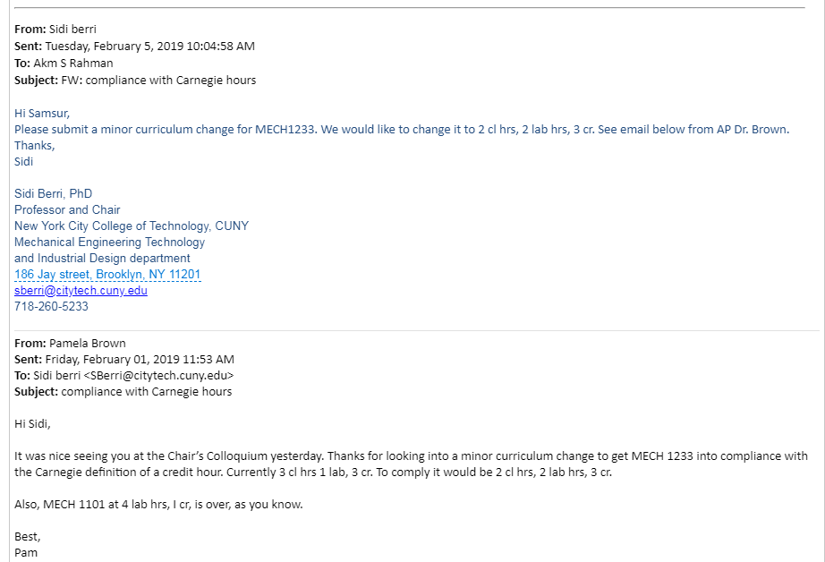

Department of Mechanical Engineering Technology
Course number/name:
MECH 1233 Statics and Strength of Materials
Credits/contact hours:
3 credits, 4 class hours
Instructor/coordinator:
Malek Brahimi, Assistant Professor of Mechanical Engineering Technology
Text book/title/author/year:
Applied Statics and Strength of Materials 5th edition, Leonard Spiegel and George F. Limbrunnere, Prentice Hall, 2009, ISBN-13: 978-0-13-194684-2, ISBN: 0-13-194684-6
Specific course information Catalog description:
The foundation for most of the courses in the mechanical engineering technology curriculum and the basis of machine and structural design. Included are the basics in problem-solving, significant figures, dimensional analysis and engineering graphs. In addition, the following are covered in depth: statics, stress and strain, properties of materials, joints, thin-walled pressure vessels, centroid and center of gravity, moment of inertia and beam analysis and design.
Pre/Corequisites:
MAT 1275, IND 1112
Required/elective/selected elective:
Required for Mechanical Engineering Technology and Industrial Design Technology
Course learning objectives:
- Ability to add coplanar forces and resolve them into components.
- Understand the concept of free-body diagram for a whole or part of a system.
- Able to solve systems in equilibrium using the equations of equilibrium.
- Understand the concept of moment of a force, and a couple and calculate them in two dimensions.
- Ability to reduce distributed loadings to a resultant force and specific location.
- Ability to develop the equations of equilibrium from a free body diagram of a rigid body and solve them.
- Ability to determine the center of gravity and the centroid for a rigid body.
- Ability to find the moment of inertia of a cross section area, and use the transfer formula.
- Ability to define the material properties such as tensile strength, yield strength, proportional limit, shear strength, hardness, modulus of elasticity, percent elongation, percent reduction, and modulus of rigidity.
- Ability to identify, analyze, and solve problems for tensile, compressive, and shear stresses.
- Ability to determine stresses in thin walled pressure vessels.
- Ability to analyze and design simple beams.

Course addresses ABET student outcomes: 3a, 3b, 3c, 3e, 3f, 3i and PC-1

Brief list of topics to be covered:
- Mechanics Overview. Application of Statics. Units of Measurement. SI units. Numerical Calculations and Accuracy.

- Principles of Statics. Force Units. Scalar and vector Quantities, Principles of Transmissibility. Types of force System. Concurrent, Resultant and Components.

- Conditions for Statics. Equilibrium of a Coplanar Force System, Free-Body Diagram. Concurrent Force System. Parallel Force System. Nonconcurrent Force System.

- Analysis of Simple Structures, Trusses, Two Force Members. Forces in members of trusses, and Methods of Joints.

- Frictions, Friction Theory and Applications.

- Center of Gravity, Centroids and Centroidal axes, Moment of Inertia, Transfer Formula. Polar Moment of Inertia.

- Stress and Strain Relationship, Properties of Material.

- Stress Considerations, Poisson’s Ratio, Thermal Effects, and Stress Concentration.

- Stresses in thin-walled pressure vessels.

- Analyze and design of simple beams.

Prepared by: Dr. Malek Brahimi Fall 2013

