New York City College of Technology, CUNY
CURRICULUM MODIFICATION PROPOSAL FORM
This form is used for all curriculum modification proposals. See the Proposal Classification Chart for information about what types of modifications are major or minor. Completed proposals should be emailed to the Curriculum Committee chair.

Title of Proposal | Withdrawal of VCT 1202 Ophthalmic Business Practices
Date | 10/18/2019
Major or Minor | Minor
Proposer’s Name | Kara Pasner
Department | Business
Date of Departmental Meeting in which proposal was approved | 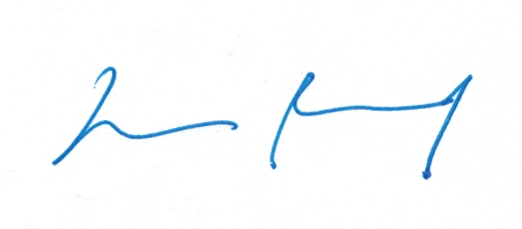  09/19/2019
Department Chair Name | Lucas Bernard
Department Chair Signature and Date | 10/20/2019
Academic Dean Name | David Smith
Academic Dean Signature and Date
Brief Description of Proposal  (Describe the modifications contained within this proposal in a succinct summary. More detailed content will be provided in the proposal body. | Withdraw VCT-1202
Brief Rationale for Proposal  (Provide a concise summary of why this proposed change is important to the department. More detailed content will be provided in the proposal body). | This is a 3-credit, 3-hour Ophthalmic business course. It is essentially a basic business course intermixed with the business intricacies of ophthalmic dispensing. We have the opportunity to allow our students to choose from several business courses such as marketing, fashion, basic finance, business management, etc. Thus, this course will be withdrawn and replaced by a choice of: BUS-2339, ACC-1101, ACC-1162, BUS-1122, BUS-2425, MKT-1100, MKT-1102, MKT-1103, and BUF-1101. We feel this would give our students a practical choice more tailored towards their interests. This will connect to our planned Bachelor in Business degree.
Proposal History  (Please provide history of this proposal: is this a resubmission? An updated version? This may most easily be expressed as a list). | First submission

Please include all appropriate documentation as indicated in the Curriculum Modification Checklist.
For each new course, please also complete the New Course Proposal and submit in this document.
Please submit this document as a single .doc or .rtf format. If some documents are unable to be converted to .doc, then please provide all documents archived into a single .zip file.

ALL PROPOSAL CHECK LIST
Completed CURRICULUM MODIFICATION FORM including:
- Brief description of proposal | x
- Rationale for proposal | x
- Date of department meeting approving the modification | x
- Chair’s Signature | x
- Dean’s Signature | x
Evidence of consultation with affected departments  List of the programs that use this course as required or elective, and courses that use this as a prerequisite. | N/A
Documentation of Advisory Commission views (if applicable). | N/A
Completed Chancellor’s Report Form. | x

EXISTING PROGRAM MODIFICATION PROPOSALS

Documentation indicating core curriculum requirements have been met for new programs/options or program changes.
Detailed rationale for each modification (this includes minor modifications)

Description of Proposal

We propose to withdraw VCT 1202 Ophthalmic Business Practices

Rationale for Proposal

This is a 3-credit, 3-hour Ophthalmic business course. It is essentially a basic business course intermixed with the business intricacies of ophthalmic dispensing. We have the opportunity to allow our students to choose from several business courses such as marketing, fashion, basic finance, business management, etc. Thus, this course will be withdrawn and replaced by a choice of: BUS-2339, ACC-1101, ACC-1162, BUS-1122, BUS-2425, MKT-1100, MKT-1102, MKT-1103, and BUF-1101. We feel this would give our students a practical choice more tailored towards their interests. This will connect to our planned Bachelor in Business degree.

