New York City College of Technology, CUNY
CURRICULUM MODIFICATION PROPOSAL FORM
This form is used for all curriculum modification proposals. See the Proposal Classification Chart for information about what types of modifications are major or minor. Completed proposals should be emailed to the Curriculum Committee chair.

Title of Proposal | BS Double-Duty Course Changes
Date | 8-28-2019
Major or Minor | Minor
Proposer’s Name | Concetta Mennella
Department | Law and Paralegal Studies
Date of Departmental Meeting in which proposal was approved | March 25, 2019
Department Chair Name | Concetta Mennella
Department Chair Signature and Date | 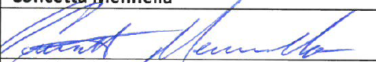08-29-19
Academic Dean Name | David Smith
Academic Dean Signature and Date | 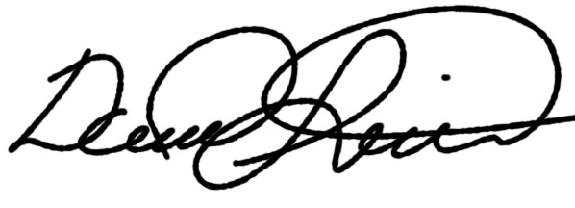2019-08-29
Brief Description of Proposal  (Describe the modifications contained within this proposal in a succinct summary. More detailed content will be provided in the proposal body. | The Department is eliminating some overlapping degree-specific and general education requirements to allow students more flexibility in selecting Pathways courses.  As such the following courses will no longer be Department requirements for the BS degree:  GOV 2410 or SOC 2403  History Electives  ENG 1161 or ANY Lit course  ENG 2570
Brief Rationale for Proposal  (Provide a concise summary of why this proposed change is important to the department. More detailed content will be provided in the proposal body). | This will enable students a broader choice of courses from the Gen Ed /Flexible core college options such as:  World Cultures,  US Experience in its Diversity  Creative Expression  Individual and Society  Scientific World
Proposal History | After much discussion the faculty feels that this change will benefit the students overall curriculum choices

The following revisions are proposed for the BS in Law and Paralegal Studies
Program:
Program Code:
Effective Date:

FROM: | TO:
[PROGRAM-SPECIFIC DEGREE REQUIREMENTS]  LAW 35XX LAW Modules (One set of three) 3 credits  LAW 4704 Legal Technology (WI) 3 credits.  COM 1340 (CE)  or COM 2402 (WI,IS) 3 credits.  GOV 2401  or SOC 2403 (IS) 3 credits.  MAT 12722 (MQR,SW)  or MAT 1372 (SW) 3 credits.  History Elective (HIS/AFR/LATS) 3 credits.  ENG 11612 (ID) or Any literature course  (Recommended ENG 1161 Language and Thinking) 3 credits.  ENG 2570 Writing in the Workplace 3 credits.  ENG 3401 Law Through Literature (WI) 3 credits.  PHIL 3211 Philosophy of Law 3 credits.  PSY 2XXX PSY 2000 Level or higher 3 credits.  4 LAW elective courses  LAW 4800 (WI) 12 credits.  or LAW 4801 (WI) 3 credits.  LAW 4900 Senior Legal Seminar (WI) 3 credits.  TOTAL CREDITS REQUIRED FOR THE DEGREE 120 | [PROGRAM-SPECIFIC DEGREE REQUIREMENTS]  COM 1340 (CE)  or COM 2402 (WI,IS) 3 credits.  MAT 12722 (MQR,SW)  or MAT 1372 (SW) 3 credits.  ENG 3401 Law Through Literature (WI) 3 credits.  PHIL 3211 Philosophy of Law 3 credits.  PSY 2XXX PSY 2000 Level or higher 3 credits.  LAW 35XX LAW Modules (One set of three) 3 credits  LAW 4704 Legal Technology (WI) 3 credits.  LAW 4800 (WI)  or LAW 4801 (WI) 3 credits.  LAW 4900 Senior Legal Seminar (WI) 3 credits.  4 LAW elective courses 12 credits  TOTAL CREDITS REQUIRED FOR THE DEGREE 120

Rationale: Eliminates some overlapping degree-specific and general education requirements to allow students more flexibility in selecting Pathways courses.

